Git useful command :

Load in local a remote branch:

git checkout –track name_of_the_remote_branch # create a tracking branch

History :

git log --patch -2 🡪 (--patch or -p) Display the differences resulting of committed changes. -2 restrict the displaying of logs to 2.

git log --stat 🡪 summarize the above command line in number of insertions/deletions by file

git log --pretty=format:”%h - %an %ad %s” 🡪 to get the some information here the references

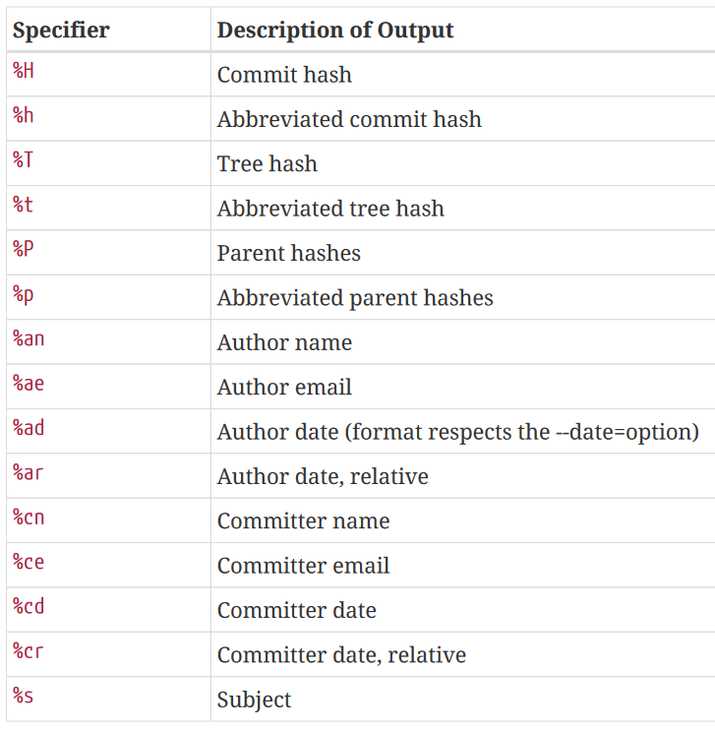

git log --pretty=format :“%h %s” --graph 🡪 generate branch diagrams

git log -- *path* 🡪 display filtered log inside *path*

git log with the below arguments

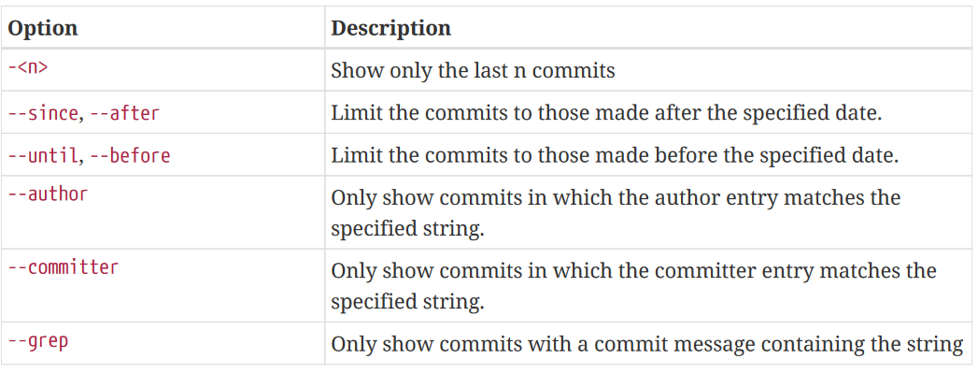

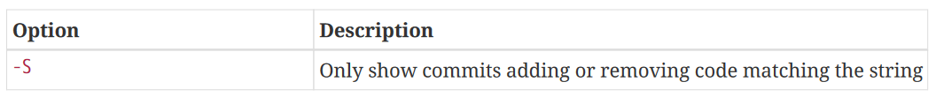

## Compare files from local and remote branch

git fetch remote_branch

git diff local_branch remote_branch – file

## Compare file unstaged file against the last committed files

git difftool HEAD --file_path

Compare 2 distinct files

git difftool HEAD: path_file_1 path_file_2

## Observer unstaged files

git ls-files -m ([ref](https://stackoverflow.com/questions/10018533/is-it-possible-to-git-status-only-modified-files))

## Read the version of a given commit/branch :

git cat-file -p <sha1>:./file.tex > wherever.tex ([ref](https://stackoverflow.com/questions/14995506/how-to-get-a-copy-of-an-older-version-of-a-file-in-a-git-repository))

## List of modified files between 2 branches/commits

git diff --name-only SHA1 SHA2 ([ref](https://stackoverflow.com/questions/1552340/how-to-list-only-the-names-of-files-that-changed-between-two-commits))

Fixing merge conflicts

([ref](https://docs.github.com/en/pull-requests/collaborating-with-pull-requests/addressing-merge-conflicts/resolving-a-merge-conflict-using-the-command-line))

Know where config elements are stored:

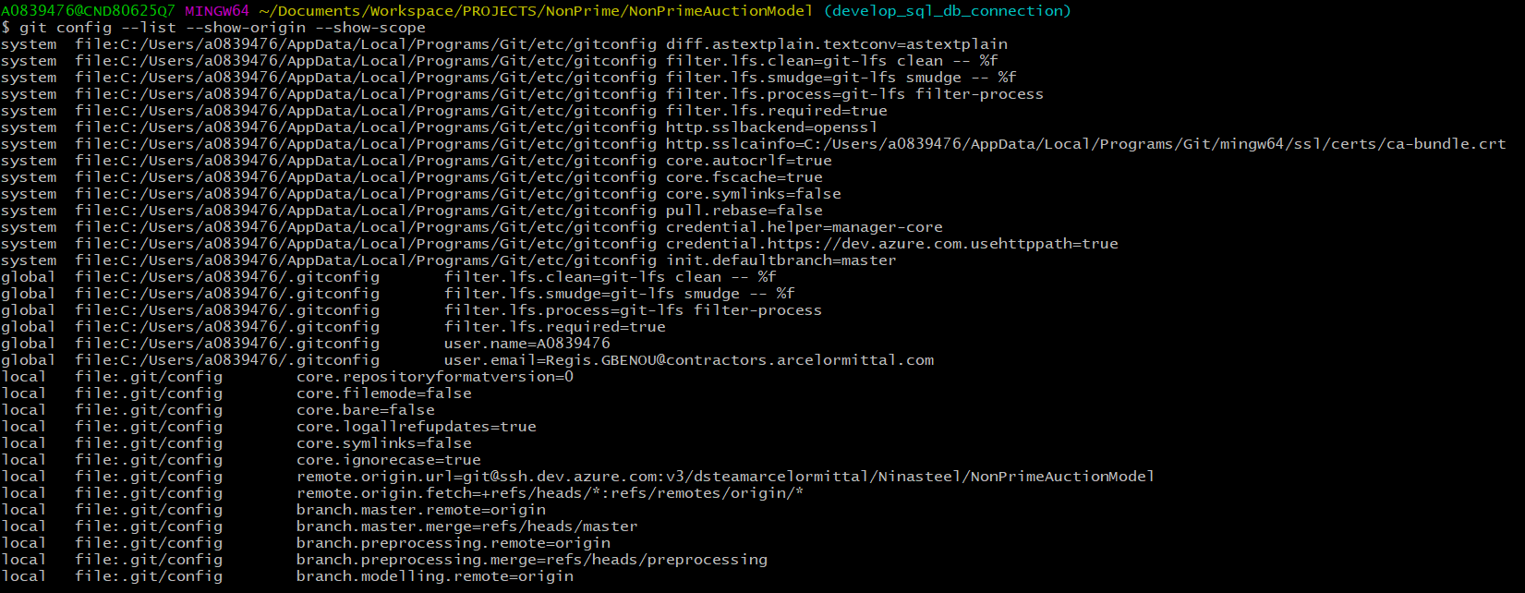

Choose the git diff tool

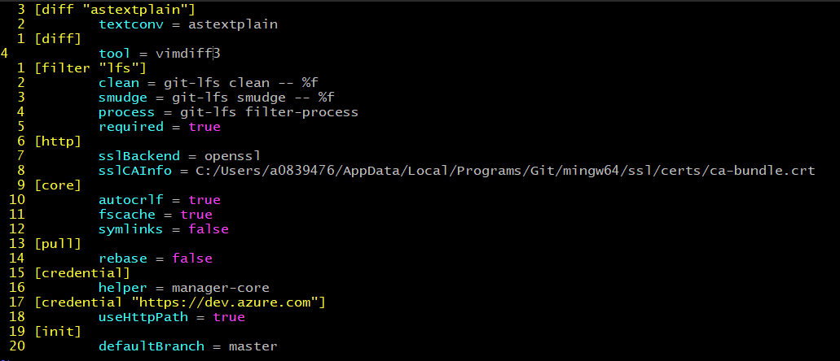

Use difftool



Remove branch

git branch -d branch_to_delete # remove branch only if it is fully merged

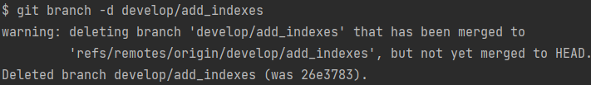

Means that the we deleted locally develop/add_indexees but we did not delete the origin version

git push origin –delete origin/branch_to_delete

Rename Branch

git branch -m new_name # on the branch that we want to rename

git branch -m old_name new_name # from another branch that the one to rename

git push origin :old_name new_name # delete the old_name remote branch an push new_name

git push origin -u new_name # reset the upstream branch for the new_name local branch