## memory usage on UNIX:

free -m # display all the information in MBs

df -h # disk filename command, with the human readable option (adapt the figures of each filesystem)

du -ch # to see the size of each elements in a given repository

grep --exclude=\*.{pyc,log} -rl './' -e ".*10\.214\.82\.92.*" # find in the current directory and its subdirectorires all the files containing the string "10.214.82.92" inside a

zip new_dir_name.zip orig_dir_name

## Processes

nohup

Here [link](https://stackoverflow.com/questions/17385794/how-to-get-the-process-id-to-kill-a-nohup-process)

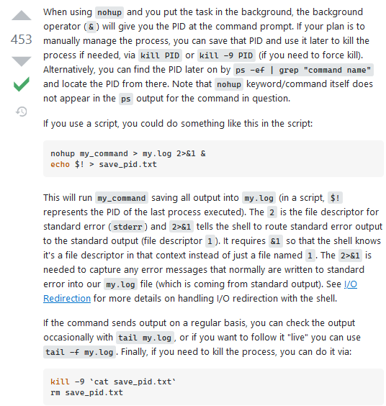

## Searches

ls -d ./*/ 🡪 all subdirectories inside the current one (recall that */ denominates all sub-directories)

find / -type d -name “myfile” 🡪 returns list of the files containing myfile

To search for a file containing ‘packages’ in its name, inside the current directory

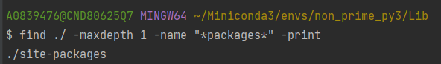

grep -rnw /path/to_dir/ ‘’ -e ‘pattern’ 🡪 returns list of files inside /path/to_dir and containing ‘pattern’

[**How do I find all files containing specific text on Linux?**](https://stackoverflow.com/questions/16956810/how-do-i-find-all-files-containing-specific-text-on-linux)

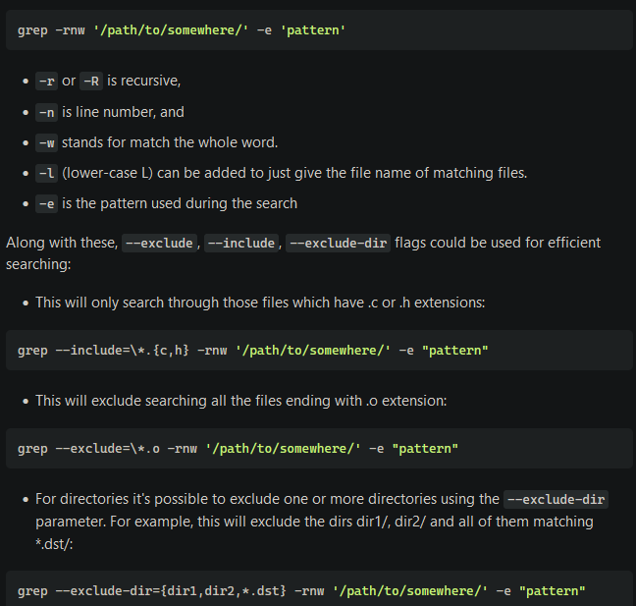

## Store the content of a variable

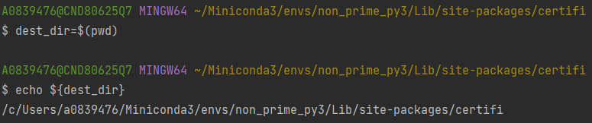

To zip a list of files we can use [this](https://superuser.com/questions/834959/how-to-zip-a-list-of-files-in-linux):

grep -rl "abc" file-* | zip archive -@ # -@ option makes zip read from STDIN