## Read data

pickle files : df = pd.read_msgpack(os.path.join(path, df_name))

## Multiindex:

Column subset: get_level_values()

## Comparing 2 data frames:

pd.DataFrame.compare()

Or more manually:  
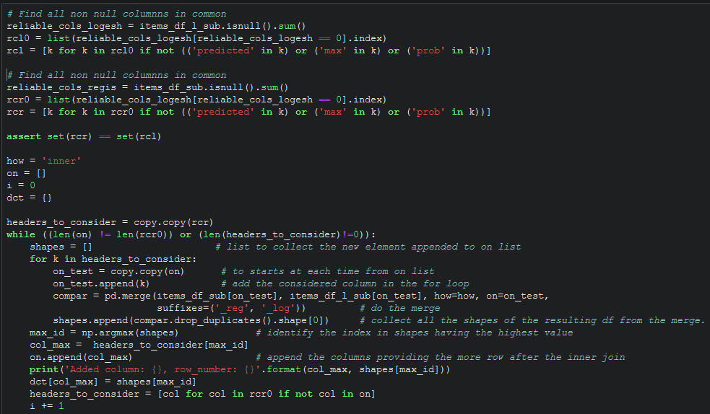

Knowing that items_df_sub and items_df_l_sub or 2 data frame to compare.

## Displaying:

Display as many rows that we want: [link](https://stackoverflow.com/questions/16424493/pandas-setting-no-of-max-rows)

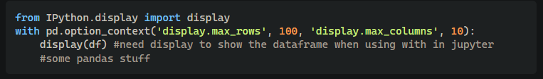

## Max Min

Use [pandas.series.argmax()](https://pandas.pydata.org/docs/reference/api/pandas.Series.argmax.html) method

### Concatenate

df_[‘concatenated_cols’] = df[list_cols_to_concatenate].agg(‘-’.join, axis=1)