## Display numbers with at least 4 digits

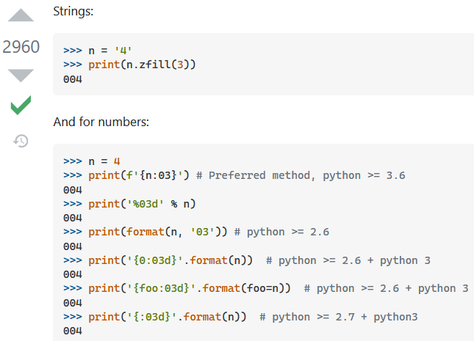

## Format print-f

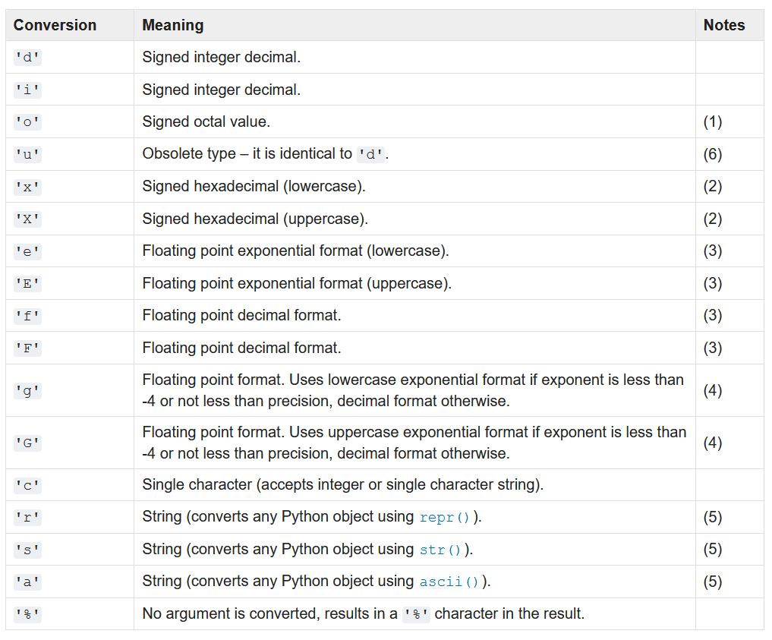

With many arguments use tuple for example:   
Hey %s, there is a 0x%x error!' % (name, errno)