Contents

SQLAlchemy 1

Data connection 1

Table creation 1

Type 1

# SQLAlchemy

## Data connection

Engine 🡪 describe how to communicate with a given database/DBAPI (Python Database API Specification, used to define common usage patterns for all database connection packages)

engine = create_engine(connectString)

For example to connect to MicrosoftServer with PyODBC:   
 connectString = mssql+pyodbc://<username>:<password>@<dsname>

## Table creation

### Type

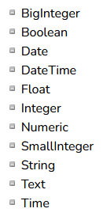

### Process

Metadata contains definitions of tables and associated objects such as index, view, triggers, …



From sqlalchemy import MetaData

Meta = MetaData

Students = Table (

)