In MongoDB Compass 🡪 Copy: **ctrl + insert**

Getting the first and last record from a collection contained in a database db: ([see](https://stackoverflow.com/questions/10920651/get-the-latest-record-from-mongodb-collection))

db.collection.find().limit(1) # first record

db.collection.find().limit(1).sort({$natural: -1}) # last record

To count ([see](https://docs.mongodb.com/manual/reference/method/db.collection.count/)):

db.collection.count()

Distinct values

db.collection.distinct(*field, query*)

Not null

Db.collection.find({‘field’: {$exists: true}}) #

To check the rows where in itemsa, ‘Quality_Fam_’ does not contain number

db.itemsa.find({'Quality_Fam_': {$not: {$type: 'number'}}}, {'Quality_Fam_': 1})

To get the maximum of ‘auction_ID’ (a numerical field)

db.bidsa.find({}, {'auction_ID': 1}).sort({'auction_ID': -1}).limit(1)

Check if ‘sold_to’ contain any alphabetical characters:

db.bidsa.find({'sold_to': {$regex: /[A-Za-z\s]/}}, {'sold_to': 1})

Trimming string values of a given column:

db.bidsa.distinct('customer_country', {'customer_country': {$regex: /^\s|\s$/}})

Create collection:

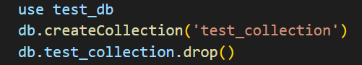

# Flakes Stock Data

In tableau connect to Stock and Sales data

Check the aggregated values:

Stock Data

For every CU, CSU, family subfamily and week to compare sum of advance and commercial stock

Compare what I have in Tableau data sources and what I have in sql table