Aggregating Dimensions:

Attribute aggregation has some advantages:

* It can ensure a consistent level of detail when blending multiple data sources
* It can provide a way to aggregate dimensions when computing table calculations
* It can improve query performance because it is computed locally

**IF MIN([dimension]) = MAX([dimension]) THEN MIN([dimension]) ELSE “*” END**

Disaggregating

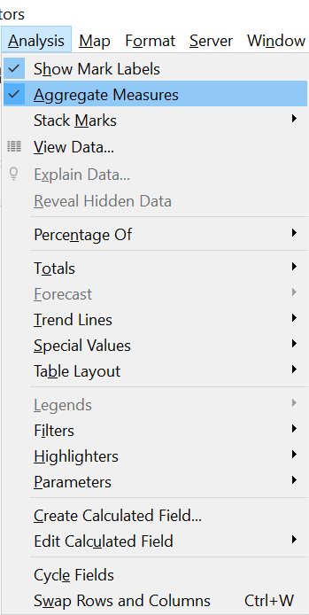

**Table Calculation**

**L.O.D. (Level Of Detail)**

**It seems possible to do the same calculation as a Table calculation can do, we just need to create a key (concatenation of dimensions to get a desired level) then incorporate it in a {FIXED:} expression and we are able to have the flexibility of a Table Calculation and the solidity of a LOD**