**UKY: FAR Search Engine Web Application**

**Application**

**Completed features/modules:**

**1) Basic Search**

Searching with 'topic' related keys(queries) with sphinx search engine which uses indexes of the data from the **ICTCollab_IntellCont** table.

**2) Result List**

**3) Detailed contact information in results**

The results table contains the detail information about the collaborators who are related to the search query. The collaborators are sorted according to their rank(designation).

**4) User login & profile editor**

Existing users can login to the system and use the search engine. New users can register to the site. Users can edit their basic information from the profile edit page.

**5) Store user search**

Search queries are stored in the database according to the user's email address. They are needed for the recommendation system.

**6) Tuning Sphinx \***

**7) Recommendation system \***

* These modules are yet to be fully completed. I intend to do some more preprocessing with the search queries as well some some post-processing of the results as well. In addition to that, the recommendation system is under development.

**Brief description:**

The application is built on the codeigniter (CI) framework. CI is a light-weight PHP based MVC framework and easy to get started with. When a URL (<http://localhost/far/index.php/auth/login>) is entered in the browser the file that is hit for the URL is **'auth.php**' inside **'./far/application/controllers/auth.php'**. The latter part ('**login**') is the name of the function in the file '**auth.php**' of the class '**Auth**'.

**Database**

The previous two tables are barely altered. The changes in the database are listed below:

**1)** Changed the '**Rank**' field in the **ICTCollab_Collaborator**. This was previously represented as a string ( Professor, Lecturer etc.). It is now represented as a integer number which are mapped with the actual Designation of the collaborator in the **ICTCollab_Designations** table.

**2)** Added table **ICTCollab_Users**. Purpose: to store the user login information.

**3)** Added table **ICTCollab_Designations**. Purpose: to store the designation table. Data in this table are static & should not be altered unless any change in the designations are needed.

**4)** Added table **ICTCollab_Publications**. Purpose: every publication is given a new ID and they are mapped with the **ICTCollab_IntellCont** table. However, no change in the **ICTCollab_IntellCont** table has been made due to the addition of this table.

**5)** Added table **ICTCollab_SearchHistory**. Purpose: to store the search queries by the users.

**ER Diagram of the database**

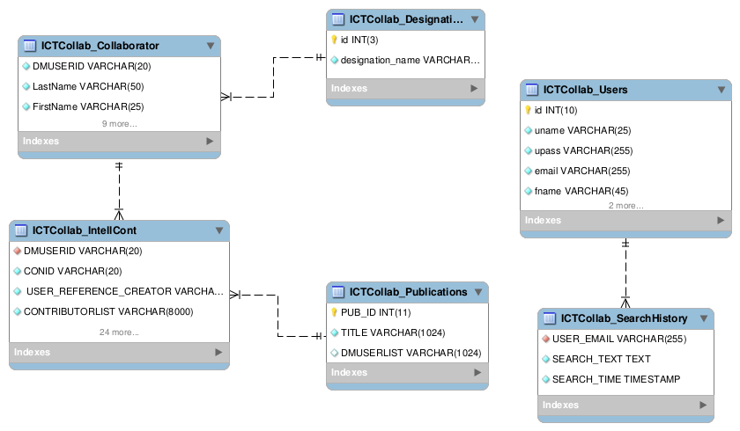

**How to install-run the application**

You need to change two files only:

* **./application/config/database.php**

:: put all the database credentials here correctly

* **./application/config/config.php**

:: change the *base_url* as required

___

* **Login:**

:: email : mail_sanjaysaha@yahoo.com

:: pass : sanjay

* **Register:**

:: Register with correctly filled up form

___

* **Database(SQL) files directory: /far/sql/**

* **Sphinx Configuration file directory: /far/sphinx/**

___

**Note:**

* If the Sphinx API is not installed with the PHP service,

put the Sphinx API file (sphinxapi.php) in the following directory:

**./application/controller/**

* After adding the API file in the controller directory, check if the following code is present in the search.php in the same folder after line number 1. If not, add this line at after line number 1:

`require 'sphinxapi.php';`

* The Database needs to be indexed by sphinx indexer, otherwise the application will not provide any search result.

* **How to index database & run sphinx**: change the indexed data location(s) & the database credentials as your pc in the sphinx.conf file. Then run the command `indexer <index_name>` to index. Now from the sphinx installation directory, run the command `searchd` to start the search server. You need to run the indexer for only once but searchd has to be run every time the pc is restarted. You can add this to your startup programs to start it when your pc boots.

**Sample execution (from register/login to search results)**

