Statistics for Neuroscience Data
A plain-language companion to Session 13
The ideas behind mean ± SEM, t-tests, ANOVA, and choosing the right plot — no maths degree required.
How to use this document
Read it once before Session 13 and keep it open while you run the demo scripts.
Each section explains WHAT a method does and WHEN to use it, then points to the MATLAB function.
The last two sections are the practical payoff: a "which test?" map and a "which plot?" guide.

1. Always describe before you test
Every analysis starts by summarising the data with three questions: where is the centre, how spread out is it, and how precisely do we know the average?
Centre — the mean (arithmetic average) or the median (middle value when sorted). If they disagree a lot, the data are skewed or contain outliers.
Spread — the standard deviation (SD) measures the typical distance of a single subject from the mean. Bigger SD = more variable subjects.
Precision of the mean — the standard error of the mean (SEM = SD / √n). It shrinks as you test more subjects, because averages settle down with more data.
SD vs SEM — the #1 confusion
SD answers "how different are individual subjects?" — it does NOT shrink with more data.
SEM answers "how sure am I about the group average?" — it shrinks as n grows.
Rule of thumb: mean ± 2×SEM is roughly a 95% confidence interval (CI) for the mean.
On any figure, ALWAYS state which one your error bars show — they can differ by 5× on the same data.
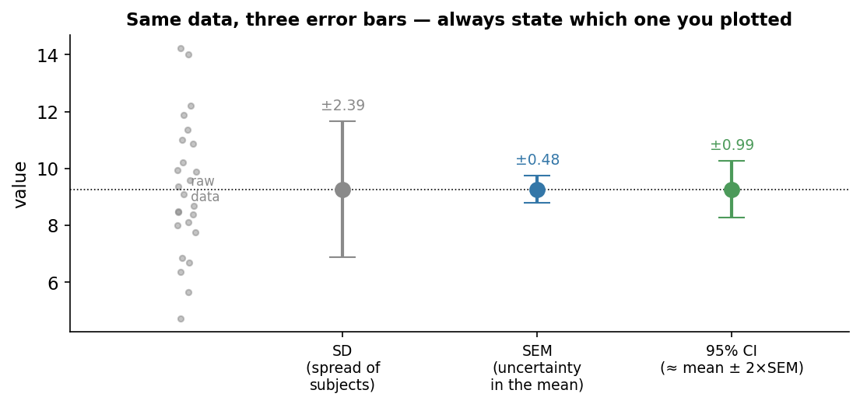
Figure 1. The same 25 data points shown with three different error bars. SD is widest (spread of subjects); SEM is narrowest (uncertainty in the mean); the 95% CI ≈ mean ± 2×SEM.

2. The logic of a hypothesis test
A statistical test answers one question: could the pattern I see be explained by chance alone?
It works by assuming the boring explanation — the null hypothesis (e.g. "the two groups have the same mean") — and then asking how surprising the observed data would be if that were true.
The p-value is that surprise, as a probability: the chance of seeing a difference at least this large IF the null were true. Small p (by convention < 0.05) means the data are hard to explain by chance, so we call the result statistically significant.
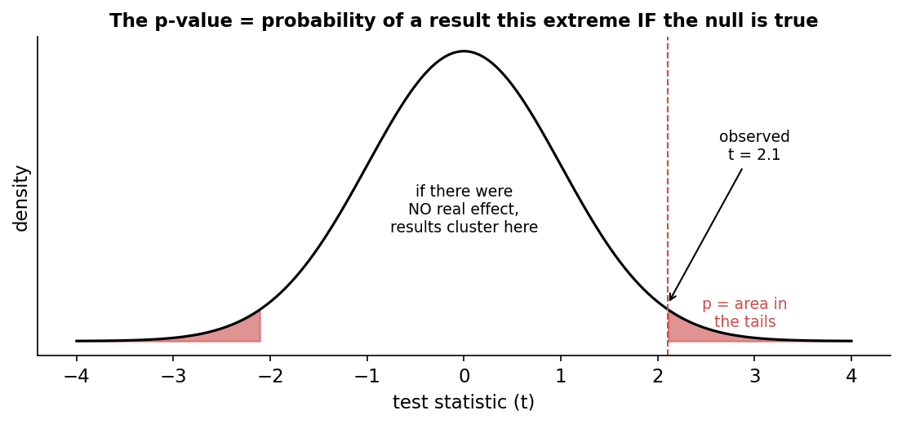
Figure 2. If there were no real effect, test statistics cluster around zero (the curve). The p-value is the shaded tail area — the probability of landing as far out as the value we actually observed.
What a p-value is NOT
It is NOT the probability that the null hypothesis is true.
A small p does NOT mean the effect is large — only that it is detectable. With enough subjects, a tiny, meaningless difference can be "significant".
Always report the effect itself (means, the difference, a CI, or an effect size like Cohen’s d) alongside p.
p = 0.06 is not "no effect" and p = 0.04 is not "proof" — 0.05 is a convention, not a law of nature.

3. t-tests: comparing one or two groups
A t-test builds a signal-to-noise ratio: t = (difference in means) / (uncertainty in that difference). A big t means the gap between groups is large compared with the noise, which gives a small p.
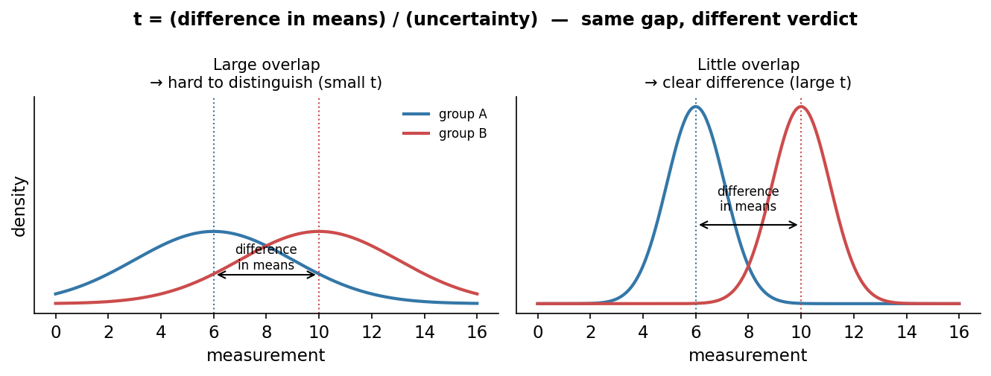
Figure 3. The gap between the two group means is identical in both panels. When the groups overlap a lot (left) t is small; when they barely overlap (right) t is large. The difference alone is never enough — the spread matters.

The three flavours in MATLAB
Situation | MATLAB | Example
One group vs a fixed value | ttest(x) | Is resting alpha power different from 0?
Two independent groups | ttest2(a, b) | Control vs treatment (different subjects)
Same subjects measured twice | ttest(before, after) | Eyes-open vs eyes-closed in the SAME people

Choosing wrongly matters: a paired test on the same subjects is more powerful because it removes between-subject differences — but only use it when the data really are paired.
Tails: by default t-tests are two-sided (a difference in either direction). Only use a one-sided test if you predicted the direction in advance.

4. ANOVA: comparing three or more groups
With three groups you might be tempted to run three t-tests. Don’t. Each test carries a 5% false-positive risk, and those risks pile up: with three pairwise tests the chance of at least one false "significant" result is about 14%, not 5%. This is the multiple-comparisons problem.
ANOVA (ANalysis Of VAriance) solves this with a single omnibus test. It compares the spread between the group means to the spread within the groups:
F = (variance between groups) / (variance within groups)
A large F means the group means are far apart relative to the noise inside each group, which gives a small p. F is always reported with two degrees-of-freedom numbers: between-groups (k − 1, where k = number of groups) and within-groups (N − k, where N = total observations). For example F(2, 45) = 30.5 means 3 groups and 48 observations.
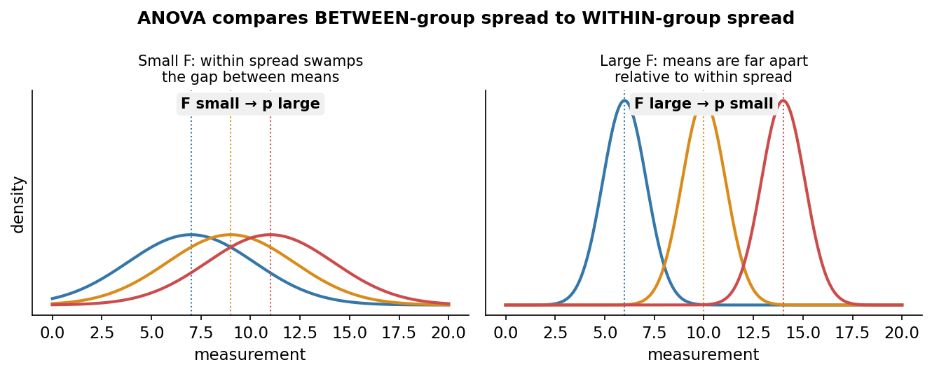
Figure 4. ANOVA compares between-group spread to within-group spread. Left: the groups overlap heavily, so F is small and p is large. Right: the same three means are now clearly separated relative to the within-group noise, so F is large and p is small.

After a significant ANOVA: which groups differ?
A significant ANOVA only says "not all the means are equal" — it does not say which pairs differ. For that, run multcompare(stats), which does every pairwise comparison while correcting for multiple tests (Tukey’s HSD by default), so the 5% error rate applies to the whole family of comparisons. If a pair’s confidence interval excludes zero, that pair is significantly different.
Step | MATLAB | What you read off
Shape the data | values column + matching group labels | One long column, one label per value
Omnibus test | [p,tbl,stats] = anova1(values,group,’off’) | F = tbl{2,5}; df = tbl{2,3} & tbl{3,3}
Post-hoc | c = multcompare(stats) | Each row = a pair; last column = its p

The group-label vector — memorise this pattern
anova1 needs ONE column of values and a MATCHING vector of labels (same number of rows).
values = [g1, g2, g3]’; % stack into one column
group = [repmat({"g1"},numel(g1),1); repmat({"g2"},numel(g2),1); repmat({"g3"},numel(g3),1)];
Getting these two the same length is 90% of making anova1 work.

5. Which test should I use?
Almost every comparison in this course fits one branch of this map. Start at the top with a single question: how many groups am I comparing?
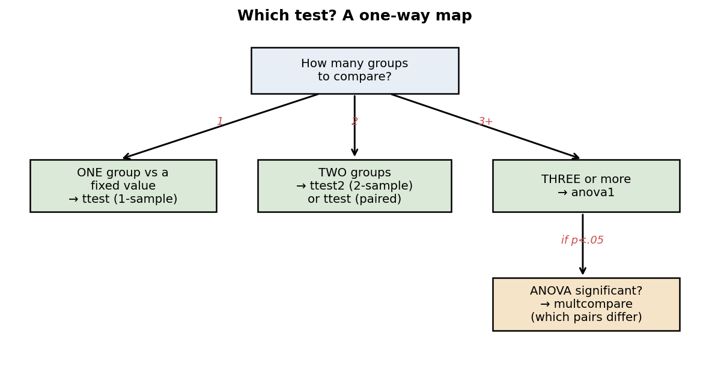
Figure 5. A one-way decision map for the tests covered in Sessions 11–13.

6. Which plot should I use?
A plot is an argument. Different plots answer different questions about the same numbers, so the choice is not decoration — it changes what your reader concludes.
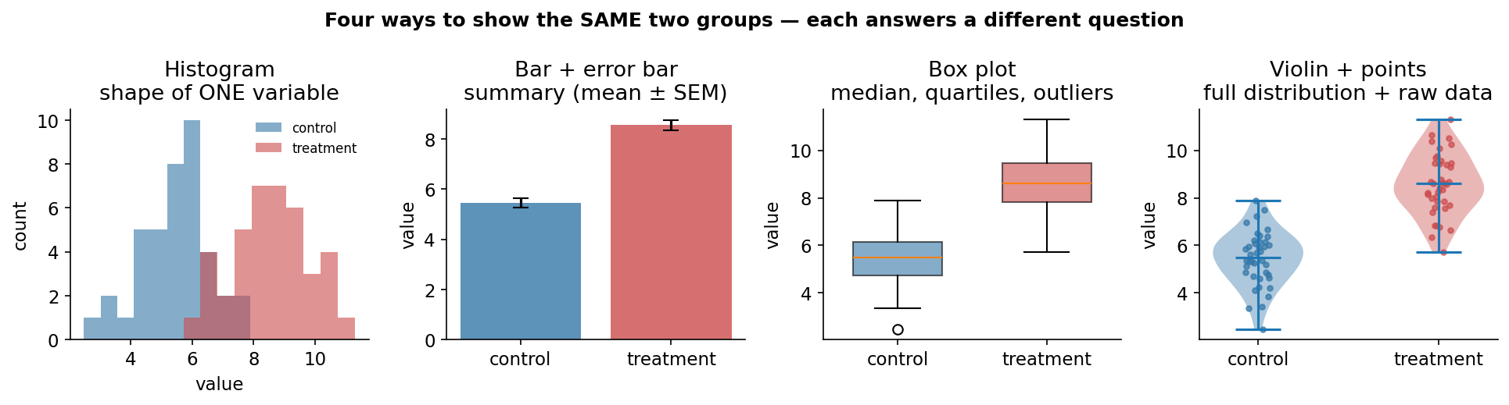
Figure 6. The same two groups drawn four ways. Each is correct; each emphasises something different.
Plot | Shows | Best for | Watch out for
Histogram | Shape of ONE variable’s distribution | Checking for skew, outliers, bimodality before testing | Bin count changes the look; hard to compare many groups
Bar + error bar | A summary: mean ± SEM/SD/CI | A quick, familiar comparison of group means | Hides the raw spread; "bar chart of means" can mislead — state the error bar!
Box plot | Median, quartiles (IQR), range, outliers | Comparing spread and skew across several groups | Hides sample size and exact shape (e.g. bimodality)
Violin / strip | Full distribution + every data point | Small samples where you want to show all the data honestly | Cluttered with very large n; violins need enough data to be meaningful

Good-figure habits for lab reports
Show the data when you can: overlay individual points on bars or boxes.
Label axes with units (Amplitude (µV), Time (ms)) and say n in the caption.
For error bars, state SD, SEM or 95% CI explicitly — never leave it ambiguous.
For colour maps use a perceptually-uniform map (parula, viridis, turbo). Avoid jet — its bright bands invent features that are not in the data.
Keep a consistent colour for each condition across every figure in a report.

7. One-page cheat sheet
I want to… | Use | Report
Summarise a group | mean, median, std, and SEM = std/sqrt(n) | mean ± SEM (and n)
Compare 1 group to a value | ttest(x) | t(df), p
Compare 2 independent groups | ttest2(a,b) | t(df), p, difference + 95% CI
Compare 2 paired measurements | ttest(before,after) | t(df), p
Compare 3+ groups | anova1(values,group) | F(df1,df2), p
Find which groups differ | multcompare(stats) | each pair’s difference + p
Show a distribution | histogram / boxplot / violin | n in caption
Summarise group means | bar + errorbar | state SD vs SEM vs CI
Show subjects × time | imagesc + parula + colorbar | colour = amplitude (µV)
Further reading
- MathWorks — anova1, multcompare, ttest, ttest2 documentation (search the function name at mathworks.com/help/stats).
- Mike X Cohen — statistics & EEG analysis in MATLAB: youtube.com/@mikexcohen1
- Rule to remember: describe → pick the test from the map → report the effect AND the p-value → draw the plot that matches your question.

