Lab Schematic – Group 2

1. State diagrams

Master FSM:

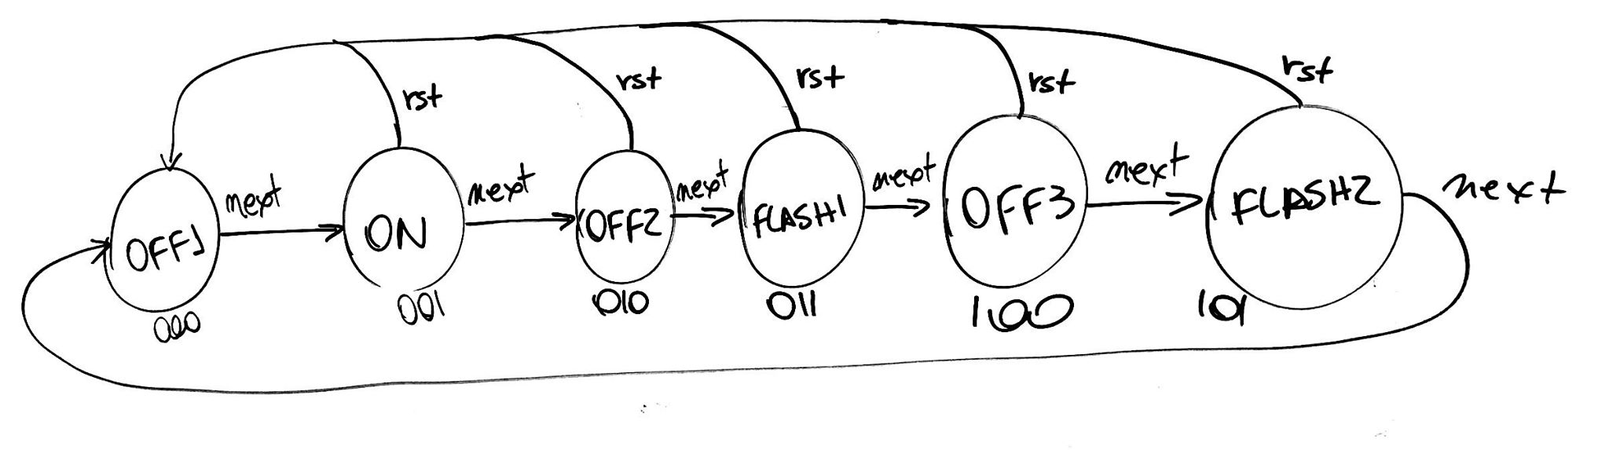

Blinker:

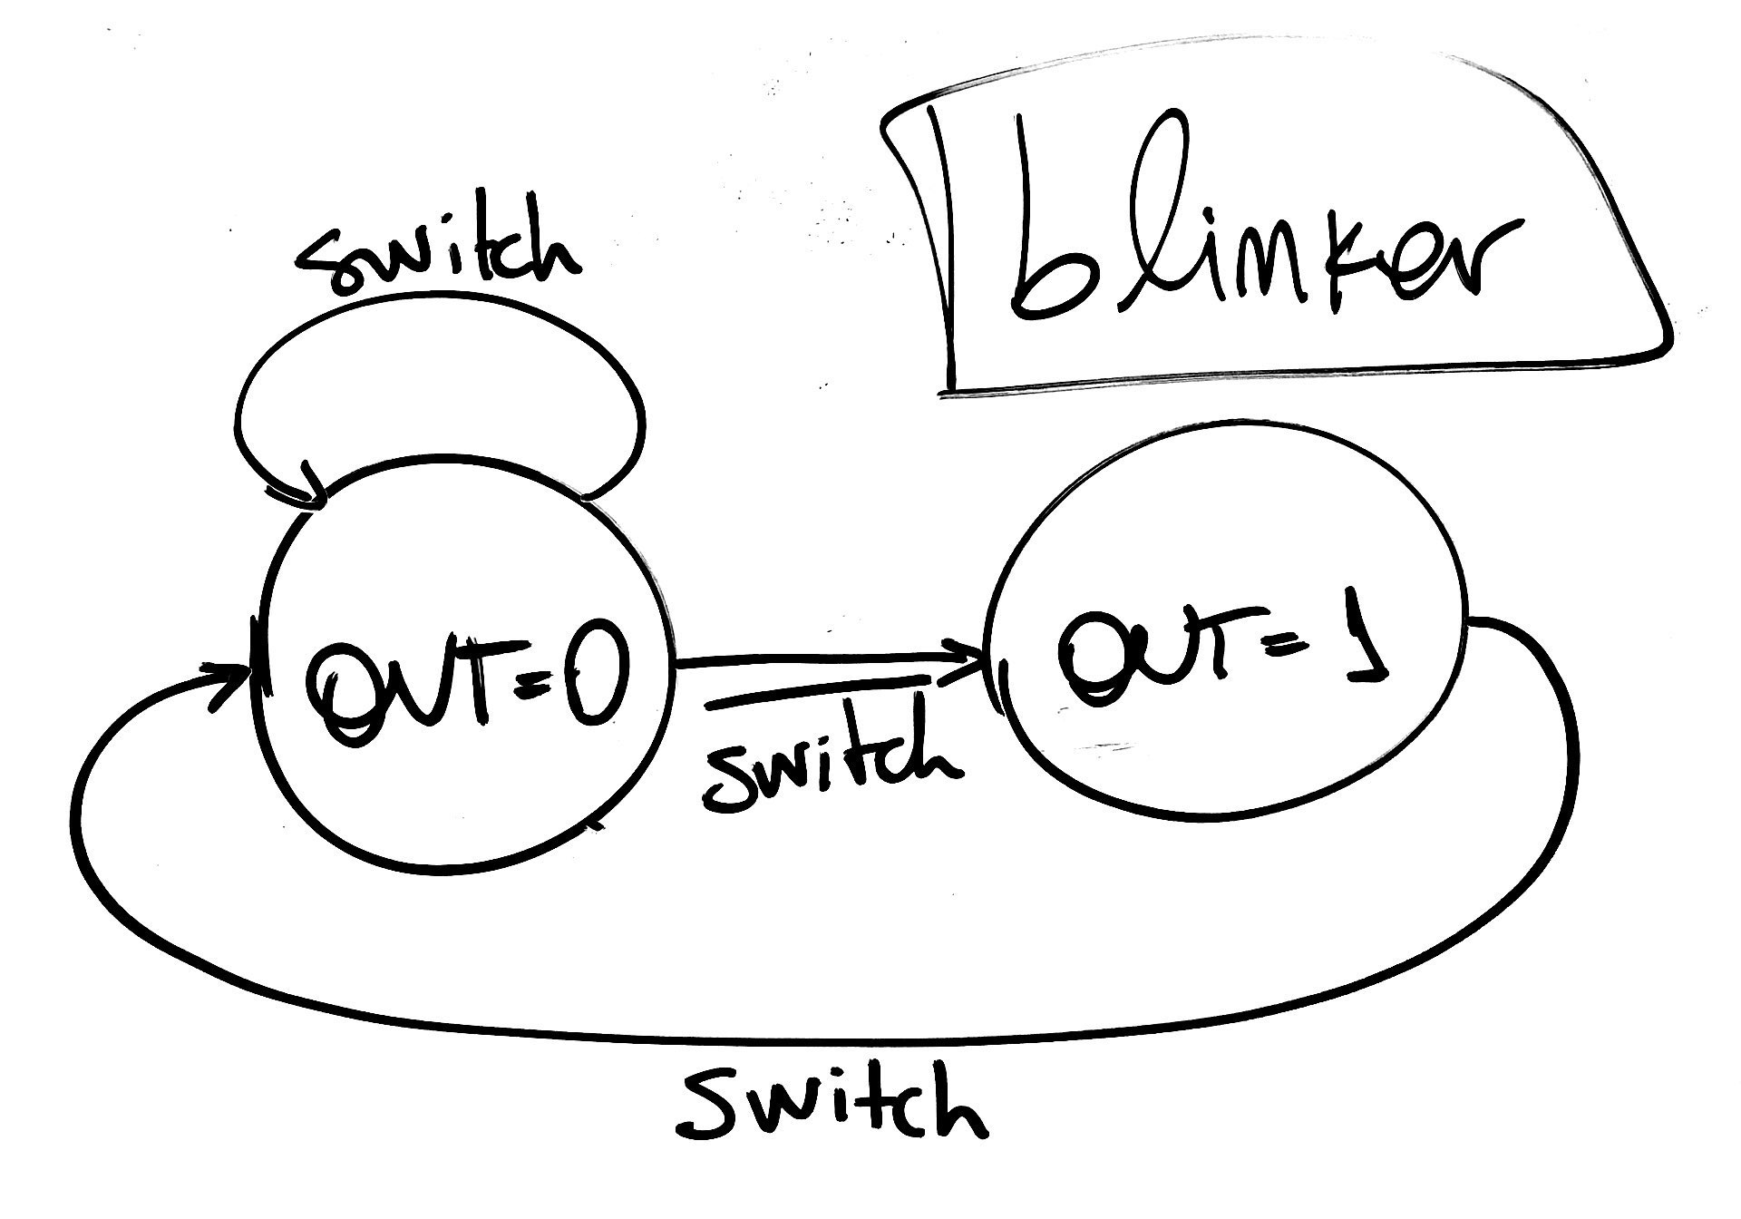

Shifter:

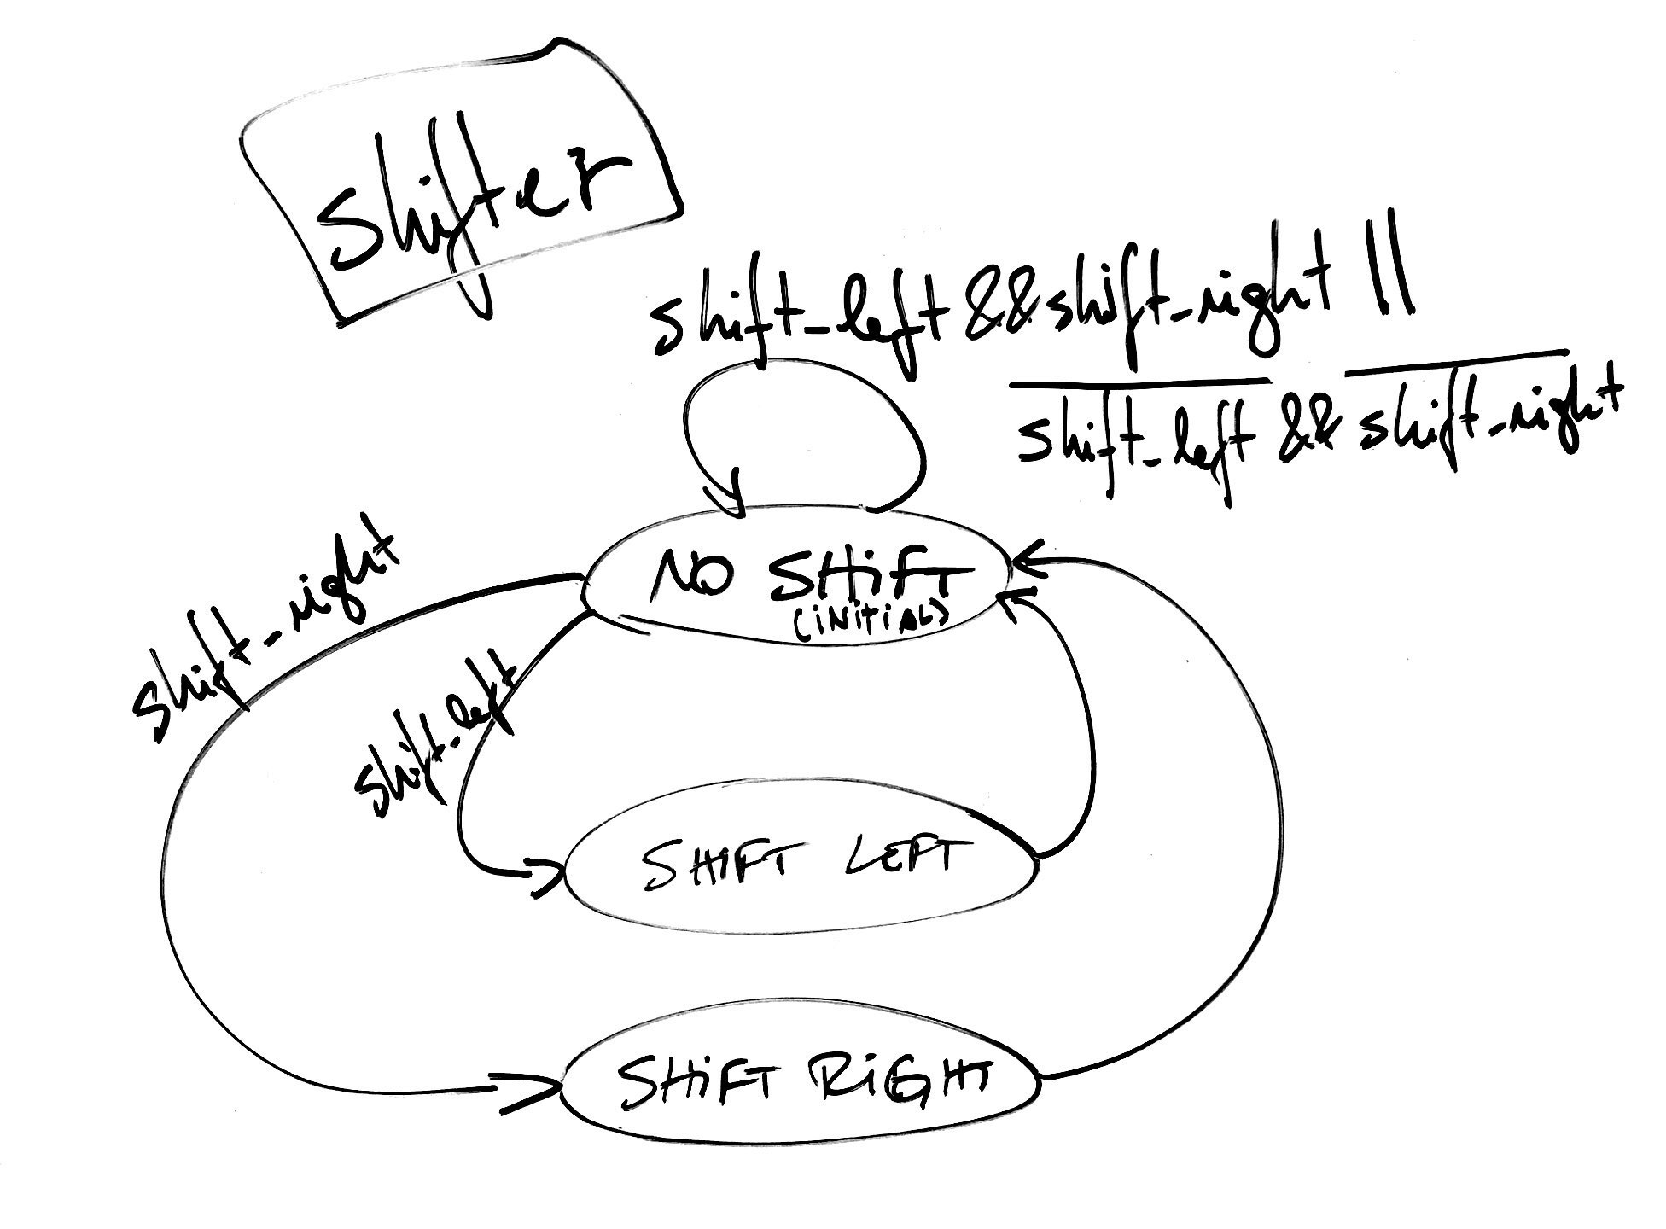

1. Block diagrams:

Timer:

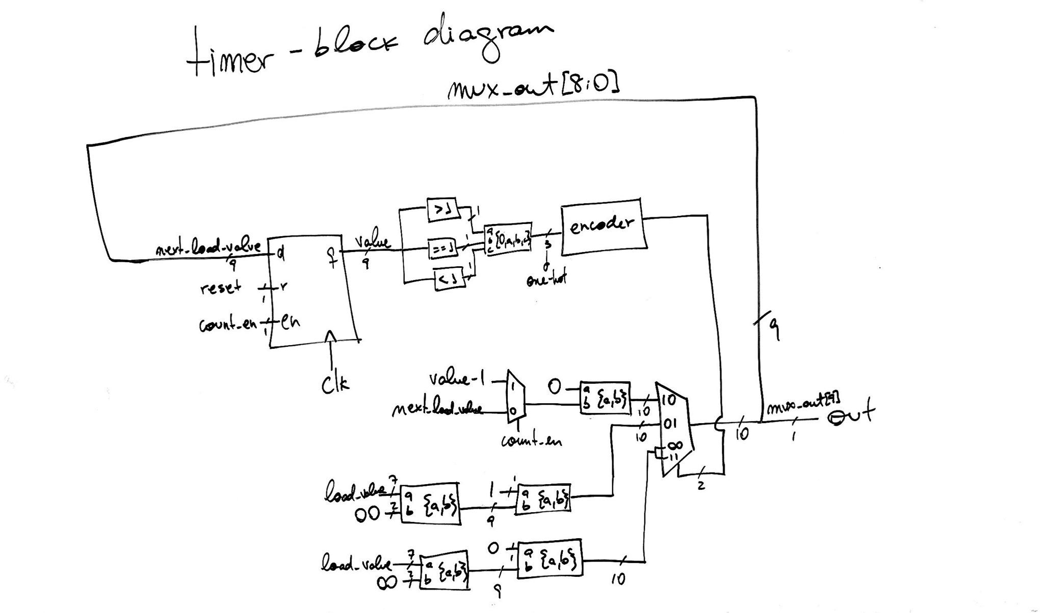

Beat 32:

