**UGANDA COUNTRY REPORT ON PROGRESS TOWARDS GVAP GOALS AND TARGETS AND PARTNER SUPPORT**

1. **Progress towards achievement of GVAP goals**
2. **Summary**

This summary table describes the current situation in Uganda regarding achieving the GVAP goals. Data used to assess progress towards achievement of GVAP goals are included in the annex (Country immunization profile).

| **Area** | **Indicator** | **Data for Uganda** |
| --- | --- | --- |
| **Socio-demographic** | **GNI 2014** | **660** |
| **WB status** | **Low Income** |
| **Infant mortality (<12 M) 2015 (UN IAG CME)** | **38** |
| **GAVI status** | **Eligible** |
| **Total population** | **39,032,000** |
| **Birth cohort** | **1,665,000** |
| **Surviving infants (JRF)** | **1,568,000** |
| **1. Interrupt wild poliovirus transmission** | **Transmission Interrupted** | **Yes** |
| **Risk of late detection: Percent of adequate stool specimens (rolling 12m) Target > 80%** | **91.3** |
| **Risk of late detection: Non polio AFP rate (rolling 12m )  Target > 2 per 100,000** | **3** |
| **Risk of spread after importation:  % of 6M-59M olds having received less than 3 doses in the last year before occurrence case/environmental positive)** | **8** |
| **2. Neonatal tetanus elimination** | **Coverage for TT (reported 2015)** | **58%** |
| **Protection at birth against tetanus (WUENIC 2014)** | **85%** |
| **Last SIAs conducted in the country** | **N/A** |
| **Elimination validation date** | **Validated in 2012** |
| **3. Measles Elimination** | **Coverage MCV1 (2014 WUENIC)** | **82%** |
| **Coverage MCV2** | **Not in schedule (planned for 2017)** |
| **Percentage of districts with MCV1 coverage ≥95% (2015 JRF)** | **46%** |
| **Last national SIA** | **2015** |
| **Post SIA coverage survey conducted** | **No** |
| **4. Rubella/CRS Elimination** | **Rubella-containing vaccine coverage** | **Not introduced** |
| **SIAs planned?** | **Planned for 2018** |
| **5. Reach 90% national coverage and 80% in every district with 3rd dose of DTP-containing vaccine** | **National coverage (WUENIC 2015)** | **78%** |
| **Drop-out rate DTP1 to DTP3 (2015 WUENIC)** | **12%** |
| **Actual numbers of children that dropped out (2014 WUENIC)** | **173,000** |
| **Difference between poorest and richest quintile DTP3 coverage (2013 data)** | **0.3%** |
| **% District coverage reaching 80% coverage from 2015 JRF** | **89%** |
| **6. Reach 90% national coverage and 80% coverage in every district with all vaccines in national immunization programme** | **National Coverage (2014 WUENIC)** | **BCG: 93 DTP1: 89 DTP3-HepB3-Hib3: 78 MCV1: 82 PCV3: 50 Polio3: 82** |
| **7. Introduction of new vaccines** | **New vaccines introduced** | **PCV in 2013; HPV in 2015; IPV in 2016 Rota and MenA introduction approved by GAVI but currently on hold** |
| **8. Reduction in under 5 mortality rate** | **Percent reduction from 2010 to 2015** | **2010: 75.2 2015: 54.6 (27.4%)** |
| **9. NITAG** | **NITAG established?** | **Yes (in 2015)** |
| **10. Government expenditure on routine immunization per live birth USD** | **Average for 2013-2015 (% change from 2010/2011)** | **2.1 to 7.0 (+232%)** |

1. **Country ownership of the immunization programme**
   1. **Immunization policy decision-making capacity**

In 2015, Uganda transitioned its Advisory Committee on Immunization (ACVI) into a fully-functioning national independent immunization technical advisory group (NITAG), with technical assistance and training from WHO and the Gates Foundation-funded SIVAC project. Core members come from academia, research institutes and other organizations, with representatives of the MOH, WHO and UNICEF serving as ex-officio members.

UNITAG has already had an important decision-making role in its short history. First, it raised concerns about the impending introduction of rotavirus and meningitis A conjugate vaccine (MenA) and the government’s ability to meet its co-financing obligations and cover operational costs for these as well as the other vaccines in the immunization schedule. As a result, the introduction of these and all other new vaccines are currently on hold until a cost analysis of the immunization program and financial sustainability plan are developed (currently underway with WHO support). Second, UNITAG helped to convince the Parliament to add a provision for an Immunization Fund to the 2016 Immunization Act that mandates vaccination of children and women (with TT). The purpose of the Fund, described below, is to better protect funding for immunization and mobilize additional resources from different sources.

Immunization also enjoys high-level support as a result of the establishment of a Parliamentary Forum on Immunization.[1] The Chairperson of this group was able to block the Parliament’s approval of the entire budget in 2012/13 until additional funds were added to the budget to increase the number of health workers and health worker salaries. The Forum also played a key role in the development and government approval of the Immunization Act.

* 1. **Government Financing of Immunization**

The Government is meeting its financial commitments in that it is paying for 100% of the procurement costs of all traditional vaccines (BCG, TT, OPV and measles). It was estimated in FY2013/14 that the Government paid 49% of the total immunization budget, with the majority going towards health worker salaries, procurement of traditional vaccines and co-financing of new vaccines (pentavalent, PCV, HPV), vaccine storage and distribution, the staff and operations of the Uganda National EPI (UNEPI), operational costs for polio and measles campaigns, and block grants to the districts to cover the costs of providing primary health care services called PHC grants.

The Government’s contribution in absolute terms has been increasing – 41% from 2009/10 to 2013/14 – mainly as a result of co-financing of newly introduced vaccines, which has increased six-fold from 2013 to 2016, as first PCV and then HPV were added to the immunization schedule (Figure 1). The country’s co-financing obligation now stands at $2.5 million per year. The Government’s contribution actually declined from 2011 to 2014, due in part to delays in making its co-financing obligations. Uganda has, in fact, been in default in co-financing each year since 2014. This is due to the fact that funds for co-financing are not “ring-fenced” and have been diverted to cover emergencies, such as pension arrears for health staff and salary increases for intern doctors who went on strike. The mismatch between the Government’s quarterly budgetary procedures and GAVI’s fiscal year cycles, as well as devaluation of the Uganda shilling have also contributed to delays in co-financing. These defaults have delayed the introduction of additional vaccines, including rotavirus and MenA.

**Figure 1.**

Trends in immunization financing

Annual co-financing obligation to GAVI in Uganda 

Purple bar (GOU) is Uganda government contribution, including shared costs for health worker salaries and the proportion of PHC grant funding going to immunization.[2]

Apart from the issue of co-financing of new vaccines, the government budget for immunization is considered insufficient, and as a result, more costly activities, such as polio and measles campaigns, can mean less funding for routine immunization activities. As mentioned in one report (EPI review), one national measles campaign can cost the equivalent of two years of recurrent costs for the routine immunization program. Because the Ugandan government could not raise its share of the operational costs for the 2015 measles campaign, the campaign was combined with the introduction of HPV vaccine and Child Health Days, to save costs and to allow vaccine introduction grant (VIG) funding from GAVI to be used in part for the measles campaign. This resulted in a reduction in the planned activities for the HPV introduction (see below).

Funding for immunization at the local level comes from PHC grants from the central government, which must pay for all of the operational costs of providing the National Minimum Health Care Package, of which immunization is one component. The grants do not have a fixed percentage allocated to immunization. PHC funding is considered vastly inadequate and as a result, health facilities often lack funding for fuel to operate refrigerators and means of transport and fuel to pick up vaccines from district medical stores or to conduct outreach immunization activities. A lack of funding at the district level makes it difficult for EPI coordinators to conduct supervisory and monitoring visits, assist with RED/REC activities and the like. All of this can negatively affect immunization coverage and overall program performance.

In the aim of mobilizing additional resources for immunization and to meet the Government’s growing co-financing obligations, an Immunization Fund is being established as part of the 2016 Immunization Act. The Fund, currently being designed, will pool funds from the Government, donations and “voluntary contributions” to pay for “vaccines and related supplies, cold chain expenses and immunization outreach activities.” Its reported purpose will be to better protect immunization funding (including co-financing) through “ring-fencing” to prevent its diversion, and to mobilize new resources for immunization, including from private industries, such as telecommunications and pharmaceutical companies.

**c. Human resource situation**

Nurses and nursing assistants make up the bulk of health workers who provide immunization services. There is a wide range of staffing levels of health professionals by region and district in Uganda, with the numbers especially inadequate in hard-to-reach and under-served areas, where retention rates are particularly low. Low salaries and a lack of housing in remote areas are key factors making it difficult to recruit and retain qualified health workers. More than 50% of the facilities visited for the Resource Tracking study (cite) reported a health worker shortage, while the 2016-2020 Comprehensive EPI Multi Year Plan (cmyp) reported that 39% of districts reported a health worker vacancy rate of more than 35%. Staff shortages at the health facility level affect morale, as well as the ability of facilities to deliver adequate immunization and other services in the minimum package, including outreach activities.

Concerning immunization-specific staff at the sub-national level, all districts have an EPI focal point, as do 66% of health facilities, but due to staff shortages, this person is often a nursing assistant (EPI review). Sixty-one percent of districts had no cold chain technician in 2014 (cmyp? Find source). Human resources for disease surveillance is also inadequate, and as a result, the surveillance system is heavily reliant on partners, especially WHO, which has a force of around 12 surveillance medical officers (SMOs) working at IDSR sub-national hubs and in districts, and supports most technical staff of the national reference laboratory (Ugandan Viral Research Institute or UVRI).

To link communities to local health facilities, Uganda has a system of Village Health Teams (VHTs), made up of several community-based volunteers in each community who assist with disease surveillance, social mobilization, sanitation activities, registering births, distributing anti-malarial drugs and the like. In the area of immunization, these volunteers participate in social mobilization, especially for vaccination campaigns and new vaccine introductions; community-based surveillance and default tracking. The recent EPI review found that 89% of health facilities visited had established links with VHTs and that these volunteers are the communities’ primary source of information concerning immunization (EPI review).

However, the volunteers receive no salary and only a stipend or allowance, as possible, and they must also juggle immunization activities with other health priorities and programs. Supervision and support from the often under-staffed (health facilities or districts? Who supervises them?) also varies from district to district. As a result, the activism and impact of VHTs varies considerably by area. To improve this situation, the Government has approved plans to create a new position of Community Health Extension Worker (CHEW), who will receive a government salary, have higher minimal qualifications that VHTs, and who will gradually replace the VHTs. To make the program more financially sustainable, one CHEW will cover several (e.g., three) villages.

1. **Progress towards specific GVAP goals (issues/challenges/successes)**
   1. **Goal 1: Achieve a world free of poliomyelitis**

Uganda was certified polio-free in 2006, but has experienced outbreaks of wild polio virus in 2009 and in 2010/2011. The country has a robust AFP and polio surveillance system, as indicated by the polio target indicators on page 1. This has been the result of various partner-supported efforts and innovations, including:

* A national roll-out of an integrated disease surveillance and reporting (IDSR) system, operating from nine sub-national hubs. By the end of July 2016, district health staff in 108 out of the country’s 112 districts have received IDSR training.
* Both international and national STOP teams that provide on-the-ground short-term assistance to “silent” or poor-performing districts to improve their ability to detect AFP/polio cases as well as other outbreak-prone diseases (e.g., measles, yellow fever) and to improve routine immunization services. The international teams – supported by the U.S. CDC and AFRO – stay in a region for around one month, while the national STOP team (NSTOP) consists of public health students who spend a week in an area visiting all health facilities to train staff in surveillance and outbreak investigations. The NSTOP program is partner-supported, but funding is considered inadequate.
* An innovative specimen transport system that uses a courier service (or the postal system?? Not sure), in which specimens arrive at the UVRI laboratory within 24 hours.
* An electronic (mTRAC) system, created four years ago with WHO and UNICEF support, in which health facility staff submit IDSR data for key diseases to districts via mobile phones using a simple interface. The data are then transferred up the chain. While it has been implemented nation-wide, there are issues with the availability of cell phones and reliability of network connections.

In addition, the country has organized national immunization days (NIDs) every year for several years, as well as sub-national immunization days (SNIDs) in high-risk and outbreak districts for children under five. The NIDs are now being incorporated into the country’s annual Child Health Days. UNEPI introduced IPV into the immunization schedule in April 2016.

There are, however, a number of challenges to sustaining the country’s polio-free status:

* While the national AFP detection and stool adequacy rates meet the targets, not all districts achieve the minimum rates (cmyp). There have been delays in the detection of low levels of transmission of wild or vaccine-derived polio virus in some areas, as well as irregular active surveillance of vaccine-preventable diseases. This is attributed to the lack of operational funds at the local level, affecting the timely investigation and notification of cases. Reportedly, inadequate surveillance led to under-detection of circulating WPV along the border with Kenya, which caused the last outbreak in 2011.
* There is cross-border transmission of polio from areas and populations with low immunization rates, such as across the borders with Kenya and S. Sudan. Synchronized NIDS with bordering countries have been discussed, but have yet to take place.
* There also exist pockets of low polio immunization coverage within the country, including in communities bordering S. Sudan and some fishing communities.
* The frequent turnover of health staff at the district and health facility levels mean that many people trained in IDSR have left. Thus, frequent trainings are needed to train new staff, which is costly.
  1. **Goal 2 : Meet global and regional elimination targets**

**a. Achieve maternal and neonatal tetanus elimination**

Uganda received validation for having eliminated MNT in 2012. The main strategies the country is employing to sustain elimination consist of:

* TT immunization of high school girls (15-17 year olds) through annual school-based vaccination campaigns;
* A strong culture of vaccinating all women who come for antenatal care services (the rates of which have been increasing) with at least two doses of TT.
* Mandating of TT vaccination for all women 18-49 years of age, as well as for all 15-17 year old girls through the new Immunization Act. Parents and schools are held responsible for ensuring vaccination of girls and can receive fines or imprisonment if they are not (the same holds true for 18-49 year old women).

The current TT coverage rate (for two doses??) is 58% among women of child-bearing age, while the protection at birth (PAB) rate among infants is 85%.

There remains some (albeit a low?) risk of not sustaining the elimination in some areas of the country, however, (confirm with Messeret or Annet) due to weak surveillance, reported cases are not always investigated and at least one district in the 2011 risk assessment report had a rate above 1/1,000 live births (ref). There remain pockets of low TT coverage. In addition, the stated policy of ring vaccination around a confirmed case is probably not taking place, according to two informants. A further constraint to high TT coverage rates is that target-age girls not enrolled in school are missed through the school-based program. In addition, health personnel have difficulty calculating PAB rates and require training in this.

The following steps can help ensure sustainability of MNT elimination:

* Improve NMT surveillance, including investigating and testing all suspected cases;
* Strengthening and sustaining the school-based TT vaccination program for girls, and extend it to 15-17 year old girls not in school;
* Provide additional booster doses (of TT or Td) during childhood and include boys, since there have been cases in boys following circumcision (at what age?). This proposal is currently under discussion within the government.

1. **Achieve measles elimination and rubella & CRS elimination**

**Measles**

An estimated 46% of districts achieved coverage with a single dose of measles vaccine of ≥95% in 2015, against the GVAP target of __% of districts, according to the Joint Reporting Form. National measles vaccination coverage is estimated by WHO and UNICEF at 82% in 2015. The country has experienced measles outbreaks each year of different magnitude, in areas with low vaccination coverage, including a large outbreak in 2015 with more than 60,000 reported cases (see Annex). The country is therefore not currently on track to eliminate the disease by 2020 (can we say this?).

A key factor in the continuing outbreaks is that, due in part to a global shortage of measles vaccine, actual measles vaccination coverage in 2012 was only around 30%, according to the cmyp (in contrast to the considerably higher WUENIC estimate) (cymp, p. 33). Because of this as well as continued low coverage in some areas of the country, there were an estimated 1.56 million children not immunized against measles by 2013 (EPI review). This has created a large susceptible population of unimmunized older children and a consequent shift in the age of cases to older children and adults, who have the potential of causing outbreaks.

Key challenges and issues affecting Uganda’s ability to meet the measles elimination target include:

* The fact that case-based measles surveillance is still weak and only an estimated 35% of cases are investigated, according to one informant. There are continues to be some “silent districts” and delays in reporting cases to higher levels of the system. The reasons are many of the same mentioned above, including a shortage of health workers, means of transport and fuel to investigate cases in the field and to collect and transport specimens to the reference lab. Polio funds are often used for case investigation, specimen transport and testing.
* While national measles SIAs are conducting every three years, along with localized campaigns in outbreak areas, actual coverage rates of these campaigns is unknown, due to data quality issues (reported coverage rates are often 100% or higher). The frequency of the SIAs is, however, considered adequate.
* The introduction of the second measles vaccine dose, originally planned for 2015, has been postponed to at least 2017, due to the issues with co-financing and the sustainability of the government’s contribution to immunization mentioned above. The year of introduction will depend on the results of the cost assessment and financial sustainability plan currently in progress and subsequent decisions about other new vaccine introductions.
* Rapidly reducing the population of susceptibles missed due to prior poor vaccination coverage would require conducting SIAs with a wide-age cohort, such as 9 month to 15 year olds. However, the Government lacks the funding to conduct these and GAVI only supports SIAs for children under five. However, UNEPI plans to conduct SIAs with measles-rubella vaccine in 2018, with GAVI support, which will target children up to 14 years of age.

**Rubella**

According to informants, rubella outbreaks have been occurring, and many suspected cases of measles that are not lab-confirmed are believed to be rubella. However, MR has not yet been introduced into the infant immunization schedule, as discussed above, though MR campaigns are planned for 2018.

**3.3 Goal 3: Meet vaccination coverage targets**

* 1. **Achieve 90% national coverage and 80% coverage in every district with 3 doses of diphtheria-tetanus-pertussis containing vaccine**
  2. **Achieve 90% national coverage and 80% coverage in every district with all vaccines included in the national schedule**

These targets have largely not yet been met. The WUENIC estimates for the third dose of pentavalent (DPT-HepB-Hib) vaccine have been 78% national for the past three years (2012 to 2014), and slightly down from 82% in 2011, with an estimated drop-out rate between the first and third doses of 12% nationally. However, according to data from the Joint Report Format, the country is close to meeting the district target, with 86% of districts having achieved 80% or greater coverage for three pentavalent doses. There are no district-specific WUENIC estimates, however, and the JRF data are based largely on administrative data (true, Kamel?), so caution should be taken in reading these statistics. A coverage survey has not taken place since 2005, though one is currently underway, which should provide a more accurate picture of both national and district-level immunization coverage.

According to the 2014 WUENIC estimates, the 90% national coverage goal has been achieved for BCG (93%), but was 82% for three polio doses, 82% for measles, and 50% for PCV3, which was introduced over a year period in 2013 and 2014. (Kamel: I don’t have district-level data for these other vaccines; are these in the JRF?)

An assessment of equity of immunization coverage by geographic areas, income level and other variable is currently taking place.

Key factors affecting UNEPI’s ability to reach its coverage targets include:

* **Insufficient availability of static immunization services**: While national policy requires that all health facilities with refrigerators offer immunization services on a daily basis, the 2015 EPI review found that only 40% of the 55 health facilities visited provided EPI daily, 18% had sessions 2-3 times a week, and 58% provided only one session per week, even though most facilities (88%) of all levels (hospitals and health centers II-IV had working refrigerators. A key factor is staff shortages, making it difficult for health clinics to provide daily immunization with all of the other services in the minimum health services package. One informant fears that adding more vaccines to the immunization schedule will make it even more difficult for health facilities to provide all vaccines on schedule. Another factor is spotty social mobilization, especially for routine immunization, affecting demand, especially for subsequent vaccine doses.
* **Insufficient outreach activities in many areas and inadequate implementation of Reach Every Community (REC) strategies**: Outreach activities were found to be irregular and insufficient in many sites included in the EPI Review. The shortage of health workers is a key reason; many facilities have only two or so qualified personnel and thus conducting outreach activities (which usually require at least two staff members) means closing down the clinic. The lack of transport and fuel due to insufficient PHC grant funds is another key factor. The recent GAVI full country evaluation for Uganda found that only around 10% of Health Centres II had access to any vehicle for vaccination, while the rate was around 45% and 60% for Health Centres II and IV, respectively (FCE full report). The EPI Review found that only 20% of health facilities had REC microplans, as did only 8 out of 112 districts. Poor implementation of REC/RED is reportedly due to insufficient training of health workers in microplanning, due to insufficient funding, high health worker attrition rate, resulting in many workers not knowledgeable in microplanning, and a lack of funding to carry out microplanning activities.
* **Vaccine shortages or stockouts at the local level**: The transition of responsibility for the storage and distribution of vaccines from UNEPI to the National Medical Stores (NMS) in 2012/13 has been completed, and after initial problems, the system was deemed “robust” since April 2014 (cymp) and the time it takes for vaccines to reach all districts from the central level has been cut in half (to two weeks) (Annet Kisakye, personal communication). Nonetheless, 71% of health facilities and 96% of districts in the EPI review of 2015 reported at least one vaccine stockout in the previous three months, especially PCV and BCG. While a global shortage of PCV contributed to the stockouts of this vaccine, other contributing factors for local vaccine stockouts are poor vaccine forecasting (especially denominator issues), lack of adequate cold storage space in some district stores, and perhaps most importantly, the continuing need for health facilities to collect vaccine from the district stores and their difficulty in doing so due to the lack of vehicles and fuel discussed above. “Last mile” vaccine delivery will therefore require additional funding.
* **Insufficient monitoring and supportive supervision**: A supervision infrastructure is in place, with EPI Coordinators in each district and some sub-districts. However, regular supervision is lacking in many areas, due to insufficient funds and transportation to make supervisory visits. In addition, defaulting tracking was also found to be taking place in 38% of health facilities in the EPI review. However, the situation is improving with the establishment of Regional Supportive Supervision Teams, starting in 2015. The teams, described in the last section of this report, are already operating in 11 of the country’s 14 regions, with funding from the polio program (and the HSS grant in the future).

The EPI Revitalization Plan, enacted by the Government from 2012 to 2014 (correct years?) in response to declining or plateauing coverage rates and disease outbreaks, has demonstrated that many of these issues and bottlenecks can be resolved with an infusion of funds and attention. With funding from many partners, the plan focused on improving coverage in poor-performing districts by providing the means with which to strengthen social mobilization, outreach activities, vaccine collection from district stores, supervision and the like (see description in the last section). The plan is believed to have played an important role in increasing district-level coverage between 2010 and 2015 (see maps in annex).

**3.4 Goal 4: Introduce new and improved vaccines and technologies**

In recent years, UNEPI has introduced PCV (in 2013-14), HPV (in 2015) and IPV (in February 2016. Below is a summary of the PCV and HPV introductions:

* **PCV**: The vaccine was launched in one district in April 2013, but not in the rest of the country until 2014, when introduction was phased in from January to June in three phases. Nation-wide introduction was stretched out over more than a year for a number of reasons, including delays in the release of government funds to the districts for training, due to the establishment of a new financial management system at the same time. The training at the local level was comprehensive (lasting three days, including refresher EPI training) and the PCV PIE indicates good knowledge about the vaccine among health workers. However, it also found that not all staff administering PCV had received formal (vs. on-the-job) training in 35% of facilities (joint EPI review/PIE). PCV coverage has been low (50% in 2014), due to the phased in roll-out, global shortages of PCV, which required NMS to ration the vaccine; and forecasting issues, including under-estimating the demand for the vaccine. The PIE conducted in February 2015 found “suboptimal routinization of PCV”, but reportedly it has become a regular part of the immunization schedule since then.
* **HPV**: UNEPI’s strategy is to vaccinate all 10 year old girls through fixed facilities, combined with outreach at schools and other community settings. The introduction, originally planned for April 2015, was delayed until November, due to a shortage of cold storage space at the central level and of fridges as lower levels. This was in turn due to procurement problems that have prevented the expansion of the cold chain system, including central cold storage facilities at NMS, with HSS funding. To enable introduction of HPV, UNICEF renovated existing NMS facilities for temporary storage of the vaccine. The introduction was combined with measles SIAs and Child Health Days to save costs, since the Government was unable to raise its 50% share of operational costs for the measles campaign. Consequently, vaccine introduction grant funds for HPV were used for the training and other operational costs for the combined campaigns/HPV introduction. This resulted in short changing the HPV introduction, as training was reduced from three to one day and little social mobilization for HPV took place. Nonetheless, population acceptance has reportedly been good. Coverage data are not yet available (true?), though reportedly the outreach activities, such as to schools, are insufficient, due to a lack of funding.

Rotavirus and meningococcal A conjugate vaccine were both scheduled for introduction into the routine program in 2016, but due to problems with the Government meeting its co-financing obligations and concerns voiced by UNITAG about the financial sustainability of additional vaccines, their introduction is on hold until the sustainability plan has been completed and the country pays its co-financing arrears.

1. **Partner support to address remaining challenges to meet the GVAP goals and targets**

Partner support for immunization activities is similar to that in many other GAVI-supported countries, with major partners providing financial support and technical assistance for polio and measles immunization campaigns, new vaccine introductions, surveillance, training, social mobilization, cold chain improvements and so forth (see Table 1). It should be noted that much of the GAVI HSS funding has been on hold for several years due to procurement issues related to the expansion of the cold chain system (including cold room expansion at the national level, construction of district-level cold rooms, and procurement of cold chain equipment), as well as the construction of health worker housing. As a result, these improvements have yet to be made.

**Table 1. Major partners supporting Uganda’s immunization program and their main activities[3]**

| **Donor/partner** | **Recent key activities funded** | **Financial contribution to EPI (as a percent of total spending in 2013/14)** |
| --- | --- | --- |
| GAVI | New vaccine introductions  Measles/polio SIAs (????)  EPI training  EPI outreach activities  Supportive supervision  Social mobilization  HSS (partially implemented): funding for cold chain system expansion, construction of health worker housing, provide private sector health facilities with cold chain equipment and training | 27% |
| UNICEF | Social mobilization (e.g., at community level)  Immunization campaigns/SIAs  Family Health Days  Microplanning/RED/REC implementation  Cold chain improvements (e.g., remote temperature monitoring system development)  Equity assessment | 11.5% |
| WHO | Disease surveillance  Immunization campaigns/SIAs  New vaccine introductions  Policy and leadership (development of NITAG, financial sustainability plan)  Cold chain improvements (EVM implementation) | 8% |
| USAID/MCSP (in 5 districts) | Support RED strategy and local-level micro-planning  Quality improvements (??Emmanual mentioned. Not sure what this is)  Supportive supervision | ≈3% |
| U.S. CDC | Data quality improvements (DITs)  Surveillance or what else??? | ?? |
| CHAI | Supportive supervision  What else????? | ???? |

At the local level, partner support is especially critical to fill in the gaps in funding for both routine immunization and campaigns, given the inadequacy of PHC grant funds from the government and lack of earmarking of these funds for EPI. The GAVI Resource Tracking Evaluation (2013/14) showed that in the seven districts included in the study, if one excludes health worker salaries and the costs of purchasing, storing and distributing vaccines, partners paid for nearly all (97%) of district-level immunization-specific activities – largely SIAs and training – with UNICEF covering 57%, WHO 21%, and GAVI 19%. PHC funding covered only 3% of these expenditures.[4]

Below we describe by objective several partner-supported projects or initiatives that address specific weaknesses in Uganda’s immunization program and have made or have the potential of making a significant difference in the program’s performance.

**Objective: To increase government funding for immunization and improve advocacy and decision-making:**

* **Organizing a high-level meeting on immunization**: Through a Gates Foundation-funded project, the Sabin Institute, along with WHO (and others?) assisted in organizing an Parliamentary Forum on Immunization[5] to advocate for increased government spending on immunization and which led to the drafting and enactment of the Immunization Act that includes a provision for an Immunization Fund. Another objective of the Forum was to encourage politicians to promote immunization in their constituencies.
* **Support for the NITAG**: Partners, especially WHO and the Gates Foundation-funded SIVAC project (true?), supported the country in establishing a NITAG and making it operational. UNITAG, as described above, has already played a critical role in making decisions about new vaccine introductions – adding the criteria of affordability and sustainability – called for a financial sustainability plan to be conducted, and was instrumental in getting an Immunization Fund provision added to the 2016 Immunization Act.

**Objective: To improve EPI coverage and program performance:**

* **Implementation of EPI Revitalization Plan**: This plan was enacted by the Government from 2012 to 2014 (correct?) with funding from UNICEF, WHO, USAID, CHAI, CDC, and other partners to fill in gaps in immunization service delivery in poor-performing districts (how many?). The infusion of funding, along with technical assistance, was used to strengthen the role of VHTs in promoting immunization and in organizing outreaches; purchase vehicles and fuel to increase outreach activities and to pick up vaccines from district stores; increase supervisory visits; implement RED/REC and microplanning; and strengthen the role of the private sector in immunization (not sure about this one). As shown in the Annex, the number of districts meeting the target of 80% coverage with three doses of DPT-containing vaccine increased significantly from 2010 to 2015, with informants attributing these gains to this Plan. (Annet: What about its sustainability? Has the funding dried up?)
* **Assisting private health facilities in providing quality immunization services**: One objective of the GAVI HSS grant that is being implemented is to improve immunization services in private sector health facilities, which make up an estimated 19% of all health service providers in the country (cmyp, p.16). This is being done by procuring refrigerators and other cold chain equipment for around 90 private clinics in Kampala, as well as providing immunization training to health workers in these facilities. The equipment procurement was delayed due to the lack of involvement of key stakeholders in selecting the health facilities and to other issues, but is not being implemented.
* **Establishment of Regional Supportive Supervision Team**: Partners, including CHAI and UNICEF, have assisted the Government in establishing these teams to increase the regular supervision of health workers, a critical element in improving and sustaining the performance of the immunization program and other components in the minimum health care services package. The teams – made up of regional EPI and IDSR supervisors, and other health professionals – operate from the regional reference hospitals and are each responsible for providing integrated supervision in to the districts in their region. Begun in 2015 with polio funding, teams have already been established in 11 of the country’s 14 regions.

**Objective: to improve the quality of EPI and other health data:**

* **Establishment of Data Improvement Teams (DITs)**: The quality of immunization and other health data is considered quite weak in Uganda, as evidenced by the 11 or 12 point difference in immunization coverage estimates between the government’s administrative data and the WHO/UNICEF estimates (e.g., 89% vs. 78% for pentavalent 3 and 94% vs. 82% for measles). Several partners, including the U.S. CDC, WHO and UNICEF, are supporting the establishment and training of district-level teams, each consisting of the district biostatistician, immunization focal point, surveillance officer and other relevant district health team members. The teams are responsible for training health facility staff in data management and harmonization, with an focus on immunization data and using DHIS2 software. Training of trainers and district-level trainings have taken place and teams are currently operating in 13 of the country’s 14 regions. The DITs are envisioned to have regular meetings to review data, such as part of surveillance meetings. A major gap is that there is at present little supervision of the DITs.

**ANNEXES**

**Annex 1: Country immunization profile**

1. **General indicators**

* GNI (USD): 660
* WB Status: Lower Income
* Infant mortality (<12 M) rate: 38
* GAVI Status: Eligible
* Total Population: 39,032,000
* Birth Cohort: 1,665,000
* Surviving Infants: 1,568,000

1. **Polio**

* **Transmission stopped in year XX.**
* **Eradication certified in 2006**

1. **Measles and rubella**

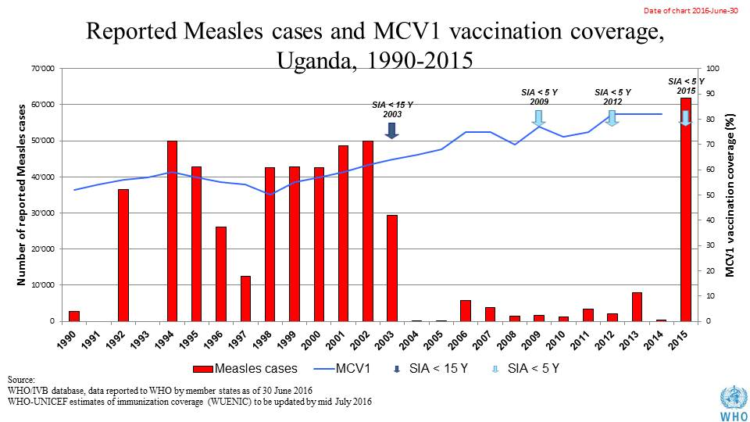

**Table XX: SIA activities planned in 2016-2017**

|  |  |  |  |  |  |  |  |  |
| --- | --- | --- | --- | --- | --- | --- | --- | --- |
| **Activity** | **Intervention** | **Year** | **Start Date** | **End Date** | **Age Group** | **Extent** | **Status** | **Target population** |
| SNID | tOPV | 2016 | 23/01/2016 | 25/01/2016 | 0 to 5 years | Sub-National | Planned | 2,540,476 |
| NID | tOPV | 2016 | 01/04/2016 | 03/04/2016 | 0 to 5 years | National | Planned | 8,092,606 |
| SNID | tOPV | 2016 | 23/04/2016 | 25/04/2016 | 0 to 5 years | Sub-National | Planned | 4,046,303 |

Source: WHO/IVB Database as at 01 July 2016

1. **MNT eliminated and elimination validated in 2011.**
2. **Coverage and Equity**

**Table XX: Reported DTPCV doses administered & coverage, Uganda, 2000-2015**

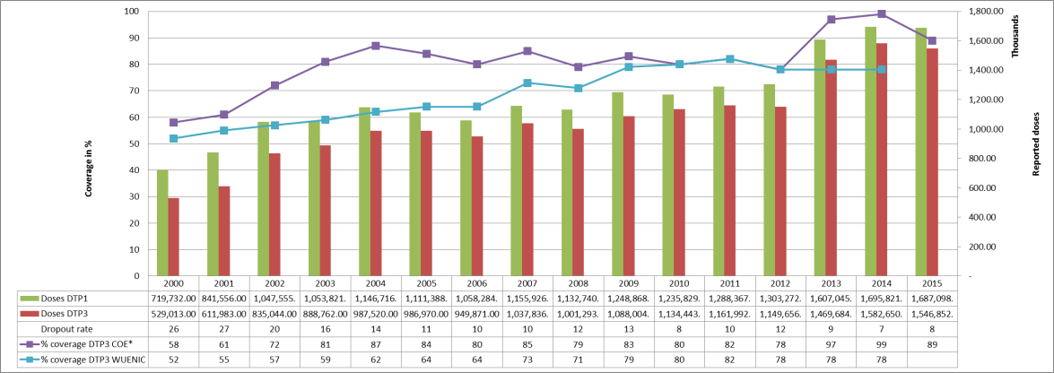

* COE: country Official Estimates

Source: WHO/IVB database, data reported to WHO by member states as of 1 July 2016

WHO/UNICEF national coverage estimates, 2014 revision, data as of July 2015

**Table XX: Percentage of district achieving <50%; 50-79% and ≥80% coverage, 2000-2015, administrative data**

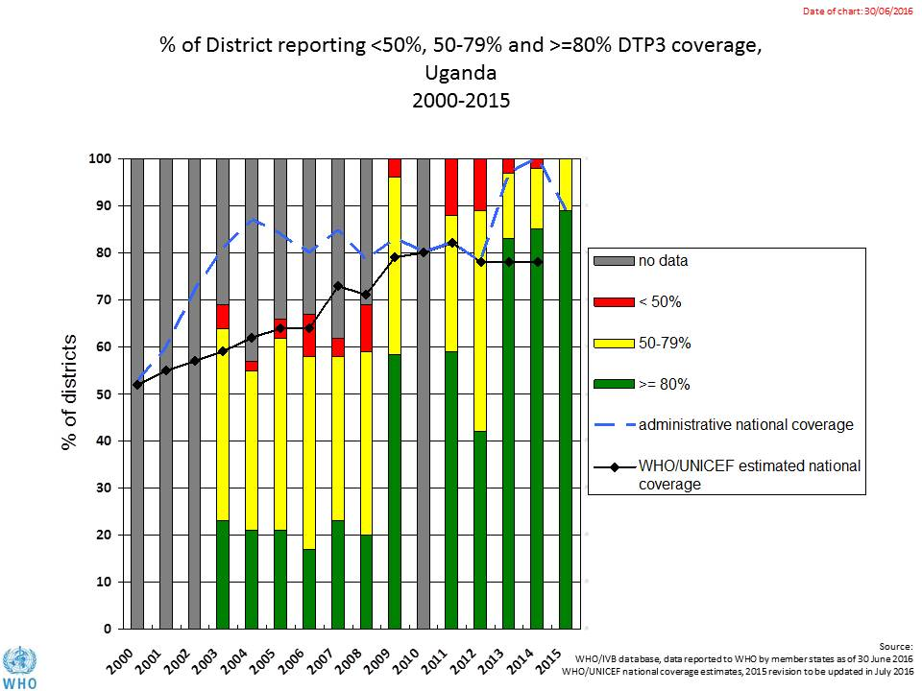

Note to Kamel: These administrative data aren’t credible, so why include?

**Graph YY: map with DTP3 coverage by district/province 2010 and 2015 (admin)**

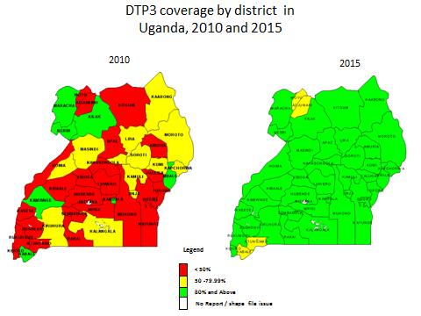

**Graph XX: Immunization coverage data disaggregated by sex and wealth quintile** (<http://apps.who.int/gho/data/view.wrapper.HE-VIZ11?lang=en&menu=hide>)

1. **Immunization systems highlights**

* Immunization schedule

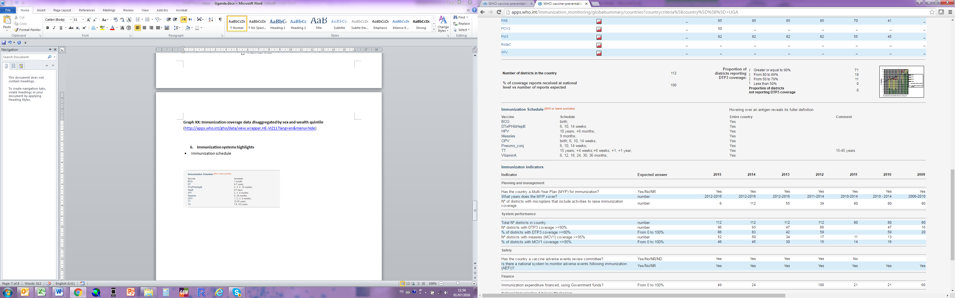

* Planning and management:
  + Stockout problems (Daniela)

Table XX: stock outs of vaccines 2016

Source: Immunization monthly update from AFR IST Central, as at 1/06/2016

* + cMYP: 2012-2016
  + Annual Plan: Yes
* Country decision making: A NITAG is established but it is no meeting the 6 minimum criteria defined by WHO for a functioning NITAG
* % of total expenditures on vaccines financed by government funds: 15%

**Three-dose pentavalent coverage from 2010 to 2015, based on the GAVI Full Country Evaluation household survey conducted in 19 districts in 2015**



1. Is this the same as the Parliamentary Task Force on Immunization? Ask Annet.
2. Sources: Resource Tracking for Immunization in Uganda, 2013/14, Full Country Evaluation brief, 2015.
3. I got this table from the GAVI Resource Tracking document and expanded upon it, using the PEF and what I know. Not sure of its accuracy and I need some help to complete (e.g., from WCO).
4. I can add a pie chart from this study, if we want.
5. It’s unclear to me whether the Forum is a group or was a meeting, since I’ve seen the word Forum used both ways in the documents and phone calls I’ve had. Annet to clarify.