**Global Vaccine Action Plan**

*Secretariat Annual Report 2016*

*Priority Country report on progress towards*

*GVAP-RVAP goals*

**CHAD**

1. **Progress towards achievement of GVAP goals**
2. **Summary**

This summary table describes the current situation in Chad regarding achieving the GVAP goals. Data used to assess progress towards achievement of GVAP goals are included in the annex.

| **Area** | **Indicator** | **Chad** |
| --- | --- | --- |
| **Socio-demographic** | **GNI 2014** | **980** |
| **WB Status** | **Low Income** |
| **Infant mortality (<12 mo.) 2015 (UN IAG CME)** | **85** |
| **GAVI status** | **Eligible** |
| **Total population** | **14,037,000** |
| **Birth cohort** | **630,000** |
| **Surviving infants (JRF)** | **573,000** |
| **1. Interrupt wild poliovirus transmission** | **Transmission interrupted** | **Yes** |
| **Risk of late detection: Percent of adequate stool specimens (Rolling 12m) Target > 80%** | **97.8** |
| **Risk of late detection: Non-polio AFP rate per 100,000 (rolling 12 mo.) (Target > 2/100,000)** | **6.3** |
| **Risk of spread after importation: % of 6-59 month olds having received less than 3 doses in the last year before occurrence case/environmental positive)** | **9** |
| **2. Neonatal tetanus elimination** | **Coverage for TT (administrative data for 2015)** | **96%** |
| **Protection at Birth against tetanus (WUENIC 2015)** | **75%** |
| **Last SIAs conducted in the country** | **SIAs taking place in 80% of the country in phases from 2011 to 2016. Two rounds took place in 46 districts. The last round in 12 remaining districts planned for 2016.** |
| **Elimination validation date** | **Not yet validated** |
| **3. Measles Elimination** | **Coverage MCV1 (2015 WUENIC)** | **62%** |
| **Coverage MCV2** | **Not in schedule** |
| **Percentage of districts with MCV1 coverage ≥95% (2015 JRF)** | **22%** |
| **Last national SIA** | **2012** |
| **Post SIA coverage survey conducted** | **No** |
| **4. Rubella/CRS Elimination** | **Rubella vaccine coverage** | **Not introduced** |
| **SIAs planned?** | **SIAs planned 2018** |
| **5. Reach 90% national coverage and 80% in every district with third dose of DTP-containing vaccine** | **National coverage (WUENIC 2015)** | **55%** |
| **Dropout rate DTP1 to DTP3 (2015 WUENIC)** | **8%** |
| **Actual numbers of children who dropped out (2015 WUENIC)** | **28,600** |
| **Difference between poorest and richest quintile DTP3 coverage (2013 data)** | **38.3** |
| **% District coverage reaching 80% coverage from 2015 JRF** | **51%** |
| **6. Reach 90% and 80% coverage with all vaccines in national immunization program** | **National Coverage (2015 WUENIC)** | **BCG: 70% DTP1: 60% DTP3-HepB3-Hib3: 55% MCV1: 62% Polio3: 62% YF: 49%** |
| **7. Introduction of new vaccines** | **New Vaccines introduced** | **Yellow fever: 2005**  **Pentavalent: 2008**  **IPV: 2015**  **Meningitis A in campaigns (phased in from 2011 to 2017)** |
| **8. Reduction in under 5 mortality rate** | **% reduction from 2010 to 2015** | **2010: 160.1 2015: 138.7 (13.4%)** |
| **9. NITAG** | **NITAG established?** | **No** |
| **10. Government expenditure on routine immunization per live birth USD** | **Baseline 2010-2011 and average for 2013-2015 (% change)** | **4.3 to 4.8 (+13%)** |

1. **Country ownership of the immunization programme**
   1. **Immunization policy decision-making capacity**

The main decision-making body for immunization in Chad is the ICC, chaired by the Minister of Health or his representative, and consisting of high-level officials from other government ministries (e.g., Finance, Communications, Social Affairs) and various UN partner organizations. The committee approves the EPI annual plan and other key decisions, coordinates partner activities, mobilizes resources for different activities, and serves as a link between development partners and government agencies. The ICC does not meet regularly to plan and monitor activities, but instead meets on an “as needed” basis to approve recommendations, sign off on key documents (e.g., GAVI proposals and Joint Appraisal reports) and make other major decisions.

Recommendations for the immunization program are made by the EPI Technical Support Committee (*Comité technique d’appui du PEV* or CTA/PEV), which is chaired by the EPI Director and made up of MOH technical staff and the immunization focal points of the major partner organizations. The CTA/PEV meets weekly to plan immunization activities, develop documents, such as annual action plans, and monitor immunization activities. All recommendations and key documents developed by the CTA/PEV then go to the ICC for approval.

No independent national advisory committee on immunization (NITAG) yet exists in Chad, although there is a high-level technical advisory group (TAG) for polio that meets twice a year to make recommendations that are then presented to the Prime Minister or President. The TAG, which includes both national and international members, has expanded its portfolio to other vaccine preventable diseases. There have been initial discussions about establishing a NITAG to replace the polio TAG.

* 1. **Government financing of immunization**

Since 1996 the Government of Chad has fully funded the cost of traditional vaccines (TT, BCG, OPV, measles) and injection supplies. It has also met its co-financing obligations to GAVI each year for procurement of new vaccines (pentavalent and yellow fever) without defaults or delays. Funds for vaccines are covered through a budgetary line item established in 2011.

Once Chad started co-financing yellow fever and pentavalent vaccine in 2010, its financial contributions to the immunization program increased more than three-fold (from around 500,000 per year to $2.2 million) (Figure 1). As a result of advocacy from the Gates Foundation and other partners and in response to a polio outbreak in 2011, the Federal Government made a large, one-time investment of more than $49 million in 2011 as part of an emergency plan to finance polio SIAs, purchase vehicles and motorcycles, buy cold chain equipment and fuel, hold planning and review meetings and other related expenses.[1] Since 2011, the Government’s contribution has largely remained flat – between $2.7 and $3.2 million per year. These funds cover, in addition to vaccine procurement, recurrent costs for cold chain and logistics and other programmatic costs (e.g., fuel for supervisory visits and for refrigerators); the Government’s share of operational costs for polio, measles and other vaccination campaigns; as well as the costs of EPI-specific staff. Local (e.g., district) governments also contribute to recurrent immunization program costs to some degree.

Figure : Trends in the Government of Chad’s expenditures for immunization, 2008-2014

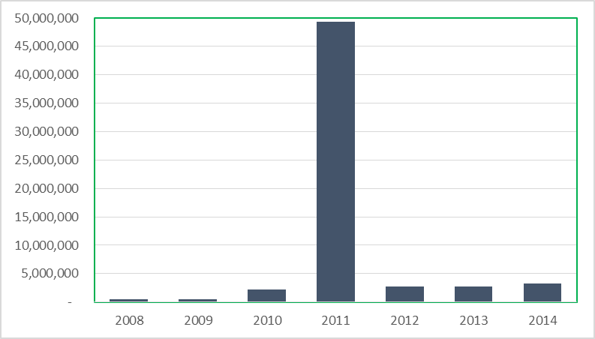

However, international partners – mainly UNICEF, WHO and GAVI – are the main funders of the national EPI program, covering 86% of the non-salary program costs from 2012 to 2014, while the Government covered the remaining 14%.[2] Partners cover much of the operational costs that makes the program function at the local level, including outreach activities, implementation of the Reach Every District (RED) strategy in selected districts, communication activities, and cold chain and logistics costs. They also pay the majority of the costs of polio, measles, MNT and meningitis vaccination campaigns, which in the 2016 EPI budget accounted for 75% of the service delivery budget and 40% of the entire immunization program budget.[3] In addition, a number of partners, such as the French cooperation, World Vision and other bilateral agencies, provide funding and technical support for immunization activities directly to certain health districts.

A key obstacle to improving the performance of the immunization program in Chad has been the complicated process of getting program funds released by the Government bureaucracy and transferred to the EPI or to health regions and districts. Only 56% of the GAVI HSS funds, which finance cold chain improvements and the implementation of the RED strategy in 60% of the country’s health districts, was spent in 2015 and only 14% in 2014.[4] This has significantly reduced the Government’s ability to increase vaccination coverage through the routine program and otherwise improve program performance.

**2.3 Human resource situation**

The number of permanent staff positions in the immunization program in Chad is quite small – with five medical officers and a total of 29 persons (including support staff) at the central level and 23 regional EPI focal points (one per region).[5] Three of the professional staff in the central EPI office are CDC or WHO consultants. The small number of professional and technical staff in the central office has severely constrained the team’s ability to provide adequate technical support, oversight and financial management of the program. Considerable staff turnover in recent years has also affected the program. To supplement this staff, partners (UNICEF, WHO and GAVI) support a contingency of 145 surveillance medical officers, communications officers and other experts, who are under contract. Many of the WHO positions are funded with polio program funds, which will be reduced, starting in 2017, under the polio transition plan.

The Government has been increasing its health workforce, which now numbers around 9,200 health workers (mainly nurses) – an increase of 1,000 since 2013.[6] While this yields a ratio of one health worker per 1,500 people, this workforce is very poorly distributed within the country and not all of them administer vaccinations. The skills level of health workers also varies; the EPI review of 2012 found that only 54% of health workers who provided immunizations had received any formal training and only half of the immunization trainings planned in 2011 (in vaccine and cold chain management, communication, safe injections) actually took place.

To further increase the number of health workers, the HSS II proposal, which is being resubmitted, calls for hiring and training an additional 174 health workers, who will focus on immunization activities.[7]

1. **Progress towards specific GVAP goals (issues/challenges/successes)**
   1. **Goal 1: Achieve a world free of poliomyelitis**

Has the GVAP target of interrupted polio transmission been achieved?

Chad has not had a case of wild polio virus (WPV) since June 2012 and no cases of vaccine-derived disease since 2013. The AFRO certification committee declared Chad polio-free in 2016. This achievement is the result of an emergency plan that the Federal Government put in place in 2011 in response to an outbreak of WVP that caused 132 lab-confirmed cases.[8] The plan – financed with an infusion of funding from the Government (as mentioned above) and by development partners – involved improving the quality of polio SIAs, strengthening AFP surveillance, improving communications activities, and identifying priority areas for special efforts.

Is Chad considered at high risk of polio transmission?

The country is considered at medium risk of polio transmission as a whole. It does have several areas at high-risk – especially along the border with the Central African Republic (CAR) and in the Lake Chad region. These areas are at elevated risk due to the movement of populations, including refugees from conflict-ridden CAR who are often not vaccinated and those from Northern Nigeria where WVP is still circulating (with two cases reported in July 2016 in Borno state).[9] These areas are also at high risk due to low routine polio immunization coverage rates. Pockets of inadequate AFP surveillance – with eight silent districts identified in 2015 – also places these areas at risk.

What needs to be done to ensure that Chad remains polio-free

Since the 2011 outbreak, the Chadian Government, with much partner support, has conducted a series of national and sub-national polio vaccination campaigns each year. Four national rounds and two local campaigns were conducted in 2015, achieving high coverage, according to administrative data. Sub-national campaigns have continued into 2016, including in the Lake Chad area and among refugees from the CAR living in camps along the border. Sub-national polio vaccination campaigns will continue into 2017.

Improving polio vaccination coverage through the routine immunization program will also be critical to preventing future outbreaks from importations. The 2015 WUENIC estimate for national measles vaccination coverage is 62%, up from only 54% in 2014, and rates are likely to be considerably lower in many districts. This is clearly inadequate to ensure sustainability of polio eradication in Chad.

Strong surveillance is the other critical piece to preventing outbreaks of imported cases and ensuring that Chad remains polio-free. The country has a strong AFP surveillance infrastructure in place. There are six surveillance hubs established with funding from the Bill & Melinda Gates Foundation that cover the entire country. There are also WHO-supported regional surveillance officers and at least two Government surveillance focal points in each district, who are responsible for investigating all reported AFP cases. Private providers, including traditional leaders, are included in the surveillance system, though traditional healers rarely report cases. The AFP/polio surveillance results are published in a weekly bulletin. To further strengthen polio surveillance, the Government established four environmental sentinel sites in 2015 in canals in N’djamena to detect polio virus.

Case-based surveillance is conducted for AFP (as well as for measles, neonatal tetanus and yellow fever) and the country has, as a whole, has met the AFP surveillance criteria since at least 2008. Over the past year (mid-July 2015 to mid-July 2016), 98% of notified cases were investigated within two days of being reported, and the non-polio AFP rate was 6.15/100,000 (meeting the target of >2/100,000 children).[10] However, there remains no polio testing laboratory in the country, which uses a reference lab in Yaounde, Cameroon.

* 1. **Goal 2 : Meet global and regional elimination targets**

**3.2.1 Achieve maternal and neonatal tetanus elimination**

Chad developed an MNT elimination plan for 2008-2011, but it was not fully or adequately implemented. The country continues to report an average of around 200 cases each year and nearly all districts (84/87) in 2015 reported at least one MNT case. However, according to several documents, there is likely to be under-reporting of MNT cases in the country.[11]

There are two major challenges to Chad achieving MNT elimination by the target date of 2017 stated in its comprehensive multi-year plan for EPI (cMYP):

1. TT coverage for pregnant women remains inadequate. The majority of women (66%) still give birth without a skilled birth attendant and use of antenatal care services remains quite low, with only 31% of pregnant women making at least four antenatal care visits.[12] As a result, according to the 2015 DHS/MICS study, the protection at birth (PAB) rate against tetanus was only 56% in 2014.
2. MNT case-based surveillance remains inadequate, with only 37% of cases reported in the first half of 2016 investigated and ring vaccination conducted in response to only 74% of these cases.[13] Data on MNT cases are also not consistent across different sources. WHO is working with the Ministry of Health to improve MNT surveillance, which is conducted by the same surveillance teams that perform strong AFP surveillance.

While delayed, TT campaigns have been conducted for women of childbearing age in phases since 2010, covering around 80% of the country. The last phase – targeting the remaining 12 high-risk districts – is being carried out in 2016. The SIAs are a key factor contributing to the jump in the WUENIC estimate for children protected at birth from 60% in 2014 to 75% in 2015. Chad will begin to prepare a dossier for certification of elimination once the SIAs are completed. Improving routine TT coverage among pregnant women and MNT surveillance will be critical to achieving and sustaining MNT elimination.

* + 1. **Achieve measles elimination and rubella & CRS elimination**

Measles

Chad continues to report measles cases and outbreaks each year, with 1,275 cases reported to WHO in 2014 and 418 cases in 2015. Given that measles surveillance in the country is still not at the level of AFP/polio surveillance, the disease is likely significantly under-reported.

The main reasons why measles persists in Chad is inadequate vaccination coverage rates through the routine immunization program. With the WUENIC measles vaccination coverage rate only at 62% nationally, the routine program is failing to reach sufficient numbers of infants with measles vaccination. The problems related to vaccination coverage through the routine program are discussed in detail in Section 3.3 below. The Government does not yet have plans to introduce a second measles vaccine dose into the routine schedule.

To supplement routine immunization, the EPI has conducted national measles SIAs every three or four years since 2005, with smaller, local campaigns in between the SIA years and in response to outbreaks. SIAs for children under five (in most cases) have been taking place in 2016 in five districts experiencing local outbreaks. The last national measles catch-up campaigns – targeting all children under the age of ten – took place in 2013. However, the campaigns have reportedly not been well implemented in many instances and have missed many children, especially in urban areas, resulting in continual outbreaks.[14]

The suboptimal quality of the campaigns is not reportedly due to a lack of funding from the Government or delayed releases of funds, as is the case in many countries in the region. Unlike for the routine program, the Government has a record of providing funds to cover its share of the operational costs of SIAs in a timely fashion.[15]

With GAVI support, the EPI is conducting national follow-up campaigns in September and October 2016. To improve the quality of these SIAs and their evaluation, GAVI has provided an international consultant to assist with their planning, monitoring and assessment.

Measles surveillance has improved markedly in the past two years in Chad, earning the country congratulations from the WHO inter-country support team (IST) in Libreville. The percent of suspected cases that have been investigated and tested in the country’s measles laboratory in N’djamena rose from 3% in 2009 to 25% in 2011, 33% in 2015 and 45% thus far in 2016.[16] These improvements are due to a new focus on measles surveillance starting in 2013, once polio cases disappeared. Measles is now included in the quarterly AFP surveillance meetings, and training of district and zonal surveillance focal points in measles surveillance has recently been conducted with WHO support. However, the rate of cases investigated is still well below the target of 80%. In addition, only 65% of districts in 2016 have thus far reported at least one suspected measles case, compared to the target of 80%.[17]

Meeting the goal of measles elimination in Chad by 2020 will require substantially improving the measles vaccination coverage rates through the routine program. Adding a second measles dose in the routine immunization schedule, which is not yet under consideration, would help the country in meeting this target.

Rubella

Rubella surveillance is taking place in conjunction with measles surveillance; all specimens collected from suspected measles cases are also tested for rubella in the measles laboratory in N’djamena. In addition, the country plans to conduct, with GAVI support, national catch-up measles-rubella vaccination campaigns in 2018.

**3.3 Goal 3: Meet vaccination coverage targets**

* 1. **Achieve 90% national coverage and 80% in every district with 3 doses of diphtheria-tetanus-pertussis containing vaccines**
  2. **Achieve 90% national coverage and 80% in every district with all vaccines included in the national schedule**

Chad is still quite far from meeting the national and district-level coverage targets for DPT-containing vaccine (pentavalent) and for all other vaccines in the immunization schedule. The 2015 WUENIC estimates show national coverage of 55% for three pentavalent doses, 62% for measles and for three doses of OPV, and 49% for yellow fever. The 2014-2015 DHS/MICS survey shows considerably lower coverage rates, however, with rates for three pentavalent vaccine doses among 12-23 month olds of 33%, 50% for three doses of polio vaccine, and 57% for measles vaccination.[18] High dropout rates – estimated to be 17-26% between DPT1 and DPT3 by several sources – are a major contributing factor for the low coverage rates of both pentavalent and polio vaccines. Administrative data show that 51% of districts in 2015 had achieved DPT3 coverage of ≥80% and these rates are likely to be inflated.[19]

Nonetheless, immunization coverage rates have improved somewhat in the past five years or so, especially for DTP3 and polio 3, with a noticeable jump from 2014 to 2015 (Figure 2). This increase has been mainly attributed to the recent expansion of the RED strategy – to now 54 of the country’s approximately 90 health districts. Efforts to improve coverage among hard-to-reach populations like nomadic herders through intensified vaccination activities may have also played a role. Other factors may include recent improvements in the security situation in the country and the movement of populations from insecure to secure areas, including camps, where they have better access to health care services.

Figure : Trends in WUENIC immunization coverage rates in Chad

While there has not been a formal equity assessment, the 2014-15 DHS/MICS showed a 64% increase in pentavalent 3 coverage from the lowest to the highest income quintile (27% vs. 45%), double the coverage rates for children whose mothers had a secondary school education over those with no education (54% vs. 27%) and an eight-point higher coverage rate in urban than rural areas (40% vs. 32%). Coverage is especially low among nomadic and hard-to-reach populations living in remote desert areas.

The main factors contributing to the low immunization coverage rates in Chad include:

* **Insufficient availability of health services, including immunization**

There are not enough health facilities in Chad to make health care services assessable to all. While the government’s plan is to have one health zone (consisting of a health facility) for every 10,000 people – which would require around 1,450 facilities – there are at present around 1,160 functioning health facilities. Health facilities are especially lacking in remote areas with sparse populations. In addition, the 2012 EPI review found that about a quarter of health facilities (24%) do not offer immunization services.[20]

The frequency of immunization services in health facilities that do provide this service is quite favorable compared to several neighboring countries, with 51% of those included in the EPI review reporting that they hold immunization sessions once or twice a week and 39% offering services 5-7 days a week.[21] However, the review also found that 27% of health centers had had to cancel planned immunization services in the prior six months, the main reasons being a lack of personnel, injection supplies and/or kerosene for their refrigerators (or broken down refrigerators). In addition, most vaccinations are provided at fixed sites and the frequency of outreach and mobile activities is inadequate, often as a result of a lack of staff and/or vehicles.[22]

* **Inadequate communications about immunization and weak community involvement in immunization activities**

Chad has a system of health volunteers (*agents de santé communautaire*) in each village, who, among other tasks, promote immunization, inform their communities about upcoming immunization activities and track vaccination defaulters. However, these mobilizers are reportedly not well motivated or involved much in immunization in many areas.[23] There has also been in the past little involvement of civil society organizations (CSOs) in immunization. In addition, the small (three-person) communication team within the central EPI office is over-stretched, has limited resources and focuses mainly on communications in conjunction with the national immunization days and other campaigns. While new vaccine introductions provide the opportunity to increase population awareness about immunization and to therefore increase demand, Chad has not introduced a new vaccine (other than IPV) since 2008. Communications and social mobilization for routine immunization is therefore inadequate. The low literacy rate among women in Chad (32%) creates an additional communications challenge with the public about immunization.

To improve this situation, 22 local associations in 10 districts where the RED approach is being implemented with GAVI support have signed an agreement to promote vaccination in their communities, with assistance from UNICEF. As a result, 1,500 community leaders participated in 2015 in promoting and assisting with immunization activities, 640 community volunteers were recruited and trained to conduct home visits, seek out defaulters and hold social mobilization meetings and other communications activities in their community. Through these efforts, nearly 46,000 children under the age of two were enumerated – the vast majority of whom (86-87%) had not completed their vaccinations and were referred to health facilities to receive missed doses.[24]

* **Insufficient implementation of the Reach Every District (RED) strategy**

With WHO and UNICEF technical support and funding from the Gates Foundation, Chad began implementing the RED strategy in 18 districts in 2004. The program has expanded gradually over time to now 54 of the country’s 90 or so districts, including 22 districts supported through the GAVI HSS grant. Through this support, districts have conducted a series of activities to increase vaccination coverage, including developing and implementing micro-plans, having UNICEF-paid consultants go house-to-house to track defaulters and get them vaccinated, procuring cold chain equipment, increasing the frequency of outreach activities, conducting regular review meetings, and increasing supervisory visits. In 10 of the districts supported by the GAVI HSS grant, 100 new health centers are also being built and equipped with cold chain equipment and motorcycles for outreach activities.

The RED strategy is supposed to be applied nation-wide, but implementation is reportedly weak in the 40% of districts not receiving international assistance for its implementation. Even those that do receive support have had to curtail planned activities due to the slow release of government funds at times. In the GAVI-supported RED districts, activities that did not take place in 2014 due to delays in the disbursement of government funds included the purchase of a refrigerated truck, MLM training for health workers, and supportive supervisory visits.[25] According to one WHO informant, the lack of available budgeted funds at the local level is the first barrier that needs to be overcome to improve the performance of the immunization program.

* **Poor distribution of vaccines and supplies and an inadequate cold chain and logistics system**

Vaccine stockouts at the central level are not a serious problem in Chad, since the Government pays for traditional vaccines and co-financing for yellow fever and pentavalent vaccines in time and in full. However, stockouts of vaccines and related supplies are quite common at the regional, district and health center levels because of a poor vaccine distribution system and inadequate stock management. While a regular vaccine distribution schedule exists on paper (with quarterly deliveries from the central stores to the regions and monthly deliveries from the regions to the health districts), in practice deliveries are erratic and depend on the availability of appropriate transport, which is often lacking.

At the local level, a 2015 cold chain inventory found that while 85% of health centers had refrigerators, only 72% of them were functioning and thus only 62% of health centers could store vaccines.[26] This means that they must collect vaccine from the district stores or from another health center on the day of immunization sessions and are dependent on transportation being available.

* **Weak quality and monitoring of immunization program data**

Administrative coverage data show rates that are 20-40 percentage points higher than the WUENIC estimates; for instance 93% vs. 55% for three pentavalent doses in 2015 and 90% vs. 62% for measles.[27] These high, inaccurate rates can create an unwarranted complacency and prevent the program from taking remedial action in low-performing areas. With partner assistance, district EPI coordinators in the 54 RED districts have been trained on the use of monitoring tools, data harmonization and validation meetings have taken place at the national level, and data review meetings are held at the district level. However, the district meetings are irregular in many places.

* **Geographic inaccessibility and security issues**

Around 4-7% of Chad’s population, including nomadic herders, live in remote areas with poor access to health services. They are also not sufficiently covered by outreach or mobile services, resulting in especially low immunization coverage rates. With support from WHO and other partners, a series of intensified vaccination activities have been carried out in the past several years in seven zones to improve immunization coverage in this population. These are integrated outreach sessions that provide all vaccinations for children under the age of five and TT for pregnant women, as well as distribute malaria medicines and issue birth certificates. An innovative strategy that is used as a further incentive to ensure high participation in these events is to also offer vaccinations for their cattle (e.g., against pasteurellosis and contagious bovine pleuropnemonia).[28]

A lack of security in certain areas, including the Lake Chad region due to Boko Haram terrorists, has also negatively affected immunization coverage rates in the recent past. This situation has recently improved with a four-country security agreement and the removal of residents from insecure areas (e.g., the islands in Lake Chad) to IDP camps and more secure areas.

* **Interruption of routine immunization services during frequent SIAs**

Polio and other SIAs have been frequent in Chad, with and six polio campaigns in 2015 (four national and two local) and many more in the recent past (e.g., 10 or 11 polio campaigns per year in 2010 and 2011). The impact of these frequent events on the delivery of routine immunization services has been raised as a particular issue in Chad in several documents and in interviews with informants.[29] The 2012 EPI review found that 27% of health centers in the study reported that they stopped routine immunization services during the SIAs, mainly because of a lack of health workers and too heavy of a workload. Planning for the campaigns can also interfere with immunization services leading up to the events.

Efforts to address several of these bottlenecks with partner support are discussed in Section B below.

**3.4 Goal 4: Introduce new and improved vaccines and technologies**

Chad introduced yellow fever vaccine in 2005 and pentavalent vaccine in 2008. It was also in the second group of countries in Africa to conduct catch-up campaigns of meningitis A vaccination for 1-29 year olds, which took place in four phases in 2011 and 2012 throughout the entire country.[30] The EPI program also introduced IPV in 2015 with few reported problems.

Because of many competing activities, including the many polio and measles campaigns, and the need to expand cold chain capacity, the EPI decided to delay the planned introduction of several other new vaccines. The introduction of meningitis A vaccine into the routine schedule – originally planned for 2016 – is now planned for 2017. PCV introduction – planned in the cMYP for 2015 – has been pushed to 2018.

The Government will introduce MR vaccine by conducting nation-wide SIAs in 2018, with GAVI support, to begin to control rubella.

1. **Partner support to address key challenges to meeting the GVAP goals**

As mentioned in Section 2.2. above, development partners cover the majority of costs of the immunization program, with large portions of expenditures going towards polio, measles and other vaccination campaigns, improvements in the logistics and cold chain system, and implementation of the RED strategy in 54 districts. In addition, but WHO and UNICEF provide 145 staff and consultants to fill in the considerable gap in personnel for the immunization program. These include 55 staff and consultants paid by WHO to assist with RED activities, the intensified vaccination campaigns for nomads and other hard-to-reach populations described above, and other efforts to improve vaccination coverage and reduce missed opportunities. UNICEF’s workforce includes more than 60 consultants providing on-the-ground assistance with communications and implementation of RED strategies.

Three areas of support from international partners that have been the most critical to the functioning of and improvements with Chad’s immunization program are:

* **Rehabilitation and expansion of the cold chain and logistics system**. With support from the GAVI HSS grant and technical support from several partners, the central cold rooms have been expanded from four to seven, four sub-national depots with cold rooms have been built, and solar-powered refrigerators are being procured for the district stores and health centers to reduce the need for kerosene. The plan is to have a (solar) refrigerator in all of the nation’s 1,100 health centers.[31] Partners are also providing technical support and training in cold maintenance, vaccine management and data monitoring.
* **RED strategy implementation**. This has been a major effort, involving many partners (the Gates Foundation, WHO, UNICEF, GAVI and others) to improve the routine immunization program in selected low-performing health districts, now 54. GAVI, jointly with the Government, supports implementation of the RED strategy in 22 districts, UNICEF supports another 22 districts and WHO supports ten.[32] This funding has gone into creating and equipping new health centers in under-served areas, procuring cold chain equipment and vehicles, and paying for operational expenses such as fuel for vehicles and refrigerators. Besides funding, partners have provided technical assistance, though national and international staff and consultants – in developing micro-plans, working with communities to increase coverages rates through home visits and default tracking, among other activities. Administrative data show a significant increase in immunization coverage in the partner-supported districts, likely contributing to the increase in national WUENIC estimates from 2014 to 2015.
* **Training and capacity-building**. Partners have provided and are continuing to provide financial and technical support for a range of trainings to increase the skills and capacity of those involved in immunization and disease surveillance. This includes training of health staff in RED activities; surveillance training for zonal surveillance focal points; training of Reginal EPI focal points in data collection, data management and interpretation using the DVD-MT software to improve data quality; and mid-level managers (MLM) training at the regional level.

**Acknowledgments**

We would like to thank the following people who were interviewed for this report:

* Richelot Ayanma (WHO CO)
* Dah Cheick (WHO IST)

**Annex 1: Country immunization profile**

1. **Polio**

* **Transmission stopped in 2013**
* **Eradication certified: not yet**

1. **Measles and rubella**

Figure 3: Reported Measles cases and MCV coverage, Chad, 1990-2015

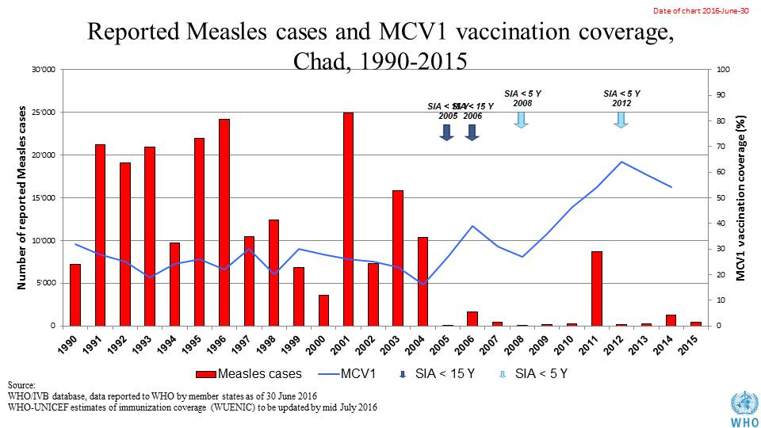

Table 1: SIA activities planned in 2016-2017

|  |  |  |  |  |  |  |  |  |
| --- | --- | --- | --- | --- | --- | --- | --- | --- |
| **Activity** | **Intervention** | **Year** | **Start Date** | **End Date** | **Age Group** | **Extent** | **Status** | **Target** |
| Follow Up | Measles | 2016 | 01/10/2016 |  | 9-59 M | National | planned | 1,123,643 |
| Follow Up | Measles | 2016 | 01/11/2016 |  | 9-59 M | National | planned | 1,664,934 |
| SNID | bOPV | 2016 | 01/09/2016 | 01/09/2016 | 0 to 5 years | Sub-National | Planned | 1,930,338 |
| NID | bOPV | 2016 | 01/10/2016 |  | 0 to 5 years | National | Planned | 3,860,675 |
| NID | tOPV | 2016 | 26/02/2016 | 28/02/2016 | 0 to 5 years | National | Planned | 4,179,810 |
| NID | tOPV | 2016 | 25/03/2016 | 27/03/2016 | 0 to 5 years | National | Planned | 4,179,810 |

Source: WHO/IVB Database as at 01 July 2016

1. **MNT: not yet eliminated.**
2. **Coverage and Equity**

Figure 4: All vaccines national coverage, Chad, 2000-2015

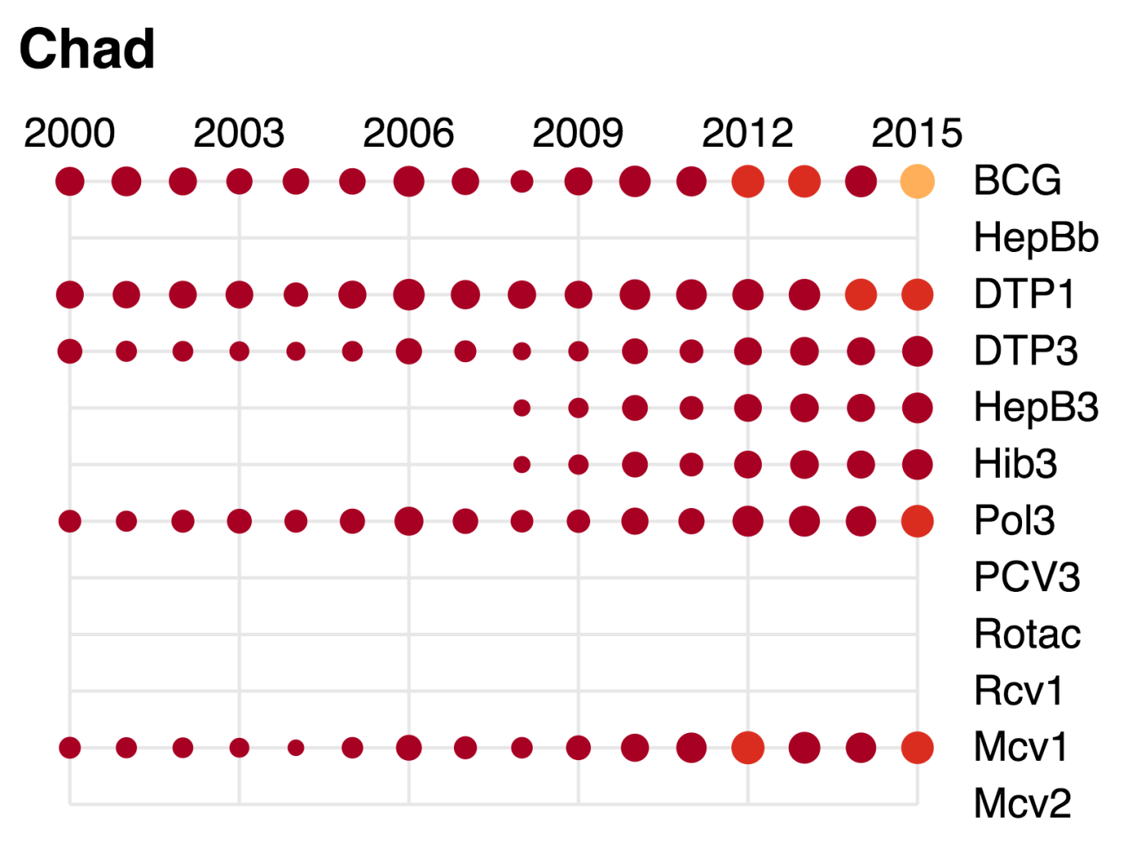

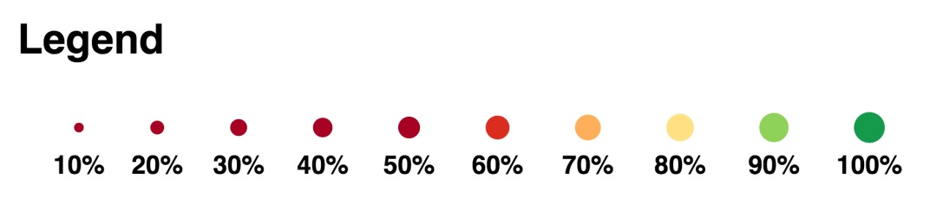

Table 2: Reported DTPCV doses administered & coverage, Chad, 2000-2015

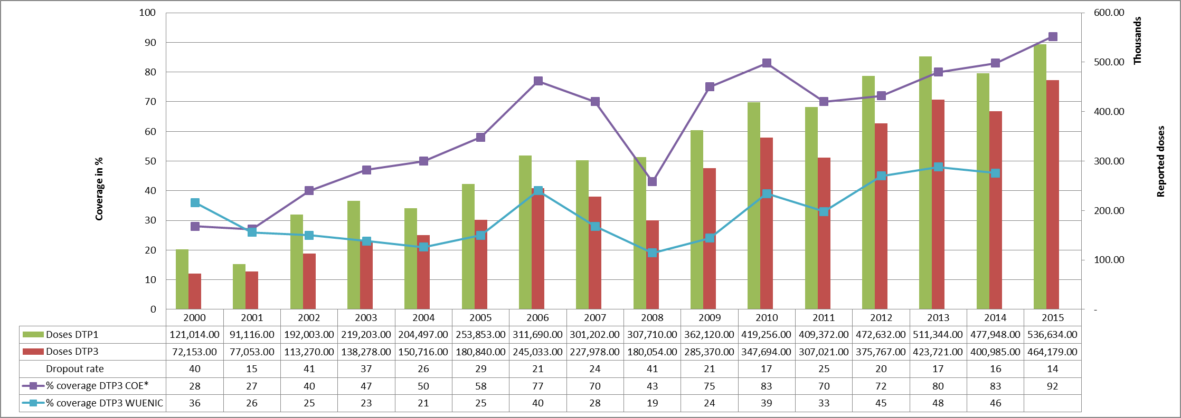

* COE: country Official Estimates

Source:

WHO/IVB database, data reported to WHO by member states as of 1 July 2016

WHO/UNICEF national coverage estimates, 2014 revision, data as of July 2015

Figure 5: Percentage of district achieving <50%; 50-79% and ≥80% coverage, 2000-2015

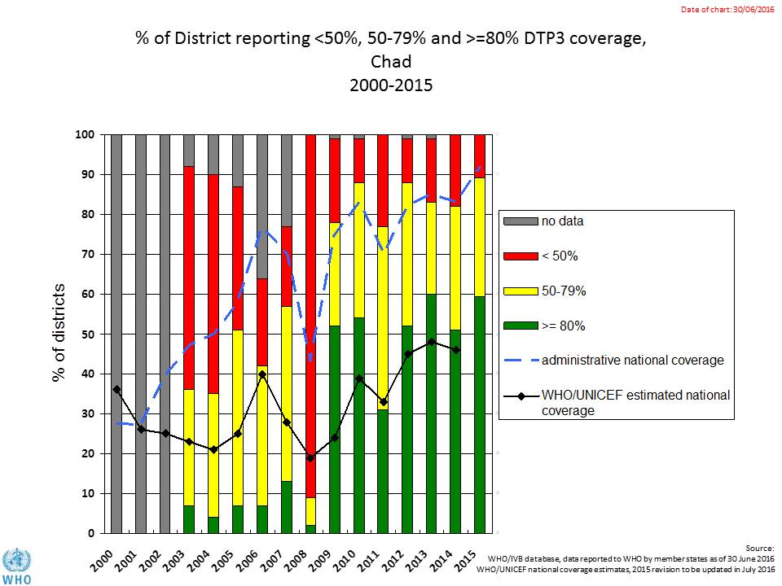

Figure 6: DTP3 coverage by district/province, Chad, 2010 and 2015 (admin)

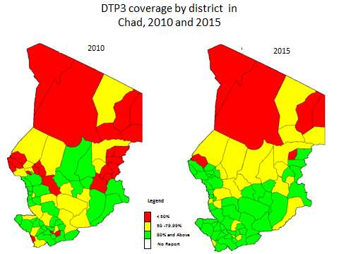

Figure 7: Immunization coverage data disaggregated by sex and wealth quintile

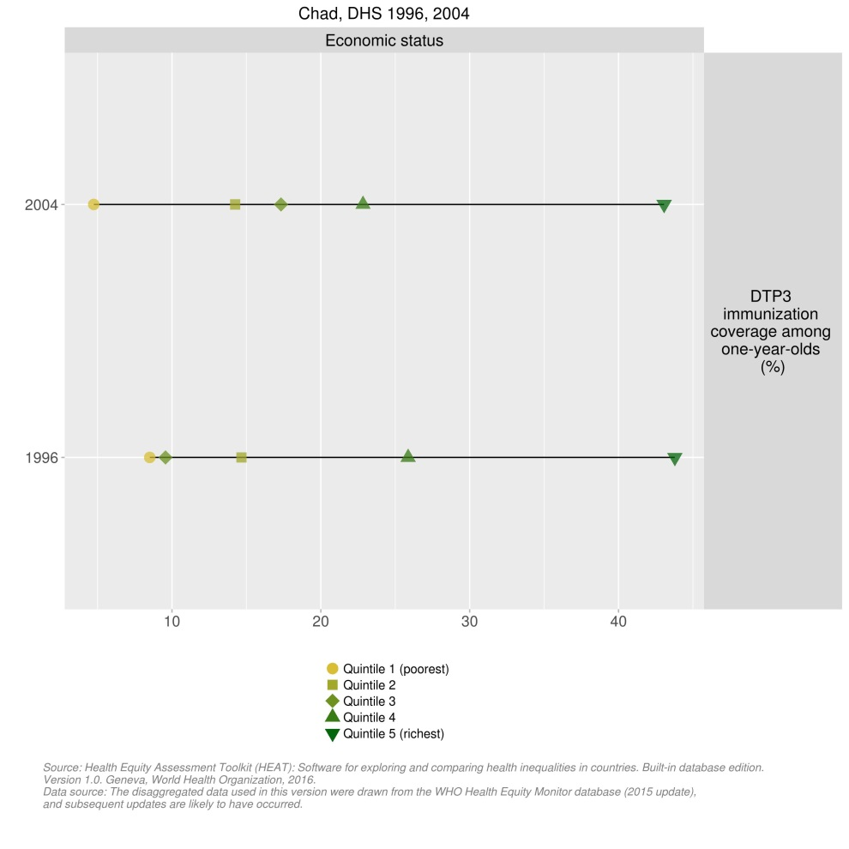

1. **Immunization systems highlights**

* Immunization schedule

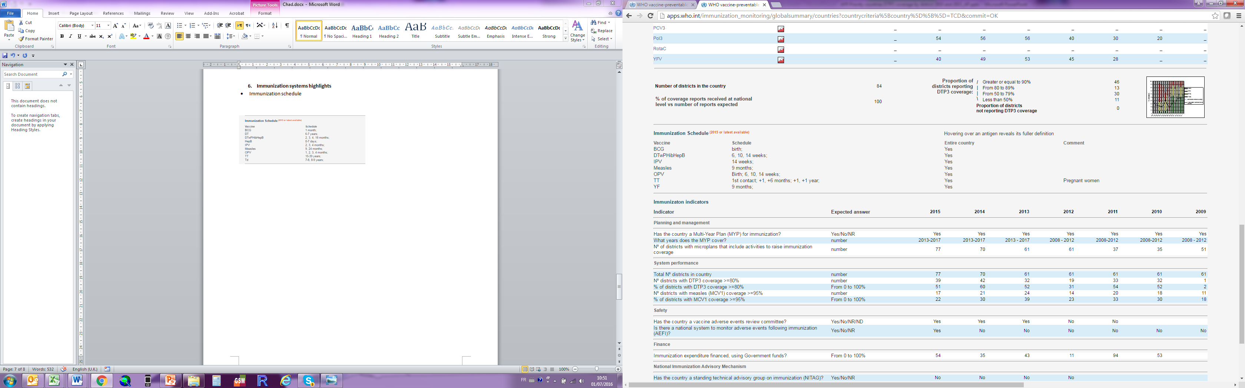

* Planning and management:
  + Vaccines stockout: no event in 2015
  + cMYP: 2013-2017
  + Annual Plan: Yes
* Country decision making: No NITAG
* % of total expenditures on vaccines financed by government funds: 98%

1. EPI review 2012.
2. Joint Appraisal report, 2016.
3. Chad Annual EPI Action Plan, 2016.
4. Joint Appraisal report, 2016. The low spending rate in 2014 was due to the temporary suspension of GAVI funds, due to financial management issues.
5. Chad Annual EPI Action Plan, 2016.
6. Joint Appraisal report 2016.
7. Joint Appraisal report 2016.
8. Comprehensive multi-year plan for the EPI program, Chad, 2013-2017.
9. Polio weekly global update, 10 August 2016.
10. WHO. Situation polio et PEV/Tchad, Semaine 28 (du 11 au 17 juillet 2016).
11. Comprehensive multi-year plan for the EPI program, Chad, 2013-2017, Chad Annual EPI Action Plan, 2016.
12. Republic of Chad, Demographic and Health Survey (DHS) and Multiple indicator Cluster Survey (MICS), 2015.
13. WHO. Situation polio et PEV/Tchad, Semaine 28 (du 11 au 17 juillet 2016).
14. Joint Appraisal report 2016.
15. Personal communications with WCO immunization focal point.
16. cMYP 2013-2017, Chad 2016 Annual EPI Action Plan, WHO. Situation polio et PEV/Tchad, Semaine 28 (du 11 au 17 juillet 2016).
17. WHO. Situation polio et PEV/Tchad, Semaine 28 (du 11 au 17 juillet 2016).
18. Republic of Chad, Demographic and Health Survey (DHS) and Multiple indicator Cluster Survey (MICS), 2015.
19. WHO Immunization country profile (do link).
20. Report of the External Review of the Chad EPI, June 2012
21. Report of the External Review of the Chad EPI, June 2012.
22. Joint Appraisal report 2016.
23. cMYP 2013-2017.
24. Chad Annual EPI Action Plan, 2016
25. Joint appraisal report 2015.
26. Chad EPI Annual Action Plan 2016.
27. Joint appraisal report 2016.
28. Government of Chad and WHO. Report of the third routine vaccination round for nomadic and cross-border populations in the health district of Mani, 7-16 November 2015.
29. EPI review, cMYP.
30. cMYP.
31. Joint appraisal report 2016.
32. Joint appraisal report 2016.