**Global Vaccine Action Plan**

*Secretariat Annual Report 2016*

*Priority Country report on progress towards*

*GVAP-RVAP goals*

**CHAD**

1. **Progress towards achievement of GVAP goals**
2. **Summary**

This summary table describes the current situation in Chad regarding achieving the GVAP goals. Data used to assess progress towards achievement of GVAP goals are included in the annex.

| **Area** | **Indicator** | **Chad** |
| --- | --- | --- |
| **7. Introduction of new vaccines** | **New Vaccines introduced** | **Yellow fever: 2005**  **Pentavalent: 2008**  **IPV: 2015**  **Meningitis A in campaigns (phased in from 2011 to 2017)** |

**3.4 Goal 4: Introduce new and improved vaccines and technologies**

Chad introduced yellow fever vaccine in 2005 and pentavalent vaccine in 2008. It was also in the second group of countries in Africa to conduct catch-up campaigns of meningitis A vaccination for 1-29 year olds, which took place in four phases in 2011 and 2012 throughout the entire country.[1] The EPI program also introduced IPV in 2015 with few reported problems.

Because of many competing activities, including the many polio and measles campaigns, and the need to expand cold chain capacity, the EPI decided to delay the planned introduction of several other new vaccines. The introduction of meningitis A vaccine into the routine schedule – originally planned for 2016 – is now planned for 2017. PCV introduction – planned in the cMYP for 2015 – has been pushed to 2018.

The Government will introduce MR vaccine by conducting nation-wide SIAs in 2018, with GAVI support, to begin to control rubella.

**Annex 1: Country immunization profile**

Figure 4: All vaccines national coverage, Chad, 2000-2015

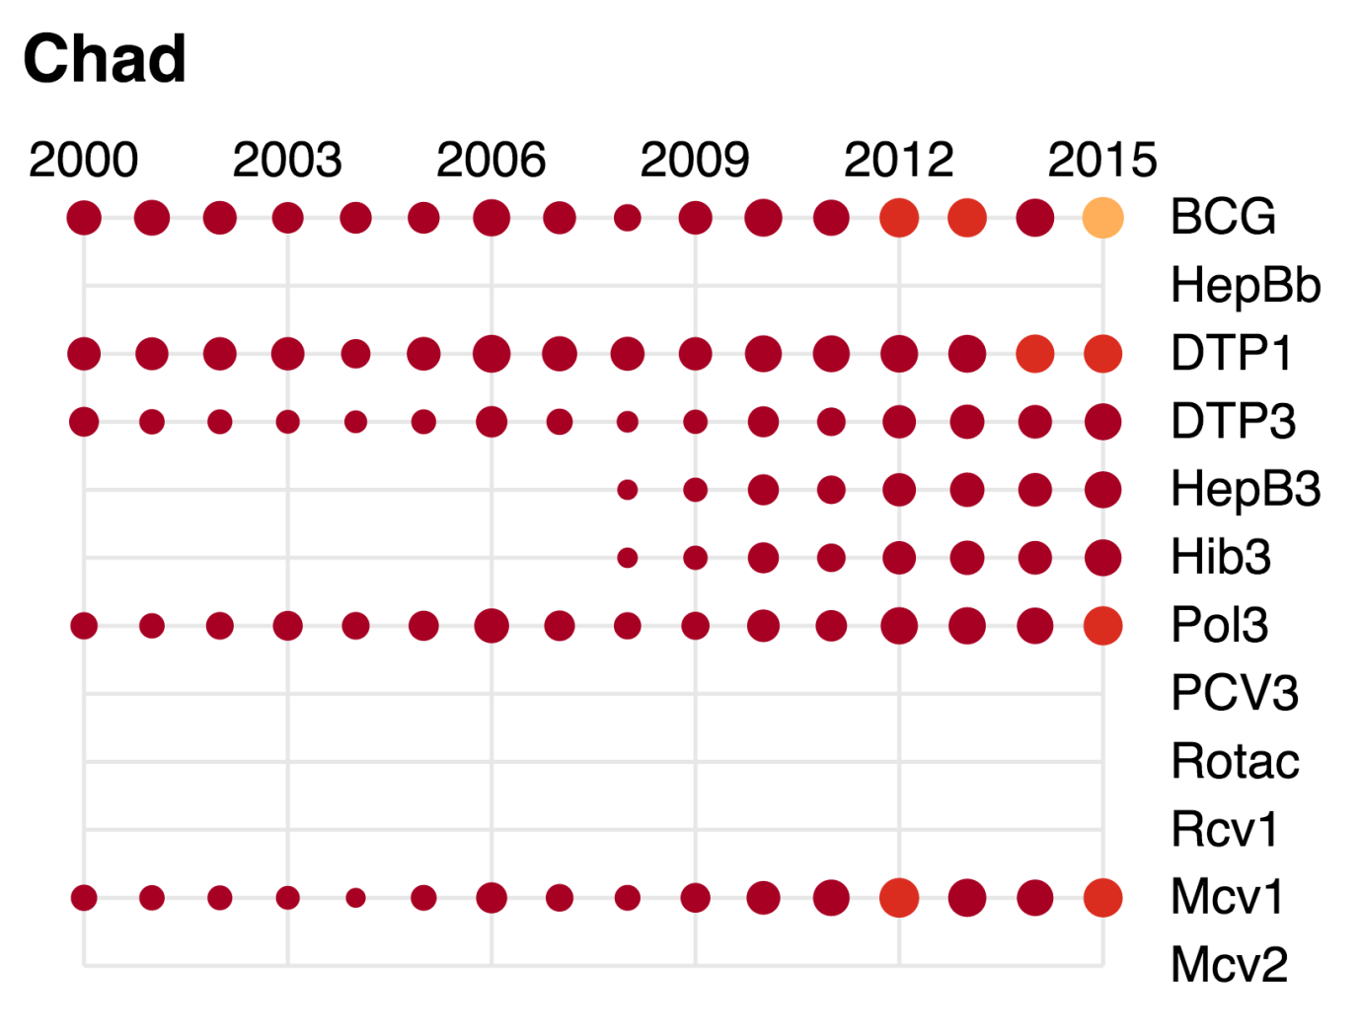

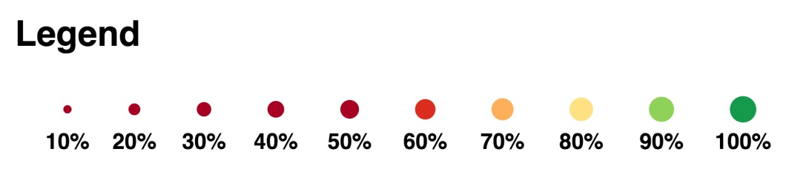

1. cMYP.