**Global Vaccine Action Plan**

*Secretariat Annual Report 2016*

*Priority Country report on progress towards*

*GVAP-RVAP goals*

**DEMOCRATIC REPUBLIC OF CONGO**

1. **Progress towards achievement of GVAP goals**
2. **Summary**

This summary table describes the current situation in DRC regarding achieving the GVAP goals. Data used to assess progress towards achievement of GVAP goals are included in the annex (Country immunization profile).

| **Area** | **Indicator** | **DR Congo** |
| --- | --- | --- |
| **9. NITAG** | **NITAG established?** | **No (2015)** |

1. **Country ownership of the immunization programme**
   1. **Immunization policy decision-making capacity**

The main body for making recommendations and decisions concerning the immunization program continues to be the country’s Strategic Inter-Agency Coordinating Committee (ICC), which is headed by the Minister of Public Health (MOPH) and enjoys strong ownership by the Ministry. Members include Ministry of Public Health staff, representatives from the Ministry of Finance and Budget, and from several partner organizations, such as WHO and UNICEF. The core committee meets twice a year. Under it are four technical sub-committees – technical, logistics, communications, and finance – each of which meet monthly and are chaired by the Secretary General of the Ministry of Public Health or his designee. The Technical sub-committee is headed by the EPI manager and includes technical MOPH staff as well as the immunization focal points of the major partner organizations. The EPI program also meets on a weekly basis and produce a weekly report of progress against the annual EPI workplan. In addition, each province has its own ICC, headed by the provincial Health Minister or his/her designee, to discuss technical and financial issues and plan activities.

Several efforts have been made by partners to assist the country in establishing a NITAG, including a regional training at WHO/AFRO headquarters in Brazzaville attended by DRC representatives, and visits by EPI team members in 2016 to other countries (U.S., Belgium) to examine different models of NITAGs. A change in EPI managers has delayed a decision on establishing a NITAG, which is currently pending MOPH approval. Informants believe that a strong NITAG with well-respected members could speed up decision-making (e.g., to apply to GAVI for rotavirus vaccine introduction), help convince the Government to pay its GAVI co-financing obligations on time, and convince it of the value of introducing a second measles vaccine dose to reduce outbreaks and the need for costly measles vaccination campaigns.

DRC does benefit from having the Congolese Parliamentary Network to Support Vaccination (REDACAV) – an influential group of parliament members who lobby the Government for increased funding in immunization. REDAVAC monitors the disbursement rate of funds for immunization, and individual members have been known to contact Ministry of Finance officials to get allocated funds released for GAVI co-financing and other expenditures. Some REDACAV members also participated in the development of the latest comprehensive multi-year immunization plan (for 2015-2019). With help from the Sabin Institute, the group drafted an Immunization Bill to make vaccination mandatory and lay out the Government’s responsibilities for immunization financing. However, the bill was not passed, since the Parliament is proposing an overall Health Act that will include immunization.

**2.3 Human resource situation**

The DRC Government has an extensive EPI team. In 2016, there were 115 staff members at the central level, including 36 professionals.[1] At the provincial and *antenne* (sub-provincial) level, there are 364 immunization-specific staff, for a total at all levels of 479 people, including 75 doctors (16%). The size of the team is considered adequate and they are generally well-trained. However, there is considerable staff turnover.

Another factor affecting human resources for immunization is the recent change in the administrative structure of the health sector, in which 26 provincial health divisions (*divisions provincial de la santé* or DPS) have replaced the 11 provinces.[2] This change has required the creation of new EPI staff positions in the newly-established DPSs, who are currently in the process of being trained. This expansion in provincial health divisions has caused major disruptions to the health sector, including the immunization program.

At the operational level, most vaccines are administered by nurses working in government hospitals and the 8,830 health centers throughout the country.[3] According to a situation analysis conducted for the 2015 GAVI joint appraisal, at least one person was trained in immunization in more than half of the health centers surveyed. However, most health center staff (90% according to the Joint Appraisal) receive no government salary and only a portion (e.g., 25%) receive a “risk bonus” (prime de risqué), which covers the cost of supporting a family for only five days. Health workers share a portion of the revenues from patient fees for curative care services, which constitute the main source of financing to keep health centers functioning in many places[4] However, this remuneration is low, especially in poor areas. Thus, health workers are often demotivated, resulting in retention problems, uneven quality of personnel, and a lack of interest in making special efforts for preventive health services that are not remunerated, such as conducting outreach visits and establishing immunization hours convenient to mothers.[5]

1. **Partner support to address remaining challenges to meet the GVAP goals and targets**

Partners, including GAVI, WHO, UNICEF, USAID and others, have been instrumental to the functioning and improvements of DRC’s immunization program, providing financing, manpower, technical assistance and training. As mentioned above, they have covered the vast majority of the costs of the program for many years. Much of the financial and technical support has gone into:

* **Immunization campaigns** (polio, measles, meningitis A), with WHO, UNICEF and GAVI covering most of the operational costs of the campaigns and providing technical assistance, along with other partners, in communications, planning and other activities. SIAs accounted for 13% of the EPI expenditures in 2015, most of that for polio campaigns;[6]
* **Disease surveillance**: WHO heavily supports the country’s surveillance system for polio and other vaccine-preventable diseases (VPDs), financing a team of around 100 people working in the provinces, including surveillance medical officers, logisticians, administrative assistants and drivers. While the team is supported by polio funding, they also work to improve case-based surveillance of measles and other VPDs. Periodic international STOP teams, described above, provide additional support to the country in conducting disease surveillance and organizing SIAs.
* **New vaccine introductions**: Partners have been critical to the introduction of PCV and IPV, providing assistance in planning, training, communications/social mobilization and other areas. GAVI financial support for pentavalent, PCV and yellow fever vaccines accounted for 45% of the total EPI expenditures in 2014 ($51 million out of $114 million).[7]

Three projects or activities where partner support has especially made a difference to the immunization program are highlighted below:

* **Support for implementation of the Reach Every Zone (REZ) approach**. GAVI, through the HSS grant, along with the Gates Foundation and other partners, has provided financial and technical assistance to implement the REZ approach in 65 of the country’s 516 health districts (zones de santés). Catalytic funding, along with technical assistance, has enabled these districts to conduct MLM training, pay for vaccine transport and cold chain maintenance, purchase cold chain equipment, conduct many more outreach activities (based on micro-planning), and increase supportive supervision and monitoring, including monthly meetings to review immunization coverage and activities. This support has also helped activate community participation in default tracking and in promoting health and immunization services. An external evaluation showed an increase in pentavalent 3 coverage in these 65 districts from 57% in 2010 to 80% in 2014, and a doubling of districts reaching 80% coverage in three years (Figure 2).[8] Support for REZ implementation is being expanded to 112 districts in all through the HSS II grant. Sustainability of this effort, once partner support ends, is a major question.
* **An upgrading of the vaccine supply chain and cold chain system**. With support from the GAVI HSS grant, UNICEF and WHO, DRC is substantially expanding and modernizing its cold chain system to accommodate new vaccines and greatly improve its distribution and storage of vaccines. In addition to constructing new cold rooms in Kinshasa, the project involves establishing three sub-national distribution hubs to which vaccines will be flown directly from the central stores. This should lessen the storage capacity needs of the central level and improve efficiency in vaccine distribution to the DPSs and districts. To reduce the system’s dependence on a few airlines as well as airfreight costs, GAVI funds are being used to acquire a boat equipped with cold chain equipment that will travel up the Congo River to deliver vaccines and other medical supplies to the new hubs. Solarization of the cold chain system to reduce the costs of procuring and distributing fuel, is another major component, with the procurement of solar refrigerators at the central, hub and DPS levels, as well as solar generators in all DPSs currently off the grid or that experience frequent power outages. These stores are also being equipped with remote temperature monitoring systems.

Figure 3: Change in DTP3 coverage in the 65 districts receiving support for Reach Every Zone (REZ) implementation



Source: 2015 Joint Appraisal report

* A **civil society organization (CSO) project** funded by GAVI, with support from UNICEF, USAID and other partners. Four local CSOs operating in 33 districts in five provinces work with communities to strengthen community participation in health promotion, tracking defaulters, and strengthen links between the communities and health centers. These efforts led to a substantial increase in demand for immunization, resulting in an increase in coverage of three pentavalent vaccine doses from less than 60% to more than 80% in these districts.

**ANNEX: Country immunization profile**

* Planning and management:
  + Vaccines stockout issues: DRC: 1 DTP (less than 1 month), 1 BCG (3 months duration), see Table 3 below for 2016.
  + cMYP: 2013-2015
  + Annual Plan: Yes
* Country decision making: No NITAG

Table 3: stock outs of vaccines, RDC, 2016

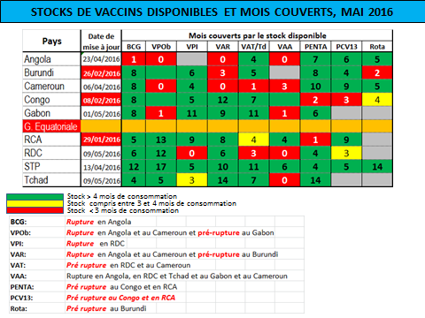

Figure 9: Change in administrative boundaries from 11 provinces to 26 Divisions de provinces sanitaires (DPSs)

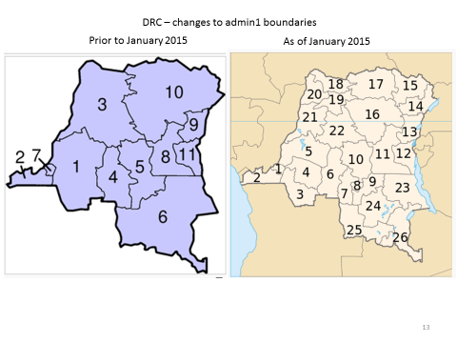

1. Draft EPI Action Plan for 2016, February 2016.
2. The administrative structure for the health sector now consists of 26 DPSs (vs. 11 provinces formerly), 44 antennes (sub-provinces), 516 health districts (*zones de santé*) and around 8.800 health centers (*aires de santé*).
3. 2015 joint appraisal report for DRC.
4. cMYP 2015-2019
5. 2015 joint appraisal report for DRC.
6. Draft EPI Action Plan for 2016, February 2016.
7. 2015 joint appraisal report for DRC.
8. 2015 joint appraisal report for DRC.