**Global Vaccine Action Plan**

*Secretariat Annual Report 2016*

*Priority Country report on progress towards*

*GVAP-RVAP goals*

**DEMOCRATIC REPUBLIC OF CONGO**

1. **Progress towards achievement of GVAP goals**
2. **Summary**

This summary table describes the current situation in DRC regarding achieving the GVAP goals. Data used to assess progress towards achievement of GVAP goals are included in the annex (Country immunization profile).

| **Area** | **Indicator** | **DR Congo** |
| --- | --- | --- |
| **2. Neonatal tetanus elimination** | **Coverage for TT (reported in 2015 JRF)** | **91%** |
| **Protection at Birth against tetanus (WUENIC 2015)** | **82%** |
| **Last SIAs conducted in the country** | **SIAs in 2013 and 2014 in 75 high-risk districts, following SIAs in 2012 in 31 districts.** |
| **Elimination validation date** | **Not yet validated. Pre-validation assessment planned for Aug-Sept 2016** |

* 1. **Goal 2 : Meet global and regional elimination targets**

**3.2.1 Achieve maternal and neonatal tetanus elimination**

DRC has not yet achieved elimination status of maternal and neonatal tetanus (MNT) and continues to officially report cases in most years, including more than 1,250 in 2012, 201 in 2014 and 330 to 2015. However, the actual incidence is likely to be much higher, since according to the cMYP, less than 10% of neonatal tetanus cases are reported by the routine surveillance system. According to a study conducted in 2005, 7% of neonatal deaths in DRC were due to neonatal tetanus.[1]

A key problem affecting DRC’s ability to eliminate MNT is its continual weak surveillance of the disease, including active surveillance. Only 17% of reported NMT cases were investigated between 2012 and 2015, with considerable variation by province.[2] This is in marked contrast to the 91% investigation rate cited above for AFP surveillance, into which donors have poured considerable funding and technical support. In addition, the standard response to confirmed cases by conducting ring vaccination in households surrounding a confirmed cases only occurred on average 32-41% of the time during this period.[3]

DRC has made considerable progress in providing TT vaccine to pregnant women in the past several years – with rates of children protected at birth (PAB) jumping from 45% in 2000 to 82% for the past two years, according to the WHO-UNICEF estimates. This has mainly been due to the marked increase in the use of antenatal care services – from 68% of pregnant women making at least one ANC visit in 2001 to 88% by 2013/14. However, many women remain unprotected due to large variations in TT2+ coverage by province and district. While the national TT2 coverage rate in the 2012 DHS was estimated at 62% in 2012, provincial rates ranged from 28% to 82%.

The EPI has also organized MNT campaigns for women of reproductive age in high-risk districts. These SIAs began in 31 out of 83 identified high-risk districts in 2012, during which a reported 1.8 million women were vaccinated with TT. The campaigns were marked by a high dropout rate between doses, relatively weak social mobilization and inadequate preparation.[4]

DRC developed an MNT elimination plan in 2013, setting the goal of elimination by 2015. Seventy-five high-risk districts were identified in the plan and targeted for SIAs in 2013 and 2014, during which another approximately 1.8 million women received two TT doses. The Government reported an overall coverage rate of 82% for the campaigns, though several provinces reported rates of >100%, so the actual coverage rate is uncertain. A new analysis in 2015 identified two additional high-risk districts and targeted them for intensified immunization activities.[5] The analysis also found 11 districts reporting at least one case per 1,000 live births (the threshold for elimination).

Achieving MNT elimination in the DRC will therefore require substantially improving case-based surveillance and response (e.g., ring vaccination around cases), as well as increasing TT coverage in areas where it continue to be low.

**ANNEX: Country immunization profile**

1. **MNT**

Elimination not yet validated. Pre-validation assessment planned for Aug-Sept 2016.

1. **Coverage and Equity**

Figure 5: All vaccines national coverage, DRC, 2000-2015

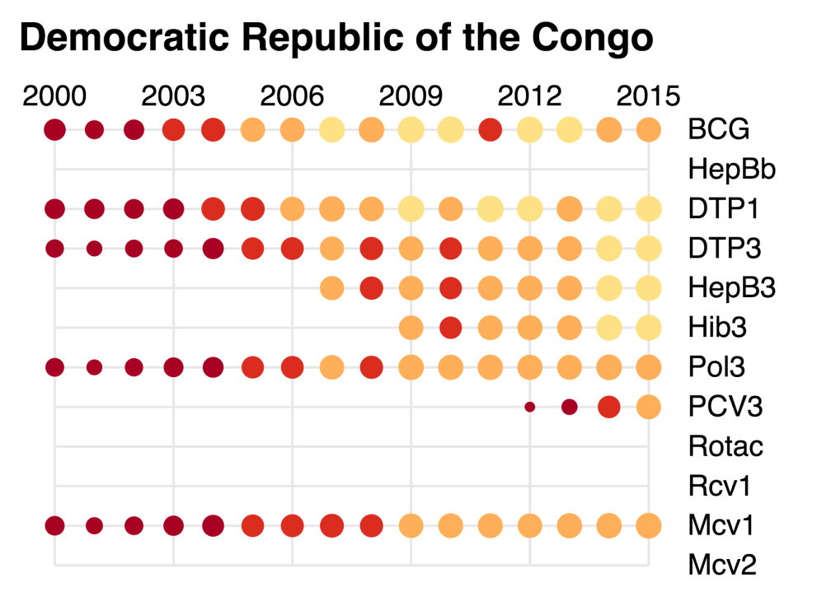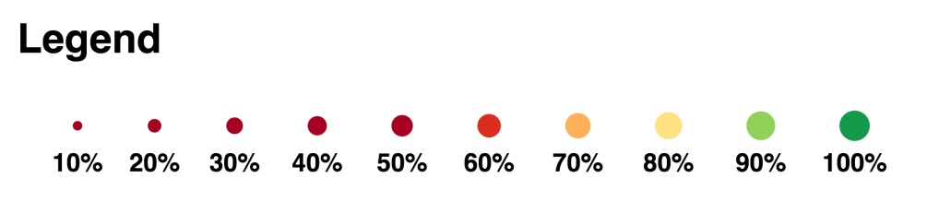

1. cMYP 2015-2019.
2. Draft EPI Action Plan for 2016, February 2016.
3. cMYP 2015-2019 and draft EPI Action Plan for 2016, February 2016.
4. cMYP 2015-2019.
5. Draft EPI Action Plan for 2016, February 2016.