**Global Vaccine Action Plan**

*Secretariat Annual Report 2016*

*Priority Country report on progress towards*

*GVAP-RVAP goals*

**DEMOCRATIC REPUBLIC OF CONGO**

1. **Progress towards achievement of GVAP goals**
2. **Summary**

This summary table describes the current situation in DRC regarding achieving the GVAP goals. Data used to assess progress towards achievement of GVAP goals are included in the annex (Country immunization profile).

| **Area** | **Indicator** | **DR Congo** |
| --- | --- | --- |
| **1. Interrupt wild poliovirus transmission** | **Transmission Interrupted** | **Yes (since 2012)** |
| **Risk of late detection Percent of adequate stool specimens (Rolling 12m) (Target > 80%)** | **77%** |
| **Risk of late detection Non polio AFP rate/100,000 (Rolling 12 mo.) (Target > 2/100,000 children <15)** | **5.5/100,000** |
| **Risk of spread after importation:**  **Percent of 6-59 month olds having received less than 3 doses in the last year before occurrence case/environmental positive** | **19** |

1. **Progress towards specific GVAP goals (issues/challenges/successes)**

**3.1 Goal 1: Achieve a world free of poliomyelitis**

Has polio transmission been interrupted?

Polio transmission has been interrupted in DR Congo, with no cases of wild polio virus (WPV) detected since December 2011, when 93 cases were reported (and 100 cases the previous year). There were 29 cases of vaccine-derived disease from 2010 to 2012 and not again until 2016, when one case was reported in March.[1] This decline in polio cases could be the result of a series of national immunization days and sub-national immunization days (*Journées locales de vaccination* or JLVs) that the country has conducted in response to the WPV cases and to eradicate the disease (see below). The Government presented a dossier to be declared polio-free in November 2015, which was granted by WHO.

Is the country considered at high risk of polio transmission?

According to the risk assessment for polio transmission conducted by WHO in June 2016,[2] DR Congo is at medium risk of polio transmission for the country as a whole. This determination is based on the combination of the potential for transmission in-country and beyond its borders – which is considered high – and the strength of its capacity to respond to and contain an outbreak – which is considered strong. As shown in Figure 2, a number of the country’s 516 health districts (*zones de santé*) have levels of population movement, a lack of security due to armed conflicts, and poor immunization coverage that place them at risk.

Figure 2: The level of polio risk from importations by health district, 2016

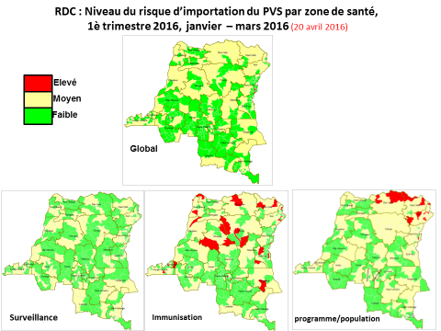

Source: Risk assessment for polio virus transmission: DR Congo presentation (June 15, 2016)

What needs to be done to keep DRC polio free?

To keep DRC free of polio outbreaks, good AFP and polio surveillance must be maintained. The country currently meets several AFP surveillance targets, including a national rate of non-polio AFP incidence of 5.5/100,000 children under the age of 15 and a rate of 91% of reported AFP cases investigated within 48 hours. The percent of cases with adequate stool samples nation-wide is 77% − just below the target of 80%. However, the quality of AFP surveillance is uneven in the country, with 28% of the 516 districts “silent” (reporting no AFP cases) for the first six months of 2016 and six DPSs with adequate stool rates of 60% of less.[3] In poor-performing areas, there is limited case-based surveillance and investigations of possible cases, often due to a lack of transport, as well as poor documentation.

The surveillance system is heavily supported by WHO, which maintains a team of several dozen staff and consultants in the provinces (including support staff and drivers), as well as 12 staff at the national level. The country is also supported by the CDC-funded international STOP teams, made up of 10-14 or so surveillance experts who spend time working with health authorities in silent districts to provide technical assistance and training to improve surveillance for AFP and other diseases. They hope to reduce the number of districts not reporting any AFP cases to zero in 2016.

The immunization program has conducted a series of sub-national polio campaigns, including catch-up campaigns following the detection of vaccine-derived polio cases, every year for the past several years. These include three rounds of JLVs (local vaccination days) in 2015 and two rounds of national immunization days in 2016, with a third planned for October. Due to problems with data quality, the campaigns constantly register coverage rates in excess of 100%. However, one LQA survey following the campaigns in 2015 found that 30% of the districts had what they considered “poor coverage” and an estimated 6% of the children had been missed.[4]

Achieving high polio vaccination coverage through the routine immunization program is also critical to reducing the risk of the disease from re-emerging. According to the WHO-UNICEF estimates, national coverage of three polio vaccine doses has been in the range of 74-79% since 2011 and was 78% in 2015. This is up from 42% national coverage in 2000, but below the GVAP target of 90% nationally. In addition, the 2016 polio risk assessment identified several districts with poor vaccination coverage, putting them at risk of transmission (see the lower middle map in Figure 2).

According to two studies conducted in 2011, refusal of parents to have their children vaccinated against polio was the second most common reason children were not vaccinated against polio, in contrast to measles, for which refusals were found to be negligible.[5] Refusals to polio vaccination were found to be due to the existence of 60 or so religious groups who were against the polio SIAs, the population’s low perceived risk of the disease, the repetitiveness of polio vaccination campaigns, and inadequate communications and social mobilization activities targeting pregnant women and anti-vaccine groups. Intensified communications activities by national consultants and STOP Team members in low-performing provinces and *antennes* in 2012 reduced the number of groups still opposed to vaccination from 60 to 10 and otherwise increased parents’ knowledge about polio vaccination.[6]

**ANNEX: Country immunization profile**

1. **Polio**

* **Transmission stopped in 2011.**
* **Eradication certified: not yet.**

Table 1: SIA activities planned in 2016-2017

|  |  |  |  |  |  |  |  |  |
| --- | --- | --- | --- | --- | --- | --- | --- | --- |
| **Activity** | **Intervention** | **Year** | **Start Date** | **End Date** | **Age Group** | **Extent** | **Status** | **Target** |
| Catch up | MR | 2017 |  |  | 6 M-14 Y | National rollout | planned | 7,320,281 |
| Follow up | Measles | 2016 | 19/07/2016 | 01/11/2016 | 6-59 M | National rollout | planned | 16,109,995 |
| SNID | bOPV | 2016 | 01/10/2016 |  | 0 to 5 years | Sub-national | Planned | 8,121,548 |
| NID | tOPV | 2016 | 14/04/2016 | 16/04/2016 | 0 to 5 years | National | Planned | 18,166,533 |
| NID | tOPV | 2016 | 24/03/2016 | 26/03/2016 | 0 to 5 years | National | Planned | 18,166,533 |
| SNID | tOPV | 2016 | 25/04/2016 | 27/04/2016 | 0 to 9 years | Sub-national | Planned | 1,430,939 |
| Campaign | MenA | 2016 | 01/02/2016 |  | 1-29 Y | Sub-national | planned | 10,117,371 |
| Campaign | MenA | 2016 | 01/05/2016 |  | 1-29 Y | Sub-national | planned | 7,927,555 |

Source: WHO/IVB Database as at 12/4/2016

Figure 5: All vaccines national coverage, DRC, 2000-2015

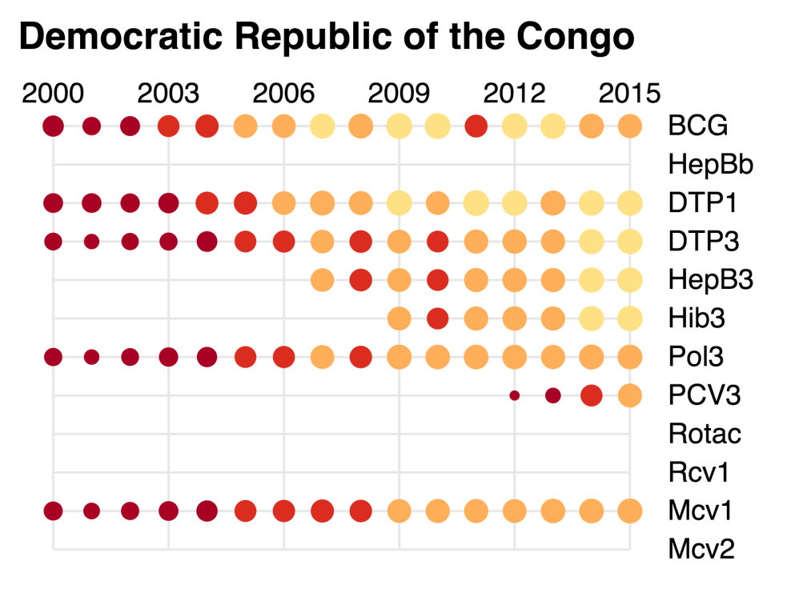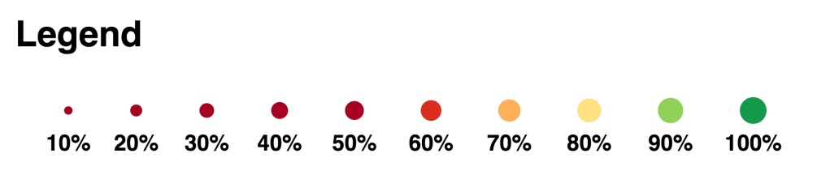

1. WHO/Geneva. Risk assessment for poliovirus transmission: DR Congo, 15 June 2016 (presentation).
2. WHO/Geneva. Risk assessment for poliovirus transmission: DR Congo, 15 June 2016 (presentation).
3. Internal WHO/UNICEF memo, July 5, 2016.
4. Draft EPI Action Plan for 2016, February 2016.
5. cMYP 2015-2019.
6. cMYP 2015-2019.