**Global Vaccine Action Plan**

*Secretariat Annual Report 2016*

*Priority Country report on progress towards*

*GVAP-RVAP goals*

**ETHIOPIA**

1. **Progress towards achievement of GVAP goals**
2. **Summary**

This summary table describes the current situation in Ethiopia regarding achieving the GVAP goals. Data used to assess progress towards achievement of GVAP goals are included in the annex (Country immunization profile).

| **Area** | **Indicator** | **Ethiopia** |
| --- | --- | --- |
| **3. Measles elimination** | **Coverage MCV1 (2015 WUENIC)** | **78%** |
| **Coverage MCV2** | **Not in schedule** |
| **Percentage of districts with MCV1 coverage ≥95% (2015 JRF)** | **30%** |
| **Last national SIA** | **2013** |
| **Post SIA coverage survey conducted** | **Yes** |

* + 1. **Achieve measles elimination and rubella and CRS elimination**

**Measles**

Ethiopia is not currently on track to meet the goal of measles elimination by 2020, despite the federal Government’s commitment to do so and its considerable efforts to combat the disease with multiple national and sub-national campaigns. The number of reported measles outbreaks has increased in recent years – from 145 in 2012, to 243 in 2013 and 302 in 2014,[1] as has the number of reported cases (see figure in the Annex). The highest number of annual reported cases was, in fact, in 2015 (nearly 18,000 cases, as compared to 5,000 or less each year from 2006 to 2013). Improved measles surveillance and reporting could be a factor in the increased reported incidence, however. Annual national measles incidence for 2015/16 (laboratory and epidemiologically confirmed cases) was estimated at 83 per one million population, compared to the elimination threshold of <1/1 million.[2] Reported measles incidence varies dramatically by region – from as low as 0 to as high as 220 per million.

Outbreaks earlier in this decade (e.g., 2010/11) were concentrated in “developing regions”, such as Somali and Afar, and were believed to be caused by an increase in refugees from Somalia. However, the disease has spread in recent years to other areas far from the Somali border, such as Oromia in the South and the Southern Nations Nationalities Peoples (SNNP) region.

The main reason given by informants and reports for the recent increase in measles incidence is the accumulation of susceptible individuals due to a failure to vaccinate sufficient numbers of children through routine immunization and SIAs. Ethiopia conducted its first national measles catch-up campaign in a phased manner from 2003 to 2005 for children up to 15 years of age, followed by three follow-up campaigns for children under four or five every three years or so. While these later SIAs led to a sharp reduction in measles cases in children four years and younger, the disease struck older children and adults; 70% of confirmed cases in the first four months following the 2011 SIAs were more than five years of age.[3] The movement of people from sparsely-populated areas with low vaccination coverage, such as Somali and Afar, to more populated parts of the country is implicated in the geographic spread and increase in incidence of the disease.

The immunization program is now conducting measles SIAs on a yearly basis, though they reportedly vary in quality, with some, including the recent April 2016 campaign, implemented without adequate preparation time, making is more difficult to reach more remote areas. However, the main problem remains the inability of the routine immunization program to achieve sufficiently high measles vaccination coverage to eliminate the disease. According to the WUENIC estimates, national measles coverage reached 78% in 2015, but ranged from 62-68% in the four previous years. Coverage is very uneven by region – with rates ranging from 34% to 98% among 12-23 months in the 2012 immunization coverage survey.[4] According to administrative coverage data, only 30% of districts in 2015 met the target of ≥95% measles vaccination coverage.

An investigation of continual measles outbreaks in the SNNP region conducted in 2014 attributed the insufficient performance of the routine immunization program to many of the problems discussed under Section 3.3 below (e.g., lack of daily immunization services, cold chain inadequacies, frequent vaccine stockouts).[5] Two additional problems identified in the measles outbreak investigation were:

* A reluctance among health workers to open multi-dose vials of measles vaccine for less than six or seven children at a time to reduce wastage, resulting in missed opportunities to vaccinate against measles;
* Over-reporting of coverage numbers due to “persistent demand for unrealistically perfect performance” from higher-ups and a performance-based reward system. This results in high administrative coverage rates for measles, and complacency until outbreaks began to occur. In one area, a post-outbreak survey revealed a covered rate of 52%, compared to 80-100% administrative coverage rates for the previous seven years.

As mentioned above, the Government has increased the frequency of measles SIAS in order to halt the increase and spread of outbreaks, and measles vaccination coverage has improved in the past three years. Coverage should also improve once the EPI introduces a second measles vaccine dose into the routine program, currently planned for 2018. Ethiopia also has a relatively strong surveillance infrastructure for measles, due to the existence of surveillance focal points at all levels of the health system, and district-level rapid response teams, as well as epidemic response committees at all levels. This system is heavily supported by WHO and UNICEF, which cover the costs of the 11 regional surveillance coordinators and surveillance medical officers (SMOs) and supporting staff in zonal health departments throughout the country. The WHO-supported surveillance team alone, including administrative assistants and drivers, numbered 114 persons in 2015.

**ANNEXES**

1. **Measles and rubella**

Figure 3: Reported Measles cases and MCV coverage, Ethiopia, 1990-2015

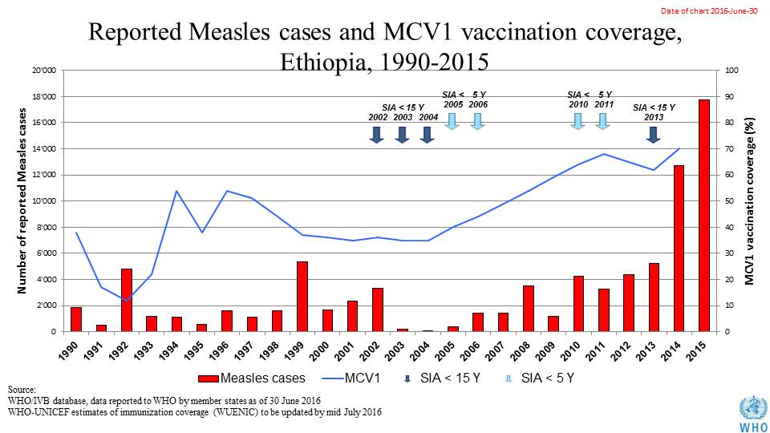

Table 1: SIA activities planned in 2016-2017

|  |  |  |  |  |  |  |  |  |
| --- | --- | --- | --- | --- | --- | --- | --- | --- |
| **Activity** | **Intervention** | **Year** | **Start Date** | **End Date** | **Age Group** | **Extent** | **Status** | **Target** |
| ORI | Measles | 2016 | 22/04/2016 | 28/04/2016 | 6 months to <15 years | Sub-national | done | 25,894,518 |
| SNID | tOPV | 2016 | 19/02/2016 | 21/02/2016 | 0 to 5 years | Sub-National | Planned | 4,043,159 |
| NID | tOPV | 2016 | 01/03/2016 | 01/03/2016 | 0 to 5 years | National | Planned | 12,251,996 |
| Follow Up | Measles | 2016 | 01/10/2016 | 31/10/2016 | 9 months to 14 years | Sub-national | planned | 11,777,083 |
| SNID | bOPV | 2016 | 01/05/2016 | 01/05/2016 | 0 to 5 years | Sub-National | Planned | 3,732,146 |
| SNID | bOPV | 2016 | 01/09/2016 | 01/09/2016 | 0 to 5 years | Sub-National | Planned | 4,043,159 |

Source: WHO/IVB Database as at 12/4/2016

Figure 4: All vaccines national coverage, Ethiopia, 2000-2015

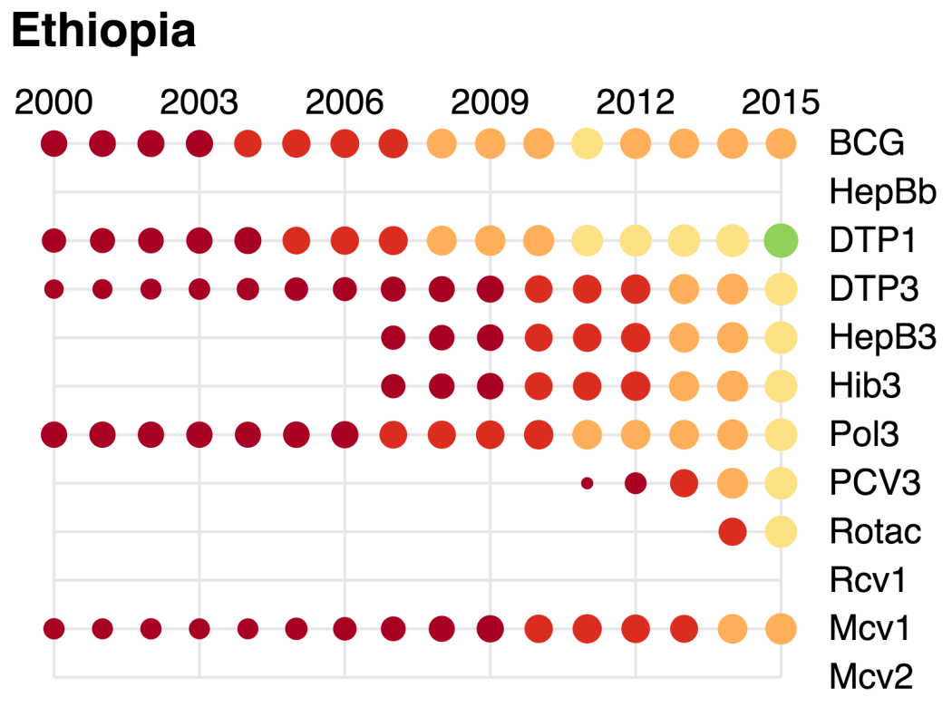

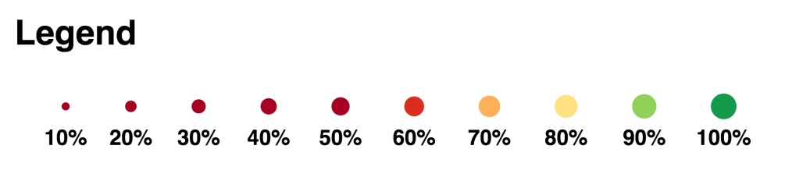

1. cMYP 2016-2020.
2. WHO presentation on Desk analysis of measles surveillance data, July 2016.
3. WHO/ESA IST. Summary report on the investigation of recurrent measles outbreaks in SNNPR, Ethiopia, March-April 2014.
4. Ministry of Health, Federal Democratic Republic of Ethiopia. Ethiopian Immunization Coverage Survey, 2012.
5. WHO/ESA IST. Summary report on the investigation of recurrent measles outbreaks in SNNPR, Ethiopia, March-April 2014.