**Global Vaccine Action Plan**

*Secretariat Annual Report 2016*

*Priority Country report on progress towards*

*GVAP-RVAP goals*

**ETHIOPIA**

1. **Progress towards achievement of GVAP goals**
2. **Summary**

This summary table describes the current situation in Ethiopia regarding achieving the GVAP goals. Data used to assess progress towards achievement of GVAP goals are included in the annex (Country immunization profile).

| **Area** | **Indicator** | **Ethiopia** |
| --- | --- | --- |
| **2. Neonatal tetanus elimination** | **Coverage for TT (official country estimate 2015)** | **92%** |
| **Protection at birth against tetanus (WUENIC 2015)** | **80%** |
| **Last SIAs conducted in the country** | **SIAs in 2015 in 4/103 zones (3rd round of SIAs in high-risk districts that started in 2012.** |
| **Elimination validation date** | **Partial validation in 2011 (remaining Somali Region likely before the end of 2016 and national validation by 2018)** |

* 1. **Goal 2 : Meet global and regional elimination targets**
     1. **Achieve maternal and neonatal tetanus elimination**

Ethiopia has partially achieved this goal – with elimination validated in 2011 in 10 of the country’s nine regions and two city administrations (all but the Somali region). This has been accomplished through TT vaccination campaigns targeting 15-49 year old females in 62 high-risk zones with three vaccine doses, beginning in 1999, when the country had an estimated 13,400 neonatal tetanus deaths.[1] The campaigns – using nurses, HEWS, nursing and medical students – vaccinated 15 million women from 1999 to 2013, achieving an average coverage rate of 81% for two TT doses and 66% for three doses, according to EPI administrative data.[2] The WHO-UNICEF (WUENIC) estimated coverage rate for protection at birth was 80% in 2015. The AFP/polio surveillance network is used for case-based MNT surveillance.

According to informants, the country is on track to achieve MNT elimination nation-wide by the end of 2016, after it completes TT SIAs recommended by the validation committee in five zones in the Somali region that had achieved less than 80% coverage through the SIAs conducted there in 2012.

**ANNEXES**

Figure 4: All vaccines national coverage, Ethiopia, 2000-2015

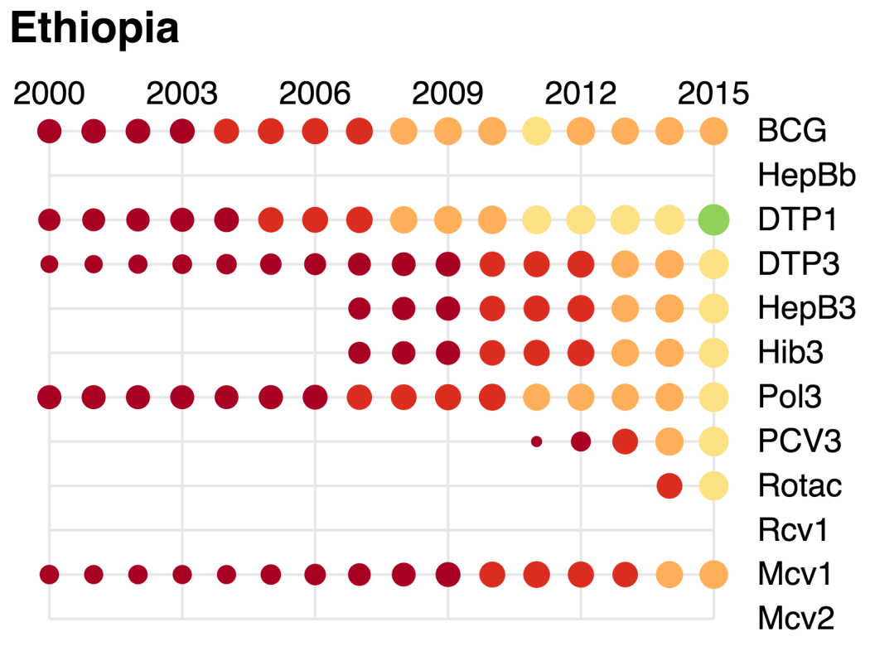

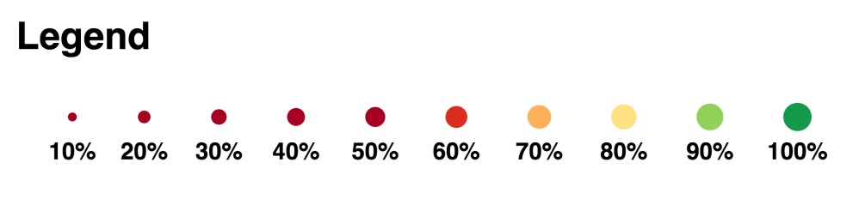

1. cMYP 2016-2020.
2. cMYP 2016-2020.