**Global Vaccine Action Plan**

*Secretariat Annual Report 2016*

*Priority Country report on progress towards*

*GVAP-RVAP goals*

**ETHIOPIA**

1. **Progress towards achievement of GVAP goals**
2. **Summary**

This summary table describes the current situation in Ethiopia regarding achieving the GVAP goals. Data used to assess progress towards achievement of GVAP goals are included in the annex (Country immunization profile).

| **Area** | **Indicator** | **Ethiopia** |
| --- | --- | --- |
| **7. Introduction of new vaccines** | **New vaccines introduced** | **PCV in 2011; rotavirus in 2013; MenA SIAs (2013-15); IPV and HPV demonstration in 2015** |

* 1. **Goal 4: Introduce new and improved vaccines and technologies**

Ethiopia has an impressive record of introducing new vaccines with GAVI support, beginning with pentavalent (DPT-HepB-Hib) vaccine in 2007, followed by PCV-10 in 2011, rotavirus and meningitis A (through campaigns) in 2013, and IPV (as the third polio vaccine dose) in 2015. The introduction of PCV, originally planned for 2010, was delayed until the following year as a result of a global vaccine shortage. Rotavirus vaccine introduction took place in late 2013 in all regions, except Somali, where it was delayed until August 2014 due to the polio outbreak and response in that region.

Post-introduction evaluations (PIEs) conducted for the PCV and rotavirus vaccine introductions indicate generally successful and smooth introductions of both vaccines and good acceptance by the population.[1] In both cases, there was extensive training nation-wide – with most HEWS trained – and personnel from private and NGO-run health facilities were included in the training of training (TOT) courses. Both vaccine introductions had a strong advocacy and communications component, including the participation of influential leaders in launch ceremonies and in raising public awareness of the new vaccine, as well as extensive media coverage. No stockouts of the new vaccines were reported in either PIE, nor in the 2014 and 2015 JFRs. There also were not any indications of the vaccine introduction disrupting the routine immunization program.

Immunization coverage rates for the new vaccines were low in the year following their launches. The PCV3 coverage rate was only 38% in 2012 and the PCV roll-out took three months to reach all regions. However, coverage has risen steadily each year and is now 85% (WUENIC estimate). Rotavirus coverage also rose from 63% in 2014 to 83% in 2015.

While the introduction of each vaccine stimulated expansion of the cold chain system, cold chain capacity was still found to be insufficient, especially after the introduction of rotavirus vaccine, which resulted in crowded cold rooms and over-packed refrigerators at different levels. Other problems reported with both vaccine introductions include poor temperature monitoring, uneven quality and length of the training at lower levels (which ranged from as little as 30 minutes to one day for HEWs in the case of PCV), inadequate coverage monitoring and reporting in many locations, and poor AEFI surveillance. To improve the cold chain and temperature monitoring gaps, the Ministry of Health, in collaboration with GAVI and partners, subsequently procured cold rooms, ice-lined refrigerators, and introduced solar direct drive (SDD) refrigerators, as well as a continuous temperature monitoring system.

Ethiopia conducted nation-wide meningitis A campaigns for 1-29 year olds in three phases from 2013 to 2015, starting with the regions at highest risk and ending in late 2015 with those at lowest risk. A post-campaign survey conducted in the Phase II zones in 2014 found a 93.5% coverage rate.

The national immunization program plans to introduce two more vaccines into the routine program in 2018 -- meningitis A and HPV – and two more in 2019 – measles-rubella and yellow fever. A pilot HPV introduction in two zones is currently underway, with reportedly high demand for the vaccine, due to media coverage about cervical cancer.

**ANNEXES**

Figure 4: All vaccines national coverage, Ethiopia, 2000-2015

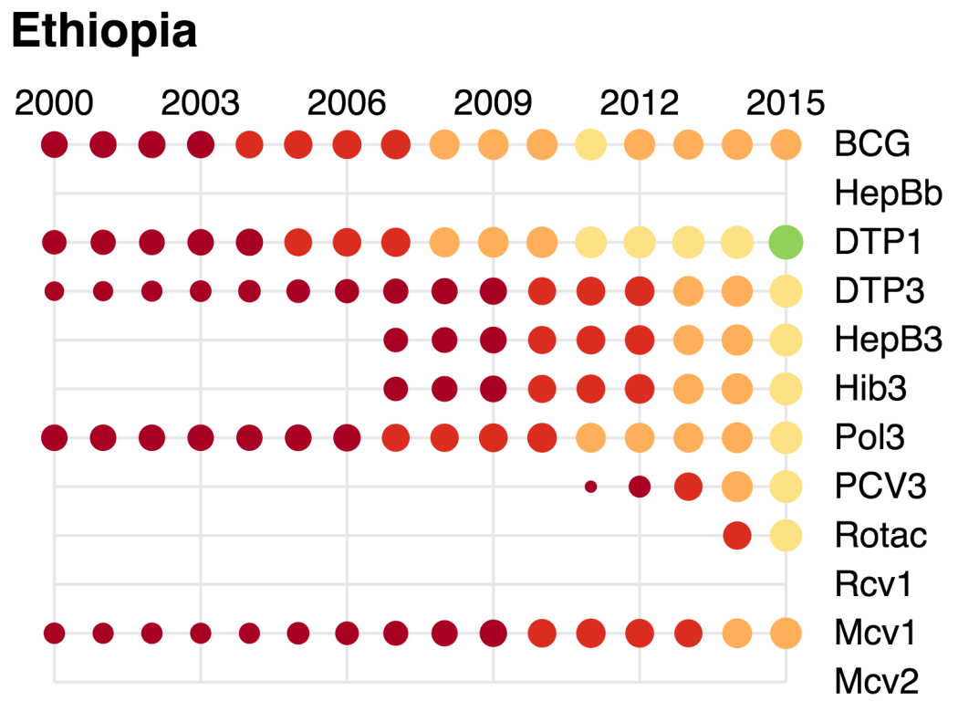

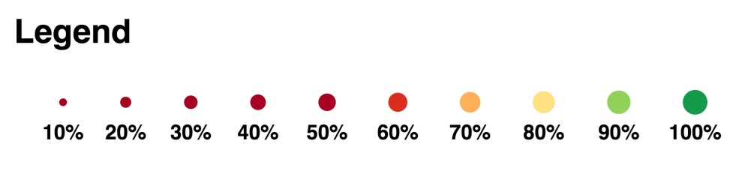

1. Federal Ministry of Health, Ethiopia. Post Introduction Evaluation of the Pneumococcal Conjugate Vaccine 10-Valent Technical Report, June 30, 2013; Federal Ministry of Health, Ethiopia. Post Introduction Evaluation of the Rotavirus Vaccine Technical Report, July 2015.