**Global Vaccine Action Plan**

*Secretariat Annual Report 2016*

*Priority Country report on progress towards*

*GVAP-RVAP goals*

**ETHIOPIA**

1. **Progress towards achievement of GVAP goals**
2. **Summary**

This summary table describes the current situation in Ethiopia regarding achieving the GVAP goals. Data used to assess progress towards achievement of GVAP goals are included in the annex (Country immunization profile).

| **Area** | **Indicator** | **Ethiopia** |
| --- | --- | --- |
| **1. Interrupt wild poliovirus transmission** | **Transmission interrupted** | **Yes** |
| **Risk of late detection: Percent of adequate stool specimens (rolling 12 mo.) (2015) Target > 80%** | **93.1** |
| **Risk of late detection: Non-polio AFP rate per 100,000 (rolling 12 mo.) (2015-2016) Target > 2/100,000** | **2.5** |
| **Risk of spread after importation: % of 6-59 month olds having received less than 3 doses in the last year before occurrence of last case/environmental positive)** | **17** |

1. **Progress towards specific GVAP goals (issues/challenges/successes)**

**3.1 Goal 1: Achieve a world free of poliomyelitis**

Ethiopia has not had an indigenous case of wild polio virus (WPV) reported since 2001. However, due to importations along the Somalian and S. Sudanese borders in 2013/2014 – with a total of 10 confirmed cases – the country has not yet been certified polio-free. The last case was in January 2014 and Ethiopia was removed from the polio outbreak list in March 2015.[1] Sporadic cases of vaccine-derived disease have also been detected (seven cases between 2008 and 2012), but none since 2012.

However, because of its location in the “WPV importation belt” in Africa and its proximity to Somalia, which has large numbers of children not immunized against polio, Ethiopia is still classified by WHO as “vulnerable to international spread” of WPV.[2]

In response to the 2013/14 outbreak, the country has conducted a series of national and sub-national immunization days – with 12 rounds of SNIDs and three NIDs alone in 2013/14. Another NID took place in 2015 and SNIDs in high-risk areas are continuing into 2016. These campaigns – often combined with measles vaccination – receive substantial financial and technical assistance from international partners, and according to independent monitoring data, have achieved high coverage (>90% in most areas).

Along with improvements to the routine immunization program in recent years, the polio SIAs have led to a jump in coverage of three doses of polio vaccine from 70% in 2011 to 85% in 2015 (WUENIC estimates). The country has also set up 28 permanent vaccination points at border crossing with Somalia and major transit points. In addition, IPV was introduced into the routine immunization (for the third polio vaccine dose) in 2015. Ethiopia plans to present its dossier for polio eradication in 2017, in anticipation of being declared polio-free in 2018.

Besides vaccination, the country’s primary means of preventing polio transmission is through strong AFP and polio surveillance. Ethiopia is considered to have a good polio surveillance infrastructure in place, due to a high commitment to and ownership of disease surveillance by the Government, led by the Public Health Emergency Management division of the Ethiopian Public Health Institute. Unlike for the immunization program, there are dedicated disease surveillance focal points in place at all levels (regional, zonal, district). Private health providers, including some traditional healers, participate in disease reporting in most regions.[3] Community-based surveillance – using HEWS and HDA volunteers – has also been implemented in most regions, most intensively in five regions with the support of 12 local NGOs. In one year (from 2014 to 2015), the percent of AFP cases notified by community volunteers in these five regions tripled – from 5% of all notified cases to 15%.[4]

An external review of the surveillance system conducted in 2015 found that more than 80% of AFP cases were validated, surveillance focal points conducted active surveillance of health facilities and submitted weekly reports (compiled into a national weekly bulletin shared with stakeholders), and the quality of case investigations was strong. However, there remain a number of gaps in the country’s AFP/polio surveillance system, which need to be addressed to reduce the risk of transmission from imported cases and to achieve polio-free status by 2018. The quality of active surveillance was found in the external review to be inadequate in all regions, due to high staff turnover and limited transportation and resources for surveillance. Some AFP cases were consequently unreported in three regions. In addition, community-based surveillance is still being developed in many regions, which is further complicated by the seasonal movement of people in some regions.

**ANNEXES**

1. **Polio**

* **Transmission stopped in year 2001 (imported cases in 2013 and 2015).**
* **Eradication certified: not yet (planned for 2018).**

Table 1: SIA activities planned in 2016-2017

|  |  |  |  |  |  |  |  |  |
| --- | --- | --- | --- | --- | --- | --- | --- | --- |
| **Activity** | **Intervention** | **Year** | **Start Date** | **End Date** | **Age Group** | **Extent** | **Status** | **Target** |
| ORI | Measles | 2016 | 22/04/2016 | 28/04/2016 | 6 months to <15 years | Sub-national | done | 25,894,518 |
| SNID | tOPV | 2016 | 19/02/2016 | 21/02/2016 | 0 to 5 years | Sub-National | Planned | 4,043,159 |
| NID | tOPV | 2016 | 01/03/2016 | 01/03/2016 | 0 to 5 years | National | Planned | 12,251,996 |
| Follow Up | Measles | 2016 | 01/10/2016 | 31/10/2016 | 9 months to 14 years | Sub-national | planned | 11,777,083 |
| SNID | bOPV | 2016 | 01/05/2016 | 01/05/2016 | 0 to 5 years | Sub-National | Planned | 3,732,146 |
| SNID | bOPV | 2016 | 01/09/2016 | 01/09/2016 | 0 to 5 years | Sub-National | Planned | 4,043,159 |

Source: WHO/IVB Database as at 12/4/2016

Figure 4: All vaccines national coverage, Ethiopia, 2000-2015

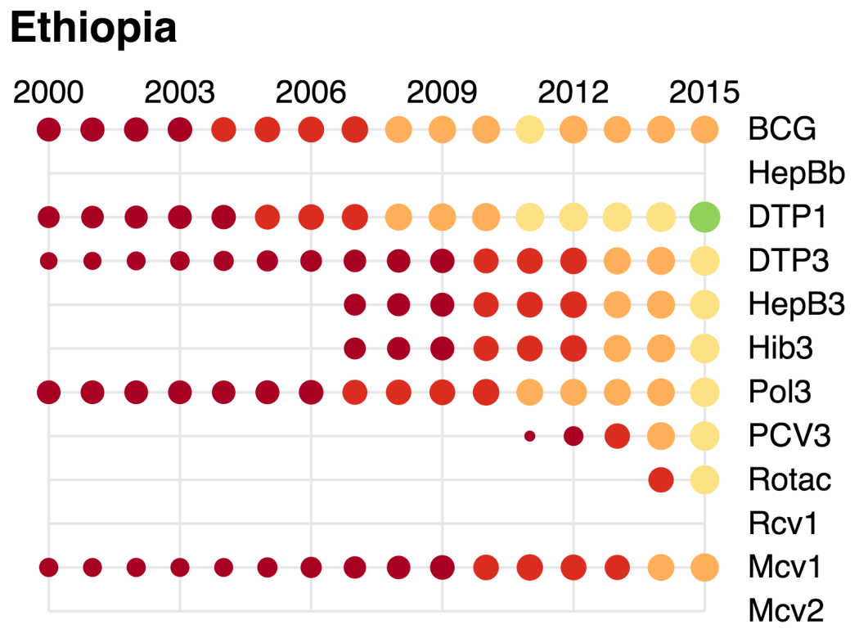

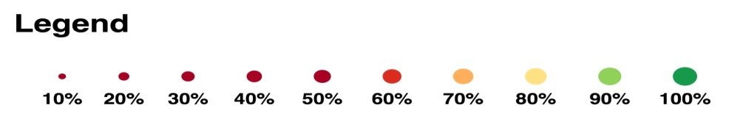

1. Comprehensive multi-year plan (cMYP), 2016-2020.
2. Global polio eradication initiative website (<http://www.polioeradication.org/Keycountries.aspx>).
3. cMYP 2016-2020.
4. WHO presentation on External Surveillance Review, Ethiopia, 29 Sept – 9 October, 2015.