**Global Vaccine Action Plan**

*Secretariat Annual Report 2016*

*Priority Country report on progress towards*

*GVAP-RVAP goals*

**INDONESIA**

1. **Progress towards achievement of GVAP goals**
2. **Summary**

This summary table describes the current situation in Indonesia regarding achieving the GVAP goals. Data used to assess progress towards achievement of GVAP goals can be found in the annex.

| **Area** | **Indicator** | **Indonesia** |
| --- | --- | --- |
| **3. Measles Elimination** | **Coverage MCV1 (WUENIC 2015)** | **69%** |
| **Coverage MCV2** | **76%** |
| **Percentage of districts with MCV1 coverage ≥95% (2015 JRF)** | **39%** |
| **Last national SIA** | **2009-2011. SIAs in 183 high-risk districts planned for August 2016** |
| **Post SIA coverage survey conducted** | **No** |

**3.2.2 Achieve measles elimination and rubella & CRS elimination**

**Measles**

Is the GVAP target achieved?

While measles incidence has declined significantly since the 1990s and early 2000s, Indonesia continues to experience measles transmission, with between 8,400 and around 22,000 cases reported each year on the Joint Report Format from 2010 to 2014[1] and 65 to 251 lab-confirmed outbreaks.[2] Measles incidence seems to have declined in 2015, with only 26 lab-confirmed outbreaks and 818 reported cases – by far the lowest in many years.

To control the disease, the NIP conducted a national measles catch-up vaccination campaign for children 9 months to 15 years in phases between 2005 and 2007. Follow-up campaigns for children under five – combined with polio vaccination – took place from 2009 to 2011 in three phases. Once the country shifted its goal from measles control to measles elimination, it introduced case-based surveillance in a phase manner (starting in 2008), added measles vaccination to the schedule for first graders through the school-based BIAS program, and in 2013 added a second measles dose at 24 months to the routine immunization schedule (the third dose for school children will be phased out).

To meet the 2020 target date for measles elimination, the NIP will be conducting “crash” vaccination campaigns in August 2016 in 183 high-risk districts identified through the surveillance system for four million children 9-59 months old. This will be followed by GAVI-supported national measles-rubella (MR) campaigns for children nine months to 15 years in 2017 and 2018 targeting over 70 million children.

Key issues affecting progress towards measles elimination

There are two main challenges to achieving measles elimination by 2020 in Indonesia:

* **Insufficient case-based measles surveillance**. The joint EPI/surveillance review conducted in 2013 found that the implementation of case-based measles surveillance has been uneven. The review found evidence of unreported measles outbreaks, as well as suspected outbreaks that were not investigated (accounting for 12% of all suspected outbreaks in 2013).[3] Only around 16-26% of suspected cases each year between 2010 and 2013 were lab-tested,[4] due in part to insufficient funding to test all individual cases (the NIHRD lab continues to rely on WHO funds for testing specimens).
* **Lackluster measles coverage rates and pockets of low coverage**. According to the WUENIC estimates, coverage rates for a single measles vaccine dose have not improved significantly in the past ten years and have declined somewhat in the past four years (from 82% in 2012 to 72% in 2015)[5] (see Figure 2). (Coverage with the dose given to six year olds in school (referred to as MCV2 in the figure) appears to be greater than that of the infant dose.) Measles coverage rates also vary widely by province; the 2013 Riskesdas survey found that provincial coverage rates among 12-23 month olds ranged from 57% to 94%. This points to a need to improve the delivery of vaccination to infants through the routine immunization program. Issues concerning the routine program are discussed in the next section.

Figure 2: Measles vaccination coverage rates and measles cases, 1980 to 2015, WUENIC estimates[6]

* 

**ANNEXES**

1. **Measles and rubella**

Figure 4: Reported Measles cases and MCV coverage WHO-UNICEF estimates, Indonesia, 1990-2015

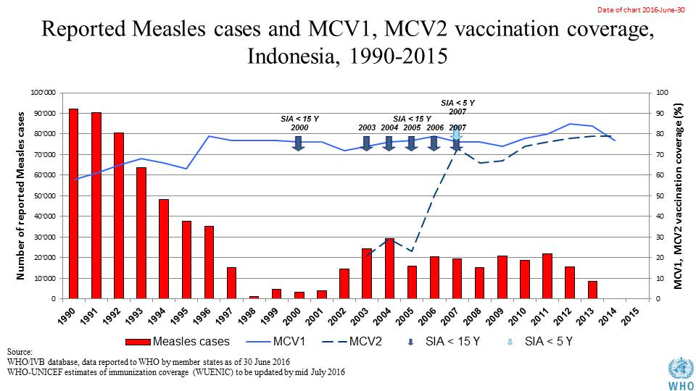

Table 1: SIA activities planned in 2016-2017

|  |  |  |  |  |  |  |  |  |
| --- | --- | --- | --- | --- | --- | --- | --- | --- |
| **Activity** | **Intervention** | **Year** | **Start Date** | **End Date** | **Age Group** | **Extent** | **Status** | **Target** |
| **Follow Up** | **Measles** | **2016** | **01/10/2016** |  | **9-59 M** | **Sub-national** | **planned** | **3,900,554** |
| **Campaign** | **MR** | **2017** | **01/08/2017** |  | **9 M-15 Y** | **National** | **planned** | **70,000,000** |
| **NID** | **tOPV** | **2016** | **01/03/2016** |  | **0 to 5 years** | **National** | **Planned** | **23,093,592** |

Source: WHO/IVB Database as at 01 July 2016

1. **Coverage and Equity**

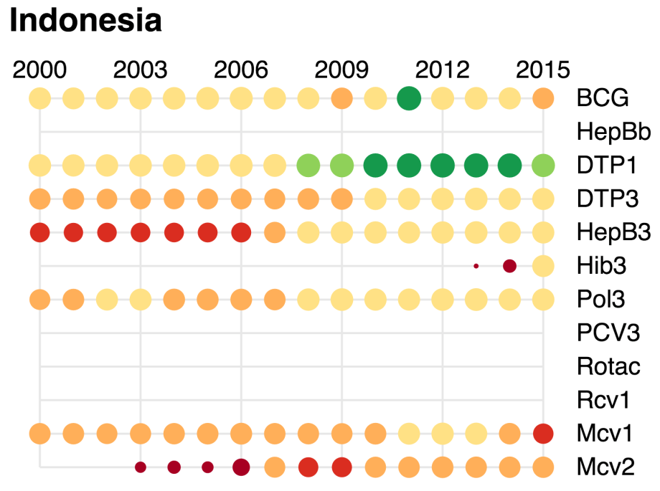

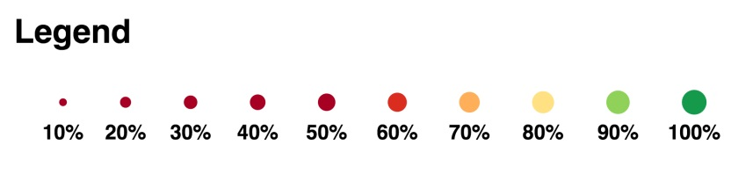

1. SEARO. EPI Fact Sheet, Indonesia, 2016.
2. Presentation by the Sub-Directorate, Surveillance & Outbreak Response, Indonesia on Vaccine preventable disease surveillance and immunization analysis, May 2016.
3. World Health Organization. Joint national and international EPI and VPD surveillance review, Indonesia, 2014.
4. cMYP.
5. SEARO. EPI Factsheet for Indonesia, 2016.
6. SEARO. EPI Factsheet, Indonesia, 2016.