**Global Vaccine Action Plan**

*Secretariat Annual Report 2016*

*Priority Country report on progress towards*

*GVAP-RVAP goals*

**INDONESIA**

1. **Progress towards achievement of GVAP goals**
2. **Summary**

This summary table describes the current situation in Indonesia regarding achieving the GVAP goals. Data used to assess progress towards achievement of GVAP goals can be found in the annex.

| **Area** | **Indicator** | **Indonesia** |
| --- | --- | --- |
| **4. Rubella/CRS Elimination** | **Rubella vaccination coverage** | **Not introduced (2015)** |
| **SIAs planned?** | **MR SIAs planned for 2017-2018** |

**Rubella**

There appears to be a significant burden of rubella in Indonesia. Of 145 suspected measles outbreaks that were investigated in 2012, more of them (56%) turned out to be rubella or mixed measles/rubella outbreaks than measles.[1] The country’s disease surveillance system reported between seven and 76 rubella outbreaks each year between 2010 and 2015, including 152 outbreaks and more than 3,200 reported cases in 2014.[2] The estimated incidence of rubella in 2015 was nearly identical to that for measles: 3.26 cases per million population for rubella and 3.23 cases for measles. CRS surveillance has been established with WHO support in 13 major hospitals in 10 provinces.

As mentioned above, Indonesia will introduce rubella vaccination (MR vaccine) in catch-up campaigns in 2017 and 2018 and in the routine immunization schedule in two doses (at nine and 24 months), starting in 2018.

**ANNEXES**

1. **Coverage and Equity**

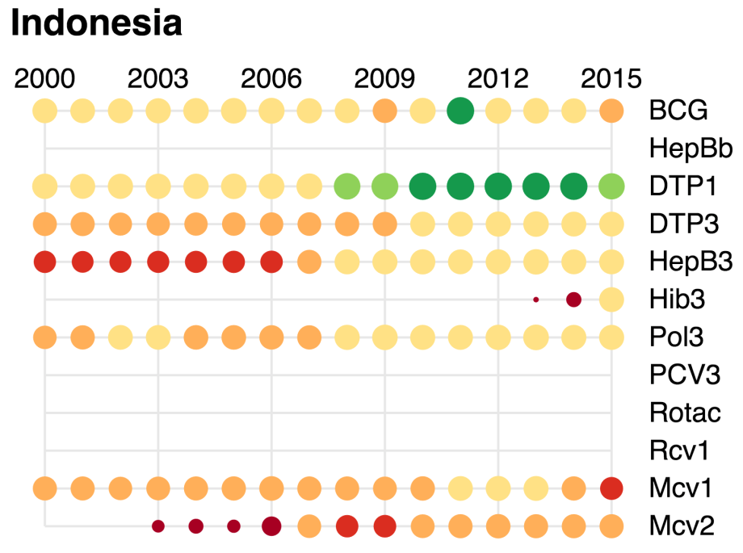

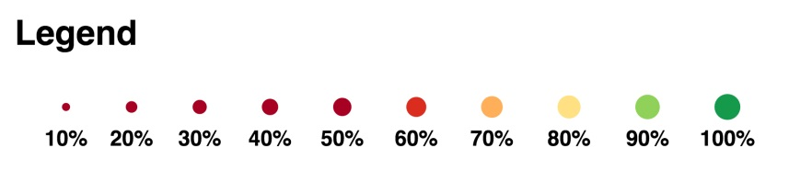

1. World Health Organization. Joint national and international EPI and VPD surveillance review, Indonesia, 2014.
2. SEARO. EPI Factsheet for Indonesia, 2016.