**Global Vaccine Action Plan**

*Secretariat Annual Report 2016*

*Priority Country report on progress towards*

*GVAP-RVAP goals*

**NIGERIA**

1. **Progress towards achievement of GVAP goals**
2. **Summary**

The summary table below describes the current situation in Nigeria regarding achieving the GVAP goals. Data used to assess progress towards achievement of GVAP goals are included in the annex.

| **Area** | **Indicator** | **Nigeria** |
| --- | --- | --- |
| **Socio-demographic** | **GNI 2014** | **$2,950** |
| **WB Status** | **Lower Middle Income** |
| **Infant mortality (<12 M) 2015 (UN IAG CME)** | **69** |
| **GAVI status** | **Eligible (will be in accelerated transition phase starting in 2017 and will graduate in 2021)** |
| **Total population** | **182,202,000** |
| **Birth cohort** | **7,133,000** |
| **Surviving Infants (JRF)** | **6,622,000** |
| **1. Interrupt wild poliovirus transmission** | **Transmission Interrupted** | **No, 2 new WPV cases detected in 2016** |
| **Risk of late detection: Percent of adequate stool specimens (Rolling 12m) (target > 80%)** | **99.1** |
| **Risk of late detection: Non polio AFP rate (Rolling 12m )  (target > 2/100,000)** | **18/100,000** |
| **Risk of spread after importation:  % of 6-59 month olds having received less than 3 doses in the last year before occurrence case/environmental positive)** | **2%** |
| **2. Neonatal tetanus elimination** | **TT2+ coverage (reported on JRF 2015)** | **40%** |
| **Rate of protection at birth against tetanus (2015 WUENIC)** | **55%** |
| **Last SIAs conducted in the country** | **Round 1 conducted in 61 high-risk districts in October 2014.  Rounds 2 and 3 scheduled for Sept 2016 and 2017 in same districts.** |
|  | **Elimination validation date** | **Not yet validated: pre-validation assessment planned in 1-2 geopolitical zones before the end of 2016** |
| **3. Measles elimination** | **Coverage MCV1 (2015 WUENIC)** | **54%** |
| **Coverage MCV2** | **Not in schedule** |
| **Reported percentage of districts with MCV1 coverage ≥95% (2015 JRF)** | **53%** |
| **Last national SIA** | **2015** |
| **Post SIA coverage survey conducted** | **Yes** |
| **4. Rubella/CRS elimination** | **Rubella vaccine coverage** | **Not introduced (2015)** |
| **SIAs planned?** | **Not to date** |
| **5. Reach 90% national coverage and 80% in every district with 3 doses of DTP-containing vaccine** | **National coverage (2015 WUENIC)** | **56%** |
| **Drop-out rate DTP1 to DTP3 (2015 WUENIC)** | **20%** |
| **Actual numbers of children that dropped out (2015 WUENIC)** | **927,146** |
| **Difference between poorest and richest quintile DTP3 coverage (2013 DHS)** | **64.7 percentage point** |
| **Reported percent of districts with ≥80% coverage (from 2015 JRF)** | **80%** |
| **6. Reach 90% national coverage and 80% coverage in every district with all vaccines in national immunization program** | **National coverage (2015 WUENIC)** | **BCG: 68% DTP1-HepB1-Hib1: 70% DTP3-HepB3-Hib3: 56% MCV1: 54% Polio3: 556 YF: 54** |
| **7. Introduction of new vaccines** | **New vaccines introduced** | **Pentavalent: 2012-2014; PCV: 2014-2016; IPV in 2015. Meningitis A in routine program planned for 2017 and rotavirus for 2018.** |
| **8. Reduction in under 5 mortality rate** | **Percent reduction between 2010 and 2015** | **16.5% (from 130.3 to 108.8)** |
| **9. NITAG** | **NITAG established?** | **Yes, inaugurated in August 2015** |
| **10. Government expenditure on routine immunization per live birth (US$)** | **Baseline 2010-2011 and average for 2013-2015 (% change)** | **4.1 to 12.9 (+216%)** |

1. **Country ownership of the immunization program**
   1. **Immunization policy decision-making capacity**

The main decision-making and coordinating body for the immunization program in Nigeria is the ICC, which is chaired by the Minister of Health and includes senior-level officials from the Federal Ministry of Health (FMOH) and around 18 development partners and bilateral organizations. The ICC, which meets every two months, endorses the GAVI work plan, makes decisions about new vaccine introductions and other key program decisions. The technical arm of the ICC is called the Core Group, which is chaired by the Executive Director of the parastatal organization that manages the immunization program – the National Primary Health Care Development Agency (NPHCDA) – and includes EPI team leaders from different immunization stakeholders and partners in the country. The Core Group, which meets once a month, provides direction to and oversight of various technical working groups, and makes recommendations based on their input and analysis, which must then be approved by the ICC.

Among the technical working groups – which include logistics, social mobilization, M&E and finance – is the Routine Immunization Working Group, which is chaired by the director of routine immunization at the NPHCDA and whose members are immunization program officers and experts from different stakeholder and partner organizations. The states – which are responsible, along with local government authorities (LGAs), for the delivery of health services in the country and implementation of health programs – also each have their own working groups (e.g., routine immunization and logistics).

The functioning of the ICC and regularity of meetings have improved considerably in the past few years and the committee is reportedly held in high esteem by the Government.

A NITAG has recently been established, with support from WHO, CHAI and SIVAC, and its inaugural meeting held in August 2015. Unlike the ICC and Core Group, its 10-12 members are independent of the immunization program and include pediatricians, microbiologists and other experts from academia, research institutes and the private sector. A number of partner organizations, including WHO, UNICEF and CHAI, participate as observers. Unlike the ICC, the NITAG will have solely an advisory – not a decision-making role. Its impact on decision-making for the immunization program, as well as its role vis-à-vis that of the ICC’s Routine Immunization Working Group, has yet to be determined. It should also be noted that decisions have already been made about most vaccine introductions currently supported by GAVI (e.g., rotavirus, meningitis A, HPV).

The Nigeria Government’s decision-making capacity and implementation of the immunization program is complicated by the fact that the program – along with several other components of the primary health care program – is managed not by the Federal Ministry of Health, but by the NPHCDA, which is a separate, parastatal organization. However, a number of key activities related to immunization, such as disease surveillance and supportive supervision, fall under the responsibility of the FMOH. In some cases, the NPHCDA and FMOH have parallel systems, causing confusion and duplication of effort. There are, for example, separate supervision checklists for each agency and two health information systems – the HMIS run by the FMOH and the immunization program’s vaccination monitoring system run by the NPHCDA. Each system uses a different platform (the DHIS2 in the case of the HMIS and the DVT-MT in the case of the EPI’s system) and different population data for their denominators. Key primary health care programs, including malaria control, nutrition and family planning, are still under the FMOH, complicating the delivery of integrated health services and such activities as intensified vaccination activities that provide other MCH interventions. As another example, disease surveillance officers are under the FMOH at the state level, while those at the LGA level report to the local PHCDA.

* 1. **Government financing for immunization**

According to the 2015 GAVI Joint Appraisal report, the federal government contributed 36% of the estimated immunization expenditures in 2014, while its contribution in 2011 was 34%. There was thus a marginal increase in the Government’s share of immunization expenditures in four years. The federal Government’s expenditures cover the cost of traditional vaccines ($12.6 million in 2013), co-financing for the GAVI-supported new vaccines (pentavalent and PVC) (≈$25 million in 2015), personnel costs for the EPI staff as well as per diems for vaccinators and supervisory staff, and other recurrent costs.[1] The Government also pays for a share of the operational costs of polio and other SIAs. In addition to the federal government’s contribution, subnational (state and LGA) governments contribute personnel and other operational costs for the routine program – to the tune of $14.6 million (7%) of the estimated total routine immunization program costs in 2013.[2]

The Government has been making its co-financing payments for GAVI-supported vaccines without delays or defaults, as well as purchasing traditional vaccines for the routine program, though there have been some reports delays in vaccine purchases, causing stock-outs. This has not occurred, however, since 2013.

Financing for the routine immunization program is considered inadequate and the often slow release of government funds results in delays in planned immunization activities. Other recent developments that have had an impact on immunization funding are:

* The sharp reduction in oil revenues, which account for 70% of the country’s consolidated revenues, as a result of the decline in global oil prices. This has affected the ability of some states – which are responsible for the delivery of immunization services – to pay health worker salaries, operational costs for outreach activities and other costs affecting the immunization program. Several states have declared bankruptcy in recent years as a result;
* The freezing of all GAVI cash support, including HSS grant funding since March 2014, due to financial management issues. This has delayed several planned activities, including the training of health workers on integrated PHC service delivery, TT campaigns as part of the maternal and neonatal elimination program, and an immunization coverage survey. Some priority activities funded through the HSS grant are being implemented with funds channeled through UNICEF.

There have been two recent developments that should increase financing for immunization. The first is the Government’s plan to extend health services to the entire population, including to under-served areas, by providing “primary health care under one roof” (PHCUOR). The vision is to establish functional PHC centers open 24 hours a day in each of the country’s more than 9,500 political wards, manned by at least two certified nurses or midwives. To fund this plan, the Government passed a National Health Act in 2014 that creates a Basic Health Care Provision Fund – half of which will be used to cover the costs of the PHC centers, including vaccines, equipment and operational costs. The National Health Act is currently in the planning stage and is being affected by the decline in oil revenues, which are a major source of funding for its implementation.

The second effort to increase immunization financing is the development of agreements between state governments and two foundations to secure more stable funding for routine immunization, using a basket funding mechanism with contributions from the state governments and the foundations (the latter to be phased out over time). This initiative – currently operating in two states and being planned in four more – is described in more detail in Section B.

**2.3 Human resource situation**

Immunization program staff in Nigeria consist of a national EPI team at the NPHCDA, EPI teams in each of the country’s 37 states, and LGA immunization officers (LIOs) in each of the 774 LGAs. There are also surveillance officers at each level. There have been MLM and other trainings for these staff in recent years, although turnover and transfers are common.

To supplement this staff, partners have been supporting a contingent of more than 11,000 persons funded through the polio eradication program, including 408 WHO staff, 2,070 “surge staff” and more than 8,600 social mobilizers who work for UNICEF.[3] The EPI has come to rely on these staff for not just polio activities (AFP surveillance and polio SIAs), but also for measles control, disease surveillance, and improvements to the routine immunization program. As part of the polio transition, polio program funds (apart from funds for SIAs) will be cut by more than half between 2016 and 2019 – likely resulting in a substantial reduction in this supplemental workforce.

At the operational level, most vaccinations given in the public sector are administered by nurses or midwives or – especially in the under-served North – by community health extension workers (CHEWs). These are facility-based, salaried health workers with secondary school education and a year or so of training, who focus on providing preventive health services, including in the community. In addition, an estimated 15% of vaccinations are provided by nurses and midwives working in private health facilities.[4]

As in many countries, the number of health workers in the public sector is inadequate in many parts of the country, due to insufficient funding at the state level (health worker salaries are paid out of state budgets) and a high rate of staff transfers. In addition, most health workers prefer to work in urban vs. rural areas, resulting in an imbalanced distribution in which more than 70% work in urban areas, and with greater concentrations in the South than in the North. This leaves many rural areas, especially in Northern states, with vastly insufficient numbers of health workers to serve the population. The skills level of many health staff is also considered to be low.

Making matters worse are frequent and prolonged health worker strikes – often lasting 4-6 months – in a number of states, especially those that have not paid their health workers for months, due to either state bankruptcies or the freezing of salaries of civil servants, as part of a “verification” process mandated by the new President to determine who actually works for the state and to weed out “ghost workers”.

To increase the health workforce, in alignment with the Government’s plan to make PHC services accessible to all, the federal government began two initiatives in the past five years. The Midwives Service Scheme (MSS) involves recruiting 8,000 qualified midwives as well as CHEWs to work in PHC facilities in under-served areas, while the SURE-P-MCH program also recruits and deploys midwives and CHEWs, as well as 5,000 village health workers, using results-based incentives. However, these initiatives are funded by the MDG debt relief funding or savings from reductions in the petroleum subsidy and both have been affected by the country’s worsening economy. The state of Kano, for instance, has had to lay off 600 midwives hired through the MSS due to the decline in the state’s revenues. Recruitment of SURE-P-MCH health workers has also reportedly been put on hold in many areas.

1. **Progress towards specific GVAP goals (issues/challenges/successes)**

**3.1 Goal 1: Achieve a world free of poliomyelitis**

Has Nigeria interrupted polio transmission?

Official data from the country’s extensive AFP/polio surveillance system showed that transmission of wild polio virus (WPV) had been interrupted by the first quarter of 2015 – with the last case reported in July 2014.[5] WP incidence had been decreasing each year since 2012 (when 122 cases were confirmed) to only six cases in 2014, and the map of the disease had narrowed to two remote states with security problems (Kano and Yobe) (Figure 1). The incidence of vaccine-derived polio virus (VDPV) – reported since 2005 – has also declined from a peak of 155 cases in 2009 to only one case in 2015.

There has been a recent setback, however, with the detection of two cases of WPV type 1 in July 2016 in Borno state in the extreme Northeast corner of the country, a remote area where Boko Haram is centered. The strain was found to be closely linked to the last WPV1 cases reported from Borno state in 2011, indicating that the virus has been circulating undetected in the state for five years. This is clearly a setback to the country’s plans to achieve certification of cessation of all types of WPV by 2018, as stated in the immunization program’s multi-year plan (cMYP).

The Nigeria Government – with partner support and under the direction of the National Polio Emergency Operations Centre (EOC) – has been conducting a series of polio vaccination campaigns for several years to halt transmission of the disease. The country has held two or three rounds of national immunization days (NIDs) and six or seven round of sub-national immunization days (SNIDs) per year, including in reaction to cases. In response to the two recent WPV cases, three large-scale SIAs using the bivalent OPV are currently being planned in Borno state.

Figure 1: Trends in incidence of confirmed wild polio virus and vaccine-derived disease in Nigeria

Source: WHO, Highlights of new wild poliovirus and cVDPV cases reported globally, week of August 9, 2016 (presentation)

The quality of the SIAs has improved in recent years, with the Government funding innovative ways and making special efforts to reach under-served and hard-to-reach areas. These include:

* Vaccination campaigns in registered IDP camps in four states (Adamawa, Borno, Gombe and Taraba) that, despite the insurgency, was able to vaccinate nearly 58,000 children 0-59 months old in one month in 2014;
* Health camps in 2013 and 2014 in areas with low utilization of routine immunization and health services. In three state where health camps were used to introduce IPV (Borno, Yobe and Kano), three million children were vaccinated in 2013.

Official data show high coverage of these campaigns (e.g., 95% of more), but given issues with data quality (often showing coverage of >100%), the numbers of children being missed by polio SIAs is uncertain.

Key problems contributing to the continual risk of polio transmission in Nigeria

* **Gaps in AFP/polio surveillance**. Nigeria’s AFP surveillance system – implemented by Disease Surveillance and Notification Officers in all 774 LGAs, State Epidemiologists and the polio “surge” staff – has met the global performance targets for more than 10 years, with a current AFP detection rate of 18 per 100,000 children under 15 years of age (up from 13/100,000 in 2014) and a 99% rate of adequate stool specimens. The system is supported by two national laboratories, a reference lab and specialized lab in the U.S. Nonetheless, both the two recent cases found in Borno state and orphan viruses detected in 2014 through genetic sequencing suggest that the virus has been circulating undetected in certain areas – for five years in the case of WPV1 in Borno state – and thus there remain gaps in the surveillance system. The challenge in conducting consistent, high-quality surveillance in inaccessible and insecure areas like Borno state is likely a key reason for this gap.
* **Continued low performance of the routine immunization program**. The WHO-UNICEF estimated routine vaccination coverage rate for three doses of polio vaccine was only 55% nationally in 2015 and 49% in 2014.[6] Coverage in remote and unsafe areas is likely considerably lower than these rates. This points to a failure of the routine program to reach children with all required vaccine doses. While issues affecting routine immunization coverage are covered in detail in Section 3.3 below, two main factors for the poor OPV coverage we can mention here are the insufficient availability of health services and low population utilization rates, especially in remote areas; and the shortage of health workers in many areas. The insecurity caused by Boko Haram in the North and militants in the South contribute to both of these problems.
  1. **Goal 2 : Meet global and regional elimination targets**
     1. **Achieve maternal and neonatal tetanus (MNT) elimination**

Nigeria has the goal of eliminating MNT by 2020 and an intermediate goal of more than 70% of LGAs having less than one case per 1,000 live births by 2018.[7] As of 2014, 17 states (46%) still reported more than one MNT per 100,000, though this represents considerable progress since 2010, when 27 states were over this threshold.[8] In addition, case-based MNT surveillance has improved since 2008, when it was added to the AFP/measles surveillance platform. However, according to the cMYP, there is still a high level of under-reporting of the disease.

Nigeria faces two main challenges to meeting its MNT elimination goal:

1. Relatively low rates of utilization of maternal health services. According to the 2013 Nigeria Demographic and Health Survey (DHS), just more than half (51%) of women made four or more antenatal care (ANC) visits during their last pregnancy, 48% received two or more TT injections, and 36% delivered their babies in a health facility.[9] Many areas have much lower rates of maternal health utilization. Nearly half (47%) of women in rural areas reported no ANC visits during their last pregnancy compared to 11% in urban areas, and eight states – all in the Northeast and Northwest regions – had protection at birth (PAB) rates of less than 40%, with some states (Kebbi, Sokoto, Zamfara) as low as 14-17%. The national PAB rate – which WHO and UNICEF estimated at 55% in 2015 – has changed little since 2000, when it was 57%. While the cMYP has the goal of reaching more than 80% national coverage with two or more doses of TT vaccine, the lack of improvement in routine TT coverage remains a key impediment to Nigeria achieving MNT elimination;
2. Delays in conducting TT campaigns in high-risk areas. SIAs for women aged 15 to 49 years and pregnant women began on a pilot bases in 2009 in five states, with the aim of providing three TT doses (through three rounds). However, only three states were able to complete all three rounds, resulting in an overall coverage rate in the pilot states of 49% for TT3.[10] Subsequently, targeting by states was abandoned and 61 LGAs were identified as high-risk areas. Plans were made to conduct three rounds of SIAs from 2014 to 2016 in these areas. The first round took place as planned in 2014, but the second round, originally scheduled for 2015, was delayed until early 2016, due to a lack of funding as a result of the suspension of GAVI operational cash support and to competition with planning for national measles campaigns. The third round is now scheduled for 2017.
   * 1. **Achieve measles elimination and rubella & CRS elimination**

Measles

Nigeria has the goal of reducing measles morbidity by 90% mortality by 95% from 2014 to 2020.[11] The number of cases reported through the disease surveillance system in 2015 was more than 12,200, which is significantly down from nearly 53,000 cases in 2013 and more than 212,000 cases in the year 2000.[12] The number of reported measles outbreaks has similarly declined from 338 in 2010 to 133 in 2014.[13]

To reduce measles incidence, the country developed a strategy of nation-wide measles vaccination campaigns, coupled with case-based surveillance, beginning with catch-up campaigns for children 9 months to 15 years that were conducted in two phases in 2005 and 2006. National follow-up campaigns for children under five have taken place with WHO and UNICEF support every two or three years since then (in 2008, 2011, 2013/14 and most recently in 2015/16). A coverage survey found that the 2013/14 campaign achieved an overall coverage rate of 74.5%.[14] The Government plans to continue the SIAs every two or three years, as needed, based on surveillance reports; SIAs are currently planned for 2017 and 2020.

Key challenges that need to be addressed to meet Nigeria’s measles reduction targets are:

* **The need to improve measles vaccination coverage rates**. Routine measles coverage rates remain low and have risen very gradually in the past several years. The national rate was 49% in 2011, dipped to 42% in 2012 and then rose to 47% in 2013 and to 55% by 2015.[15] Large parts of the country – the Northeast and Northwest regions – have extremely low coverage rates. According to the 2015 National Nutrition and Health Survey (NNHS), which found a national measles vaccination coverage rate of 51% among 12-23 month olds – four states had rates of 4% to 7%, while seven other states had rates of 15-30%[16] (see Figure 2). These findings indicate that measles immunization through the routine program in these areas is almost non-existent, though the lack of retention of immunization cards could also have been a factor for the low rates. In all, only four states reached the country’s target measles vaccination coverage rate of 80% (the federal capital territory and three Southern states), 19 states achieved coverage between 50 and 80% and 14 states had rates of less than 50%. According to the cMYP, the EPI plans to add a second measles dose to the routine immunization schedule within the next several years.
* **The need to further improve measles surveillance**. Measles surveillance includes both passive surveillance (as part of the IDSR system) and case-based surveillance, using the same infrastructure as for AFP surveillance and support from four national labs. The system appears to be fairly sensitive, reporting a non-measles febrile rash illness rate of 2.7/100,000 children in 2014, surpassing the target of <2/100,000. However, case-based surveillance still needs improvement, as 16% of LGAs did not report at least one suspected case in 2014 and only 75% of cases that year were investigated (with a blood sample obtained).[17]

Figure 2: Estimated coverage rates for three doses of pentavalent vaccine and measles vaccine among children 12-23 months of age, 2015 National Nutrition and Health Survey



Rubella

There are as yet to firm plans to introduce rubella vaccination (MR vaccine) into the routine immunization schedule, nor any plans to conduct mass MR campaigns. Rubella surveillance has also not yet been established in Nigeria.

**3.3. Goal 3: Meet vaccination coverage targets**

1. **Achieve 90% national coverage and 80% coverage in every district with three doses of diphtheria-tetanus-pertussis containing vaccines**
2. **Achieve 90% national coverage and 80% coverage in every district with all vaccines included in the national schedule**

The WHO-UNICEF estimated coverage rate for the third dose of DPT-containing vaccine (pentavalent) in 2015, which was recently revised downward following the 2015 NNHS, was 56% among children 12-23 months of age, with a dropout rate between the first and third doses of 20% (from 70% to 56%). According to the 2015 NHHS, five of the country’s 37 states (14%) reached the target of at least 80% coverage for DPT3, 15 states (40%) achieved coverage rates of between 50% and 75%, and 16 states (43%) had coverage of less than 50%. As with measles vaccination, the range of DPT3 coverage by state is enormous – from 4.4% in Sokoto state to 91% in the Southeastern state of Imo (see Figure 2 above). There are also vast inequities in rates by rural vs. urban location and by household wealth. According to the 2013 DHS, DPT3 coverage in rural areas was only 40% of that of urban areas (25% vs. 62%) and thee was an eleven-fold increase in rates from the lowest wealth quintile (7%) to the highest (79.5%).[18] The NNHS also found that 21% of 12-23 month olds had not received a single vaccination. A more in-depth equity assessment will be conducted as a condition of Nigeria applying for GAVI support for rotavirus vaccine introduction (currently planned for 2018), along with preparation of a plan to address this problem.

Nigeria has also not been able to meet these targets for other vaccines in the immunization schedule – with national coverage for measles, three doses of polio and yellow fever vaccines all at 54-55%, and BCG at the highest at 68%, according to the revised WHO-UNICEF estimates. Unimmunized children in Nigeria account for one in three of all unimmunized children in Sub-Saharan Africa and for one in six of all of those in GAVI-supported countries.[19]

The country has made progress, however, with immunization coverage rates over the past five years, especially in the past two years. According to the WUENIC estimates, BCG coverage climbed 11 percentage points from 2011 to 2015 (from 57% to 68%), DPT 3 coverage rose eight percentage points (from 48% in 2011 to 56% in 2015), yellow fever vaccine coverage increased by 16 points – from 38% to 54% (a 42% increase), and measles by five points (from 49% to 54%). Among the reasons given by informants for these gains are increased population awareness of and thus demand for vaccination as a result of the recent introduction of pentavalent vaccine and on-going introduction of PCV and accompanying communications and social mobilization activities, greater involvement of traditional and political leaders in informing the public about vaccination, and the improved regularity of the vaccine supply, especially at the national level (as there has not been a national vaccine stockout since 2013).

The most prominent factors contributing to the country’s low immunization coverage rates are the following:

* **The shortage of health personnel in the public sector**. As mentioned in Section 2.3 above, there are insufficient numbers of frontline health workers in many areas in Nigeria, due to high attrition and transfer rates and the difficulty of recruiting workers for remote, rural areas. The frequent health worker strikes in recent years in several states have exacerbated the problem, making immunization and other health services unavailable for months at a time in these areas and increasing the pool of unimmunized children. With the continued poor economy in the country, more states are facing severe financing problems, resulting in non-payment of health workers’ salaries – a major reason for the strikes.
* **Lack of security in several parts of the country**. The Boko Haram insurgency that has been going on for several years – causing tens of thousands of people to flee to IDP camps and more secure areas – has made it difficult to provide immunization and other health services in parts of the North. There have also been multiple attempts – some successful – to attack health workers engaged in immunization. It is not surprising that the recently found cases of wild polio virus were in Borno State, where Boko Haram has its headquarters and where immunization coverage rates are low (28% for measles and 32% for DPT3, according to the 2015 NNHS). At the same time, the Niger Delta has experienced a series of bombings and kidnappings to “Delta avengers”, militants who are rebelling against the Government’s decision to end “amnesty fee” payments to communities damaged by oil drilling and production. These security problems limit the free movement of the population to seek services and of health workers to provide outreach and mobile services, as well as the Government’s ability to recruit health workers to these areas.
* **Uneven availability of immunization services**. There are around 25,000 PHC facilities in the country, including more than 1,150 health centers and 228 maternities recently built as part of the Government’s plan to increase the accessibility of PHC services to all communities throughout the country. According to the cMYP, most states and LGAs follow the “1-2-3 strategy”, which entails at least one immunization session at the facility per week, two outreaches per month, and three supportive supervision visits per month. However, many health facilities have trouble adhering to this strategy, due to a lack of personnel, a lack of transportation for outreaches or to collect vaccines from the LGA stores (in health centers without functioning cold chain equipment), and a general lack of funds for operational expenses. Those with functioning refrigerators are more likely to conduct immunization sessions on a weekly or more frequent basis.
* **Insufficient communications and social mobilization activities for routine immunization services and inadequate community participation**. Nigeria has a structure for promoting immunization and other health services through social mobilization committees in each LGA, guided by the National Social Mobilization Working Group of the ICC. There is also a network of around 10,000 volunteer community mobilizers, supported with polio funding, who help with social mobilization for SIAs, track pregnancies, refer parents for routine immunization and so forth through home visits. These efforts have reportedly been important for polio and other SIAs, but are less focused on routine immunization. In many areas in the North, there has been a low demand for and lack of trust in immunization and other health services, including past resistance to polio vaccination.

To address this problem and increase demand, the country, with HSS and ISS funding, established and trained more than 700 ward or village development committees (WCDs/VCDs) in 13 states in 2010 to promote health services in the community and build transparency and accountability into the management of PHC activities. The WDCs are involved in planning community-based health activities, educating the community about health, including immunization, tracking immunization defaulters, and co-managing the health facilities. A study found that the increase in DPT3 coverage rates was significantly greater in wards with GAVI-supported WCDs than in those without.[20] However, this is a partner-driven activity and the 2015 Joint Appraisal report found that only around 40% of the targeted wards had established WDCs and 20% of these were not functional. Many also lacked a sense of community ownership and were not very engaged with the health facilities. Since then, many more are likely to be inactive, because of the suspension of GAVI HSS funds since 2014.

* **Lack of funds for routine immunization and Reach Every Ward (REW) activities at the local level.** Nigeria has a national policy of Reach Every Ward and there has been a series of trainings on this strategy, using GAVI HSS and ISS funds. This has led to all LGAs developing microplans and improving other aspects of planning (e.g., vaccine forecasting, supervision plans). However, the lack of operational funds at the local level has affected the ability of many LGAs and health facilities to implement key components of REW, especially communications, activities to involve the community in planning, supportive supervision, and monitoring for action. According to the 2015 Joint Appraisal report, LGAs also often lack funding for essential operational expenses for routine immunization, such as cold chain maintenance and fuel costs, and transport for vaccine deliveries, outreach activities and supervision visits. This is due to inadequate budgets at the state and LGA levels for such routine expenses, as well as the slow release of GAVI ISS funds available to the states. In the combined post introduction evaluation (PIE) report for the introductions of PCV and IPV, 85% of health facilities reported having had a supportive supervision visit in the previous six months. However, the majority of these visits were conducted not by government officials, but by partners.[21]

The lack of funds at the local level may at least partially explain the finding during pentavalent vaccine PIE that 8-55% of mothers interviewed in six out of the first 14 states to introduce the vaccine reported having to pay for the immunizations their children received that day.[22] A summary of the impact of limited funds for operational expenses at the local level is shown in Figure 3.

Figure 3: Summary of the impact of limited funds for immunization operational expenses

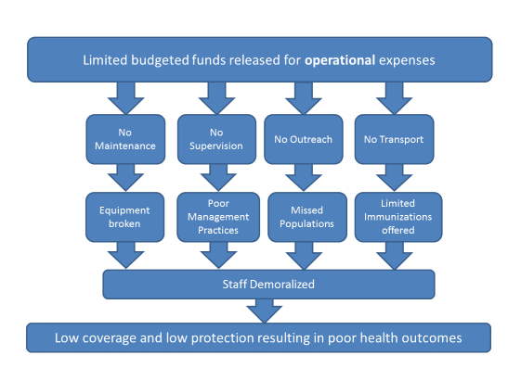

Source: Pentavalent PIE presentation, March 2013.

* **Poor quality of immunization data**. Administrative coverage data show immunization rates of more than 80% for all vaccines in most locations, while data from multiple surveys conducted in recent years (SMART, DHS, NNHS) consistently provide estimates of 20 or 30 percentage points lower. A key reason is inaccurate denominators used for administrative data. The PCV/IPV PIE found most health facilities using unrealistically low estimates for the target population. Different population data are often used for routine immunization and vaccine campaigns for the same population, making planning and reporting difficult.[23] The study also found that knowledge among health workers on how to calculate immunization coverage and dropout rates was almost universally poor, resulting in negative dropout rates at some health facilities the assessment team visited. This lack of knowledge, coupled with inadequate data management, make it difficult for program managers to monitor program performance and for health workers at the frontlines to use data for action. Data quality issues could therefore be a major contributor to the continual high dropout rates in Nigeria.
  1. **Goal 4: Introduce new and improved vaccines and technologies**

Nigeria has been slower to introduce new vaccines than a number of other countries in the region, in large measure because of GAVI’s policy for many years that required that countries achieve a national DPT3 coverage rate of at least 70% before being able to apply for support for new vaccine introductions. All vaccine introductions have received GAVI financial support, as well as technical support from several partners. These vaccine introductions have also all been phased in by state – taking eight months to one and a half years. The phased-in introductions have allowed for the variation among states in their readiness to introduce a new vaccine, including their cold chain capacity, and for the time needed to expand their cold chain and logistics system to accommodate the new vaccine. In the case of pentavalent vaccine, the phased introduction was also due to the limited global availability of the vaccine. The following vaccine introductions have taken place in the past four years:

Meningitis A vaccine in mass campaigns

Campaigns for 1-29 year olds were conducted in four phases – one per year – between 2011 and 2014 in the country’s 23 states at high risk for meningitis. A post campaign survey conducted in the Phase 4 states in 2014 estimated a coverage rate of 88% for that phase, indicating good quality of the campaigns and high population demand for the vaccine.[24]

Pentavalent (DPT-HepB-Hib) vaccine

This vaccine was introduced in three phase from May 2012 to December 2013. A post-introduction evaluation was conducted in the 14 Phase 1 states in March 2013 to provide lessons learned and inform the introduction for the two remaining phases. According to the evaluation, the introduction generally went well, with a good training program in which at least one health worker per health facility had been trained; extensive publicity about the introduction, including launch ceremonies; good population acceptance of the vaccine and high demand; and the availability of updated data collection tools in all states.[25] The main weaknesses were the lack of introduction plans at the LGA level; insufficient funds at the LGA and health facility levels to transport vaccine, repair or replace broken refrigerators or to conduct supervisory visits; and the absence of adverse events following immunization (AEFI) surveillance.

PCV-10 vaccine

PCV introduction was approved by GAVI in 2013 and slated to begin later that year in most of the same Phase 1 states as for pentavalent vaccine introduction. Phase 1 was delayed until December 2014 due to a global shortage of the vaccine and to delays in finalizing an agreement between the Government and UNICEF to allow UNICEF to serve as the fiduciary agent (or “pass through”) for GAVI vaccine introduction grant funds after GAVI HSS funds were frozen in early 2014, as described above. Phase 2, in nine more states, was scheduled for October 2015, but delayed till January 2016, and Phase 3 (originally planned for January 2016) took place in July. A key reason for the delays in the later phases was the failure of several states to pass the readiness assessment required for PCV-10 introduction to ensure proper handling by health workers of this vaccine, which is presented in two-dose vials without preservative and requires and open vials be discarded within six hours.

A PIE conducted in the Phase 1 states found a generally successful introduction, with early and strong planning, strong buy-in from some state political leaders (who participated in launch ceremonies), training of at least two health workers per facility, which included refresher training and was well-received; and no major issues with vaccine logistics or distribution.[26] The main problems identified were:

* A lag of around two months between the training of health workers and introduction of the vaccine in some states because of health workers strikes and security issues;
* Gaps in communication about the vaccine due to a lack of funds for local social mobilization activities, insufficient availability of IEC materials and inadequate inter-personal communications between health workers and parents. Consequently, 60% of caregivers interviewed for the evaluation were not aware of which vaccines their child had just received, and 24% overall (and 85-90% in two states) weren’t aware of the date for the next visit for subsequent doses;
* The reluctance among 15% of health workers overall – and 40% in three states – to administer three injections (for pentavalent, IPV and PCV) to a child during the same visit, potentially resulting in missed opportunities and increased dropout rates.

Despite these issues, the introduction of PCV, as well as pentavalent vaccine, did not appear to disrupt the routine program or negatively impact coverage rates of other vaccines in the schedule, since the WUENIC coverage rate estimates of all vaccines have increased each year since these vaccine introductions began.

Inactivated polio vaccine (IPV)

This vaccine was introduced over an eight-month period in 2015 in six phases, with delays in some states due to a delay in GAVI approval of the vaccine introduction grant and to health worker strikes. All accounts are that the introduction was well implemented.

Concerning future vaccine introductions, Nigeria is graduating as a GAVI country in December 2021, and has up to the end of 2017 to apply for GAVI support for any other vaccine introductions. Its plans call for meningitis A vaccine to be introduced into the routine schedule in 2017 in the 23 high-risk states, followed by rotavirus vaccine introduction in 2018. The country’s application for GAVI for rotavirus vaccine, first submitted in 2014, has recently been resubmitted (with revisions to address the review committee’s comments) and approved (with clarifications). Introduction of the vaccine is planned to begin in 2018.

The addition of a second measles dose, MR campaigns and a pilot HPV project are also mentioned in the 2016-2020 cMYP. However, these introductions are still in the discussion stage.

1. **Partner support to address remaining challenges to meet the GVAP goals and targets**

As in other countries, development partners have played a key role in Nigeria’s efforts to eradicate polio – by helping to build a robust AFP/polio surveillance system and conduct polio vaccination campaigns, as well as to control other epidemic-prone diseases (measles, yellow fever, meningitis A) through case-based disease surveillance and vaccination campaigns. The more than 11,000 health workers supported by WHO and UNICEF with policy eradication program funds have been critical to these efforts, as well as to helping with improvements to the routine immunization program. Technical and financial support from partners, including GAVI funding, has also played an important role in the country’s successful introduction of three new vaccines in the past four years.

Below we highlight three areas of partner support that are addressing key issues that have been discussed above.

Expansion of the cold chain system and improving vaccine management

The ability of health facilities to provide immunization services on a weekly or more frequent basis has been hampered in the past by inadequate cold chain capacity at state and LGA stores and a lack of refrigerators in many health centers. This problem has been compounded by inadequate vaccine stock management, resulting in frequent stockouts of vaccines at sub-national levels. In the PCV/IPV post-introduction evaluation, for instance, 36% of health facilities visited reports stockouts of vaccines (BCG, IPV, yellow fever) in the past six months.

To address this problem, a major activity of partners in the past several years has been to strengthen the cold chain system and vaccine management, using funds from the GAVI HSS grant and other partner support. Two sub-national hubs were established to store and distribute vaccine and devices, in addition to the central stores in Abuja. In the past few years, more than 1,600 solar direct drive (SDD) refrigerators have been procured and installed in health facilities in wards with large populations, as well as other cold chain equipment. There has also been a series of national and state-level trainings in cold chain maintenance and operations for cold officers and technicians. To address the issue of vaccine management and to prevent unnecessary local stockouts, partners (WHO, UNICEF and CHAI), worked with the Government to set up a vaccine stock management “dashboard” in 2015. This is an Excel-based tool that provides a snapshot of the vaccine inventory at all levels of the system, based on weekly reports sent By LGAs to the states, which are then passed on to the National Logistics Working Group. The dashboard has greatly increased the ability of the national and state logistics personnel to monitor vaccine stock levels at the lower levels on a weekly basis and to act accordingly. According to one source, many LGAs that were chronically under-supplied with several vaccines in the past have not experienced a single stockout during the first half of 2016.[27]

Ensuring sustainable financing for routine immunization

As described above, a lack of funds for operational costs at the local level has been a key bottleneck in improving immunization coverage rates in Nigeria. A major reason for the lack of funds is that such expenditures are not included in the states’ recurrent budgets – which are guaranteed – but are instead often included under *ad hoc*, unprotected budgets. To ensure more adequate funding for routine immunization activities, the Gates Foundation and the local Dangote Foundation have entered into three-year agreements with two Northern states, Kano and Bauchi, which require the states to include all operational costs for routine immunization in their recurrent budgets. Each state has also set up a routine immunization basket into which the state funds are placed, along with contributions from both foundations. The share of the budget paid by the foundations is 75% in the first year (and includes capital costs for refrigerators to ensure that at least one health facility per ward is able to store vaccines), and 50% in the second year. By year 3, the states will cover all costs. The partners, which also include USAID, are providing technical support under this initiative in microplanning, data management, supportive supervision, M&E and community engagement.[28] The plan is to establish similar agreements and routine immunization basket funding in four additional Northern states.

Development of a single, integrated data management system for immunization program data

As mentioned above, there are currently two parallel systems for collecting immunization data – the EPI’s system in the NPHCDA that uses the DVD-MT platform, and the FMOH’s HMIS, which uses the DHIS2 platform. Each system at present uses different population data and produces different coverage estimates. Partners, including CDC, are assisting the Government to improve the immunization component of the HMIS in the aim of creating a single immunization data management system (the DVD-MT system will be phased out over time).

**Acknowledgments**

We would like to thank the following people who were interviewed for this report:

* Thomas Cherian, WHO headquarters
* Rachel Seruyange, immunization officer, WHO/Nigeria country office
* Jenny Sequeira, Gates Foundation

Rudi Eggers at WHO headquarters also assisted with the review of this report.

**ANNEXES**

**Annex 1: Country immunization profile**

1. **General indicators**

* GNI (USD): 2,950
* WB Status: Lower Middle Income
* Infant mortality (<12 M) rate: 69
* GAVI Status: Graduating
* Total Population: 182,202,000
* Birth Cohort: 7,133,000
* Surviving Infants: 6,622,000

1. **Polio**

* Transmission stopped in 2014, but new WPV cases have been detected in August 2016.
* Eradication certified (not yet).

1. **Measles and rubella**

Figure 4: reported measles cases and MCV1 coverage, Nigeria, 1990-2015

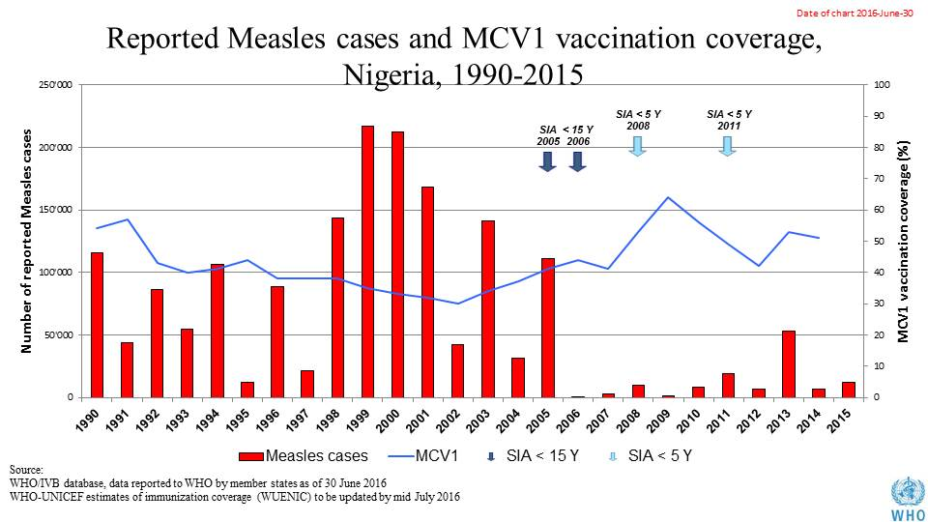

Table 1: SIA activities planned in 2016-2017

|  |  |  |  |  |  |  |  |  |
| --- | --- | --- | --- | --- | --- | --- | --- | --- |
| **Activity** | **Intervention** | **Year** | **Start Date** | **End Date** | **Age Group** | **Extent** | **Status** | **Target** |
| Catch Up | MR | 2017 | 29/02/1904 |  | 9 M-14 Y | National | Uncertain | 8,0447,735 |
| Follow Up | Measles | 2016 | 28/01/2016 | 01/02/2016 | 9-59 M | Sub-national | done | 14,562,967 |
| Mop up | mOPV2 | 2016 | 11/06/2016 | 14/06/2016 | 0 to 5 years | Sub-National | Planned | 2,536,136 |
| NID | tOPV | 2016 | 27/02/2016 | 01/03/2016 | 0 to 5 years | National | Planned | 62,037,657 |
| SNID | bOPV | 2016 | 15/10/2016 | 18/10/2016 | 0 to 5 years | Sub-National | Planned | 27,916,946 |
| SNID | tOPV | 2016 | 16/01/2016 | 19/01/2016 | 0 to 5 years | Sub-National | Planned | 2,528,986 |
| Mop up | mOPV2 | 2016 | 09/05/2016 | 12/05/2016 | 0 to 5 years | Sub-National | Planned | 2,670,459 |
| Mop up | mOPV2 | 2016 | 18/06/2016 | 19/06/2016 | 0 to 5 years | Sub-National | Planned | 3,440 |
| NID | tOPV | 2016 | 19/03/2016 | 22/03/2016 | 0 to 5 years | National | Planned | 62,037,657 |
| SNID | bOPV | 2016 | 14/05/2016 | 18/05/2016 | 0 to 5 years | Sub-National | Planned | 30,000,000 |
| SNID | tOPV | 2016 | 16/01/2016 | 19/01/2016 | 0 to 5 years | Sub-National | Planned | 27,500,275 |
| Mop up | IPV + mOPV2 | 2016 | 09/07/2016 | 16/07/2016 | 0 to 5 years,0-23M | Sub-National | Planned | 2,534,469 |
| Mop up | mOPV2 | 2016 | 25/06/2016 | 28/06/2016 | 0 to 5 years | Sub-National | Planned | 1,957,604 |
| Mop up | mOPV2 | 2016 | 23/07/2016 | 26/07/2016 | 0 to 5 years | Sub-National | Planned | 1,955,575 |
| Mop up | mOPV2 | 2016 | 27/08/2016 | 30/08/2016 | 0 to 5 years | Sub-National | Planned | 1,955,575 |

Source: WHO/IVB Database as at 12/4/2016

1. **MNT**

* Not yet validated - planning a pre-validation assessment in 1-2 geopolitical zones before the end of the year

1. **Coverage and Equity**

Table 2: Reported DTPCV doses administered & coverage, Nigeria, 2000-2015

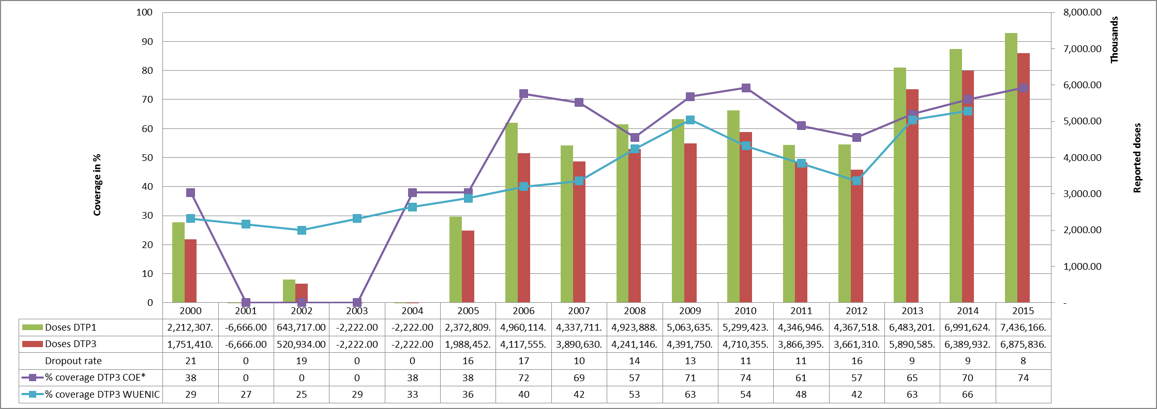

* COE: country Official Estimates

Source: WHO/IVB database, data reported to WHO by member states as of 1 July 2016

Figure 5: Percentage of district achieving <50%; 50-79% and ≥80% coverage, 2000-2015

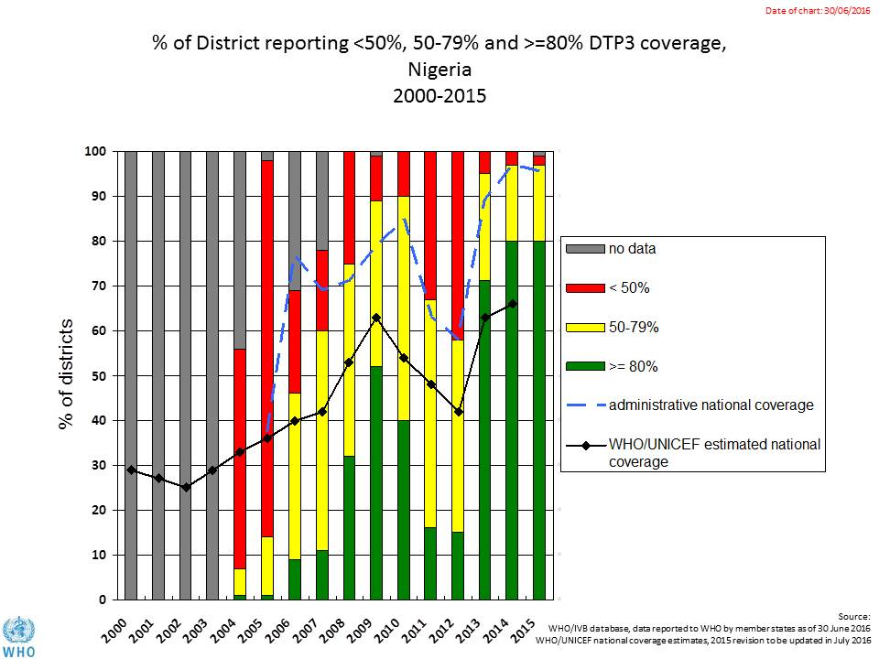

Figure 6: map with DTP3 coverage by district/province 2010 and 2015 (administrative data)

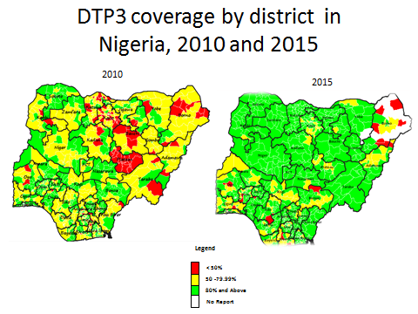

Figure 7: Immunization coverage data disaggregated by sex and wealth quintile

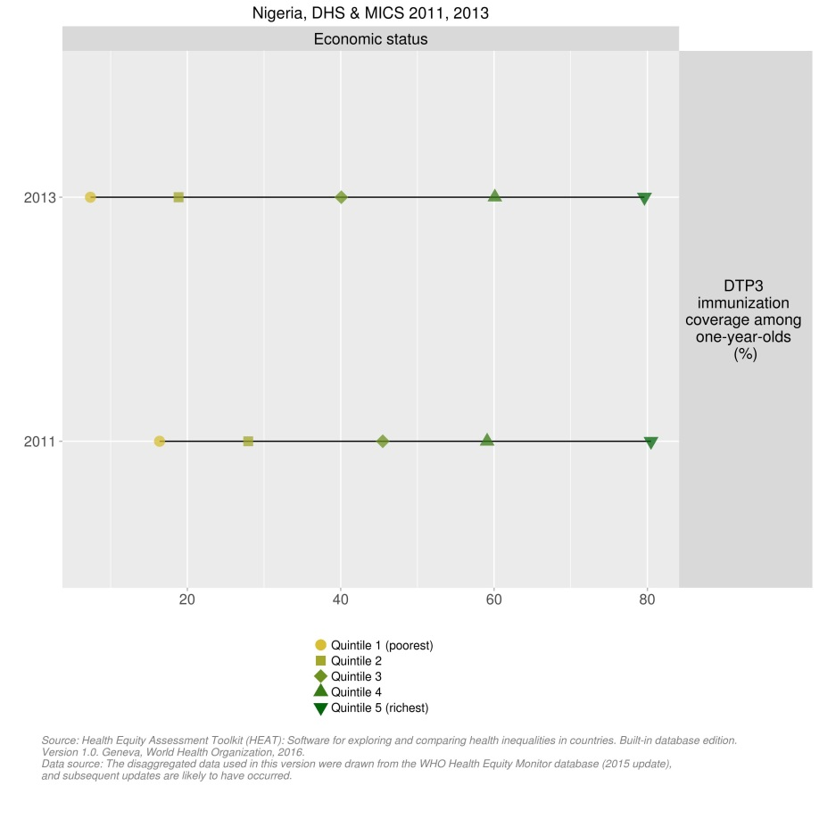

1. **Immunization systems highlights**

* Immunization schedule

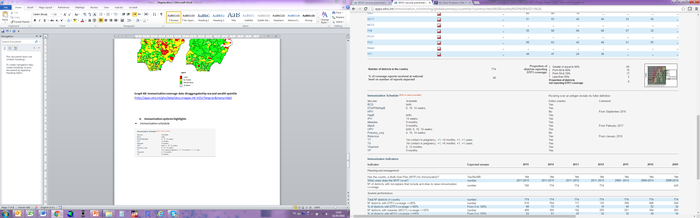

* Planning and management:
  + Stockout events 2015: none
  + cMYP: 2011-2015
  + Annual Plan: Yes
* Country decision making: NITAG recently established
* % of total expenditures on vaccines financed by government funds: 41%

1. Sources: FMOH. Comprehensive EPI multi-year plan, 2016-2020, National Primary Health Care Development Agency, 2015, and internal WHO briefing note for the 2016 joint appraisal.
2. cMYP 2016-2020.
3. Internal WHO briefing note for the 2016 joint appraisal.
4. cMYP.
5. WHO, Highlights of new wild poliovirus and cVDPV cases reported globally, week of August 9, 2016 (presentation).
6. These are recently revised estimates that were lowered following a recent survey.
7. cMYP.
8. cMYP.
9. National Population Commission. Nigeria Demographic and Health Survey 2013.
10. cMYP.
11. cMYP.
12. WHO Global summary of vaccine-preventable diseases for 2016: Nigeria.
13. cMYP.
14. GAVI Joint Appraisal report, 2015.
15. WHO Global summary of vaccine-preventable diseases for 2016: Nigeria.
16. Nigerian National Bureau of Statistics. National Nutrition and Health Survey (NNHS), 2015.
17. cMYP.
18. 2013 DHS.
19. Internal WHO briefing note for the 2016 joint appraisal.
20. cMYP.
21. Report on the Post-Introduction Evaluation of Pneumococcal Conjugate Vaccine (PCV10) and Inactivated Polio Vaccine (IPV) in Phase 1 States in Nigeria, March 2016.
22. Presentation of Post-introduction evaluation (PIE) of pentavalent vaccine introduction in Nigeria Phase I states, March 2013.
23. cMYP.
24. Joint Appraisal report, 2015.
25. Presentation of Post-introduction evaluation (PIE) of pentavalent vaccine introduction in Nigeria Phase I states, March 2013.
26. Report on the Post-Introduction Evaluation of Pneumococcal Conjugate Vaccine (PCV10) and Inactivated Polio Vaccine (IPV) in Phase 1 States in Nigeria, March 2016.
27. Internal WHO briefing note for the 2016 joint appraisal.
28. Joint Appraisal report 2015.