**Global Vaccine Action Plan**

*Secretariat Annual Report 2016*

*Priority Country report on progress towards*

*GVAP-RVAP goals*

**NIGERIA**

1. **Progress towards achievement of GVAP goals**
2. **Summary**

The summary table below describes the current situation in Nigeria regarding achieving the GVAP goals. Data used to assess progress towards achievement of GVAP goals are included in the annex.

| **Area** | **Indicator** | **Nigeria** |
| --- | --- | --- |
| **3. Measles elimination** | **Coverage MCV1 (2015 WUENIC)** | **54%** |
| **Coverage MCV2** | **Not in schedule** |
| **Reported percentage of districts with MCV1 coverage ≥95% (2015 JRF)** | **53%** |
| **Last national SIA** | **2015** |
| **Post SIA coverage survey conducted** | **Yes** |

* + 1. **Achieve measles elimination and rubella & CRS elimination**

Measles

Nigeria has the goal of reducing measles morbidity by 90% mortality by 95% from 2014 to 2020.[1] The number of cases reported through the disease surveillance system in 2015 was more than 12,200, which is significantly down from nearly 53,000 cases in 2013 and more than 212,000 cases in the year 2000.[2] The number of reported measles outbreaks has similarly declined from 338 in 2010 to 133 in 2014.[3]

To reduce measles incidence, the country developed a strategy of nation-wide measles vaccination campaigns, coupled with case-based surveillance, beginning with catch-up campaigns for children 9 months to 15 years that were conducted in two phases in 2005 and 2006. National follow-up campaigns for children under five have taken place with WHO and UNICEF support every two or three years since then (in 2008, 2011, 2013/14 and most recently in 2015/16). A coverage survey found that the 2013/14 campaign achieved an overall coverage rate of 74.5%.[4] The Government plans to continue the SIAs every two or three years, as needed, based on surveillance reports; SIAs are currently planned for 2017 and 2020.

Key challenges that need to be addressed to meet Nigeria’s measles reduction targets are:

* **The need to improve measles vaccination coverage rates**. Routine measles coverage rates remain low and have risen very gradually in the past several years. The national rate was 49% in 2011, dipped to 42% in 2012 and then rose to 47% in 2013 and to 55% by 2015.[5] Large parts of the country – the Northeast and Northwest regions – have extremely low coverage rates. According to the 2015 National Nutrition and Health Survey (NNHS), which found a national measles vaccination coverage rate of 51% among 12-23 month olds – four states had rates of 4% to 7%, while seven other states had rates of 15-30%[6] (see Figure 2). These findings indicate that measles immunization through the routine program in these areas is almost non-existent, though the lack of retention of immunization cards could also have been a factor for the low rates. In all, only four states reached the country’s target measles vaccination coverage rate of 80% (the federal capital territory and three Southern states), 19 states achieved coverage between 50 and 80% and 14 states had rates of less than 50%. According to the cMYP, the EPI plans to add a second measles dose to the routine immunization schedule within the next several years.
* **The need to further improve measles surveillance**. Measles surveillance includes both passive surveillance (as part of the IDSR system) and case-based surveillance, using the same infrastructure as for AFP surveillance and support from four national labs. The system appears to be fairly sensitive, reporting a non-measles febrile rash illness rate of 2.7/100,000 children in 2014, surpassing the target of <2/100,000. However, case-based surveillance still needs improvement, as 16% of LGAs did not report at least one suspected case in 2014 and only 75% of cases that year were investigated (with a blood sample obtained).[7]

Figure 2: Estimated coverage rates for three doses of pentavalent vaccine and measles vaccine among children 12-23 months of age, 2015 National Nutrition and Health Survey



**ANNEXES**

1. **Measles and rubella**

Figure 4: reported measles cases and MCV1 coverage, Nigeria, 1990-2015

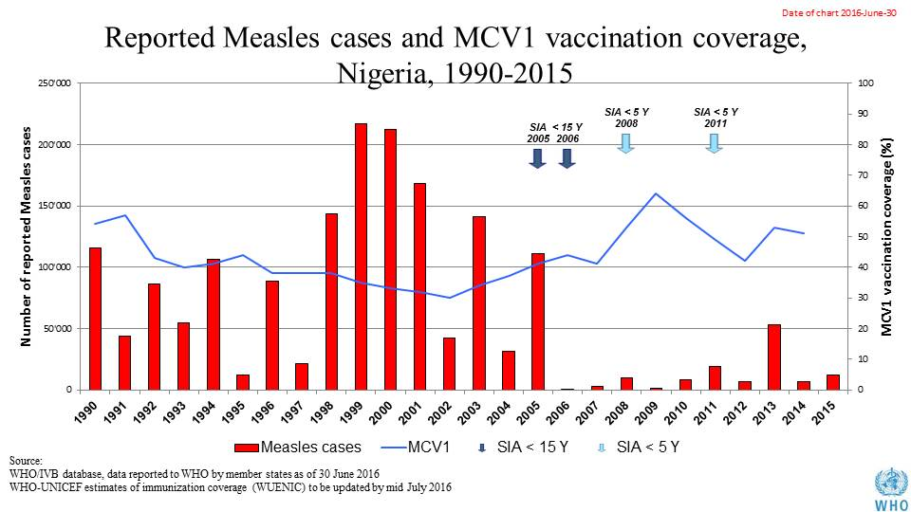

Table 1: SIA activities planned in 2016-2017

|  |  |  |  |  |  |  |  |  |
| --- | --- | --- | --- | --- | --- | --- | --- | --- |
| **Activity** | **Intervention** | **Year** | **Start Date** | **End Date** | **Age Group** | **Extent** | **Status** | **Target** |
| Catch Up | MR | 2017 | 29/02/1904 |  | 9 M-14 Y | National | Uncertain | 8,0447,735 |
| Follow Up | Measles | 2016 | 28/01/2016 | 01/02/2016 | 9-59 M | Sub-national | done | 14,562,967 |
| Mop up | mOPV2 | 2016 | 11/06/2016 | 14/06/2016 | 0 to 5 years | Sub-National | Planned | 2,536,136 |
| NID | tOPV | 2016 | 27/02/2016 | 01/03/2016 | 0 to 5 years | National | Planned | 62,037,657 |
| SNID | bOPV | 2016 | 15/10/2016 | 18/10/2016 | 0 to 5 years | Sub-National | Planned | 27,916,946 |
| SNID | tOPV | 2016 | 16/01/2016 | 19/01/2016 | 0 to 5 years | Sub-National | Planned | 2,528,986 |
| Mop up | mOPV2 | 2016 | 09/05/2016 | 12/05/2016 | 0 to 5 years | Sub-National | Planned | 2,670,459 |
| Mop up | mOPV2 | 2016 | 18/06/2016 | 19/06/2016 | 0 to 5 years | Sub-National | Planned | 3,440 |
| NID | tOPV | 2016 | 19/03/2016 | 22/03/2016 | 0 to 5 years | National | Planned | 62,037,657 |
| SNID | bOPV | 2016 | 14/05/2016 | 18/05/2016 | 0 to 5 years | Sub-National | Planned | 30,000,000 |
| SNID | tOPV | 2016 | 16/01/2016 | 19/01/2016 | 0 to 5 years | Sub-National | Planned | 27,500,275 |
| Mop up | IPV + mOPV2 | 2016 | 09/07/2016 | 16/07/2016 | 0 to 5 years,0-23M | Sub-National | Planned | 2,534,469 |
| Mop up | mOPV2 | 2016 | 25/06/2016 | 28/06/2016 | 0 to 5 years | Sub-National | Planned | 1,957,604 |
| Mop up | mOPV2 | 2016 | 23/07/2016 | 26/07/2016 | 0 to 5 years | Sub-National | Planned | 1,955,575 |
| Mop up | mOPV2 | 2016 | 27/08/2016 | 30/08/2016 | 0 to 5 years | Sub-National | Planned | 1,955,575 |

Source: WHO/IVB Database as at 12/4/2016

1. cMYP.
2. WHO Global summary of vaccine-preventable diseases for 2016: Nigeria.
3. cMYP.
4. GAVI Joint Appraisal report, 2015.
5. WHO Global summary of vaccine-preventable diseases for 2016: Nigeria.
6. Nigerian National Bureau of Statistics. National Nutrition and Health Survey (NNHS), 2015.
7. cMYP.