**Global Vaccine Action Plan**

*Secretariat Annual Report 2016*

*Priority Country report on progress towards*

*GVAP-RVAP goals*

**PAKISTAN**

1. **Progress towards achievement of GVAP goals**
2. **Summary**

This summary table describes the current situation in Pakistan regarding achieving the GVAP goals. Data used to assess progress towards achievement of GVAP goals are included in the annex (Country immunization profile).

|  |  |  |
| --- | --- | --- |
| **Area** | **Indicator** | **Pakistan** |
| **Socio-demographic** | **GNI 2014** | **1410** |
| **Socio-demographic** | **WB Status** | **Lower Middle Income** |
| **Socio-demographic** | **Infant mortality (<12 M) 2015 UN IAG CME** | **66** |
| **Socio-demographic** | **Gavi Status** | **Eligible** |
| **Socio-demographic** | **Total Population** | **188,925,000** |
| **Socio-demographic** | **Birth Cohort** | **5,451,000** |
| **Socio-demographic** | **Surviving Infants (JRF)** | **5,088,000** |
| **1. Interrupt wild poliovirus transmission** | **Transmission Interrupted** | **No** |
| **1. Interrupt wild poliovirus transmission** | **Risk of late detection Percent of adequate stool specimens (Rolling 12m) Target > 80%** | **89.9** |
| **1. Interrupt wild poliovirus transmission** | **Risk of late detection Non polio AFP rate (Rolling 12m )  Target > 2** | **9.4** |
| **1. Interrupt wild poliovirus transmission** | **Risk of spread after importation  (% of kids 6M-59M having received less than 3 doses in the last year before occurrence case/environmental positive)** | **1** |
| **2. Neonatal tetanus elimination** | **Coverage for TT (reported 2015)** | **68%** |
| **2. Neonatal tetanus elimination** | **Protection at Birth against T (WUENIC 2015)** | **75%** |
| **2. Neonatal tetanus elimination** | **Last SIAs conducted in the country** | **Last activity done was in September 2013.** |
| **2. Neonatal tetanus elimination** | **Elimination validation date** | **Not yet validated. A validation survey being planned for Punjab in October/November 2016** |
| **3. Measles Elimination** | **Coverage MCV1 (2015 WUENIC)** | **61%** |
| **3. Measles Elimination** | **Coverage MCV2** | **53%** |
| **3. Measles Elimination** | **Percentage of districts with MCV1 coverage >=95% (2015 JRF)** | **33%** |
| **3. Measles Elimination** | **Last national SIA** | **2008** |
| **3. Measles Elimination** | **Post SIA coverage survey conducted** | **No** |
| **4. Rubella/CRS Elimination** | **Coverage R** | **Not introduced (2014)** |
| **4. Rubella/CRS Elimination** | **SIAs planned?** | **SIAs planned 2018** |
| **5. Reach 90% national coverage and 80% in every district with DTP3cv** | **National coverage (WUENIC 2015)** | **72%** |
| **5. Reach 90% national coverage and 80% in every district with DTP3cv** | **Drop-out rate DTP1 DTP3 (2015 WUENIC) (DTP1-DTP3)/DTP1*100** | **9%** |
| **5. Reach 90% national coverage and 80% in every district with DTP3cv** | **Actual numbers of children that dropped out (2015 WUENIC)** | **356163** |
| **5. Reach 90% national coverage and 80% in every district with DTP3cv** | **Difference between poorest and richest quintile DTP3 coverage (2013 data)** | **58.1** |
| **5. Reach 90% national coverage and 80% in every district with DTP3cv** | **% District coverage reaching 80% coverage from 2015 JRF** | **60%** |
| **6. Reach 90% and 80% coverage with all vaccines in national immunization programmes** | **National Coverage (2015 WUENIC)** | **BCG 85 DTP1 79 DTP3-HepB3-Hib3 72 MCV1 61 MCV2 53 PCV3 72 Pol3 72** |
| **7. Introduction of new vaccines** | **New Vaccines introduced** | **PCV in 2012 and Rota planned in 2017** |
| **8. Reduction in under 5 mortality rate** | **UM5R 2010 and 2015 (% diminution between 2010 and 2015)** | **2010: 91.8 2015: 81.1 (11.7%)** |
| **9. NITAG** | **NITAG established?** | **Yes** |
| **10. Government expenditure on routine immunization per live birth USD** | **Baseline 2010-2011 and average for 2013-2015 (% change)** | **8.5 to 5.8 (-32%)** |

1. **Country ownership of the immunization programme**
   1. **Overview of country ownership in its primary health care system, including immunization**

In 2011, an amendment to the Pakistani constitution devolved the responsibility of health services from the Federal to the Provincial level and dissolved the Ministry of Health. Decentralization significantly changed the management of immunisation in Pakistan; it permitted a tailored approach to meeting provincial needs but caused initial confusion around the roles and responsibilities of EPI staff and financing at all levels, primarily due to the unclear division of roles and responsibilities for federal and provincial governments. There is also concern about the limited capacities of provincial governments to provide services, possibilities of differing immunization schedules and protocols, and disparate delivery strategies between provinces. Significant progress has been made since 2015 on the clarification of roles and responsibilities.

As it stands, provincial governments are responsible for the implementation and execution of immunization services and of increasing immunization coverage, while the Federal EPI Cell under the newly created Ministry of National Health Services, Regulations and Coordination (MoNHSRC) has the responsibility for coordination, technical support, international collaborations and donor coordination, disease information and surveillance, monitoring of infectious diseases in addition to regulations, standards and accreditations. Recently a Health Planning, System Strengthening and Information Analysis unit was created to oversee and coordinate health systems related work in the country. Immunization and health systems objectives are both represented in Pakistan’s National Immunisation Support Project (2016-2020) which is tasked with increasing the equitable coverage of services for immunisation against vaccine preventable diseases (VPD), for children under 2 years of age. This includes improving immunisation services through strengthening of routine immunisation systems (as part of the country’s health system).

Within the newly decentralized health system, the federal health authorities remains exclusively responsible for fulfilment of national commitments at the global and regional levels (such as the Sustainable Development Goals) while supporting sub-national entities in the implementation of their respective immunization programs. Political leadership on immunization has improved over the past few years, particularly at the federal level, but varies between provinces. However, despite significant efforts by the government and its partners, Pakistan’s immunization indicators have yet to reach expected benchmarks. The key goals of polio eradication and measles and neonatal tetanus elimination are still not achieved. Additionally routine vaccination coverage remains insufficient, as evident in several recent outbreaks of measles, pertussis and diphtheria in different parts of the country. Coverage of maternal and child health services, contraception, vaccination and communicable disease control is mostly better in urban areas than in rural areas, and there are significant geographic disparities.

CSOs can be essential to reaching immunization targets, particularly in hard to reach areas and urban slums. However communication and roles need to be better defined and coordinated with the EPI programme. This has been recognized in the creation of the CSO unit, a coordinating unit to serve as an interface between the Government, CSOs and UNICEF. This unit was relocated to the office of Federal EPI in 2013 to ensure that it is better positioned to fulfil its function to strengthen health systems, but has recently become non-functional due to vacancies in key positions. A window of opportunity exists in the engagement of CSOs in Pakistan in demand generation for better health service delivery, as well as community mobilisation through advocacy, communication for development and other social mobilization approaches. By the virtue of their presence, CSOs can augment the capacity and coverage of public sector community health workers by deploying additional workforce. This would be particularly suited to areas where people resist vaccination due to some myths and misconceptions. Civil society has played a significant role in health systems strengthening in Pakistan, by extending support to government counterparts.

* 1. **Immunization policy decision-making capacity**

A National Immunization Technical Advisory Group (NITAG) exists comprised of renowned scientists, experts in different technical disciplines as core members along with key technical partners and relevant professional bodies as liaison members. This body provides technical advice on immunization to the ministry and has been instrumental in recommending new vaccine introductions. The ICC, as a strong governing body for Gavi support and overall immunization, is not fully functional and needs to be further strengthened.

* 1. **Government Financing of Immunization**

Except for Penta and PCV10, all other vaccines and required injection equipment are procured by the federal government with its own resources. Penta and PCV10 are procured through co-financing agreements with Gavi, but Pakistan has been in default repeatedly since 2012 due to non-fulfilment of obligations in timely procurement of these vaccines. These defaults can be attributed to delayed or unsuccessful tenders and issues with release of funds under PC-1, which follow the financial cycle of June – July as compared to the Gavi requirement of making co financing by the end of calendar year. During the last quarter of 2015, based on government's request, Gavi approved certain flexibilities in its programmatic interaction, under the country tailored approach policy (CTA), which includes an alignment of the co-financing cycle with the country's fiscal year (adjusting Pakistan's co-financing for 2015 until June 2016). Despite this - the country did not meet all of its co-financing obligations for 2015. Pakistan is in the process of introducing IPV in the RI schedule with GAVI support and Hepatitis B birth dose with its own resources. Significantly, devolution of health services without clear division of roles and responsibilities for federal and provincial governments has negatively affected performance of Gavi grants. However in the past year, PC-1s have been approved for the provinces and implementation is underway, a milestone of post-devolution financing.

**c. Human resource situation**

The EPI in Pakistan has serious shortfalls in the quality and number of human resources at both the management and operational level. Most of the provincial/area program offices including the Federal EPI have insufficiently skilled staff with insufficient technical and managerial competency. Certain areas (Particularly FATA, CDA/ICT, GB and AJK) experience severe human resource shortages. In some areas, there are only 1-2 dedicated EPI staff. The population of the areas combined is around 10 million and contains territory with challenging terrain because of the lack of infrastructure and high insecurity. TORs are unspecific, there is an overall lack of accountability, limited career potential and often limited job security. Orientation, training and continued education is only rudimentarily provided. There is a frequent staff turnover at all levels.

Significant gaps exist specifically in cold chain and logistics staff number and technical knowledge at Federal and Provincial levels. Temporary support is provided by partners (WHO, UNICEF and USAID) to the federal and provincial program offices through secondments or other contractual arrangements, but their adequacy as well as current state of utilization is being questioned due to limited management capacity. The vaccinator / population ratio is very low resulting in highly irregular service delivery. The new EPI policy requires a minimum number of vaccinators per population and geographic area. Provinces have taken initiatives to recruit more vaccinators and at the same time train Lady Health Workers (LHWs) to perform routine immunization services.

The use of Lady Health Workers (LHWs) and Lady Health Supervisors (LHSs) is being explored by a number of provinces to strengthen Routine Immunisation through service delivery. If more LHWs are used in campaigns, then vaccinators will have more time for RI. Previously, LHWs were used in social mobilisation and health education. Pakistan has more than 110,000 Lady Health Workers at the community level and they play an integral role in bridging between health facility and community for providing essential health services to communities, especially in rural areas that are difficult to reach. Currently not all provinces allow LHWs to provide all vaccines, but this is under discussion. Ongoing training activities (funded from unspent funds from HSS-1) for LHWs and an assessment of their contribution to RI is underway. In May 2016, WHO with Gavi funding support held a consultation on the use of LHWs in RI. One of the significant workshop decisions included the formation and establishment of coordination committees at the Federal, Provincial, District and Health Facility level. Availability of these LHWs as female vaccinators will not only be a tremendous boost for vaccination service delivery for improving EPI coverage in Pakistan, but will also be more culturally acceptable to the community. LHWs have access to women and households in ways that other healthcare givers might not; they are important for increasing routine immunization and in strengthening other childcare practices.

CSOs have continued to play a significant role, particularly focusing on strengthening routine immunization, and have somewhat alleviated the personnel shortage. CSOs have clearly agreed on concrete results in terms of number of children immunized/percentage increase in immunization (BCG, Penta 3 and Measles). Because the CSOs are successful at social mobilization, they have been key for arranging vaccination camps and vaccination points to ensure vaccination of children (missed and defaulter children). There is some concern that CSOs are not fulfilling their task to reach children in areas where government vaccinators cannot go; however the CSOs have remained successful in increasing immunization coverage and addressing refusals. The district governments also truly appreciate and realize CSOs contribution. At many occasions, district health offices, issued letter of appreciation in recognition of CSOs work for immunization.

1. **Progress towards specific GVAP goals (issues/challenges/successes)**

**3.1 Goal 3 : Meet vaccination coverage targets**

* 1. **Achieve 90% National coverage and 80% in every district with 3 doses of diphteria-tetanus-pertussis containing vaccines**
  2. **Achieve 90% National coverage and 80% in every district with all vaccines included in the national schedule**

Immunization coverage in Pakistan has stayed steady over the last decade. Most of the coverage surveys in Pakistan have given varying figures, yet have a consensus on a slow progress on immunization coverage. The current coverage, as estimated by different surveys, varies between 47% and 88%. The elements of over reporting in the routine data and of recall biases in the PDHS and PSLM cannot be ruled out. Pakistan’s coverage rate with the most basic vaccines stood at 73% in 2014 although there are large variations between the four main provinces – the most recent Pakistan Demographic Health Survey, from 2013, showed Punjab had 76% coverage while in Balochistan the figure was just 27%. This can be largely attributed to Punjab’s strong political commitment to increasing coverage; through the DFID sponsored Roadmap project, which gives Android phones to vaccinators and requires them to check in to vaccination posts, coverage has increased from 64% to 82% in one year. This successful program is now being expanded to KPK and Balochistan. Measles coverage ranged from 57% to 95% by province. Children under 2 years of age who never received any vaccination ranged from 2% to 30%. The estimated coverage for a fully immunized child in Pakistan varies between 56% and 88%, with considerable variation among provinces5 (PDHS, PSLM).

Except for two provinces, the vaccine delivery model is almost entirely vertical, with challenges even for creating synergies between non-RI vaccination programs. Questions were raised about the certification of vaccinators (currently non-existent), the lack of use of other health providers such as CHWs and overall how to standardize vaccination outreach services. Pakistan is one of the ten countries where UNICEF aims to enhance the equity in routine immunization hence contributing to health system strengthening efforts with improved immunization outcomes. GAVI provided funds for the technical support to introduce and support methodologies to identify main drivers of  inequities shifting the focus beyond national level planning for ‘Reaching Every District / Reaching Every Community’ (RED/ REC) approach. Recent surveys have identified multiple barriers to immunization, including but not limited to: Disease awareness and risk perception, vaccine doubts, alternative means of prevention, healthcare provider risk perception, transport and waiting time, unavailability of vaccine and vaccinators, and missing home‑based vaccination cards/immunization record.

Additionally, there is very low level of coverage of children belonging to parents migrating for economic or social reasons. To address this, the government of Punjab took the initiative to address internal migration between districts through targeting vaccination outreach at transit points. The initiative focuses on children under 5 years of age. Transitory point locations include bus stations, airports and regular transit areas between districts.

**3.2 Goal 1 : Achieve a world free of Poliomyelitis (G1.1 & G1.2)**

Polio remains a top priority in Pakistan as one of the two remaining countries in the world still harboring the wild virus. There are increasing opportunities for synergies between the Polio and EPI programs at federal and provincial level – with improved collaboration in the Emergency Operating Centers, now also – at times - covering routine immunization issues. A PEI-EPI Synergy Plan was agreed in 2013 and updated in June 2015. Structural interaction can be much improved here, e.g. with regards to the joint oversight of service provision, the role of vaccinators in campaigns and routine immunization, the monitoring of immunization performance, and the reduction of missed opportunities.

In Pakistan, the number of children in inaccessible areas has been reduced from more than 600,000 in 2013 to 16,000 in 2015. The programme is prioritizing efforts to access the remaining unreached children, and maximizing immunity through a series of strategies including OPV SIAs, using IPV in specific areas, setting-up health camps, and expanding Continuous Community Protected Vaccination (CCPV). There have been no persistent cVDPVs since March 2015 in Pakistan. There is an ongoing study in Pakistan to assess the immunogenicity (i.e. humoral immunity) of fractional-dose IPV and its usability in SIAs.

It is well documented that parental doubts about the efficacy and safety of vaccines and immunization have the potential to lead to refusal and rejection of vaccination in both developed and developing countries. In Pakistan, supplementary immunization activities (large scale campaigns) for polio eradication have been the target of malicious rumours and misinformation, which often centre on the polio vaccine. This may to some extent have had a negative effect on public attitudes towards vaccines in general.

The delivery of the polio vaccine house to house, has left communities with the expectation that all immunisation services will be delivered to their home. There is a need to change perception/ behaviours to enable community to differentiate between polio eradication efforts and routine vaccine preventable diseases. While hesitancy and vaccine refusal may be less significant in some areas, behaviour change interventions need to focus on shifting the mind set of caregivers to seeking immunisation services from fixed vaccination centres. Communication strategy should focus on overcoming barriers to improving coverage and equity, engage effectively with communities, and localize demand generation interventions specific to the target populations. In light of increasing polio cases since 2007, a major share of funding for immunization services is earmarked to polio eradication campaigns. Continuous polio campaigns have a significant impact on routine EPI services, particularly since this entails cessation of routine EPI services for a few days every month. Polio and routine immunization interactions bring lots of opportunities and some challenges. Synergy between the two programmes should be strengthened according to the approved plan. One window of opportunity is the EPI-PEI Synergy Plan and there is a critical need for using Polio assets for strengthening RI through integrated communication for both Polio and EPI. IPV introduction under RI is a good example of integrated communication yet there is a strong need for a close coordination between National and provincial EOCs.

The number of polio cases decreased from 558 in 199 to 91 in 2013, primarily from inaccessible and security compromised areas.

* 1. **Goal 2 : Meet global and regional elimination targets**

**a) Achieve maternal and neonatal tetanus elimination (G2.1)**

TT vaccination of pregnant ladies varied from 22% in Loralai to 79% in Rawalakot; Antenatal care coverage from 22% in Tharparkar to 92% in Peshawar; and deliveries by skill birth attendants from 22% in Tharparkar to 94% in Kotli. Knowledge about proper timing of first antenatal care visit was the lowest (25%) in Sanghar and the highest (81%) in Rawalakot.

TT SIAs were implemented in early 2015 in selected tehsils of districts in Punjab. Pre-validation surveys were done in Punjab in April 2016, with validation planned for November 2016. Other provinces will be considered for validation later down the line and are currently conducting risk assessments with SIAs in high risk areas. Issues hampering progress towards this goal are active polio virus circulation, insecurity and poor access to certain areas, and availability of TT Uniject.

The number of cases of tetanus (neonatal and total) has been decreasing steadily from 1,660 in 1999 to 320 in 2012.

1. **Achieve measles elimination (G2.2) and rubella & CRS elimination (G2.2)**

Pakistan experiences outbreaks of measles in 2006, 2008, and 2013. Out of the 108,888 suspected cases, 8,046 cases of measles were laboratory confirmed. GAVI partially supported the Measles SIA following the massive measles outbreak in Pakistan in 2012 and 2013. The measles campaign was launched in 2014 in the whole of Pakistan except FATA (~3.9% of target population), where the campaign was planned to be conducted in August 2015. The campaign covered 58 million children from 6 months to 10 years of age for measles vaccine with a reported national coverage of 103%. A third party evaluation of the coverage in Sindh province found coverage to be 95%. Following the massive measles outbreak in Punjab in the early 2013, Punjab government took initiative to conduct a mass immunization activity in all districts of Punjab. The provincial government used their own resources to conduct the activity across the province in phases. All vaccine and operational cost were borne by the provincial government. Later, upon completion of the campaign in 23 districts, Punjab Health Dept. decided to conduct a 3rd party survey to assess the coverage independently. Overall coverage was estimated 91.8%. Vaccination coverage was found higher among the <5 age cohort (92.6%) than 5 to <10 years age cohort (90.9%).

Rubella was laboratory confirmed in 483 out of 2,907 suspected cases. Rubella-containing vaccine has not yet been introduced in Pakistan.

**3.4 Introduce new and improved vaccines and technologies**

Gavi commenced support to Pakistan through the introduction of Hep B vaccine in 2002 and has been supporting Pakistan’s National Immunisation Programme through different windows of support, namely New Vaccine Support (NVS), Immunisation Services Support (ISS) and Health System Strengthening (HSS). Civil Society Organization (CSO) funding was also available through the programme cycles. Penta and PCV10 were introduced in 2008 and 2012 respectively and Pakistan most recently introduced Inactivated Polio Vaccine (IPV) in July 2015, starting from Punjab province and nationally completed roll-out in January 2016 (in FATA). The introduction of IPV in 2015/2016 and the switch from tOPV to bOPV are significant recent achievements in immunisation in Pakistan. In addition, a Rotavirus application has been received by the IRC and recommended for approval with some clarifications. The Government of the Punjab Province has committed to introduce rotavirus in 6 districts in 2016 through its own resources and is getting ready for roll out the entire Province in 2017 with Gavi support. This introduction was mainly driven by strong political leadership in Punjab and a great immunization success.

1. **Partner support to address remaining challenges to meet the GVAP goals and targets area**

Partner support for immunization activities is similar to that in many other GAVI-supported countries, with major partners providing financial support and technical assistance for polio and measles immunization campaigns, new vaccine introductions, surveillance, training, social mobilization, cold chain improvements and so forth (see Table 1).

**1. Activities conducted by partners by category**

Table 1: Partners and areas of assistance in Pakistan

| **Partner** | **Assistance Areas** |
| --- | --- |
| WHO | Policy and leadership (development of cMYP, financial sustainability plan)  Disease surveillance (case-based measles surveillance as part of integrated VPD surveillance)  Immunization campaigns/SIAs  Microplanning for Reach Every District (RED)/ Reach Every Community (REC) approach  New vaccine introductions (PCV10, IPV)  HR support to Federal and Provincial levels  Cold chain improvements (EVM assessment and implementation) |
| Government of China | Provides cold rooms, refrigerators, refrigerator trucks, and repair and maintenance of the cold rooms and trucks |
| USAID | Support in the development of vaccine logistics management information system (vLMIS) for immunization along with its operationalization in 54 districts through the Deliver Project  Deliver provided both hardware and software along with the trainings on vLMIS  Funding MCHIP for routine immunization in some districts of Sindh |
| UNICEF | Implementing RED/REC starting in 23 districts; plans to scale up this approach in one-fifth of the country during the next five years  Procurement of vaccines and logistics  Supported the construction/renovation of 19 warehouses across four provinces and one area i.e., Gilgit Baltistan (GB)  Cold chain improvements (EVM assessment and implementation)  Development and implementation of the communication plans for the Measles SIA across four provinces and four areas (AJK, GB, FATA, ICT/CDA) in addition to development of Measles and RI messages  New vaccine introductions (PCV10, IPV)  Based on the findings of the National KAPB survey, supported the development of the national communication strategy for RI |
| World Bank | Support in the designing and development of National Immunization Support Project to improve coverage  Provided technical support in holding workshops for the development of Disbursement linked indicators (DLI) and for building understanding and consensus amongst the provincial programmes  Provided consultants for the development of NISP PC-1s for the Provincial and Federal levels |
| JICA | Support has been provided to measles SIAs and cold chain in KPK |
| Rotary International | Supported immunization primarily through polio work |

**2. Gaps in support to meet needs**

The main areas identified for future technical support were trainings and capacity building of health workers, LHWs and polio workers on EPI; trainings on surveillance and M&E; reporting, trainings on data reporting, use of data and analysis; need for development of robust and integrated management information system, expansion of vLMIS and scale up for integration of functions of surveillance, and M&E. The need for upgrading standardized cold chain equipment across all districts was highlighted during the EVM Assessment. In addition, demand creation for RI and the renewed engagement strategy with CSOs is an area that needs close attention.

Significantly, a census has not been undertaken for almost 18 years, leading to different practices to estimate immunisation targets. The use of different sources of data, such as polio SIA data (<1 year children from SIA tally sheet) and micro census data in certain UCs and LHW records to determine a more accurate estimate of the denominator is suggested. Provinces may consider triangulating different available sources of micro data in consultation with local experts e.g. Provincial bureau of statistics, P&D etc. and technical partners. Until this data is made available, EPI could be encouraged to use polio data for target setting in microplanning.

There are large coverage discrepancies within the country, with Punjab having the highest coverage levels and very strong political commitment, KPK and Balochistan also having strong political interest but a lower baseline than Punjab, and Sindh struggling the most. In Sindh in particular, there is significant political turnover, and a recently installed chief minister could lead to changes for the province, though this remains to be seen.

**Acknowledgments**

We would like to thank the following people who were interviewed for this report:

* Qamrul Hasan (WHO CO)
* Carsten Mantel (WHO HQ)

**ANNEXES**

**Annex 1: Country immunization profile**

1. **General indicators**

* GNI (USD): 1410
* WB Status: Lower Middle Income
* Infant mortality (<12 M) rate: 66
* GAVI Status: Eligible
* Total Population: 188,925,000
* Birth Cohort: 5,451,000
* Surviving Infants: 5,088,000

1. **Polio**

**Transmission not yet interrupted.**

1. **Measles and rubella**

Figure 1: Reported measles cases and MCV coverage, Pakistan, 1990-2015

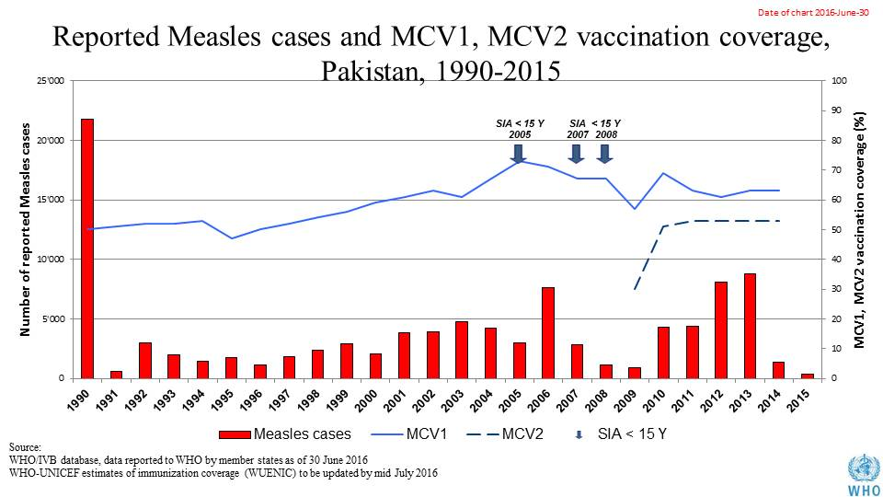

Table 2: SIA activities planned in 2016-2017

|  |  |  |  |  |  |  |  |  |
| --- | --- | --- | --- | --- | --- | --- | --- | --- |
| Activity | Intervention | Year | StartDate | EndDate | AgeGroup | Extent | Status | Target |
| NID | Measles | 2016 | 01/05/2016 |  | 6-59 M | Sub-national | planned | 1120163 |
| NID | TT | 2016 | 01/05/2016 |  | 15-49 Y | Sub-national | planned | 2900000 |
| NID | TT | 2016 | 01/11/2016 |  | 15-49 Y | Sub-national | planned | 2900000 |
| NID | Measles | 2017 | 01/03/2017 |  | 6-59 M | Sub-national | planned | 15786660 |
| SNID | bOPV | 2016 | 24/10/2016 | 27/10/2016 | 0 to 5 years | Sub-National | Planned | 16430173 |
| NID | bOPV | 2016 | 11/01/2016 | 14/01/2016 | 0 to 5 years | National | Planned | 35717767 |
| SNID | bOPV | 2016 | 18/07/2016 | 21/07/2016 | 0 to 5 years | Sub-National | Planned | 6289433 |
| Mop up | bOPV | 2016 | 20/06/2016 | 27/06/2016 | 0 to 5 years | Sub-National | Planned | 2795304 |
| SNID | bOPV | 2016 | 22/08/2016 | 25/08/2016 | 0 to 5 years | Sub-National | Planned | 16430173 |
| NID | bOPV | 2016 | 16/05/2016 | 19/05/2016 | 0 to 5 years | National | Planned | 35717767 |
| Mop up | bOPV | 2016 | 30/05/2016 | 02/06/2016 | 0 to 5 years | Sub-National | Planned | 698826 |
| SNID | bOPV | 2016 | 18/04/2016 | 21/04/2016 | 0 to 5 years | Sub-National | Planned | 22681250 |
| SNID | bOPV | 2016 | 15/02/2016 | 18/02/2016 | 0 to 5 years | Sub-National | Planned | 17335214 |
| Mop up | bOPV | 2016 | 27/01/2016 | 29/01/2016 | 0 to 5 years | Sub-National | Planned | 3040270 |
| NID | bOPV | 2016 | 26/09/2016 | 29/09/2016 | 0 to 5 years | National | Planned | 34941294 |
| NID | tOPV | 2016 | 14/03/2016 | 17/03/2016 | 0 to 5 years | National | Planned | 35717767 |

Source: WHO/IVB Database as at 01 July 2016

1. **MNT**

**MNTE not yet validated. A validation survey being planned for Punjab in October/November 2016**

1. **Coverage and Equity**

Figure 2: All vaccines national coverage, Pakistan, 2000-2015

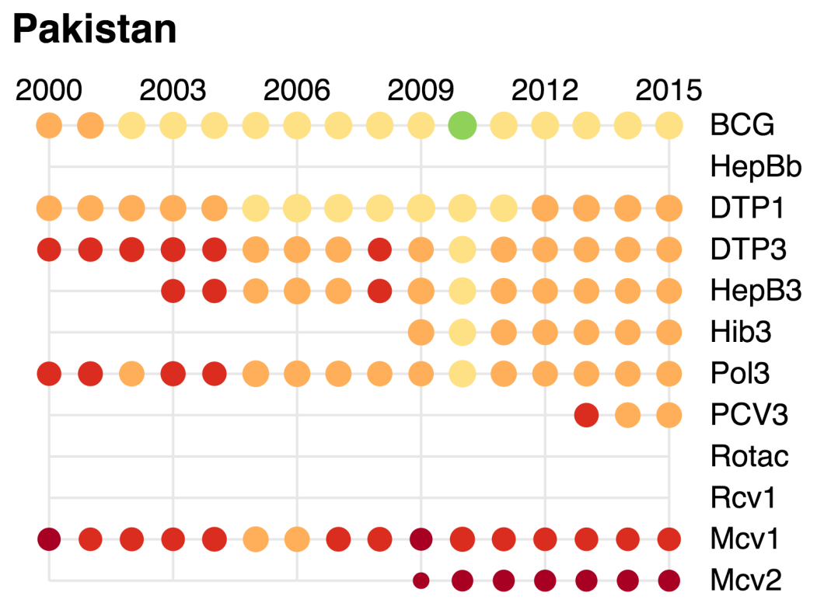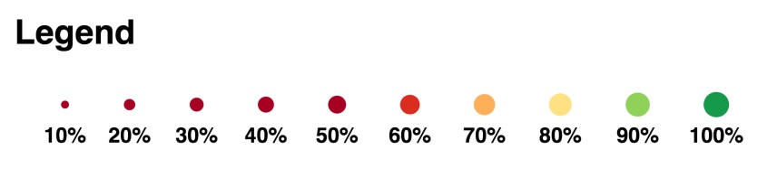

Figure 3: Reported DTPCV doses administered & coverage, Pakistan, 2000-2015

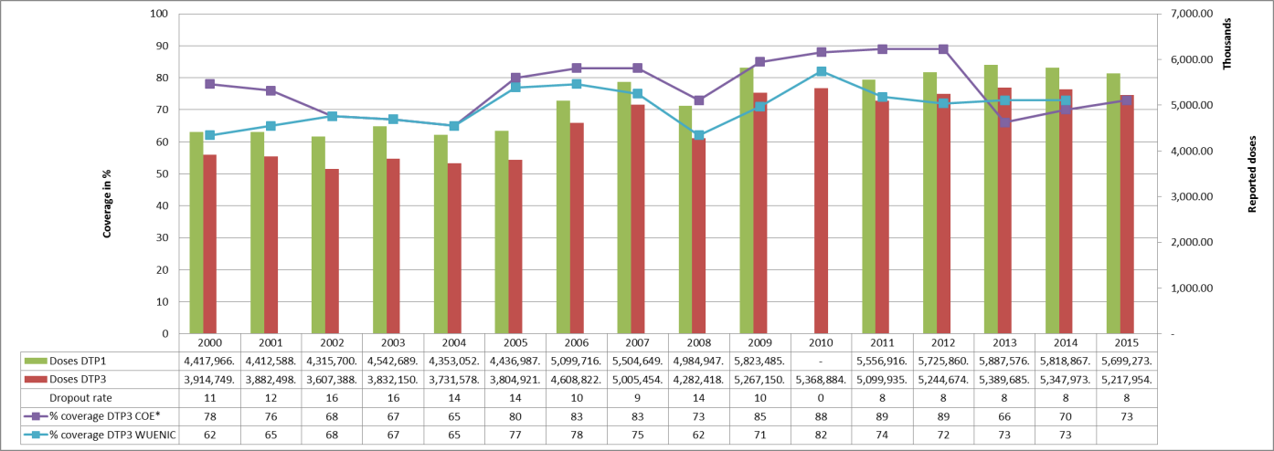

* COE: country Official Estimates

Source:

WHO/IVB database, data reported to WHO by member states as of 1 July 2016

WHO/UNICEF national coverage estimates, 2014 revision, data as of July 2015

Figure 4: Percentage of district achieving <50%; 50-79% and ≥80% coverage, 2000-2015

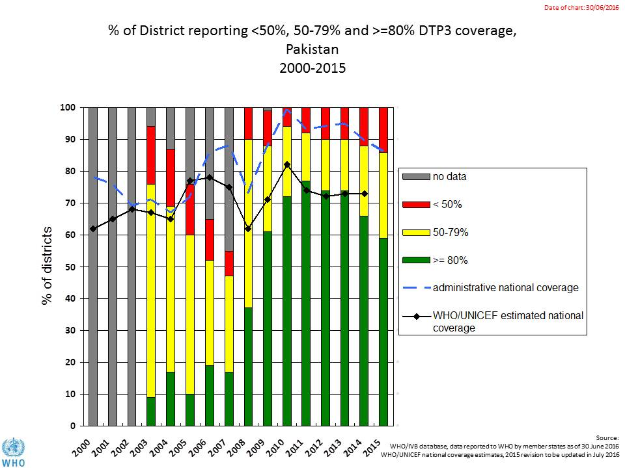

Figure 5: DTP3 coverage by district/province, Pakistan 2010 (admin)



**<50%**

**Not available / No data reported**

**80 – 89%**

**50 – 79%**

**≥90%**

Figure 6: DTP3 coverage by district/province, Pakistan 2015 (admin data)



**<50%**

**Not available / No data reported**

**80 – 89%**

**50 – 79%**

**≥90%**

Figure 7: Immunization coverage data disaggregated by sex and wealth quintile

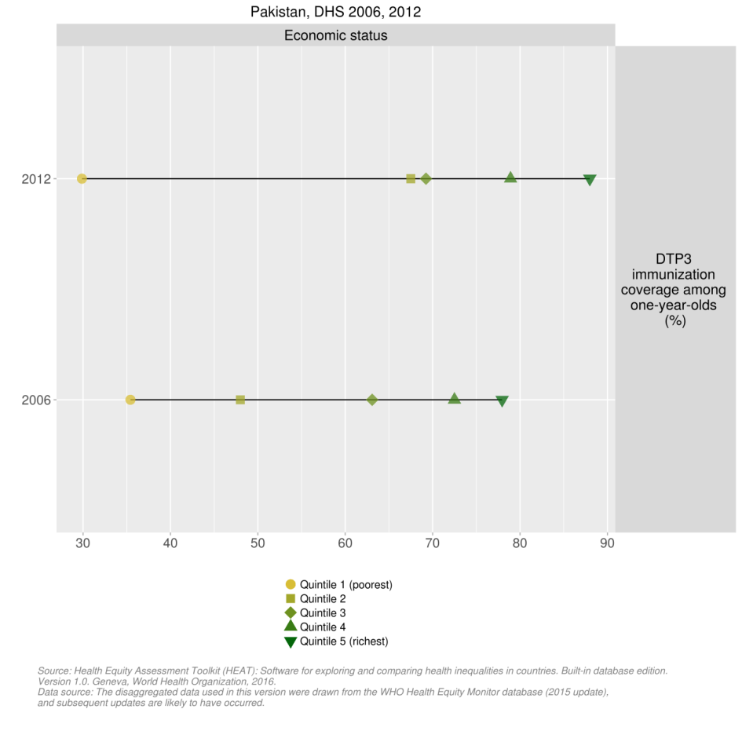

1. **Immunization systems highlights**

* Immunization schedule

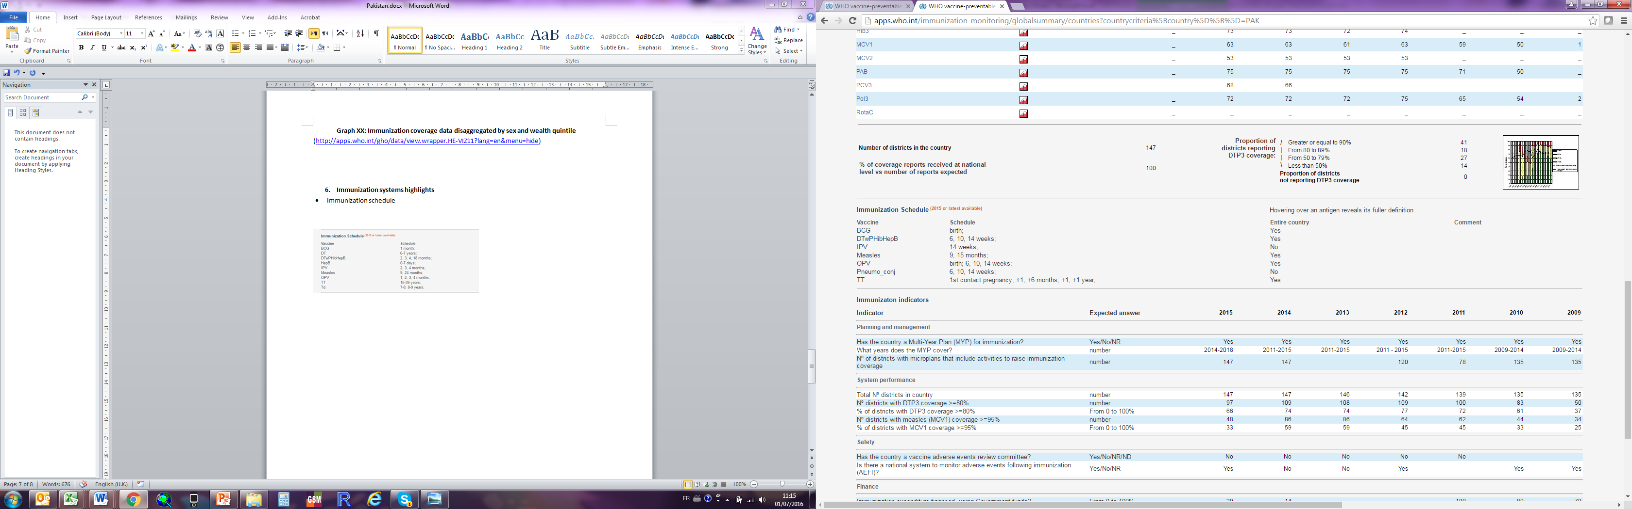

* Planning and management:
* Vaccines stockout: 1 event for BCG (3 months duration)
* cMYP: 2014-2018
* Annual Plan: Yes
* Country decision making: NITAG meeting the 6 minimum criteria defined by WHO for a functioning NITAG
* % of total expenditures on vaccines financed by government funds: 1%