**Global Vaccine Action Plan**

*Secretariat Annual Report 2016*

*Priority Country report on progress towards*

*GVAP-RVAP goals*

**PAKISTAN**

1. **Progress towards achievement of GVAP goals**
2. **Summary**

This summary table describes the current situation in Pakistan regarding achieving the GVAP goals. Data used to assess progress towards achievement of GVAP goals are included in the annex (Country immunization profile).

|  |  |  |
| --- | --- | --- |
| **Area** | **Indicator** | **Pakistan** |
| **3. Measles Elimination** | **Coverage MCV1 (2015 WUENIC)** | **61%** |
| **3. Measles Elimination** | **Coverage MCV2** | **53%** |
| **3. Measles Elimination** | **Percentage of districts with MCV1 coverage >=95% (2015 JRF)** | **33%** |
| **3. Measles Elimination** | **Last national SIA** | **2008** |
| **3. Measles Elimination** | **Post SIA coverage survey conducted** | **No** |

1. **Achieve measles elimination (G2.2) and rubella & CRS elimination (G2.2)**

Pakistan experiences outbreaks of measles in 2006, 2008, and 2013. Out of the 108,888 suspected cases, 8,046 cases of measles were laboratory confirmed. GAVI partially supported the Measles SIA following the massive measles outbreak in Pakistan in 2012 and 2013. The measles campaign was launched in 2014 in the whole of Pakistan except FATA (~3.9% of target population), where the campaign was planned to be conducted in August 2015. The campaign covered 58 million children from 6 months to 10 years of age for measles vaccine with a reported national coverage of 103%. A third party evaluation of the coverage in Sindh province found coverage to be 95%. Following the massive measles outbreak in Punjab in the early 2013, Punjab government took initiative to conduct a mass immunization activity in all districts of Punjab. The provincial government used their own resources to conduct the activity across the province in phases. All vaccine and operational cost were borne by the provincial government. Later, upon completion of the campaign in 23 districts, Punjab Health Dept. decided to conduct a 3rd party survey to assess the coverage independently. Overall coverage was estimated 91.8%. Vaccination coverage was found higher among the <5 age cohort (92.6%) than 5 to <10 years age cohort (90.9%).

**ANNEXES**

1. **Measles and rubella**

Figure 1: Reported measles cases and MCV coverage, Pakistan, 1990-2015

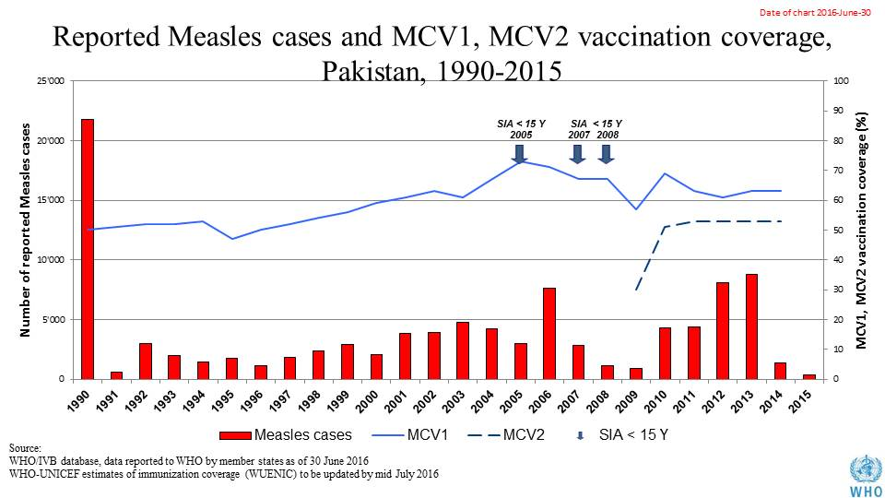

Table 2: SIA activities planned in 2016-2017

|  |  |  |  |  |  |  |  |  |
| --- | --- | --- | --- | --- | --- | --- | --- | --- |
| Activity | Intervention | Year | StartDate | EndDate | AgeGroup | Extent | Status | Target |
| NID | Measles | 2016 | 01/05/2016 |  | 6-59 M | Sub-national | planned | 1120163 |
| NID | TT | 2016 | 01/05/2016 |  | 15-49 Y | Sub-national | planned | 2900000 |
| NID | TT | 2016 | 01/11/2016 |  | 15-49 Y | Sub-national | planned | 2900000 |
| NID | Measles | 2017 | 01/03/2017 |  | 6-59 M | Sub-national | planned | 15786660 |
| SNID | bOPV | 2016 | 24/10/2016 | 27/10/2016 | 0 to 5 years | Sub-National | Planned | 16430173 |
| NID | bOPV | 2016 | 11/01/2016 | 14/01/2016 | 0 to 5 years | National | Planned | 35717767 |
| SNID | bOPV | 2016 | 18/07/2016 | 21/07/2016 | 0 to 5 years | Sub-National | Planned | 6289433 |
| Mop up | bOPV | 2016 | 20/06/2016 | 27/06/2016 | 0 to 5 years | Sub-National | Planned | 2795304 |
| SNID | bOPV | 2016 | 22/08/2016 | 25/08/2016 | 0 to 5 years | Sub-National | Planned | 16430173 |
| NID | bOPV | 2016 | 16/05/2016 | 19/05/2016 | 0 to 5 years | National | Planned | 35717767 |
| Mop up | bOPV | 2016 | 30/05/2016 | 02/06/2016 | 0 to 5 years | Sub-National | Planned | 698826 |
| SNID | bOPV | 2016 | 18/04/2016 | 21/04/2016 | 0 to 5 years | Sub-National | Planned | 22681250 |
| SNID | bOPV | 2016 | 15/02/2016 | 18/02/2016 | 0 to 5 years | Sub-National | Planned | 17335214 |
| Mop up | bOPV | 2016 | 27/01/2016 | 29/01/2016 | 0 to 5 years | Sub-National | Planned | 3040270 |
| NID | bOPV | 2016 | 26/09/2016 | 29/09/2016 | 0 to 5 years | National | Planned | 34941294 |
| NID | tOPV | 2016 | 14/03/2016 | 17/03/2016 | 0 to 5 years | National | Planned | 35717767 |

Source: WHO/IVB Database as at 01 July 2016

1. **Coverage and Equity**

Figure 2: All vaccines national coverage, Pakistan, 2000-2015

