**Global Vaccine Action Plan**

*Secretariat Annual Report 2016*

*Priority Country report on progress towards*

*GVAP-RVAP goals*

**UGANDA**

1. **Progress towards achievement of GVAP goals**
2. **Summary**

This summary table describes the current situation in Uganda regarding achieving the GVAP goals. Data used to assess progress towards achievement of GVAP goals are included in the annex (Country immunization profile).

| **Area** | **Indicator** | **Data for Uganda** |
| --- | --- | --- |
| **Socio-demographic** | **GNI 2014** | **660** |
| **WB status** | **Low Income** |
| **Infant mortality (<12 M) 2015 (UN IAG CME)** | **38** |
| **GAVI status** | **Eligible** |
| **Total population** | 36,860,700 |
| **Birth cohort** | **1,665,000** |
| **Surviving infants (JRF)** | **1,568,000** |
| **1. Interrupt wild poliovirus transmission** | **Transmission Interrupted** | **Yes** |
| **Risk of late detection: Percent of adequate stool specimens (rolling 12 mo.) (Target > 80%)** | **91.3** |
| **Risk of late detection: Non polio AFP rate (rolling 12 mo.)  (Target > 2 per 100,000 )** | **3/100,000** |
| **Risk of spread after importation:  % of 6-59 month olds having received less than 3 doses in the last year before occurrence case/environmental positive)** | **8%** |
| **2. Neonatal tetanus elimination** | **TT2 coverage (reported 2015 on JRF)** | **58%** |
| **Protection at birth against tetanus (WUENIC 2015)** | **85%** |
| **Last SIAs conducted in the country** | **N/A** |
| **Elimination validation date** | **Validated in 2011** |
| **3. Measles Elimination** | **Coverage MCV1 (2015 WUENIC)** | **82%** |
| **Coverage MCV2** | **Not in schedule** |
| **Percentage of districts with MCV1 coverage ≥95% (2015 JRF)** | **46%** |
| **Last national SIA** | **2015** |
| **Post SIA coverage survey conducted** | **No** |
| **4. Rubella/CRS Elimination** | **Rubella-containing vaccine coverage** | **Not introduced** |
| **SIAs planned?** | **Planned for 2018** |
| **5. Reach 90% national coverage and 80% in every district with 3rd dose of DTP-containing vaccine** | **National coverage (WUENIC 2015)** | **78%** |
| **Drop-out rate DTP1 to DTP3 (2015 WUENIC)** | **12%** |
| **Actual numbers of children that dropped out (2014 WUENIC)** | **173,000** |
| **Difference between poorest and richest quintile DTP3 coverage (2013 data)** | **0.3%** |
| **% District coverage reaching 80% coverage from 2015 JRF** | **89%** |
| **6. Reach 90% national coverage and 80% coverage in every district with all vaccines in national immunization programme** | **National coverage (2015 WUENIC)** | **BCG: 93 DTP3-HepB3-Hib3: 78 MCV1: 82 PCV3: 66 Polio3: 82** |
| **7. Introduction of new vaccines** | **New vaccines introduced** | **PCV10 in 2013; HPV in 2015; IPV in April 2016. Meningitis A campaign approved by GAVI. Rotavirus introduction also approved by GAVI but currently on hold by Government** |
| **8. Reduction in under 5 mortality rate** | **Percent reduction from 2010 to 2015** | **2010: 75.2 2015: 54.6 (27.4%)** |
| **9. NITAG** | **NITAG established?** | **Yes (November 2014)** |
| **10. Government expenditure on routine immunization per live birth (US$)** | **Average for 2013-2015 (% change from 2010/2011)** | **2.1 to 7.0 (+232%)** |

1. **Country ownership of the immunization programme**
   1. **Immunization policy decision-making capacity**

In November 2014, Uganda transitioned its Advisory Committee on Immunization (ACVI) into a national independent immunization technical advisory group (NITAG), with technical assistance and training from WHO and the Gates Foundation-funded SIVAC project. Core members come from academia, research institutes and other organizations, with representatives of the MOH, WHO and UNICEF serving as ex-officio members. It currently meets all of the six criteria that WHO has established for a functioning NITAG.

UNITAG has already had an important decision-making role in its short history. First, it raised concerns about the impending introduction of rotavirus and the government’s ability to meet its co-financing obligations and cover operational costs for rotavirus and the other vaccines in the immunization schedule. As a result, the introduction of rotavirus and all other new vaccines is currently on hold until a cost analysis of the immunization program and financial sustainability plan are developed (currently underway with WHO support). Second, UNITAG helped to convince the Parliament to add a provision for an Immunization Fund to the 2016 Immunization Act that mandates vaccination of children and women (with TT). The purpose of the Fund, described below, is to better protect funding for immunization and mobilize additional resources from different sources.

Immunization also enjoys high-level support as a result of the establishment of a Parliamentary Forum on Immunization. The Chairperson of this group was able to block the Parliament’s approval of the entire budget in 2012/13 until additional funds were added to the budget to increase the number of health workers and health worker salaries. The Forum also played a key role in the development and government approval of the Immunization Act (described below).

* 1. **Government financing of immunization**

The Government is meeting its financial commitments in that it is paying for 100% of the procurement costs of all traditional vaccines (BCG, TT, OPV and measles). It was estimated in FY2013/14 that the Government paid 49% of the total immunization budget, with the majority going towards health worker salaries, procurement of traditional vaccines and co-financing of new vaccines (pentavalent, PCV, HPV), vaccine storage and distribution, the staff and operations of the Uganda National EPI (UNEPI), operational costs for polio and measles campaigns, and block grants to the districts to cover the costs of providing primary health care services (called PHC grants).

The Government’s contribution in absolute terms has been increasing – 41% from 2009/10 to 2013/14 – mainly as a result of co-financing of newly introduced vaccines, which has increased six-fold from 2013 to 2016, as first PCV and then HPV were added to the immunization schedule (Figure 1). The country’s co-financing obligation now stands at $2.5 million per year. The Government’s contribution actually declined from 2011 to 2014, due in part to delays in making its co-financing obligations. Uganda has, in fact, been in default in co-financing for GAVI-supported vaccines each year since 2014. This is due to the fact that funds for co-financing are not “ring-fenced” and have been diverted to cover emergencies, such as pension arrears for health staff and salary increases for intern doctors who went on strike. The mismatch between the Government’s quarterly budgetary procedures and GAVI’s fiscal year cycles, as well as devaluation of the Uganda shilling have also contributed to delays in co-financing. These defaults have delayed the introduction of additional vaccines into the routine immunization program, including rotavirus vaccine.

Apart from the issue of co-financing of new vaccines, the government budget for immunization is considered insufficient, and as a result, more costly activities, such as polio and measles campaigns, can mean less funding for routine immunization activities. As mentioned in one report,[1] one national measles campaign can cost the equivalent of two years of recurrent costs for the routine immunization program. Because the Ugandan government could not raise its share of the operational costs for the 2015 measles campaign, the campaign was combined with the introduction of HPV vaccine and Child Health Days, to save costs and to allow funding from the GAVI vaccine introduction grant (VIG) to be used in part for the measles campaign. This resulted in a reduction in the planned activities for the HPV introduction (see below).

Figure 1: **Trends in Ugandan Government financing for immunization**



Annual co-financing obligation to GAVI in Uganda 

In the top chart, the purple bar (GOU) is Uganda government contribution, including shared costs for health worker salaries and the proportion of PHC grant funding going to immunization.[2]

Funding for immunization at the local level comes from PHC grants from the central government, which must pay for all of the operational costs of providing the National Minimum Health Care Package, of which immunization is one component. The grants are distributed to each district, but do not have a fixed percentage allocated to immunization. PHC funding is considered inadequate and as a result, health facilities often lack funding for fuel to operate refrigerators and means of transport and fuel to pick up vaccines from district medical stores or to conduct outreach immunization activities. A lack of funding at the district level makes it difficult for EPI coordinators to conduct supervisory and monitoring visits, assist with RED/REC activities and the like. All of this can negatively affect immunization coverage and overall program performance.

In the aim of mobilizing additional resources for immunization and to meet the Government’s growing co-financing obligations, an Immunization Fund is being established as part of the 2016 Immunization Act. The Fund, currently being designed, will pool funds from the Government, donations and “voluntary contributions” to pay for “vaccines and related supplies, cold chain expenses and immunization outreach activities.” Its reported purpose will be to better protect immunization funding (including co-financing) through “ring-fencing” to prevent its diversion, and to mobilize new resources for immunization, including from private industries, such as telecommunications and pharmaceutical companies.

**2.3 Human resource situation**

Nurses and nursing assistants make up the bulk of health workers who provide immunization services in Uganda. There is a wide range of staffing levels of health professionals by region and district, with the numbers especially inadequate in hard-to-reach and under-served areas, where retention rates are particularly low. Low salaries and a lack of housing in remote areas are key factors making it difficult to recruit and retain qualified health workers. More than 50% of the facilities visited for the Resource Tracking study[3] reported a health worker shortage, while the 2016-2020 Comprehensive EPI Multi-Year Plan (cMYP) reported that 39% of districts reported a health worker vacancy rate of more than 35%.[4] Staff shortages at the health facility level affect morale, as well as the ability of facilities to deliver adequate immunization and other services in the minimum package, including outreach activities.

Concerning immunization-specific staff at the sub-national level, all districts have an EPI focal point, as do 66% of health facilities. Due to staff shortages, this person is often a nursing assistant.[5] Sixty-one percent of districts had no cold chain technician in 2014. Each district also assigns a health officer to serve as the surveillance focal points, who has other responsibilities as well. In addition, there are around 12 surveillance medical officers (SMOs) working at the country’s nine IDSR sub-national hubs and in districts. These are government employees who receive additional funding from WHO to enable them to focus on surveillance and supportive supervision for immunization. WHO also supports most technical staff of the national reference laboratory (Ugandan Viral Research Institute or UVRI).

To link communities to local health facilities, Uganda has a system of Village Health Teams (VHTs), made up of several community-based volunteers in each community who assist with disease surveillance, social mobilization, sanitation activities, registering births, distributing anti-malarial drugs and the like. In the area of immunization, these volunteers participate in social mobilization, especially for vaccination campaigns and new vaccine introductions; community-based surveillance; and default tracking. The recent EPI review found that 89% of health facilities visited had established links with VHTs and that these volunteers are the communities’ primary source of information concerning immunization.[6]

However, the volunteers receive no salary and only a stipend or allowance, as possible, and they must also juggle immunization activities with other health priorities and programs. As a result, the activism and impact of VHTs varies considerably by area. To improve this situation, the Government has approved plans to create a new position of Community Health Extension Worker (CHEW), who will receive a government salary, have higher minimal qualifications that VHTs, and who will gradually replace the VHTs. To make the program more financially sustainable, one CHEW will cover several (e.g., three) villages.

1. **Progress towards specific GVAP goals (issues/challenges/successes)**
   1. **Goal 1: Achieve a world free of poliomyelitis**

Uganda was certified polio-free in October 2006, but has experienced outbreaks of imported wild polio virus (WPV) in 2009 and in 2010/2011. The country has a robust AFP and polio surveillance system, as indicated by the polio target indicators on page 1. This has been the result of various partner-supported efforts and innovations, including:

* A national roll-out of an integrated disease surveillance and reporting (IDSR) system, operating from nine sub-national hubs. By the end of July 2016, district health staff in 108 out of the country’s 112 districts have received IDSR training.
* Both international and national STOP teams that provide on-the-ground short-term assistance to “silent” or poor-performing districts to improve their ability to detect AFP/polio cases as well as other outbreak-prone diseases (e.g., measles, yellow fever) and to improve routine immunization services. The international teams – supported by the U.S. CDC and WHO/AFRO – stay in a region for about a month, while the national STOP team (NSTOP) consists of public health students who spend a week in an area visiting all health facilities to train staff in surveillance and outbreak investigations. The NSTOP program is partner-supported, but funding is considered insufficient.
* An innovative specimen transport system established by the MOH with support from partners that delivers specimens on filter paper to the UVRI laboratory within 24 hours.
* An electronic (mTRAC) system, established in 2012 with WHO and UNICEF support, in which health facility staff submit IDSR data for key diseases to districts via mobile phones using a simple interface on a weekly basis. The data are then transferred up the chain. While it has been implemented nation-wide, there are issues with the availability of cell phones and reliability of network connections.

In addition, the country has organized polio national immunization days (NIDs) every year for several years, as well as sub-national immunization days (SNIDs) in high-risk and outbreak districts for children under five. Additional doses of OPV are also provided during the country’s annual Child Health Days. UNEPI introduced IPV into the immunization schedule in April 2016.

There are, however, a number of challenges to sustaining the country’s polio-free status:

* While the national AFP detection and stool adequacy rates meet the targets, not all districts achieve the minimum rates.[7] The surveillance system is also not sensitive enough to detect every possible case of wild polio virus or vaccine-derived virus in a timely fashion. In addition, active surveillance of vaccine-preventable diseases is not conducted systematically in some areas, due to delays in the disbursement of funds from higher levels, affecting the timely investigation and notification of cases. Reportedly, inadequate surveillance led to under-detection of WPV circulating along the border with Kenya, which caused the last outbreak in 2011.
* There is cross-border transmission of polio from areas and populations with low immunization rates, such as across the borders with Kenya and S. Sudan. Synchronized NIDS with bordering countries have been discussed, but have yet to take place.
* There also exist pockets of low polio immunization coverage within the country, including in communities bordering S. Sudan and some fishing communities.
* The frequent turnover of health staff at the district and health facility levels mean that many people trained in IDSR have left. Thus, frequent trainings are needed to train new staff, which is costly.
  1. **Goal 2 : Meet global and regional elimination targets**

**3.2.1 Achieve maternal and neonatal tetanus elimination**

Uganda received validation for having eliminated MNT in 2011. The main strategies the country is employing to sustain elimination consist of:

* TT immunization of high school girls (15-17 year olds) through annual school-based vaccination campaigns;
* A strong culture of vaccinating all women who come for antenatal care services (the rates of which have been increasing) with at least two doses of TT.
* Mandating of TT vaccination for all women 18-49 years of age, as well as for all 15-17 year old girls through the new Immunization Act. Parents and schools are held responsible for ensuring vaccination of girls and can receive fines or imprisonment if they are not (the same holds true for 18-49 year old women).

The current TT coverage rate for two or more doses is 58% among pregnant women, while the protection at birth (PAB) rate among infants is 85%. The low TT coverage rate is reportedly due to recording problems rather than to women not being vaccinated, as women who have received the full time doses or only need one more dose when they are pregnant are not often not included in the TT2 coverage reports.

There remains some risk of not sustaining the elimination in some areas of the country, however, due to weak implementation of case-based NNT surveillance in some districts to confirm whether reported cases are truly NNT. At least one district in the 2011 MNT risk assessment report had a rate above 1/1,000 live births.[8] In addition, the stated policy of ring vaccination around a confirmed case is probably not taking place, according to two informants. A further constraint to high TT coverage rates is that target-age girls not enrolled in school are missed through the school-based program. In addition, health personnel have difficulty calculating PAB rates and require training in this.

The following steps can help ensure sustainability of MNT elimination:

* Improve NMT surveillance, including investigating and testing all suspected cases;
* Strengthening and sustaining the school-based TT vaccination program for girls, and extend it to 15-17 year old girls not in school;
* Provide additional booster doses (of TT or Td) during childhood and include boys, since there have been a few cases in young men following circumcision. This proposal is currently under discussion within the government.
  + 1. **Achieve measles elimination and rubella & CRS elimination**

Measles

An estimated 46% of districts achieved coverage with a single dose of measles vaccine of ≥95% in 2015, against the GVAP target of 100% of districts, according to the Joint Reporting Form. National measles vaccination coverage is estimated by WHO and UNICEF at 82% in 2015. The country has experienced measles outbreaks each year of different magnitude, in areas with low vaccination coverage. Uganda is therefore not currently on track to eliminate the disease by 2020.

A key factor contributing to the continuing outbreaks is that, due in part to a global shortage of measles vaccine, actual measles vaccination coverage in 2012 was only around 30%, according to the cMYP (in contrast to the considerably higher WUENIC estimate). Because of this as well as continued low coverage in some areas of the country, there were an estimated 1.56 million children not immunized against measles by 2013.[9] This has created a large susceptible population of unimmunized older children and a consequent shift in the age of cases to older children and adults, who have the potential of causing outbreaks.

Key challenges and issues affecting Uganda’s ability to meet the measles elimination target include:

* The fact that case-based measles surveillance is still weak and only an estimated 35% of cases are investigated, according to one informant. There continues to be some “silent districts” and delays in reporting cases to higher levels of the system. The reasons are many of the same mentioned above, including a shortage of health workers, means of transport and fuel to investigate cases in the field and to collect and transport specimens to the reference lab. Polio funds are often used for case investigations, specimen transport and testing.
* While national measles SIAs take place every three years, along with localized campaigns in outbreak areas, actual coverage rates of these campaigns is unknown, due to data quality issues (reported coverage rates are often 100% or higher). The frequency of the SIAs is, however, considered adequate.
* Rapidly reducing the population of susceptibles who were missed due to poor vaccination coverage in the past would require conducting SIAs (e.g., using MR vaccine) for a wide-age cohort, such as 9 month to 15 year olds. However, the Government lacks the funding to conduct these and GAVI provides supports only for SIAs targeting children under five. However, UNEPI plans to conduct SIAs with measles-rubella vaccine in 2018, with GAVI support, which will target children up to 14 years of age.

It should be noted that the Government plans to introduce a second measles vaccine dose into the routine schedule (using MR vaccine). The year of introduction will depend on the results of the cost assessment and financial sustainability plan currently in progress and subsequent decisions about other new vaccine introductions.

Rubella

According to informants, rubella outbreaks have been occurring, and many suspected cases of measles that are not lab-confirmed are believed to be rubella. For instance, while the routine disease surveillance system reported more than 60,000 cases of measles in 2015, many of these are believed to have been rubella. To quickly reduce rubella transmission in the population, UNEPI is planning MR catch-up campaigns in 2018, with GAVI support.

**3.3 Goal 3: Meet vaccination coverage targets**

* 1. **Achieve 90% national coverage and 80% coverage in every district with 3 doses of diphtheria-tetanus-pertussis containing vaccine**
  2. **Achieve 90% national coverage and 80% coverage in every district with all vaccines included in the national schedule**

These targets have largely not been met. The WUENIC estimates for the third dose of pentavalent (DPT-HepB-Hib) vaccine have been 78% national for the past three years (2012 to 2014), and slightly down from 82% in 2011, with an estimated drop-out rate between the first and third doses of 12% nationally. However, according to data from the Joint Report Format, the country is close to meeting the district target, with 86% of districts having achieved 80% or greater coverage for three pentavalent doses. There are no district-specific WUENIC estimates, however, and the JRF data are based largely on administrative data, so caution should be taken in reading these statistics. A coverage survey is currently underway, which should provide a more accurate picture of both national and district-level immunization coverage.

According to the 2015 WUENIC estimates, the 90% national coverage goal has been achieved for BCG (93%), but was 82% for three polio doses, 82% for measles, and 66% for PCV3, which was introduced over a period of a year in 2013 and 2014. District-level WUENIC estimates for these vaccines (to determine the percent of districts reaching 80% coverage) are not available.

An assessment of equity of immunization coverage by geographic areas, income level and other variable is currently taking place.

Key factors affecting UNEPI’s ability to reach its coverage targets include:

* **Insufficient availability of static immunization services**: While national policy requires that all health facilities with refrigerators offer immunization services on a daily basis, the 2015 Comprehensive EPI, surveillance and immunization financing review (referred to as the “EPI review” in this document) found that only 40% of the 55 health facilities visited provided EPI daily, 18% had sessions 2-3 times a week, and 58% provided only one session per week. This is despite the fact that most facilities (88%), including hospitals and health centers levels II-IV, had working refrigerators. A key factor is staff shortages, making it difficult for health clinics to provide daily immunization along with all of the other services in the minimum health services package. One informant fears that adding more vaccines to the immunization schedule will make it even more difficult for health facilities to provide all vaccines on schedule. Another factor is spotty social mobilization, especially for routine immunization, affecting demand, especially for subsequent vaccine doses.
* **Insufficient outreach activities in many areas and inadequate implementation of Reach Every Community (REC) strategies**: Outreach activities were found to be irregular and insufficient in many sites included in the EPI Review. The shortage of health workers is a key reason; many facilities have only two or so qualified personnel and thus conducting outreach activities (which usually require at least two staff members) means closing down the clinic. The lack of transport and fuel due to insufficient PHC grant funds is another key factor. The 2015 GAVI Full Country Evaluation for Uganda found that only around 10% of Health Centres II had access to any vehicle for vaccination, while the rate was around 45% and 60% for Health Centres II and IV, respectively.[10] The EPI Review found that only 20% of health facilities had REC microplans, as did only 8 out of 112 districts. Poor implementation of REC/RED is reportedly due to insufficient training of health workers in microplanning, high health worker attrition rates, resulting in many workers not knowledgeable in microplanning, and a lack of funding to carry out microplanning activities.
* **Vaccine shortages or stock outs at the local level**: The transition of responsibility for the storage and distribution of vaccines from UNEPI to the National Medical Stores (NMS) in 2012/13 has been completed, and after initial problems, the system was deemed “robust” since April 2014[11] and the time it takes for vaccines to reach all districts from the central level has been cut in half (to two weeks). Nonetheless, 71% of health facilities and 96% of districts in the 2015 EPI review reported at least one vaccine stock out in the previous three months, especially PCV and BCG. While a global shortage of BCG contributed to the stock outs of this vaccine, other contributing factors for local vaccine stock outs are poor vaccine forecasting (especially denominator issues), lack of adequate cold storage space in some district stores, and perhaps most importantly, the continuing need for health facilities to collect vaccine from the district stores and their difficulty in doing so due to the lack of vehicles and fuel discussed above. “Last mile” vaccine delivery will therefore require additional funding.
* **Insufficient monitoring and supportive supervision**: A supervision infrastructure is in place, with EPI Coordinators in each district and some sub-districts. However, regular supervision is lacking in many areas, due to insufficient funds and transportation to make supervisory visits. In addition, the EPI review found that defaulting tracking was occurring regularly in only 38% of health facilities. However, the situation is improving with the establishment of Regional Supportive Supervision Teams, starting in 2015. The teams, described in the last section of this report, are already operating in 11 of the country’s 14 regions, with funding from the polio program (and the HSS grant in the future).

The EPI Revitalization Plan, enacted by the Government from 2012 to 2014 in response to declining or plateauing coverage rates and disease outbreaks, has demonstrated that many of these issues and bottlenecks can be resolved with an infusion of funds and attention. With funding from many partners, the plan focused on improving coverage in poor-performing districts by providing the means with which to strengthen social mobilization, outreach activities, vaccine collection from district stores, supervision and the like (see description in the last section). Administrative coverage data show an increase in coverage between 2010 and 2015, which many attribute in large measure to the plan (see maps in annex).[12]

**3.4 Goal 4: Introduce new and improved vaccines and technologies**

In recent years, UNEPI has introduced PCV (in 2013-14), HPV (in 2015) and IPV (in April 2016. Below is a summary of the PCV and HPV introductions:

* **PCV**: The vaccine was launched in one district in April 2013, but not in the rest of the country until 2014, when introduction was phased in from January to June in three phases. Nation-wide introduction was stretched out over more than a year for a number of reasons, including delays in the release of government funds to the districts for training, due to the establishment of a new financial management system. The training at the local level was comprehensive (lasting three days, including refresher EPI training) and the PCV post-introduction evaluation (PIE) indicates good knowledge about the vaccine among health workers.[13] However, it also found that not all staff administering PCV had received formal (vs. on-the-job) training in 35% of facilities. PCV coverage has been low (50% in 2014), due to the phased in roll-out, global shortages of PCV, which required the national medical stores (NMS) to ration the vaccine; and forecasting issues, including under-estimating the demand for the vaccine. The PIE conducted in February 2015 found “suboptimal routinization of PCV”, but it has become a regular part of the immunization schedule since then.
* **HPV**: UNEPI’s strategy is to vaccinate all 10 year old girls through fixed facilities, combined with outreach at schools and other community settings. The introduction, originally planned for April 2015, was delayed until November, due to a shortage of cold storage space at the central level and of refrigerators as lower levels. This was in turn due to procurement problems that have prevented the expansion of the cold chain system, including central cold storage facilities at NMS, with HSS funding. To enable the introduction of HPV, UNICEF renovated existing NMS facilities for temporary storage of the vaccine using GAVI HSS funds. The introduction was combined with measles SIAs and Child Health Days to save costs, since the Government was unable to raise its 50% share of operational costs for the measles campaign. Consequently, GAVI vaccine introduction grant funds for HPV were used for the training and other operational costs for the combined campaigns/HPV introduction. This resulted in short changing the HPV introduction, as training was reduced from three to one day and little social mobilization for HPV took place. Nonetheless, population acceptance has reportedly been good. Coverage data are not yet available, though reportedly the outreach activities, such as to schools, are insufficient, due to a lack of funding.

The introduction of rotavirus vaccine was scheduled for 2016, but due to problems with the Government meeting its co-financing obligations and concerns voiced by UNITAG about the financial sustainability of additional vaccines, this activity is currently on hold. UNEPI plans to apply to GAVI for support for rotavirus vaccine introduction once the financial sustainability plan has been completed, UNITAG has provided guidance, and the country has paid its co-financing arrears, as well as responded to the recommendations of the GAVI program capacity assessment conducted in 2015.

1. **Partner support to address remaining challenges to meet the GVAP goals and targets**

Partner support for immunization activities is similar to that in many other GAVI-supported countries, with major partners providing financial support and technical assistance for polio and measles immunization campaigns, new vaccine introductions, surveillance, training, social mobilization, cold chain improvements and so forth (see Table 1). It should be noted that much of the GAVI HSS funding had been on hold for several years due to procurement issues related to the expansion of the cold chain system (including cold room expansion at the national level, construction of district-level cold rooms, and procurement of cold chain equipment), as well as the construction of health worker housing. These issues have recently been resolved and GAVI has approved a second HSS grant (HSS II), with implementation expected to begin in 2017.

Table 1: Major partners supporting Uganda’s immunization program and their main activities[14]

| **Donor/partner** | **Recent key activities funded** | **Financial contribution to EPI (as a percent of total spending in 2013/14)** |
| --- | --- | --- |
| GAVI | New vaccine introductions  Measles/polio SIAs  EPI training  EPI outreach activities  Supportive supervision  Social mobilization  HSS (partially implemented): funding for cold chain system expansion, construction of health worker housing, provide private sector health facilities with cold chain equipment and training | 27% |
| UNICEF | Social mobilization (e.g., at community level)  Immunization campaigns/SIAs  Family Health Days  Microplanning/RED/REC implementation  Cold chain improvements (e.g., remote temperature monitoring system development)  Equity assessment | 11.5% |
| WHO | Disease surveillance  Immunization campaigns/SIAs  New vaccine introductions  Policy and leadership (development of NITAG, financial sustainability plan)  Cold chain improvements (EVM implementation) | 8% |
| USAID/MCSP (in 5 districts) | Support RED strategy and local-level micro-planning  Supportive supervision | ≈3% |
| U.S. CDC | Data quality improvements (DITs)  NSTOP activities to strengthen surveillance | NA |
| CHAI | Supportive supervision  Logistics management | NA |

At the local level, partner support is especially critical to fill in the gaps in funding for both routine immunization and campaigns, given the inadequacy of PHC grant funds from the government and lack of earmarking of these funds for EPI. The GAVI Resource Tracking Evaluation (2013/14) showed that in the seven districts included in the study, if one excludes health worker salaries and the costs of purchasing, storing and distributing vaccines, partners paid for nearly all (97%) of district-level immunization-specific activities – largely SIAs and training – with UNICEF covering 57%, WHO 21%, and GAVI 19%. PHC funding covered only 3% of these expenditures.[15]

Below we describe by objective several partner-supported projects or initiatives that address specific weaknesses in Uganda’s immunization program and have made or have the potential to make a significant difference in the program’s performance.

To increase government funding for immunization and improve advocacy and decision-making:

* **Support to a high-level immunization lobbying group**: Through a Gates Foundation-funded project, the Sabin Institute, along with WHO and other partners, has assisted the Parliamentary Forum on Immunization in advocating for increased government spending on immunization. The Forum’s efforts led to the drafting and enactment of the Immunization Act that includes a provision for an Immunization Fund. The Forum also encourages politicians to promote immunization amongst their constituents.
* **Support for the NITAG**: Partners, especially WHO and the SIVAC project, supported the country in establishing a NITAG and making it operational. UNITAG, as described above, has already played a critical role in making decisions about new vaccine introductions – adding the criteria of affordability and sustainability – called for a financial sustainability plan to be conducted, and was instrumental in getting an Immunization Fund provision added to the 2016 Immunization Act.

To improve EPI coverage and program performance:

* **Implementation of EPI Revitalization Plan**: This plan was enacted by the Government from 2012 to 2014 with funding from UNICEF, WHO, USAID, CHAI, CDC, and other partners to fill in gaps in immunization service delivery in poor-performing districts. The infusion of funding, along with technical assistance, was used to strengthen the role of VHTs in promoting immunization and in organizing outreaches; purchase vehicles and fuel to increase outreach activities and to pick up vaccines from district stores; increase supervisory visits; and implement RED/REC and microplanning. As shown in the Annex, the number of districts meeting the target of 80% coverage with three doses of DPT-containing vaccine increased significantly from 2010 to 2015, with informants attributing these gains to this Plan.
* **Assisting private health facilities in providing quality immunization services**: One objective of the GAVI HSS grant that is being implemented is to improve immunization services in private sector health facilities, which make up an estimated 19% of all health service providers in the country.[16] This is being done by procuring refrigerators and other cold chain equipment for around 90 private clinics in Kampala, as well as providing immunization training and supportive supervision to health workers in these facilities. The equipment procurement was delayed due to the lack of involvement of key stakeholders in selecting the health facilities and to other issues, but is now being implemented.
* **Establishment of Regional Supportive Supervision Team**: Partners, including WHO, CHAI and UNICEF, have assisted the Government in establishing these teams to increase the regular supervision of health workers, a critical element in improving and sustaining the performance of the immunization program and other components in the minimum health care services package. The teams – made up of regional EPI and IDSR supervisors, and other health professionals – operate from the regional reference hospitals and are each responsible for providing integrated supervision in to the districts in their region. Begun in 2003 with polio funding, teams have already been established in 11 of the country’s 14 regions.

To improve the quality of EPI and other health data:

* **Establishment of Data Improvement Teams (DITs)**: The quality of immunization and other health data in Uganda needs to be strengthened, as evidenced by the 11 or 12 point difference in immunization coverage estimates between the government’s administrative data and the WHO/UNICEF estimates (e.g., 89% vs. 78% for pentavalent 3 and 94% vs. 82% for measles). Several partners, including the U.S. CDC, WHO and UNICEF, are supporting the establishment and training of district-level teams, each consisting of the district biostatistician, immunization focal point, surveillance officer and other relevant district health team members. The teams are responsible for mentoring and training health facility staff in data management and harmonization, with an focus on immunization data and using DHIS2 software. Training of trainers and district-level trainings have taken place and teams are currently operating in 13 of the country’s 14 regions. The DITs are envisioned to have regular meetings to review data, such as part of surveillance meetings. A major gap is that there is at present little supervision and follow up of the DITs.

**Acknowledgments**

We would like to thank the following people who were interviewed for this report:

* Emmanuel Tanywa (WHO CO)
* Annet Kisakye (WHO CO)
* Meseret Eshetu (WHO IST/ESA)
* Tracey Goodman (WHO HQ)

**ANNEX: Country immunization profile**

1. **General indicators**

* GNI (USD): 660
* WB Status: Lower Income
* Infant mortality (<12 M) rate: 38
* GAVI Status: Eligible
* Total Population: 39,032,000
* Birth Cohort: 1,665,000
* Surviving Infants: 1,568,000

1. **Polio**

* Transmission stopped in 2011.
* Eradication certified in 2006 and in 2015 ARCC accepted a report on the response to the imported WPV outbreak following complete documentation.

1. **Measles and rubella**

Figure 2: Reported measles cases and MCV1 coverage, Uganda, 1990-2015

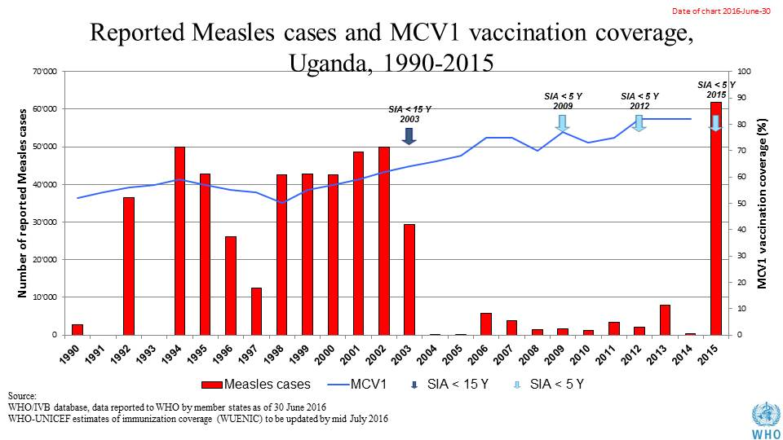

**Table 2: SIA activities planned in 2016-2017**

|  |  |  |  |  |  |  |  |  |
| --- | --- | --- | --- | --- | --- | --- | --- | --- |
| **Activity** | **Intervention** | **Year** | **Start Date** | **End Date** | **Age Group** | **Extent** | **Status** | **Target population** |
| SNID | tOPV | 2016 | 23/01/2016 | 25/01/2016 | 0 to 5 years | Sub-National | Planned | 2,540,476 |
| NID | tOPV | 2016 | 01/04/2016 | 03/04/2016 | 0 to 5 years | National | Planned | 8,092,606 |
| SNID | tOPV | 2016 | 23/04/2016 | 25/04/2016 | 0 to 5 years | Sub-National | Planned | 4,046,303 |

Source: WHO/IVB Database as at 01 July 2016

1. **MNT**

MNTE elimination was validated in 2011.

1. **Immunization coverage and equity**

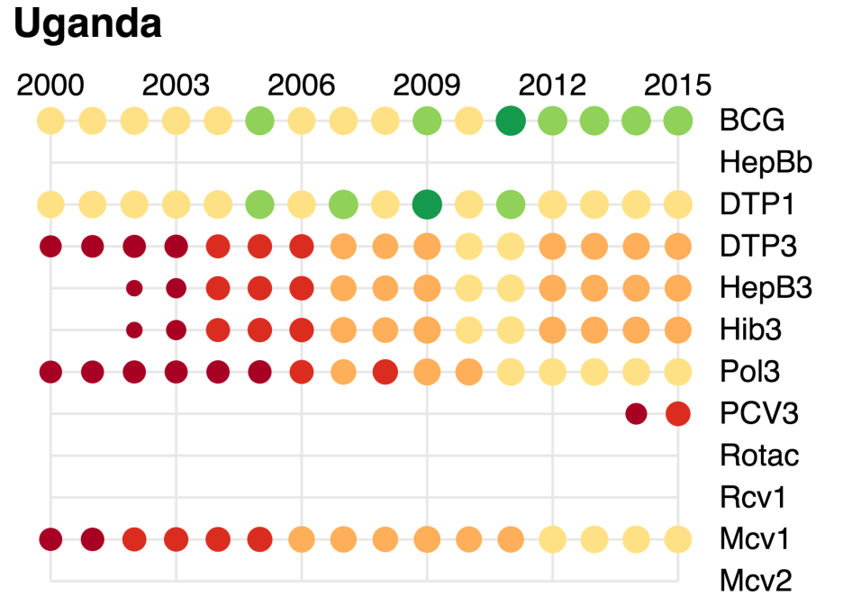

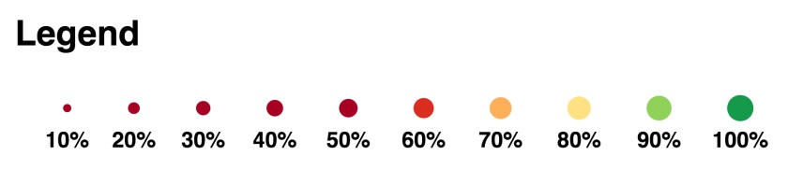

Figure 4: Reported DTPCV doses administered & coverage, Uganda, 2000-2015

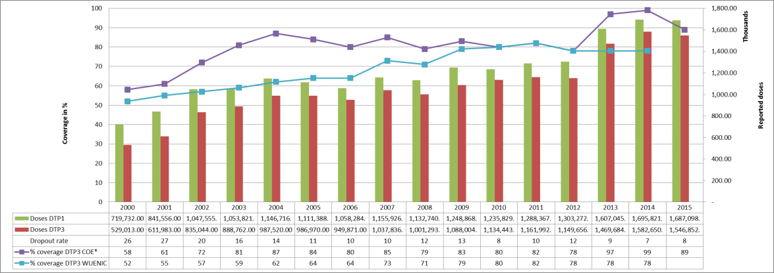

* COE: country Official Estimates

Source: WHO/IVB database, data reported to WHO by member states as of 1 July 2016

WHO/UNICEF national coverage estimates, 2014 revision, data as of July 2015

Figure 5: Percentage of district achieving <50%; 50-79% and ≥80% coverage, 2000-2015, administrative data

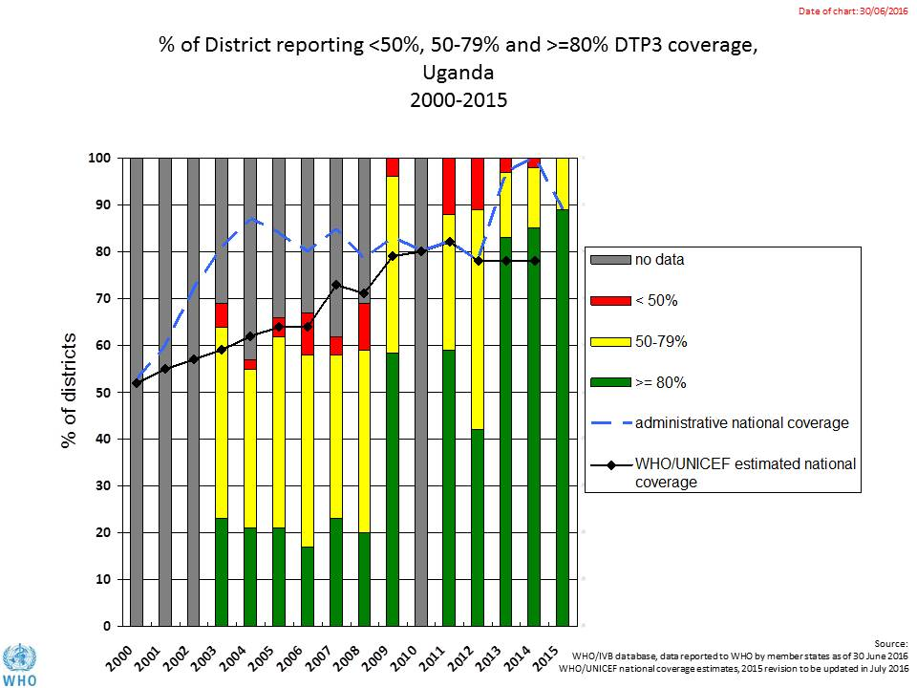

**Figure 6: DTP3 coverage by district/province 2010 and 2015 (administrative data)**

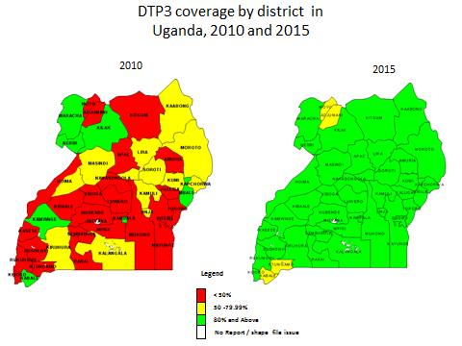

Figure 7: Three-dose pentavalent coverage from 2010 to 2015, based on the GAVI Full Country Evaluation household survey conducted in 19 districts in 2015



**Figure 8: Immunization coverage data disaggregated by sex and wealth quintile**

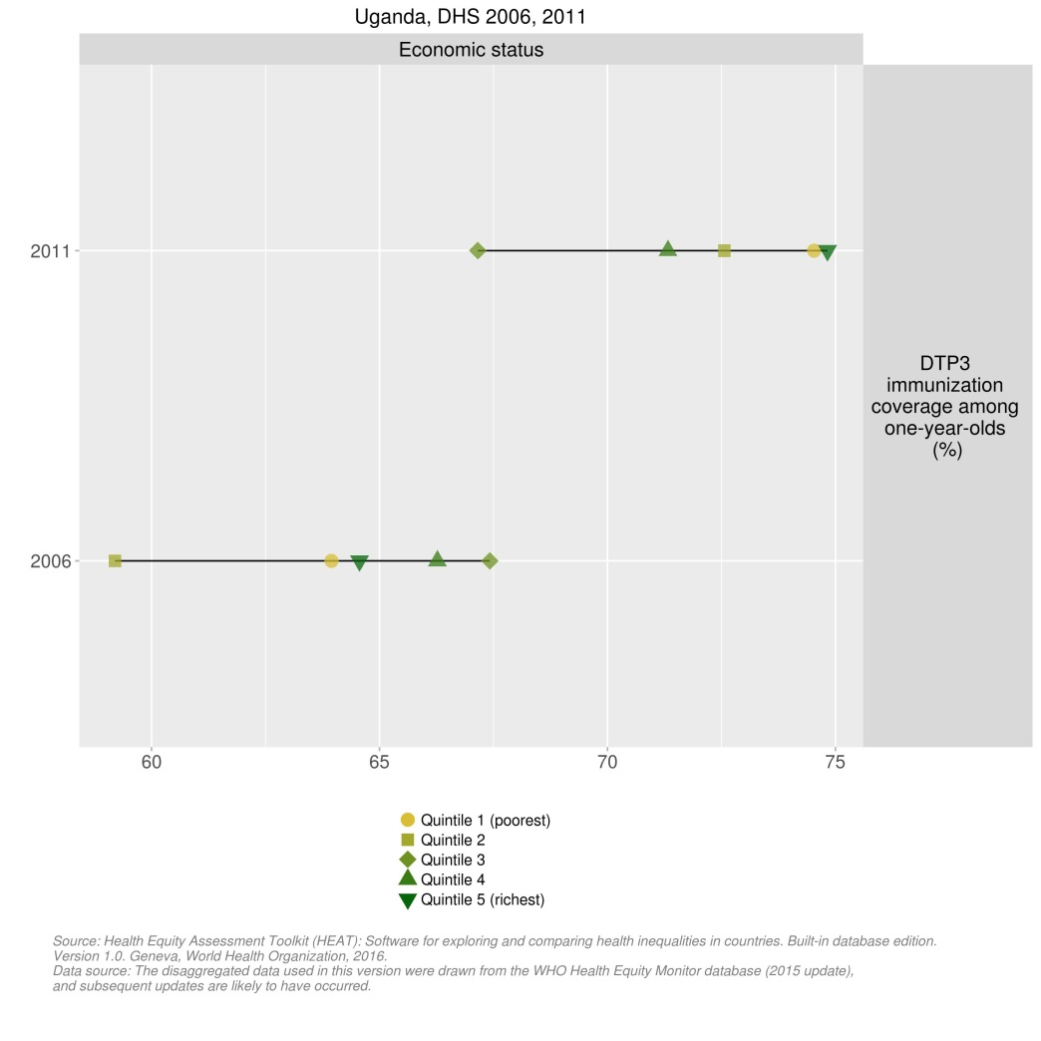

1. **Immunization systems highlights**

* Immunization schedule

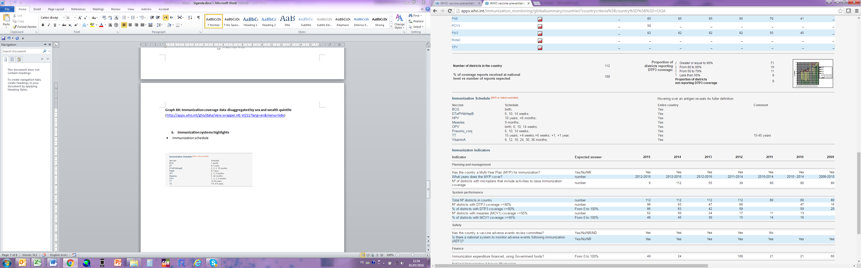

* Planning and management:
  + - Stockouts events in 2015: 1 month for BCG
  + cMYP: 2012-2016
  + Annual Plan: Yes
* Country decision making: A NITAG was established in 2014 and meets five of the six minimum criteria defined by WHO for a functioning NITAG.
* % of total expenditures on vaccines financed by government funds: 15%

1. Uganda Comprehensive EPI, Surveillance, Immunization Financing Review and Post-introduction Evaluation of Pneumococcal vaccine, 23 Feb – 6 March 2015.
2. Sources: Resource Tracking for Immunization in Uganda, 2013/14, Full Country Evaluation brief, 2015.
3. Resource tracking for immunization in Uganda, 2013/14, GAVI evaluation. HealthNet Consult Infectious Diseases Research Collaboration, August 4, 2015.
4. Government of Uganda. The Uganda national Expanded Programmed on Immunisation multi-year plan, 2016-2020.
5. Uganda Comprehensive EPI, Surveillance, Immunization Financing Review and Post-introduction Evaluation of Pneumococcal vaccine, 23 Feb – 6 March 2015.
6. Uganda Comprehensive EPI, Surveillance, Immunization Financing Review and Post-introduction Evaluation of Pneumococcal vaccine, 23 Feb – 6 March 2015.
7. CMYP.
8. cMYP.
9. Uganda Comprehensive EPI, Surveillance, Immunization Financing Review and Post-introduction Evaluation of Pneumococcal vaccine, 23 Feb – 6 March 2015.
10. GAVI Full Country Evaluation, 2015 annual dissemination report, Uganda report.
11. cMYP.
12. Note that the WUENIC estimates for those years to not reflect these reported increases in coverage over this period and the WUENIC estimates are currently being challenged.
13. Uganda Comprehensive EPI, Surveillance, Immunization Financing Review and Post-introduction Evaluation of Pneumococcal vaccine, 23 Feb – 6 March 2015.
14. I got this table from the GAVI Resource Tracking document and expanded upon it, using the PEF and what I know. Not sure of its accuracy and I need some help to complete (e.g., from WCO).
15. Resource tracking for immunization in Uganda, 2013/14, GAVI evaluation. HealthNet Consult Infectious Diseases Research Collaboration, August 4, 2015.
16. CMYP.