**Global Vaccine Action Plan**

*Secretariat Annual Report 2016*

*Priority Country report on progress towards*

*GVAP-RVAP goals*

**UGANDA**

1. **Progress towards achievement of GVAP goals**
2. **Summary**

This summary table describes the current situation in Uganda regarding achieving the GVAP goals. Data used to assess progress towards achievement of GVAP goals are included in the annex (Country immunization profile).

| **Area** | **Indicator** | **Data for Uganda** |
| --- | --- | --- |
| **3. Measles Elimination** | **Coverage MCV1 (2015 WUENIC)** | **82%** |
| **Coverage MCV2** | **Not in schedule** |
| **Percentage of districts with MCV1 coverage ≥95% (2015 JRF)** | **46%** |
| **Last national SIA** | **2015** |
| **Post SIA coverage survey conducted** | **No** |

* + 1. **Achieve measles elimination and rubella & CRS elimination**

Measles

An estimated 46% of districts achieved coverage with a single dose of measles vaccine of ≥95% in 2015, against the GVAP target of 100% of districts, according to the Joint Reporting Form. National measles vaccination coverage is estimated by WHO and UNICEF at 82% in 2015. The country has experienced measles outbreaks each year of different magnitude, in areas with low vaccination coverage. Uganda is therefore not currently on track to eliminate the disease by 2020.

A key factor contributing to the continuing outbreaks is that, due in part to a global shortage of measles vaccine, actual measles vaccination coverage in 2012 was only around 30%, according to the cMYP (in contrast to the considerably higher WUENIC estimate). Because of this as well as continued low coverage in some areas of the country, there were an estimated 1.56 million children not immunized against measles by 2013.[1] This has created a large susceptible population of unimmunized older children and a consequent shift in the age of cases to older children and adults, who have the potential of causing outbreaks.

Key challenges and issues affecting Uganda’s ability to meet the measles elimination target include:

* The fact that case-based measles surveillance is still weak and only an estimated 35% of cases are investigated, according to one informant. There continues to be some “silent districts” and delays in reporting cases to higher levels of the system. The reasons are many of the same mentioned above, including a shortage of health workers, means of transport and fuel to investigate cases in the field and to collect and transport specimens to the reference lab. Polio funds are often used for case investigations, specimen transport and testing.
* While national measles SIAs take place every three years, along with localized campaigns in outbreak areas, actual coverage rates of these campaigns is unknown, due to data quality issues (reported coverage rates are often 100% or higher). The frequency of the SIAs is, however, considered adequate.
* Rapidly reducing the population of susceptibles who were missed due to poor vaccination coverage in the past would require conducting SIAs (e.g., using MR vaccine) for a wide-age cohort, such as 9 month to 15 year olds. However, the Government lacks the funding to conduct these and GAVI provides supports only for SIAs targeting children under five. However, UNEPI plans to conduct SIAs with measles-rubella vaccine in 2018, with GAVI support, which will target children up to 14 years of age.

It should be noted that the Government plans to introduce a second measles vaccine dose into the routine schedule (using MR vaccine). The year of introduction will depend on the results of the cost assessment and financial sustainability plan currently in progress and subsequent decisions about other new vaccine introductions.

**ANNEX: Country immunization profile**

1. **Measles and rubella**

Figure 2: Reported measles cases and MCV1 coverage, Uganda, 1990-2015

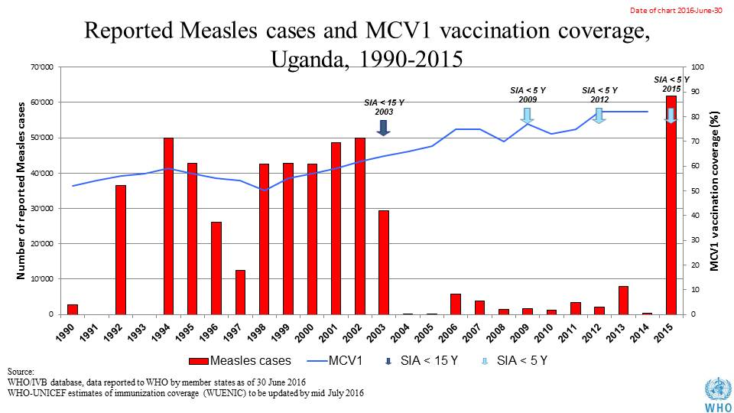

1. **Immunization coverage and equity**

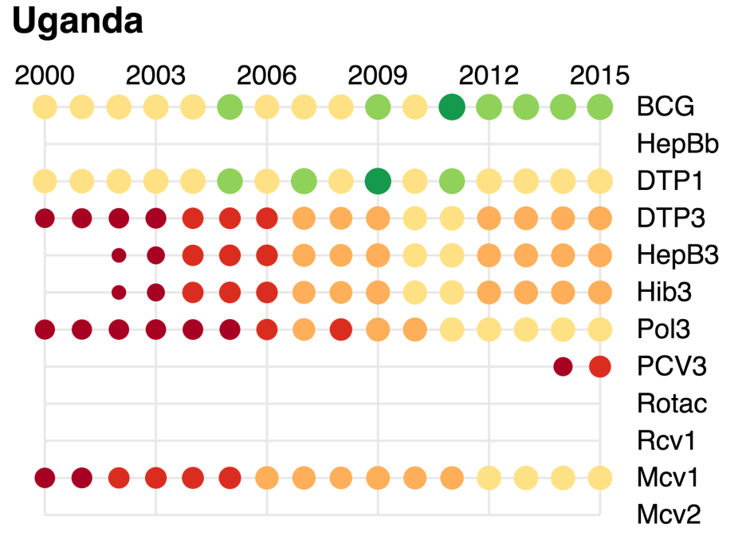

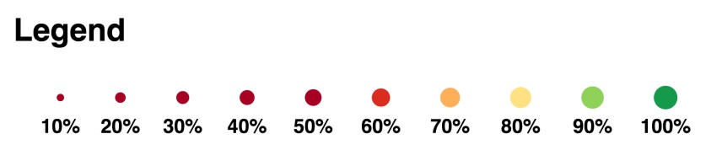

1. Uganda Comprehensive EPI, Surveillance, Immunization Financing Review and Post-introduction Evaluation of Pneumococcal vaccine, 23 Feb – 6 March 2015.