**Global Vaccine Action Plan**

*Secretariat Annual Report 2016*

*Priority Country report on progress towards*

*GVAP-RVAP goals*

**DEMOCRATIC REPUBLIC OF CONGO**

1. **Progress towards achievement of GVAP goals**
2. **Summary**

This summary table describes the current situation in DRC regarding achieving the GVAP goals. Data used to assess progress towards achievement of GVAP goals are included in the annex (Country immunization profile).

| **Area** | **Indicator** | **DR Congo** |
| --- | --- | --- |
| **Socio-demographic** | **GNI 2015** | **410** |
| **WB income category** | **Low income** |
| **Infant mortality (<12 mo.) 2015 (UN IAG CME)** | **75** |
| **Gavi status** | **Eligible** |
| **Total population** | **77,267,000** |
| **Birth cohort** | **3,127,000** |
| **Surviving Infants (JRF)** | **2,994,000** |
| **1. Interrupt wild poliovirus transmission** | **Transmission Interrupted** | **Yes (since 2012)** |
| **Risk of late detection Percent of adequate stool specimens (Rolling 12m) (Target > 80%)** | **77%** |
| **Risk of late detection Non polio AFP rate/100,000 (Rolling 12 mo.) (Target > 2/100,000 children <15)** | **5.5/100,000** |
| **Risk of spread after importation:**  **Percent of 6-59 month olds having received less than 3 doses in the last year before occurrence case/environmental positive** | **19** |
| **2. Neonatal tetanus elimination** | **Coverage for TT (reported in 2015 JRF)** | **91%** |
| **Protection at Birth against tetanus (WUENIC 2015)** | **82%** |
| **Last SIAs conducted in the country** | **SIAs in 2013 and 2014 in 75 high-risk districts, following SIAs in 2012 in 31 districts.** |
| **Elimination validation date** | **Not yet validated. Pre-validation assessment planned for Aug-Sept 2016** |
| **3. Measles Elimination** | **Coverage MCV1 (2015 WUENIC)** | **79%** |
| **Coverage MCV2** | **Not in schedule** |
| **Percentage of districts with MCV1 coverage ≥95% (2015 JRF)** | **36%** |
| **Last national SIA** | **2013 and 2014 (children <5 years)** |
| **Post SIA coverage survey conducted** | **No** |
| **4. Rubella/CRS Elimination** | **Rubella vaccine coverage** | **Vaccine not introduced** |
| **SIAs planned?** | **SIAs planned for 2017** |
| **5. Reach 90% national coverage and 80% in every district with DTP3cv** | **National coverage (2015 WUENIC)** | **81%** |
| **Drop-out rate DTP1 to DTP3 (2015 WUENIC)** | **1%** |
| **Actual numbers of children that dropped out (2015 WUENIC)** | **29,937** |
| **Difference between poorest and richest quintile in DTP3 coverage (2013 DHS data)** | **34.9** |
| **% of districts reaching 80% coverage (2015 JRF)** | **86%** |
| **6. Reach 90% and 80% coverage with all vaccines in national immunization programmes** | **National coverage (2015 WUENIC)** | **BCG: 74 DTP-HepB-Hib1: 82  DTP-HepB-Hib3: 81 MCV1: 79 PCV3: 73  Polio3: 78  YF: 65** |
| **7. Introduction of new vaccines** | **New vaccines introduced** | **Pentavalent: 2009**  **PCV: 2011-2013 (phased in)**  **IPV: 2015** |
| **8. Reduction in under 5 mortality rate** | **UM5R 201 and 2015 (% diminution between 2010 and 2015)** | **2010: 116.1 2015: 98.3 (15.3%)** |
| **9. NITAG** | **NITAG established?** | **No (2015)** |
| **10. Government expenditure on routine immunization per live birth (USD)** | **Baseline 2010-2011 and average for 2013-2015 (% change)** | **0.7 to 1.4 (+101%)** |

1. **Country ownership of the immunization programme**
   1. **Immunization policy decision-making capacity**

The main body for making recommendations and decisions concerning the immunization program continues to be the country’s Strategic Inter-Agency Coordinating Committee (ICC), which is headed by the Minister of Public Health (MOPH) and enjoys strong ownership by the Ministry. Members include Ministry of Public Health staff, representatives from the Ministry of Finance and Budget, and from several partner organizations, such as WHO and UNICEF. The core committee meets twice a year. Under it are four technical sub-committees – technical, logistics, communications, and finance – each of which meet monthly and are chaired by the Secretary General of the Ministry of Public Health or his designee. The Technical sub-committee is headed by the EPI manager and includes technical MOPH staff as well as the immunization focal points of the major partner organizations. The EPI program also meets on a weekly basis and produce a weekly report of progress against the annual EPI workplan. In addition, each province has its own ICC, headed by the provincial Health Minister or his/her designee, to discuss technical and financial issues and plan activities.

Several efforts have been made by partners to assist the country in establishing a NITAG, including a regional training at WHO/AFRO headquarters in Brazzaville attended by DRC representatives, and visits by EPI team members in 2016 to other countries (U.S., Belgium) to examine different models of NITAGs. A change in EPI managers has delayed a decision on establishing a NITAG, which is currently pending MOPH approval. Informants believe that a strong NITAG with well-respected members could speed up decision-making (e.g., to apply to GAVI for rotavirus vaccine introduction), help convince the Government to pay its GAVI co-financing obligations on time, and convince it of the value of introducing a second measles vaccine dose to reduce outbreaks and the need for costly measles vaccination campaigns.

DRC does benefit from having the Congolese Parliamentary Network to Support Vaccination (REDACAV) – an influential group of parliament members who lobby the Government for increased funding in immunization. REDAVAC monitors the disbursement rate of funds for immunization, and individual members have been known to contact Ministry of Finance officials to get allocated funds released for GAVI co-financing and other expenditures. Some REDACAV members also participated in the development of the latest comprehensive multi-year immunization plan (for 2015-2019). With help from the Sabin Institute, the group drafted an Immunization Bill to make vaccination mandatory and lay out the Government’s responsibilities for immunization financing. However, the bill was not passed, since the Parliament is proposing an overall Health Act that will include immunization.

* 1. **Government financing of immunization**

As shown in Figure 1, government expenditures for immunization have increased since 2010, after DRC started paying for traditional vaccines in 2009 and co-financing new vaccine introductions. However, the figure clearly shows that government contributions have not been rising steadily, but in fact have dipped considerably in the past four years. This is due to the fact that the transfer of funds from the Government is often slow and funds can be diverted to other uses. As a result, the Government paid for only 20% of the cost of procuring traditional vaccines in 2014 ($2.4 million out of $11.8 million), with UNICEF covering the remaining 80%.[1] These delays in releasing funds contributed to national stockouts of several vaccines in 2014 (BCG, TT, measles), as discussed below. The difficulty in getting the Government to release funds has greatly affected DRC’s ability to co-finance new vaccines. The country was in default to GAVI in 2014 and 2015 and did not pay the its co-financing obligation for 2014 until July of 2015. DRC continues to be late in making co-financing payments.

Figure 1: Trends in government expenditures for immunization and vaccines

**2010-2015 (from the JRF)**

As a result of the disbursement problem, the Government provided only 15% of its immunization budget in 2015 ($2.3 million out of $15 million) and 25% in 2014, with most of the funds going to vaccine procurement and very little to the operational costs of routine immunization.[2] Several partner organizations contributed more than budgeted to help make up the difference, especially for operational costs for vaccination campaigns and routine immunization. In all, the Government’s contribution to the EPI budget was 5% in 2014 (due to no co-financing in that year).[3] This is a lower rate than in most countries and includes personnel costs. However, these costs are low since most health workers receive no government salary and at most, a small stipend (see next section).

As a result of advocacy for immunization, most provincial governments are now contributing to the operational costs of the EPI, by, for example, buying fuel and BCG syringes and paying for transportation of supplies from higher levels.[4]

**2.3 Human resource situation**

The DRC Government has an extensive EPI team. In 2016, there were 115 staff members at the central level, including 36 professionals.[5] At the provincial and *antenne* (sub-provincial) level, there are 364 immunization-specific staff, for a total at all levels of 479 people, including 75 doctors (16%). The size of the team is considered adequate and they are generally well-trained. However, there is considerable staff turnover.

Another factor affecting human resources for immunization is the recent change in the administrative structure of the health sector, in which 26 provincial health divisions (*divisions provincial de la santé* or DPS) have replaced the 11 provinces.[6] This change has required the creation of new EPI staff positions in the newly-established DPSs, who are currently in the process of being trained. This expansion in provincial health divisions has caused major disruptions to the health sector, including the immunization program.

At the operational level, most vaccines are administered by nurses working in government hospitals and the 8,830 health centers throughout the country.[7] According to a situation analysis conducted for the 2015 GAVI joint appraisal, at least one person was trained in immunization in more than half of the health centers surveyed. However, most health center staff (90% according to the Joint Appraisal) receive no government salary and only a portion (e.g., 25%) receive a “risk bonus” (prime de risqué), which covers the cost of supporting a family for only five days. Health workers share a portion of the revenues from patient fees for curative care services, which constitute the main source of financing to keep health centers functioning in many places[8] However, this remuneration is low, especially in poor areas. Thus, health workers are often demotivated, resulting in retention problems, uneven quality of personnel, and a lack of interest in making special efforts for preventive health services that are not remunerated, such as conducting outreach visits and establishing immunization hours convenient to mothers.[9]

1. **Progress towards specific GVAP goals (issues/challenges/successes)**

**3.1 Goal 1: Achieve a world free of poliomyelitis**

Has polio transmission been interrupted?

Polio transmission has been interrupted in DR Congo, with no cases of wild polio virus (WPV) detected since December 2011, when 93 cases were reported (and 100 cases the previous year). There were 29 cases of vaccine-derived disease from 2010 to 2012 and not again until 2016, when one case was reported in March.[10] This decline in polio cases could be the result of a series of national immunization days and sub-national immunization days (*Journées locales de vaccination* or JLVs) that the country has conducted in response to the WPV cases and to eradicate the disease (see below). The Government presented a dossier to be declared polio-free in November 2015, which was granted by WHO.

Is the country considered at high risk of polio transmission?

According to the risk assessment for polio transmission conducted by WHO in June 2016,[11] DR Congo is at medium risk of polio transmission for the country as a whole. This determination is based on the combination of the potential for transmission in-country and beyond its borders – which is considered high – and the strength of its capacity to respond to and contain an outbreak – which is considered strong. As shown in Figure 2, a number of the country’s 516 health districts (*zones de santé*) have levels of population movement, a lack of security due to armed conflicts, and poor immunization coverage that place them at risk.

Figure 2: The level of polio risk from importations by health district, 2016

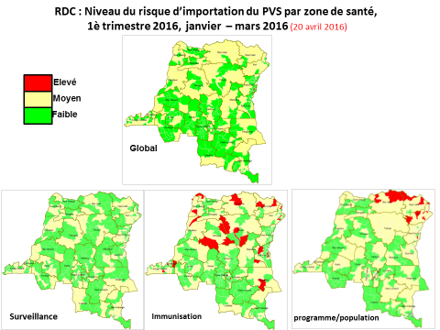

Source: Risk assessment for polio virus transmission: DR Congo presentation (June 15, 2016)

What needs to be done to keep DRC polio free?

To keep DRC free of polio outbreaks, good AFP and polio surveillance must be maintained. The country currently meets several AFP surveillance targets, including a national rate of non-polio AFP incidence of 5.5/100,000 children under the age of 15 and a rate of 91% of reported AFP cases investigated within 48 hours. The percent of cases with adequate stool samples nation-wide is 77% − just below the target of 80%. However, the quality of AFP surveillance is uneven in the country, with 28% of the 516 districts “silent” (reporting no AFP cases) for the first six months of 2016 and six DPSs with adequate stool rates of 60% of less.[12] In poor-performing areas, there is limited case-based surveillance and investigations of possible cases, often due to a lack of transport, as well as poor documentation.

The surveillance system is heavily supported by WHO, which maintains a team of several dozen staff and consultants in the provinces (including support staff and drivers), as well as 12 staff at the national level. The country is also supported by the CDC-funded international STOP teams, made up of 10-14 or so surveillance experts who spend time working with health authorities in silent districts to provide technical assistance and training to improve surveillance for AFP and other diseases. They hope to reduce the number of districts not reporting any AFP cases to zero in 2016.

The immunization program has conducted a series of sub-national polio campaigns, including catch-up campaigns following the detection of vaccine-derived polio cases, every year for the past several years. These include three rounds of JLVs (local vaccination days) in 2015 and two rounds of national immunization days in 2016, with a third planned for October. Due to problems with data quality, the campaigns constantly register coverage rates in excess of 100%. However, one LQA survey following the campaigns in 2015 found that 30% of the districts had what they considered “poor coverage” and an estimated 6% of the children had been missed.[13]

Achieving high polio vaccination coverage through the routine immunization program is also critical to reducing the risk of the disease from re-emerging. According to the WHO-UNICEF estimates, national coverage of three polio vaccine doses has been in the range of 74-79% since 2011 and was 78% in 2015. This is up from 42% national coverage in 2000, but below the GVAP target of 90% nationally. In addition, the 2016 polio risk assessment identified several districts with poor vaccination coverage, putting them at risk of transmission (see the lower middle map in Figure 2).

According to two studies conducted in 2011, refusal of parents to have their children vaccinated against polio was the second most common reason children were not vaccinated against polio, in contrast to measles, for which refusals were found to be negligible.[14] Refusals to polio vaccination were found to be due to the existence of 60 or so religious groups who were against the polio SIAs, the population’s low perceived risk of the disease, the repetitiveness of polio vaccination campaigns, and inadequate communications and social mobilization activities targeting pregnant women and anti-vaccine groups. Intensified communications activities by national consultants and STOP Team members in low-performing provinces and *antennes* in 2012 reduced the number of groups still opposed to vaccination from 60 to 10 and otherwise increased parents’ knowledge about polio vaccination.[15]

* 1. **Goal 2 : Meet global and regional elimination targets**

**3.2.1 Achieve maternal and neonatal tetanus elimination**

DRC has not yet achieved elimination status of maternal and neonatal tetanus (MNT) and continues to officially report cases in most years, including more than 1,250 in 2012, 201 in 2014 and 330 to 2015. However, the actual incidence is likely to be much higher, since according to the cMYP, less than 10% of neonatal tetanus cases are reported by the routine surveillance system. According to a study conducted in 2005, 7% of neonatal deaths in DRC were due to neonatal tetanus.[16]

A key problem affecting DRC’s ability to eliminate MNT is its continual weak surveillance of the disease, including active surveillance. Only 17% of reported NMT cases were investigated between 2012 and 2015, with considerable variation by province.[17] This is in marked contrast to the 91% investigation rate cited above for AFP surveillance, into which donors have poured considerable funding and technical support. In addition, the standard response to confirmed cases by conducting ring vaccination in households surrounding a confirmed cases only occurred on average 32-41% of the time during this period.[18]

DRC has made considerable progress in providing TT vaccine to pregnant women in the past several years – with rates of children protected at birth (PAB) jumping from 45% in 2000 to 82% for the past two years, according to the WHO-UNICEF estimates. This has mainly been due to the marked increase in the use of antenatal care services – from 68% of pregnant women making at least one ANC visit in 2001 to 88% by 2013/14. However, many women remain unprotected due to large variations in TT2+ coverage by province and district. While the national TT2 coverage rate in the 2012 DHS was estimated at 62% in 2012, provincial rates ranged from 28% to 82%.

The EPI has also organized MNT campaigns for women of reproductive age in high-risk districts. These SIAs began in 31 out of 83 identified high-risk districts in 2012, during which a reported 1.8 million women were vaccinated with TT. The campaigns were marked by a high dropout rate between doses, relatively weak social mobilization and inadequate preparation.[19]

DRC developed an MNT elimination plan in 2013, setting the goal of elimination by 2015. Seventy-five high-risk districts were identified in the plan and targeted for SIAs in 2013 and 2014, during which another approximately 1.8 million women received two TT doses. The Government reported an overall coverage rate of 82% for the campaigns, though several provinces reported rates of >100%, so the actual coverage rate is uncertain. A new analysis in 2015 identified two additional high-risk districts and targeted them for intensified immunization activities.[20] The analysis also found 11 districts reporting at least one case per 1,000 live births (the threshold for elimination).

Achieving MNT elimination in the DRC will therefore require substantially improving case-based surveillance and response (e.g., ring vaccination around cases), as well as increasing TT coverage in areas where it continue to be low.

* + 1. **Achieve measles elimination and rubella & CRS elimination**

**Measles**

DRC is not currently on track to eliminate measles by 2020. In fact, there has been a resurgence of measles since 2010, with annual outbreaks affecting more than 134,000 reported cases in 2011, more than 87,000 in 2013 and nearly 51,000 cases in 2015, including 565 deaths. The outbreaks jump around to different areas from year to year, but both the 2011 and 2015 epidemics were concentrated in Katanga province (or the DPSs that were formerly in Katanga), where 80% of cases in 2015 took place. Outbreaks have continued into 2016, but at a lower intensity, with around 5,400 reported cases from January to early July in 13 of the country’s 516 health districts (down from 44 affected districts in 2015.[21]

The main reason given in documents and by WHO informants for the continual measles outbreaks is insufficient measles vaccination coverage through the routine program and through measles SIAs that vary in quality and miss too many children. The 2015 Katanga outbreak, for instance, has been attributed to a large accumulation of children not vaccinated against measles, due to geographic inaccessibility in the worse-affected districts, insecurity caused by the presence of armed groups, an inadequate cold chain system at the local level – resulting in most health centers offering immunization only once a month (see below) – and resistance to vaccination in some communities due to religious or cultural reasons.[22] The WUENIC estimates for national measles immunization coverage ranged from 72-77% from 2011 to 2014 and reached 79% in 2015, showing gradual improvement, but still quite a bit below the 90% national GVAP target. Some provinces and districts have much lower coverage rates, notably Katanga (at 53% in the 2013 DHS) and Kasi-Oriental (58%).[23]

DRC, with the support of many partners, has conducted a series measles campaigns in the past five years to reduce incidence and halt outbreaks. Catch-up campaigns for children under 15 years of age were conducted in 2012 in 31 health districts in eight provinces, followed by follow-up campaigns for children under five conducted nation-wide in three phases in 2013 and 2014, often in combination with polio campaigns. A series of catch-up campaigns took place in 2015 in 40 outbreak districts, targeting varying age groups (<5s, <10 or <14 or 15), depending on the area and supporting partner organization. Some of the 2015 SIAs took place quite late after cases were identified due to problems mobilizing funds for operational costs, they lacked coordination among various partners, and independent coverage surveys often didn’t take place.[24] The 2015 campaigns have been described as “too little, too late”. One indication of the suboptimal quality and coverage of the SIAs in some areas is the fact that confirmed measles outbreaks in several districts took place within a month or more of SIAs having been conducted in these same districts.[25] Nonetheless, administrative data consistently show coverage rates of more than 100% for nearly all measles campaigns since 2012.

While it has improved in recent years, measles surveillance – including case-based surveillance linked to the AFP/polio surveillance system – is considered inadequate and another key factor for DRC’s difficulty in reducing measles incidence. The country as a whole meets the target non-measles febrile infection rate of ≥2/100,000 children, with a national rate of 2.16/100,000 in 2015.[26] However, more than half of the provinces (six out of 11) had rates below this threshold and three had rates of <1/100,000. In addition, the percent of districts reporting at least one measles case with a specimen obtained was 61% in 2015 (compared to the target of 80%) and only three provinces met this target.

**Rubella**

Rubella has also not been eliminated in DRC and rubella vaccine is not yet used in the public sector. Sentinel site surveillance for rubella – in the same three sites where rotavirus and bacterial meningitis surveillance is taking place – has just begun. However, for several years, blood samples of suspected measles cases that test negative for measles are tested for rubella and the number of positive rubella cases found each year through this testing has more than doubled in five years – from 320 in 2011 to more than 760 in both 2013 and 2014. Few cases of CRS have been detected, however. The sentinel site surveillance should provide better estimates of rubella and CRS incidence.

The 2015-2019 cMYP calls for the immunization program to conduct measles-rubella vaccination campaigns in 2017, followed by the introduction of two MR doses in the routine schedule in 2018. Activities have yet to take place (as of mid-July 2016) to apply for GAVI funding for the SIAs.

**3.3 Goal 3: Meet vaccination coverage targets**

* 1. **Achieve 90% national coverage and 80% in every district with three doses of diphtheria-tetanus-pertussis containing vaccines**
  2. **Achieve 90% national coverage and 80% in every district with all vaccines included in the national schedule**

While DRC has not yet reached the goal of 90% national coverage for three doses of DPT-containing vaccine (pentavalent), according to the WHO-UNICEF estimates, it achieved an overall coverage of 81% in 2015 – up from 74-75% from 2011 to 2013. The WUENIC dropout rate from the first to the third dose of pentavalent vaccine was reportedly 1%. However, the 2013 DHS found a pentavalent coverage rate of only 61% national in 2012 (while the WUENIC rate was 75% for that same year) and a dropout rate of 25%.[27] Administrative data show a marked improvement in district-specific coverage rates in the past five years (see map in the Annex). However, there are no WUENIC estimates for district coverage and given the fact that there is a 13-point difference between administrative and WHO-UNICEF DPT3 coverage estimates for 2015 (94% vs. 81%), the actual degree to which the country has met the goal of 80% coverage in each district is unknown.

Concerning other vaccines in the immunization schedule, the WUENIC national estimates for 2015 were in the upper 70s for measles and three doses of polio vaccine, the mid-70s for PCV3 and BCG, and 65% for yellow fever vaccine. The increase in WUENIC coverage rates for these vaccines in the past five years was less than for pentavalent vaccine; for example, polio coverage was 77% in 2011 and 78% in 2015. The fact that administrative coverage data show national coverage rates of 90% or greater for most vaccines, except measles and PCV3 (at 89% and 86%) highlights issues with the quality of immunization data in DRC.

There are large income and geographic inequities in immunization coverage. The difference in coverage of three pentavalent doses between the lowest and highest income quintile in the 2013 DHS was 35 percentage points (48% vs. 83%), while the coverage rate for all vaccines jumped from 36% in the lowest quintile to 65% in the highest (see figure in the Annex). Those in the middle quintile had rates much closer to the lowest than the highest quintile – indicating great inequality by income. The largest number of non- or under-immunization children are in the country’s nine poorest DPSs.[28]

The performance of DRC’s routine immunization program is affected by serious health system challenges. These include:

* **A lack of investment in human resources for health and consequent high attrition rates and low motivation among health workers.** As mentioned above, most health workers receive no government salary and many do not even receive the inadequate risk bonus. Consequently, they rely on a share of revenues generated by user fees for curative care services. This creates a disincentive for health workers to provide non-remunerative services, such immunization, especially outreach activities and other extra efforts to improve vaccination coverage that require time away from the health center. Many health facilities in the poorest provinces, where user free generation is low, reportedly charge patients for vaccinations, further suppressing coverage.[29]
* **Insufficient availability of immunization services**. According to a Service Availability and Readiness Assessment (SARA) conducted in 2014, the number of health facilities in DRC – both public and private – is sufficient, with more than 600 hospitals, 10,000 health centers (of different levels) and more than 5,500 health posts.[30] This yields a ratio of 2.2 health facilities per 10,000 people, meeting the WHO recommended benchmark of 2/10,000. Seventy-five percent of the facilities in the assessment were found to provide immunization services. However, most (59%) held immunization sessions only once a month, 37% held them once a week, and only 2% had immunization services available on a daily basis. A key reason – in addition to the health worker issues described above – is the fact that only 16% of the 1,012 health facilities in the SARA study had refrigerators, and only 2% of health posts. Thus, health facilities must collect vaccine from the district medical stores themselves on the day of an immunization session. This situation may have improved recently with the purchase of addition cold chain equipment through the GAVI HSS grant.
* **Frequent vaccine shortages and stockouts**. Vaccine stockouts are common at all levels of the health system in DRC. At the central level, there were stockouts of BCG, yellow fever, and PCV vaccines in 2015 and of measles and BCG in 2014. [31] As of early July 2016, there was no supply in the central stores of bivalent OPV and IPV and only one month’s supply of TT vaccine. Some of these stockouts are due to a global supply shortage, notably BCG, which was absent from the central store for 73 days in 2015.[32] Delays in the Government releasing funds for vaccine purchases also contribute to the stockouts at this level.

At the sub-national level, 92% of districts surveyed in the PCV post-introduction evaluation (PIE) in 2014 had experienced a stockout of at least one vaccine in the previous six months, including PCV, even though it was available at the central level during at the time.[33] This points to severe distribution problems from the national to the lower levels. Only two provinces (Bas-Congo and Bandundu) and the city of Kinshasa have vaccines delivered by road; all other provinces are at the mercy of a few air-freight companies for their vaccine deliveries. These companies have routes and itineraries that do not necessarily meet the needs of the provinces, and they charge more than $2 million a year to airship vaccines to the interior. In addition, many health provinces (DPSs) do not have appropriate, functioning means of transporting vaccines to the districts, although more are now obtaining vehicles with HSS support.

The unavailability of vaccines at the health facility level was the top reason found in the 2013 DHS that children did not get vaccinated – cited by 26% of parents whose children did not receive vaccines on schedule.[34] Vaccine stockouts were also found in the 2012 EPI review to be the cause in 27% of the cases where planned outreach activities did not take place.[35] While health facilities without refrigerators are not expected to store vaccine, the SARA study found that vaccine stockouts in facilities with refrigerators were also common. At the time of the assessment team’s visit, 44% of these facilities had no PCV vaccine and 19-24% had stockouts of measles, pentavalent or polio vaccines.[36] These stockouts are due to the vaccine shortages at high levels, as well as to a lack of transport at health facilities to collect vaccine from the district stores.

* **Inadequate outreach activities**. According to the SARA study, 80% of health facilities offering immunization provide services only at the facility. The 2013 DHS found that, while 27% of children lived far enough away from a health facility to be eligible for outreach services, only 7% of vaccinated children were reached through this strategy, increasing the likelihood of their being missed or not completing these immunizations. A lack of transportation was given as the reason outreach activities did not take place in 41% of cases in the 2012 EPI review.[37] Other likely factors are the shortage of health workers and lack of financial incentive to conduct outreach activities.
* **Insufficient community-based communications and community involvement in health and immunization promotion**. DRC has established a system to link health facilities to each community and involve community members in health promotion, including immunization. In principal, one community volunteer (*relais communautaire*) exists for every 25-30 households, and one volunteer per village is a member of the Development Committee (CODESA) for the catchment area (*aire de santé*) of the health center. In the area of immunization, these volunteers inform community members about vaccines and immunization services, help plan and implement disease surveillance and vaccination activities, track immunization defaulters, and participate in health district council meetings. Each DPS has a communications focal point and most districts have community workers (*animateurs communautaires*) who support the health centers and community volunteers with communication and social mobilization activities. The PCV post-introduction evaluation (PIE) found that 34% of mothers knowledgeable about the new vaccine had learned about it from a community volunteer and they were the #2 source of information after health personnel.[38]

However, although the number of community volunteers has reportedly increased, the reality on the ground is different. According to the 2012 EPI review, these volunteers often lack motivation and are increasingly disengaged in some districts.

Inadequate knowledge and demand from the population were found to be a major reason for children not being vaccinated. In the 2012 DHS, coverage for pentavalent vaccine fell from 81% for the first dose to 61% for the third (a dropout rate of 25%), while the dropout rate for polio vaccine from the first to the third dose was 28%. A lack of knowledge about the importance of vaccination, about the need for more than one dose for several vaccines, and about the time and place of vaccination were commonly cited by mothers whose 1-11 month olds did not complete their vaccinations.[39] Religious objections were also a reason for children not being vaccinated, accounting for 7% of responses about all factors contributing to the non-vaccination of children.

The results of these factors – along with inadequate supervision – is many missed opportunities. A child may come to the health center, but it’s not the one day of the month when an immunization session is held, or if it is, certain vaccines are not available, discouraging parents from coming back. Health workers may also miss the opportunity to inform mothers of the needs to bring their child back for subsequent doses and when to do this.

Given the severity of these problems – the lack of salaries for most health workers, the infrequency of immunization services and frequent vaccine stockouts – not to mention the low disbursement rate and delays in the release of government funds for immunization and the presence of armed groups in some areas – it seems quite remarkable that the WHO-UNICEF national coverage estimate for DPT3 is 81%, a figure that surpasses that of several other countries in the region (e.g., Nigeria, Uganda, Chad) and matches that of Indonesia. It may be that the WUENIC estimate is high, given the 14 percentage point difference between the WUENIC and DHS DPT3 coverage estimates for 2012. Other possible explanations for this relatively high coverage include:

* **Implementation of vaccination campaigns and special events** that raise awareness of and/or increase access to immunization. These include periodic intensified routine immunization campaigns (PIRIs) that have taken place in some provinces in recent years, and African Vaccination Weeks. In addition, the numerous polio campaigns that go door-to-door have increased the population’s knowledge about and demand for vaccination in general.
* **Implementation of the Reach Every Zone (REZ) strategy** in 65 of the worse-performing districts (13% of all districts) through the GAVI HSS I grant, supplemented by support from the Gates Foundation, WHO and other partners. Immunization coverage in these districts has increased markedly from 2010 to 2014 (see Section B below). Through the HSS II grant, the number of target districts for REZ support has increased to 112.

**3.4 Introduce new and improved vaccines and technologies**

DRC introduced PCV-13 vaccine over a 2.5 year period from 2011 to 2013. The introduction was phased in and delayed due to the Government defaulting on its GAVI co-financing obligations and to delays in procuring and installing cold chain equipment needed to accommodate the new vaccine throughout the country. Post-introduction evaluations (PIEs) were conducted for the first four provinces, the fifth province and the country as a whole. The introduction was plagued by stockouts of the vaccine at all levels, high wastage rates (11% in the facilities included in the national PIE), and high dropout rates between doses one and three (19% according to administrative data from 2013). However, the situation has improved since, with the WHO-UNICEF estimates of PCV3 coverage reaching 73% by 2015. The PIE also described good planning and social mobilization for the PCV introduction, as well as good population acceptance of the vaccine.

IPV was introduced over a four-month period in 2015, with few reported problems. Meningitis A vaccine campaigns were conducted in 2015/16 for 1-29 year olds in the country’s three provinces where the disease is endemic. No decision has yet been made concerning its introduction into the routine immunization schedule in these three provinces.

Rotavirus vaccine introduction was originally planned for 2014, but was postponed as a result of the country’s problems meeting its co-financing obligations and the prolonged roll-out of the PCV introduction. According to the cMYP, the country is supposed to introduce the vaccine by 2019. DRC also plans to apply to GAVI in early 2017 for a pilot HPV project in two districts. As mentioned above, the cMYP also calls for measles-rubella campaigns to take place in 2017, to be followed by introduction of two MR doses into the routine program in 2018. Preparation of the application to GAVI for the SIAs has not yet begun.

1. **Partner support to address remaining challenges to meet the GVAP goals and targets**

Partners, including GAVI, WHO, UNICEF, USAID and others, have been instrumental to the functioning and improvements of DRC’s immunization program, providing financing, manpower, technical assistance and training. As mentioned above, they have covered the vast majority of the costs of the program for many years. Much of the financial and technical support has gone into:

* **Immunization campaigns** (polio, measles, meningitis A), with WHO, UNICEF and GAVI covering most of the operational costs of the campaigns and providing technical assistance, along with other partners, in communications, planning and other activities. SIAs accounted for 13% of the EPI expenditures in 2015, most of that for polio campaigns;[40]
* **Disease surveillance**: WHO heavily supports the country’s surveillance system for polio and other vaccine-preventable diseases (VPDs), financing a team of around 100 people working in the provinces, including surveillance medical officers, logisticians, administrative assistants and drivers. While the team is supported by polio funding, they also work to improve case-based surveillance of measles and other VPDs. Periodic international STOP teams, described above, provide additional support to the country in conducting disease surveillance and organizing SIAs.
* **New vaccine introductions**: Partners have been critical to the introduction of PCV and IPV, providing assistance in planning, training, communications/social mobilization and other areas. GAVI financial support for pentavalent, PCV and yellow fever vaccines accounted for 45% of the total EPI expenditures in 2014 ($51 million out of $114 million).[41]

Three projects or activities where partner support has especially made a difference to the immunization program are highlighted below:

* **Support for implementation of the Reach Every Zone (REZ) approach**. GAVI, through the HSS grant, along with the Gates Foundation and other partners, has provided financial and technical assistance to implement the REZ approach in 65 of the country’s 516 health districts (zones de santés). Catalytic funding, along with technical assistance, has enabled these districts to conduct MLM training, pay for vaccine transport and cold chain maintenance, purchase cold chain equipment, conduct many more outreach activities (based on micro-planning), and increase supportive supervision and monitoring, including monthly meetings to review immunization coverage and activities. This support has also helped activate community participation in default tracking and in promoting health and immunization services. An external evaluation showed an increase in pentavalent 3 coverage in these 65 districts from 57% in 2010 to 80% in 2014, and a doubling of districts reaching 80% coverage in three years (Figure 2).[42] Support for REZ implementation is being expanded to 112 districts in all through the HSS II grant. Sustainability of this effort, once partner support ends, is a major question.
* **An upgrading of the vaccine supply chain and cold chain system**. With support from the GAVI HSS grant, UNICEF and WHO, DRC is substantially expanding and modernizing its cold chain system to accommodate new vaccines and greatly improve its distribution and storage of vaccines. In addition to constructing new cold rooms in Kinshasa, the project involves establishing three sub-national distribution hubs to which vaccines will be flown directly from the central stores. This should lessen the storage capacity needs of the central level and improve efficiency in vaccine distribution to the DPSs and districts. To reduce the system’s dependence on a few airlines as well as airfreight costs, GAVI funds are being used to acquire a boat equipped with cold chain equipment that will travel up the Congo River to deliver vaccines and other medical supplies to the new hubs. Solarization of the cold chain system to reduce the costs of procuring and distributing fuel, is another major component, with the procurement of solar refrigerators at the central, hub and DPS levels, as well as solar generators in all DPSs currently off the grid or that experience frequent power outages. These stores are also being equipped with remote temperature monitoring systems.

Figure 3: Change in DTP3 coverage in the 65 districts receiving support for Reach Every Zone (REZ) implementation



Source: 2015 Joint Appraisal report

* A **civil society organization (CSO) project** funded by GAVI, with support from UNICEF, USAID and other partners. Four local CSOs operating in 33 districts in five provinces work with communities to strengthen community participation in health promotion, tracking defaulters, and strengthen links between the communities and health centers. These efforts led to a substantial increase in demand for immunization, resulting in an increase in coverage of three pentavalent vaccine doses from less than 60% to more than 80% in these districts.

**Acknowledgments**

We would like to thank the following people who were interviewed for this report:

* Patrick Lydon (WHO HQ)
* Yolande Masambe Vuo (WHO CO)
* Renee Nsamba (WHO CO)

**ANNEX: Country immunization profile**

1. **General indicators**

* GNI (USD): 410
* WB Status: Low income
* Infant mortality (<12 M) rate: 75
* GAVI Status: Eligible
* Total Population: 77,267,000

1. **Polio**

* **Transmission stopped in 2011.**
* **Eradication certified: not yet.**

1. **Measles and rubella**

Figure 4: Reported Measles cases and MCV coverage, DRC, 1990-2015

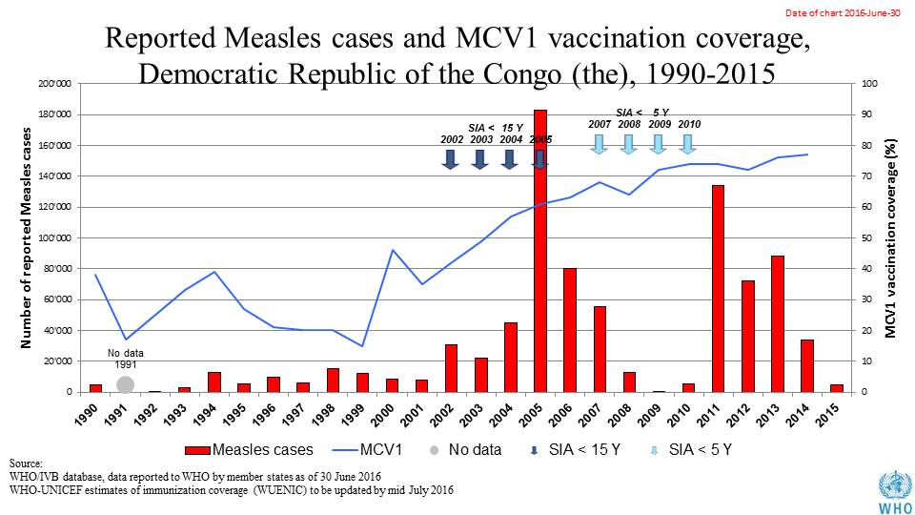

Table 1: SIA activities planned in 2016-2017

|  |  |  |  |  |  |  |  |  |
| --- | --- | --- | --- | --- | --- | --- | --- | --- |
| **Activity** | **Intervention** | **Year** | **Start Date** | **End Date** | **Age Group** | **Extent** | **Status** | **Target** |
| Catch up | MR | 2017 |  |  | 6 M-14 Y | National rollout | planned | 7,320,281 |
| Follow up | Measles | 2016 | 19/07/2016 | 01/11/2016 | 6-59 M | National rollout | planned | 16,109,995 |
| SNID | bOPV | 2016 | 01/10/2016 |  | 0 to 5 years | Sub-national | Planned | 8,121,548 |
| NID | tOPV | 2016 | 14/04/2016 | 16/04/2016 | 0 to 5 years | National | Planned | 18,166,533 |
| NID | tOPV | 2016 | 24/03/2016 | 26/03/2016 | 0 to 5 years | National | Planned | 18,166,533 |
| SNID | tOPV | 2016 | 25/04/2016 | 27/04/2016 | 0 to 9 years | Sub-national | Planned | 1,430,939 |
| Campaign | MenA | 2016 | 01/02/2016 |  | 1-29 Y | Sub-national | planned | 10,117,371 |
| Campaign | MenA | 2016 | 01/05/2016 |  | 1-29 Y | Sub-national | planned | 7,927,555 |

Source: WHO/IVB Database as at 12/4/2016

1. **MNT**

Elimination not yet validated. Pre-validation assessment planned for Aug-Sept 2016.

1. **Coverage and Equity**

Figure 5: All vaccines national coverage, DRC, 2000-2015

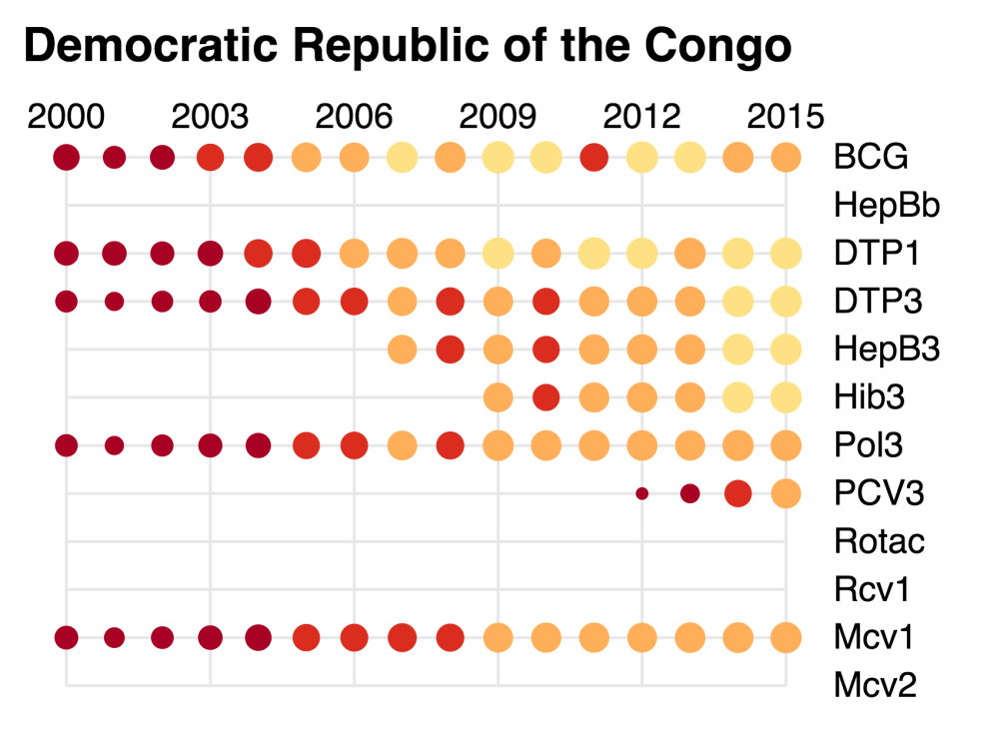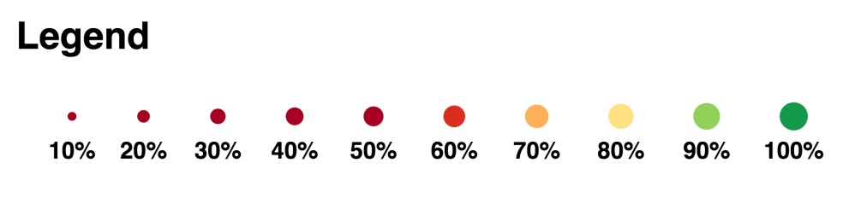

Table 2: Reported DTPcv doses administered & coverage, DR Congo, 2000-2015

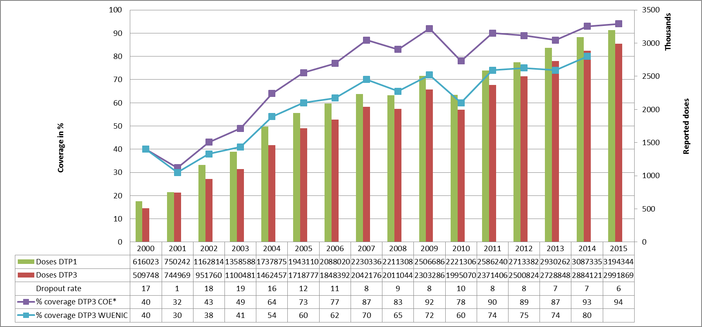

* COE: country Official Estimates

Source:

WHO/IVB database, data reported to WHO by member states as of 1 July 2016

WHO/UNICEF national coverage estimates, 2014 revision, data as of July 2015

Figure 6: Percentage of district achieving <50%; 50-79% and ≥80% coverage, 2000-2015

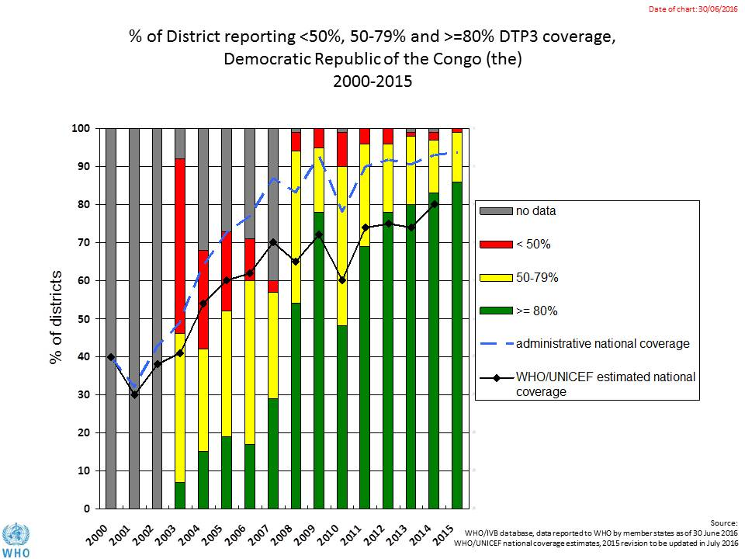

Figure 7: DTP3 coverage by district/province, DRC, 2010 and 2015 (administrative data)

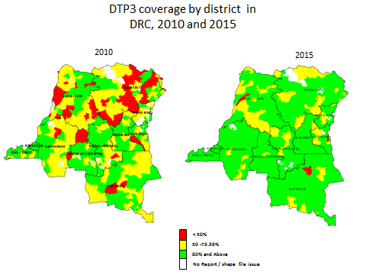

Figure 8: Immunization coverage data disaggregated by sex and wealth quintile

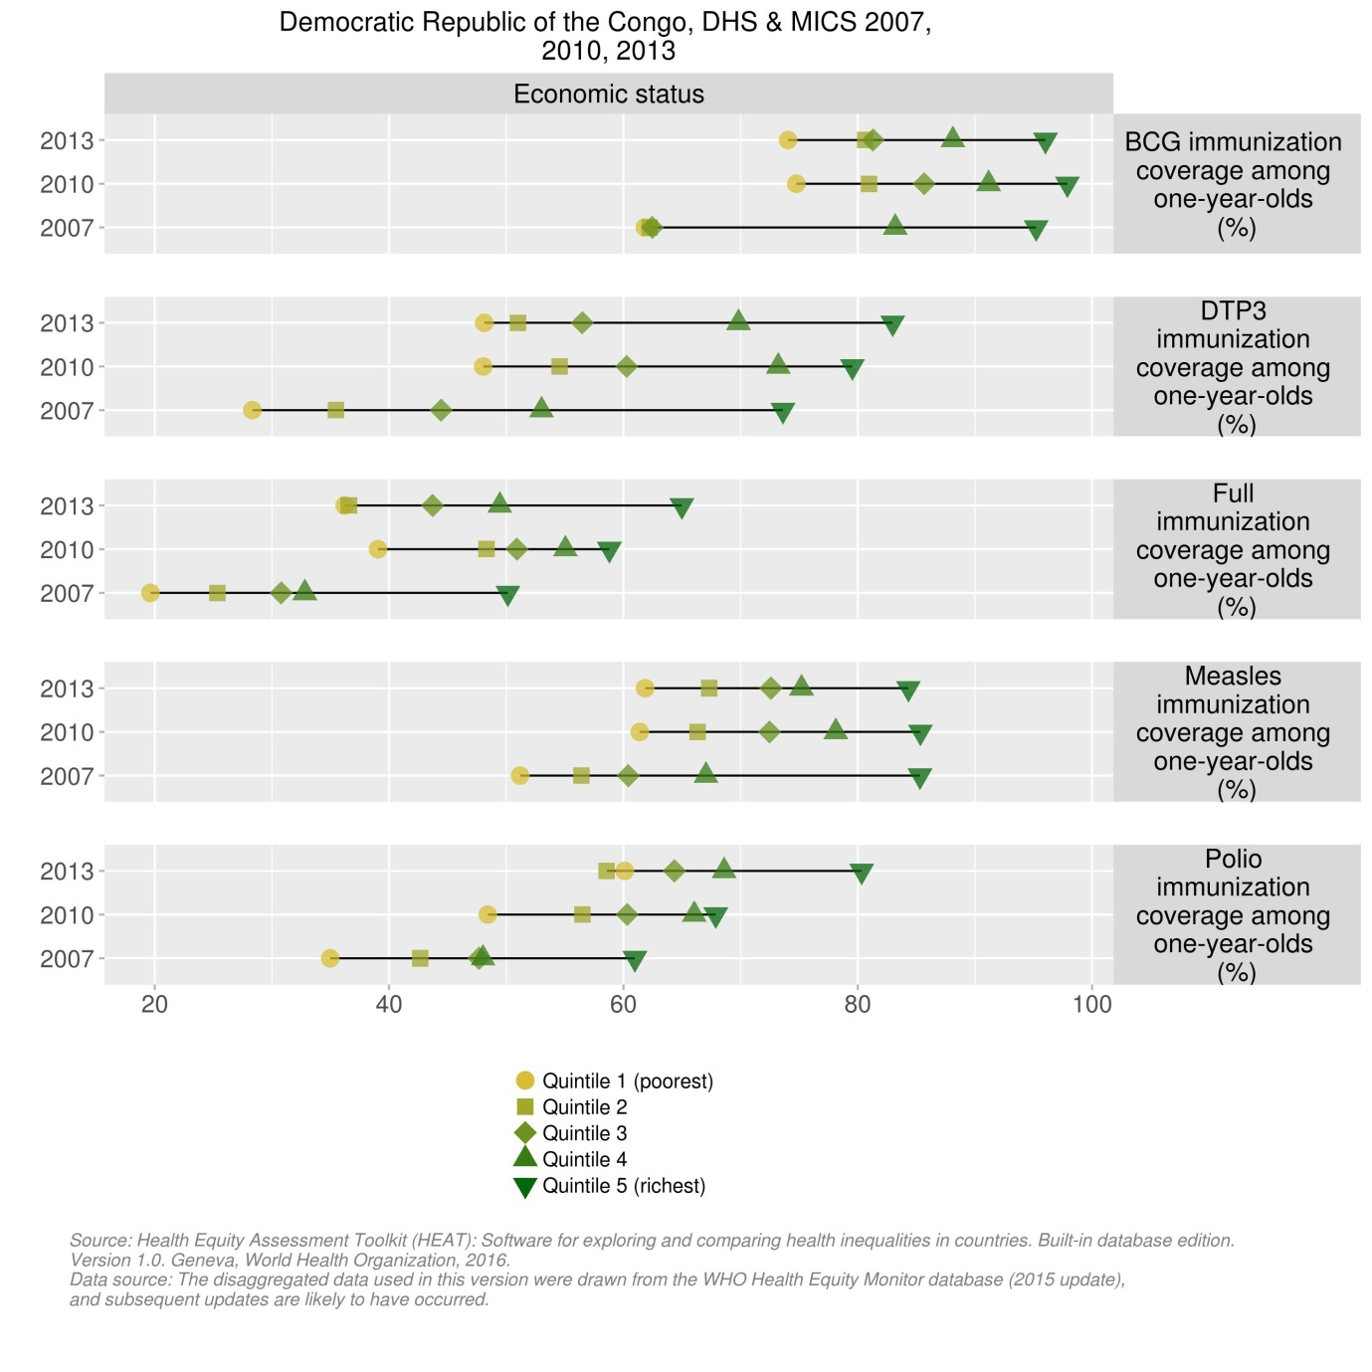

1. **Immunization systems highlights**

* Immunization schedule

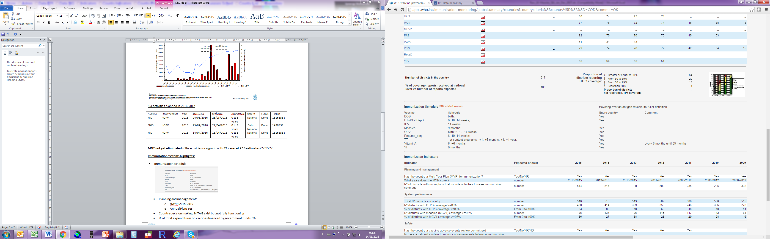

* Planning and management:
  + Vaccines stockout issues: DRC: 1 DTP (less than 1 month), 1 BCG (3 months duration), see Table 3 below for 2016.
  + cMYP: 2013-2015
  + Annual Plan: Yes
* Country decision making: No NITAG
* % of total expenditures on vaccines financed by government funds: 4%

Table 3: stock outs of vaccines, RDC, 2016

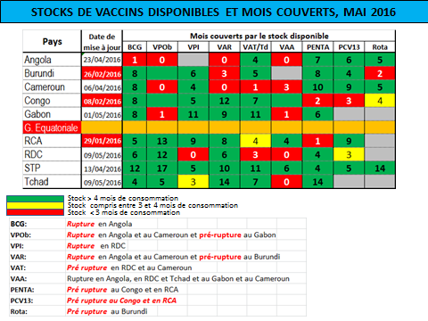

Figure 9: Change in administrative boundaries from 11 provinces to 26 Divisions de provinces sanitaires (DPSs)

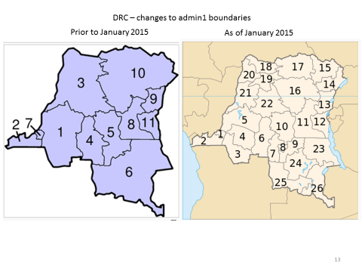

1. 2015 joint appraisal report for DRC.
2. Sources: Financial data from DRC’s JRF, 2015 joint appraisal report for DRC, Draft EPI Action Plan for 2016, February 2016.
3. 2015 joint appraisal report for DRC.
4. Comprehensive multi-year EPI plan (cMYP) for DRC, 2015-2019, November 2014.
5. Draft EPI Action Plan for 2016, February 2016.
6. The administrative structure for the health sector now consists of 26 DPSs (vs. 11 provinces formerly), 44 antennes (sub-provinces), 516 health districts (*zones de santé*) and around 8.800 health centers (*aires de santé*).
7. 2015 joint appraisal report for DRC.
8. cMYP 2015-2019
9. 2015 joint appraisal report for DRC.
10. WHO/Geneva. Risk assessment for poliovirus transmission: DR Congo, 15 June 2016 (presentation).
11. WHO/Geneva. Risk assessment for poliovirus transmission: DR Congo, 15 June 2016 (presentation).
12. Internal WHO/UNICEF memo, July 5, 2016.
13. Draft EPI Action Plan for 2016, February 2016.
14. cMYP 2015-2019.
15. cMYP 2015-2019.
16. cMYP 2015-2019.
17. Draft EPI Action Plan for 2016, February 2016.
18. cMYP 2015-2019 and draft EPI Action Plan for 2016, February 2016.
19. cMYP 2015-2019.
20. Draft EPI Action Plan for 2016, February 2016.
21. Internal WHO/UNICEF memo, July 5, 2016.
22. Measles epidemic in the Democratic Republic of Congo: WHO and UNICEFF concerned about the spread of the epidemic in the former province of Katanga. ReliefWeb report, 5 October 2015 (<http://reliefweb.int/report/democratic-republic-congo/measles-epidemic-democratic-republic-congo-who-and-unicef-concerned>).
23. cMYP 2015-2019.
24. Draft EPI Action Plan for 2016, February 2016.
25. cMYP 2015-2019.
26. DRC MOH and WHO. Situation epidemiologique de al rougeole en RDC, 21 June 2016 (weekly disease reporting bulletin).
27. cMYP 2015-2019.
28. 2015 joint appraisal report for DRC.
29. 2015 joint appraisal report for DRC.
30. WHO. Service Availability and Readiness Assessment (SARA) in the Democratic Republic of Congo, June 2015.
31. Draft EPI Action Plan for 2016, February 2016.
32. Draft EPI Action Plan for 2016, February 2016.
33. Post-introduction evaluation report for PCV-13 in the Democratic Republic of Congo, 27 March – 11 April 2014.
34. cMYP 2015-2019.
35. HSS II application to GAVI by DRC, 20 April 2014.
36. WHO. Service Availability and Readiness Assessment (SARA) in the Democratic Republic of Congo, June 2015.
37. HSS II application to GAVI by DRC, 20 April 2014.
38. Post-introduction evaluation report for PCV-13 in the Democratic Republic of Congo, 27 March – 11 April 2014.
39. cMYP 2015-2019.
40. Draft EPI Action Plan for 2016, February 2016.
41. 2015 joint appraisal report for DRC.
42. 2015 joint appraisal report for DRC.