**Global Vaccine Action Plan**

*Secretariat Annual Report 2016*

*Priority Country report on progress towards*

*GVAP-RVAP goals*

**ETHIOPIA**

1. **Progress towards achievement of GVAP goals**
2. **Summary**

This summary table describes the current situation in Ethiopia regarding achieving the GVAP goals. Data used to assess progress towards achievement of GVAP goals are included in the annex (Country immunization profile).

| **Area** | **Indicator** | **Ethiopia** |
| --- | --- | --- |
| **5. Reach 90% national coverage and 80% in every district with 3 doses of DTP-containing vaccine** | **National coverage (2015 WUENIC)** | **86%** |
| **Drop-out rate DTP1 to DTP3 (2015 WUENIC)** | **8.5%** |
| **Actual numbers of children who dropped out (2015 WUENIC)** | **242,480** |
| **Difference in DPT3 coverage between poorest and richest quintile (2010 data from WHO Health Equity Monitor Database)** | **37.5 percentage points** |
| **% of districts achieving ≥80% coverage for DPT3 (2015 JRF)** | **74%** |

* 1. **Goal 3: Meet vaccination coverage targets**

1. **Achieve 90% national coverage and 80% in every district with 3 doses of diphtheria-tetanus-pertussis containing vaccine**

According to WHO-UNICEF estimates, Ethiopia has come close to meeting the national coverage target of 90% for three doses of DPT-containing vaccine – reaching 86% for three doses of pentavalent (DPT-HepB-Hib) vaccine in 2015. This is a significant jump from the WUENIC estimate of 77% in 2014 and 65% in 2011. A decline in the dropout rate between the first and third doses has been one factor contributing to the recent increase in pentavalent 3 coverage – falling by more than half from 19% in 2011 to 8.5% in 2015, according to the WUENIC estimates.

However, the immunization program has been less successful in achieving high coverage in all parts of the country. Administrative data, which is almost certainly inflated, shows that only 65% of districts in 2015 achieved coverage of ≥80% for three pentavalent vaccine doses. A perhaps more accurate picture comes from data from the Routine Immunization Improvement Plan (RIIP) being implemented in 51 of the country’s 103 zones. The percent of zones achieving ≥80% for the third pentavalent dose was 41% in 2015 (but up from 17% in 2013) (see Figure 2 in Section B below). There are also large disparities in immunization coverage by income level. The 2013 immunization coverage survey found a difference in pentavalent 3 coverage rates of 49 percentage points between the richest and poorest income quintiles, while data from 2010 found a difference of 37.5 percentage points (WHO Health Equity Monitor Database).[1]

There has been a similar jump in national coverage estimates by WHO and UNICEF for other vaccines in the immunization schedule, with three vaccines approaching the 90% national coverage target in 2015: PCV3 and polio 3 – both at 85% -- and rotavirus (at 83%). The lowest rates are for BCG (75% and measles (78%). WUENIC estimates for these vaccines are not available by district to determine their progress in meeting the goal of at least 80% coverage in all districts.

Some of the key factors contributing to the 21 percentage point gain in pentavalent 3 coverage from 2011 to 2015 are:

* **The continual buildup of the HEW workforce**, as well as an increase in local and international NGOs supporting health facilities directly;
* Implementation of the **Reach Every Community (REC) strategy**, which began in 2004;
* Implementation of the **Routine Immunization Improvement Plan (RIIP)**, starting in 2014, in the half of the country’s zones with the poorest immunization program performance. The maps in Figure 2 below suggest that the project has had an important impact on improving vaccination coverage rates in the target zones (see Section B).
* **Establishment of the Health Development Army**. This army of community-based volunteers, describe in Section 2.4 above, forms the backbone of the Government’s new Intensification Plan to reduce the number of unimmunized or under-immunized children by 80% in each zone, in large part by identifying missed children, tracking defaulters, and ensuring catch-up immunization of these children. According to one informant, however, these volunteers could be used more efficiently, and given the newness of the program and its rapid scale-up, there is to date little information on their impact in improving utilization of immunization services.

While progress has been significant in the past five years, there are a number of issues that need to be addressed in order for Ethiopia to meet its immunization coverage targets, especially in narrowing the geographic and income class inequities in performance. These include:

* The existence of **geographic pockets with low coverage**, especially in pastoralist communities that are concentrated in three regions (Afar, Somali and Gambella). The sparse populations, nomadic lifestyle and weaker health infrastructure in these areas make it challenging to provide immunizations on schedule. The situation is reportedly improving with the increase in the number of health posts and HEWs in these areas, and through efforts by NGOs in pastoralist areas to find creative ways to deliver immunization and other health services to this population. One strategy, for example, involves government health workers meeting nomadic groups at pre-arranged locations and dates to provide immunization and other health services.
* The fact that **most health facilities do not provide immunization services on a daily basis** – as stipulated in the national routine immunization policy. The 2012 immunization coverage survey found that only 26% of health facilities surveyed (mainly health centers) offered daily immunization services, and only 5% of health posts did so. Three-quarters (76%) of health posts offered immunization once a month, as did 48% of all health facilities in the study. The infrequency of EPI services results in many missed opportunities to reach children with vaccinations.
* **Vaccine supply chain and cold chain issues**: A major reason that health posts do not offer daily immunization is that only around 30% of them have cold chain equipment, according to an EVM assessment conducted in 2013.[2] In addition, many refrigerators were found in a 2013 cold chain inventory to be non-functional – 38% of those at health facilities and 36% of those at zonal and district stores – due to a lack of trained cold chain technicians, spare parts and fuel (kerosene). The country’s five-tier vaccine supply chain system is also weak – often resulting in overstocking at the central level and vaccine shortages or stockouts at sub-national cold rooms. This situation is improving with the transition of vaccine logistics management from the FMOH to the quasi-governmental Pharmaceuticals Fund Supply Agency (PFSA), which is now responsible for delivering vaccines to the zones and districts. Health facilities must still collect the vaccines themselves from zonal or district stores, which can be difficult due to limited staff (especially at health posts) and limited transportation.

As a result of both the lack of working refrigerators in health facilities and weak vaccine distribution, local-level vaccine stockouts are quite common. The 2015 rotavirus post-introduction evaluation found that nearly half (47%) of health facilities surveyed had experienced a vaccine or supply stockout in the previous six months.[3] The 2012 immunization coverage survey found that vaccine stockouts were the major reason that health facilities cancel planned immunization sessions, resulting in further missed opportunities to vaccinate children.

* **Gaps in monitoring and supervision**: There is a supportive supervision system in place, but its impact on the immunization program is considered insufficient, due to the lack of funding for regular, consistent visits to the field and to the fact that the supervisory visits cover all components of the minimum health services package, therefore not always focusing sufficiently on immunization.[4]

There is also anecdotal, but no documented evidence that multiple rounds of polio and measles campaigns – as many as 19 over three years in some areas – can negatively impact the delivery of routine immunization services. Each campaign can require two weeks of planning, leaving the often over-stretched HEWs little time to provide routine immunization. On the other hand, the repeated campaigns and accompanying social mobilization, has reportedly increased population awareness of and demand for vaccination. Some districts have used the opportunity of the SIAs to catch up children with all their immunizations, by, for instance, having nearby health posts offer routine immunization services at the same time as an SIA is being held at an outreach site, and encouraging parents to take their children to the health post for their other vaccinations.

Vaccine hesitancy is not considered to be a major issue in Ethiopia, according to informants.

**ANNEXES**

Figure 4: All vaccines national coverage, Ethiopia, 2000-2015

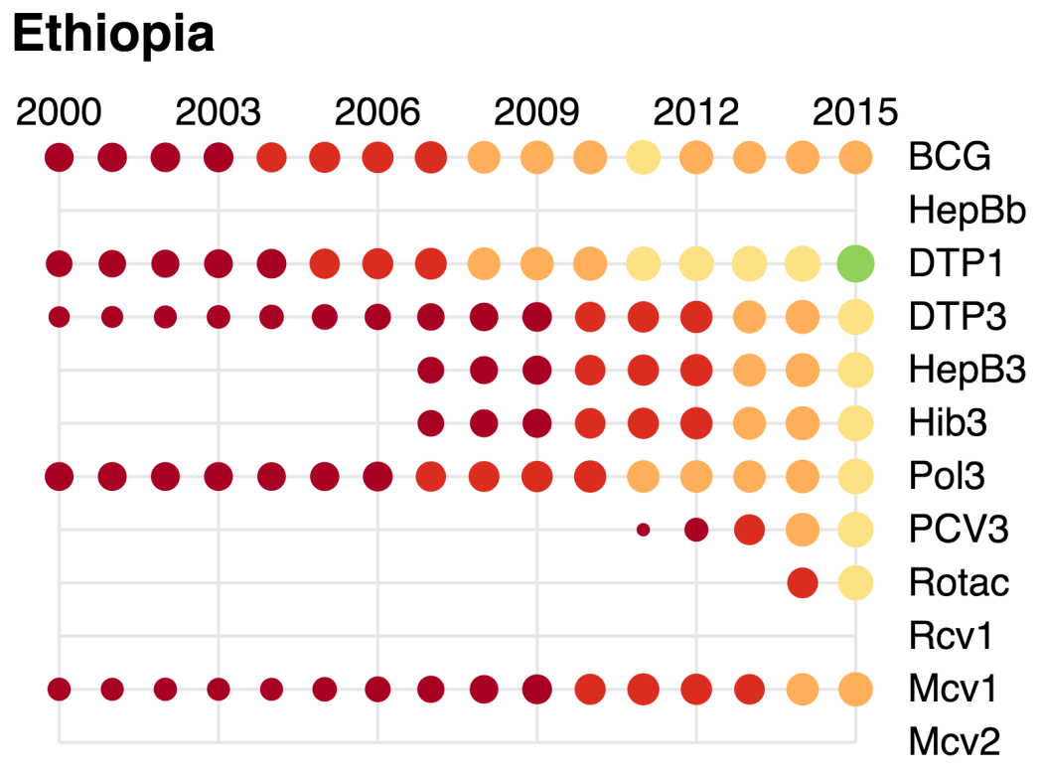

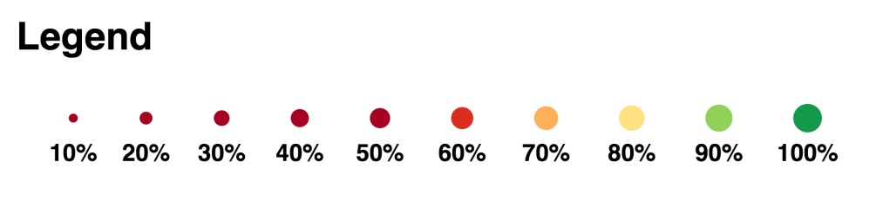

Table 2: Reported DTPcv doses administered & coverage, 2000-2015

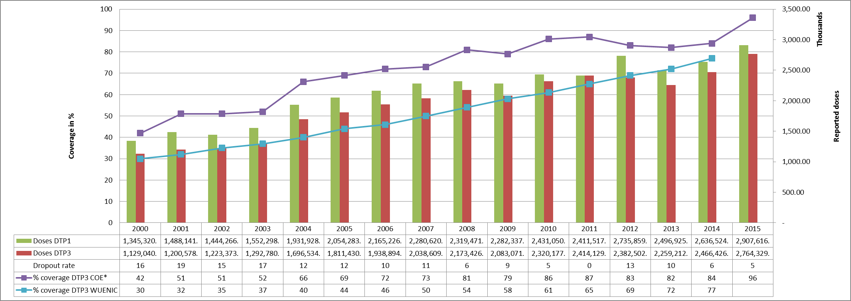

* COE: country Official Estimates

Source:

WHO/IVB database, data reported to WHO by member states as of 1 July 2016

WHO/UNICEF national coverage estimates, 2014 revision, data as of July 2015

Figure 5: Percentage of district achieving <50%; 50-79% and ≥80% coverage, 2000-2015

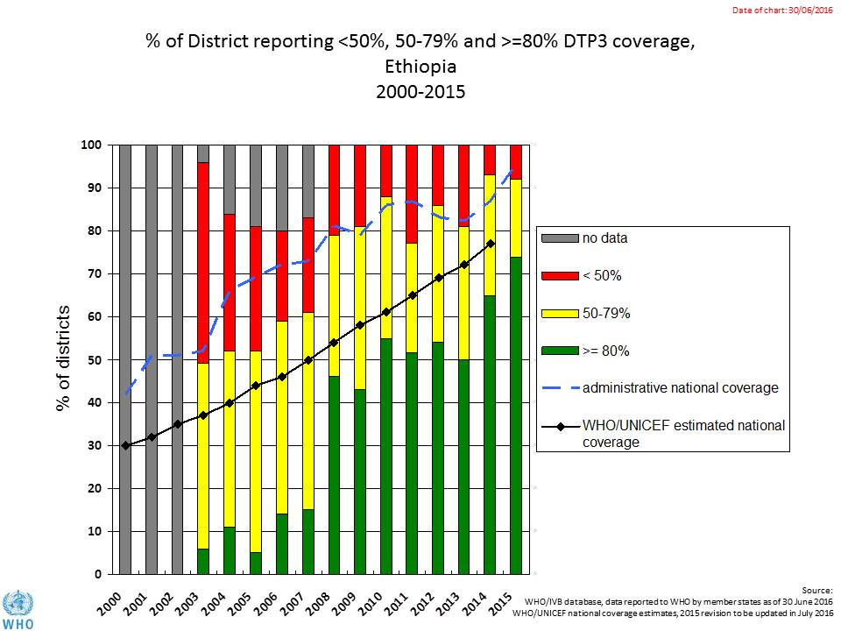

Figure 6: map with DTP3 coverage by district/province 2010 and 2015 (admin. data)

2015

2010

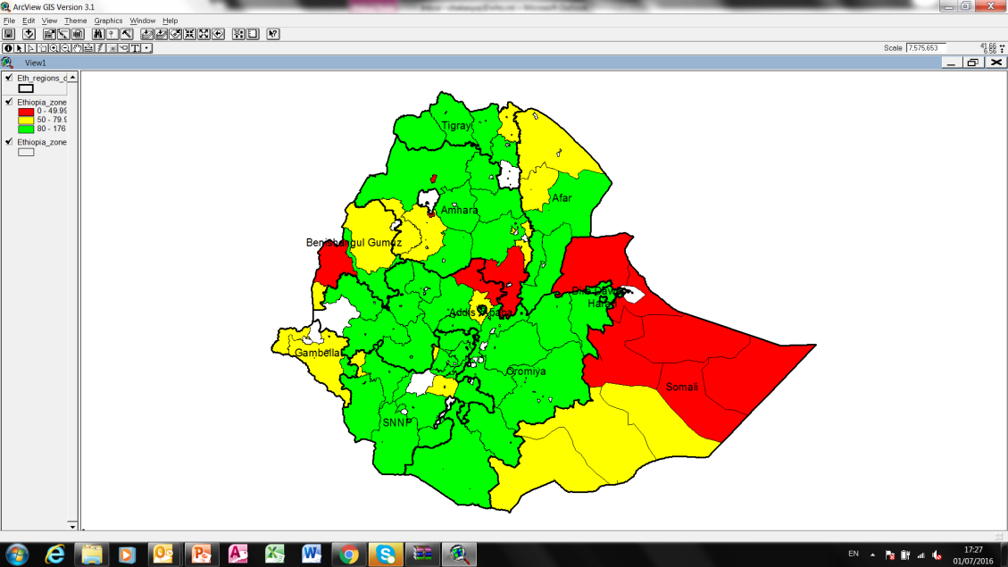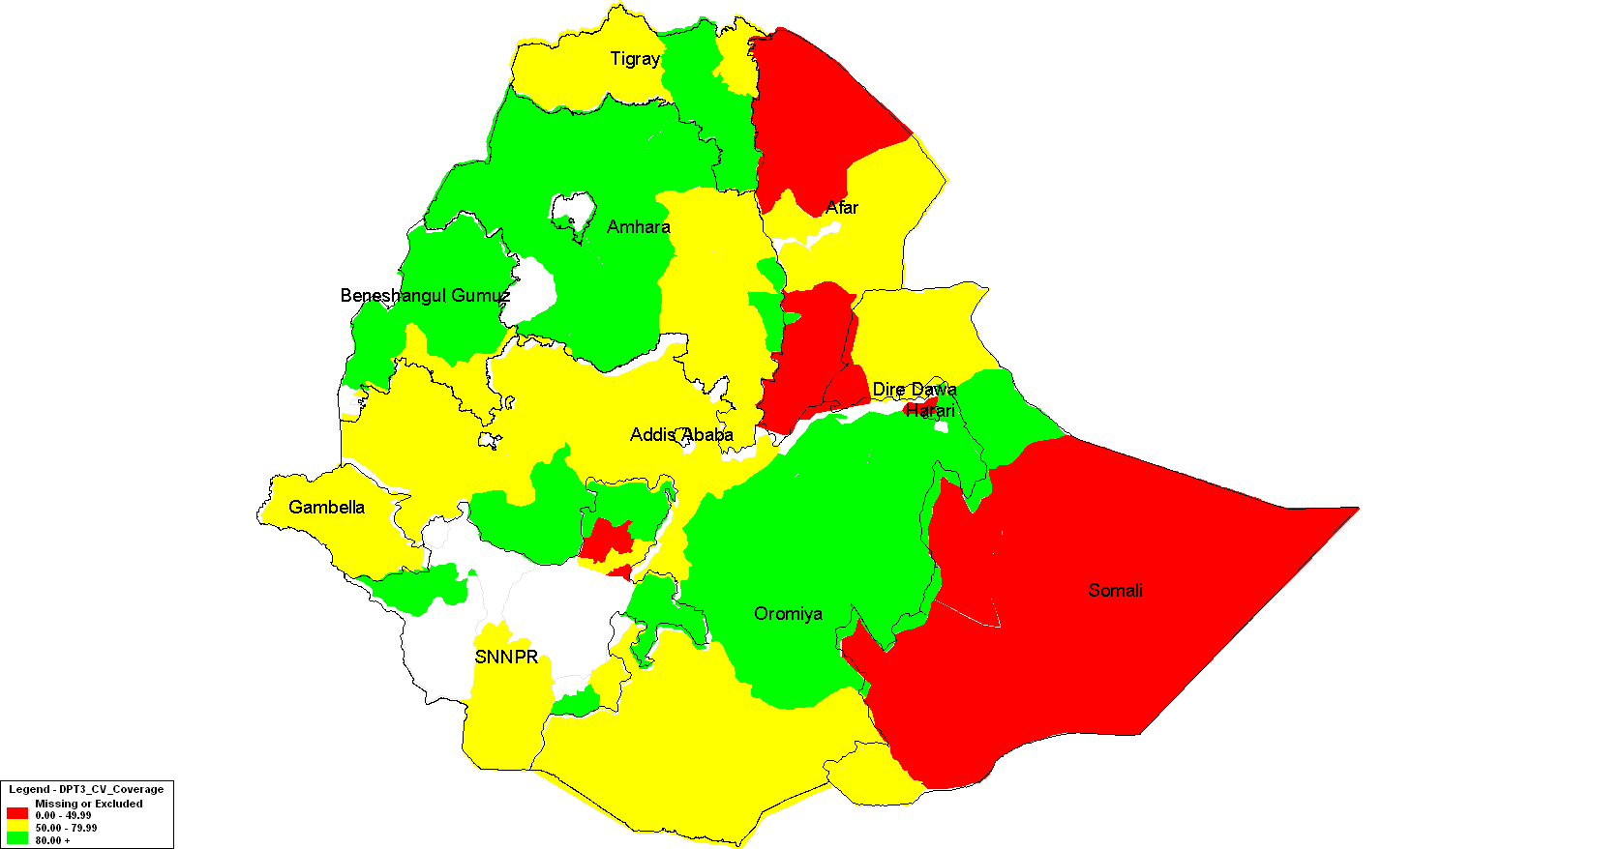

**80% and Above**

**< 50%**

**50 -79.99%**

**No Report / shape file issue**

**Legend**

Figure 7: Immunization coverage data disaggregated by sex and wealth quintile

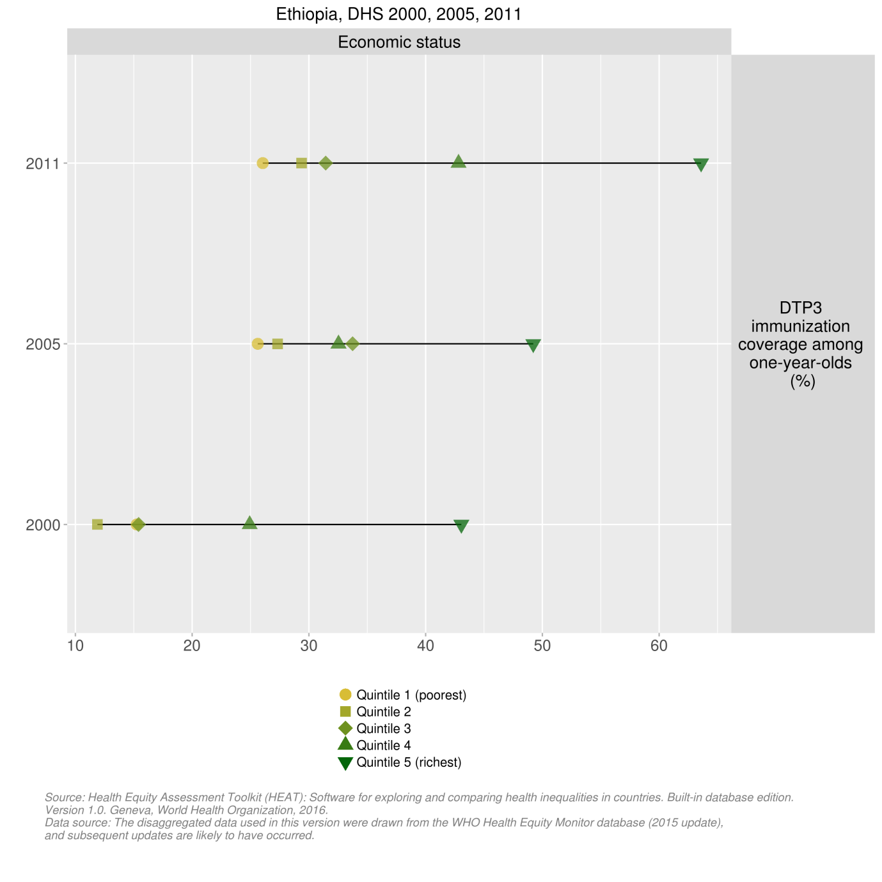

1. WHO Health Equity Monitor database (found at: [https://whoequity.shinyapps.io/HEAT/#](https://whoequity.shinyapps.io/HEAT/).
2. cMYP 2016-2020.
3. Federal Ministry of Health, Ethiopia. Post Introduction Evaluation of the Pneumococcal Conjugate Vaccine 10-Valent Technical Report, June 30, 2013.
4. Ethiopia: summary on key barriers in EPI, June 2013.