**Global Vaccine Action Plan**

*Secretariat Annual Report 2016*

*Priority Country report on progress towards*

*GVAP-RVAP goals*

**ETHIOPIA**

1. **Progress towards achievement of GVAP goals**
2. **Summary**

This summary table describes the current situation in Ethiopia regarding achieving the GVAP goals. Data used to assess progress towards achievement of GVAP goals are included in the annex (Country immunization profile).

| **Area** | **Indicator** | **Ethiopia** |
| --- | --- | --- |
| **Socio-demographic** | **GNI 2014** | **550** |
| **WB status** | **Low Income** |
| **Infant mortality (<12 mo.) 2015 (UN IAG CME)** | **41** |
| **GAVI status** | **Eligible, in preparatory transition phase** |
| **Total population** | **99,391,000** |
| **Birth cohort** | **3,176,000** |
| **Surviving infants (JRF)** | **3,031,000** |
| **1. Interrupt wild poliovirus transmission** | **Transmission interrupted** | **Yes** |
| **Risk of late detection: Percent of adequate stool specimens (rolling 12 mo.) (2015) Target > 80%** | **93.1** |
| **Risk of late detection: Non-polio AFP rate per 100,000 (rolling 12 mo.) (2015-2016) Target > 2/100,000** | **2.5** |
| **Risk of spread after importation: % of 6-59 month olds having received less than 3 doses in the last year before occurrence of last case/environmental positive)** | **17** |
| **2. Neonatal tetanus elimination** | **Coverage for TT (official country estimate 2015)** | **92%** |
| **Protection at birth against tetanus (WUENIC 2015)** | **80%** |
| **Last SIAs conducted in the country** | **SIAs in 2015 in 4/103 zones (3rd round of SIAs in high-risk districts that started in 2012.** |
| **Elimination validation date** | **Partial validation in 2011 (remaining Somali Region likely before the end of 2016 and national validation by 2018)** |
| **3. Measles elimination** | **Coverage MCV1 (2015 WUENIC)** | **78%** |
| **Coverage MCV2** | **Not in schedule** |
| **Percentage of districts with MCV1 coverage ≥95% (2015 JRF)** | **30%** |
| **Last national SIA** | **2013** |
| **Post SIA coverage survey conducted** | **Yes** |
| **4. Rubella/CRS elimination** | **Coverage rubella vaccine** | **Not introduced** |
| **SIAs planned?** | **SIAs planned for 2019** |
| **5. Reach 90% national coverage and 80% in every district with 3 doses of DTP-containing vaccine** | **National coverage (2015 WUENIC)** | **86%** |
| **Drop-out rate DTP1 to DTP3 (2015 WUENIC)** | **8.5%** |
| **Actual numbers of children who dropped out (2015 WUENIC)** | **242,480** |
| **Difference in DPT3 coverage between poorest and richest quintile (2010 data from WHO Health Equity Monitor Database)** | **37.5 percentage points** |
| **% of districts achieving ≥80% coverage for DPT3 (2015 JRF)** | **74%** |
| **6. Reach 90% national coverage and 80% coverage in every district with all vaccines in the national immunization program** | **National coverage (%) (2015 WUENIC)** | **BCG: 75 Penta1:94 Penta3: 86 MCV1: 78 PCV3: 85 Polio3: 85 Rotavirus: 83** |
| **7. Introduction of new vaccines** | **New vaccines introduced** | **PCV in 2011; rotavirus in 2013; MenA SIAs (2013-15); IPV and HPV demonstration in 2015** |
| **8. Reduction in under 5 mortality rate** | **Percent reduction from 2010 to 2015** | **21.8% (from 75.7/1,000 live births in 2010 to 59.2 in 2015)** |
| **9. NITAG** | **NITAG established?** | **Yes: in 2016 (no meeting has yet taken place)** |
| **10. Government expenditure on routine immunization per live birth (US$)** | **Average for 2013-15 and 2010-2011 (% change) (JFR 2015)** | **13.8 to 11.5 (-16%)** |

1. **Country ownership of the immunization program**
   1. **Overview of country ownership in its primary health care system, including immunization**

The Ethiopian government has made a significant commitment to increase access to primary health care services for its nearly 100 million people in the past 12 years or so, with the construction of more than 16,000 new health posts in order to bring health services to where people live. The health care delivery system now consists of a three-tiered Primary Health Care Unit in each of the country’s 914 districts – each comprising a primary care hospital, health centers (serving 15,000 – 25,000 people) and five satellite health posts for each health center (serving 3,000 – 5,000 people) – all connected by a referral system. Approximately 90% of the population now lives within 10 kilometers of a health facility, even if rudimentary.[1] Concurrently, the Government has rapidly scaled up its workforce of health extension workers (HEWs) – created in 2004 as part of its Health Extension Program – to staff the new health posts, and created a Health Development Army of community-based volunteers to further increase population access to health care services (both are further described in Section 2.4 below).

Country ownership of the immunization program, including response to infectious disease outbreaks, such as measles, was described by one informant, as “strong, almost to a fault”. Plans for vaccination campaigns in response to outbreaks are not always shared with partners; the lack of a detailed proposal to GAVI for a measles campaign resulted in GAVI delaying its release of funds for this purpose. At the local level, with the devolution of power to the 11 regions and city administrations, ownership of the EPI is demonstrated by the fact that some regions and districts (*woredas*) are starting to allocate funds from their budgets for immunization operational costs.[2]

* 1. **Immunization policy decision-making capacity**

The ICC has been the principal group advising the Government on immunization and in assisting with resource mobilization and advocacy, as well as with the preparation of new vaccine introductions. The main ICC meets twice a year, is chaired by State Minister of Health and includes members from UN agencies, NGOs, Directorates of the Federal Ministry of Health and civil society organizations. The ICC also has a technical sub-committee that meets quarterly (see Figure 1). Under the technical sub-committee is a National EPI Task Force, which meets every two weeks, and along with technical working groups, is responsible for preparing and overseeing new vaccine introductions, vaccination campaigns, and improvements with the routine immunization program. In the absence of a NITAG, the ICC has made recommendations on the introduction of new vaccines.

A NITAG has only recently been established, with WHO and SIVAC assistance. Its first meeting had not yet taken place as of mid-July 2016. It took some time for government officials to understand the role and importance of having an advisory group independent of both the Government and development partners. The newly-formed NITAG consists of professionals with strong and diverse skills.

The FMOH has also established a Ministerial Delivery Unit to strengthen leadership in the immunization program and to make immunization a regular agenda item in key policymaker meetings.

Figure 1: The ICC structure in Ethiopia

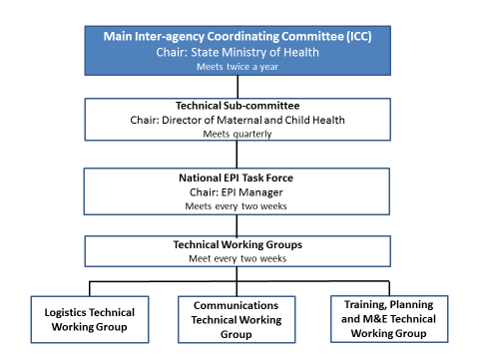

* 1. **Government Financing of Immunization**

The Government has a pooled funding mechanism – the MDG Performance Fund[3] – into which funds from the Government and development partners, including GAVI HSS funding – are placed to finance health programs and health system strengthening. The Fund, established as part of the country’s Joint Financing Arrangement (under the IHP+), in an effort to simplify budgetary and financial management by having one plan, one budget, and one reporting mechanism to which all developmental partners agree.

In 2014/15, the federal Government paid for 63% of the costs of procuring traditional vaccines ($1.8 million out of $2.9 million), using Government and MDG funds, while UNICEF paid for the remaining 37%.[4] A budget line item now exists for vaccine purchases, including co-financing of the new vaccines that Ethiopia has introduced with GAVI support. While the Government still does not cover 100% of the cost of procuring traditional vaccines, it has to date met its co-financing obligations to GAVI for new vaccines, without once being in arrears or default. These obligations have grown substantially in the past five years as new vaccines have been added to the EPI. By 2015, co-financing totaled $6.2 million, or 77% of the Government’s total expenditures for vaccines, with traditional vaccines making up the remaining 23%.[5]

Of the total expenditures for vaccines used by the Ethiopian immunization program, including GAVI support, the Government’s contribution for vaccine purchases increased from 5% in 2010 to 14% by 2015 – mainly due to co-financing. The Government paid for 33% of the overall national EPI budget in 2014/15, including staff salaries and other operational costs.[6] This is up from 8% in 2012, according to JRF data. It should be noted, however, that since MDG Performance Funds are used for traditional vaccine purchases and co-financing, the actual government contribution for vaccines and to the overall EPI budget is not clear, nor is it clear to what extent the Government has increased immunization spending using its own funds.

**2.4 Human resource situation and its impact on EPI performance**

Immunization services in Ethiopia are largely provided by Health Officers (nurses) working from health centers and by the large cadre of health extension workers (HEWs) operating from the 16,000 or so health posts built in the 2000s. The workforce of community-based HEWs, created to address Ethiopia’s critical shortage of skilled health workers, numbered more than 35,000 by 2013. These female health workers are recruited from the communities in which they served, with the active participation of community leaders and members. They must have at least 10 years of schooling and are trained for one year at technical vocational education centers, including practical training at health centers. Two HEWs work at each health posts – splitting their time between the health post and nearby communities – and are responsible for providing a range of health services, from immunization and other MCH services, to the prevention and treatment of infectious diseases (e.g., TB, HIV/AIDS, malaria), first aid, sanitation and health education. The also work with community volunteers, village councils and local health offices and health centers.

According to several studies, these health workers have become the focal point in many communities for health and specifically for immunization.[7] Through their work organizing immunization sessions, raising awareness about immunization, establishing partnerships with community leaders and volunteers, and default tracking, they are considered a key factor in the country’s increase in immunization coverage since 2004, when DPT3 rates were 40% nationally. According to informants, the problems of high attrition rates and low morale among rural health workers that plague many countries are less prominent thus far among the HEWs. This is due to the fact that they come from the communities in which they serve and their government salaries (paid out of the MDG Development Fund) have increased over time and are considered quite competitive.

Assessments have found deficiencies in the skills and knowledge of this new workforce[8] and consequently, they are currently receiving additional training and will continue to do through in-service training. There are also gaps in the supervision, monitoring and accountability of HEWs by district and health center officials. In addition, the HEWs sometimes have other responsibilities beyond health and in some cases are reportedly spending increasing amounts of time attending political meetings, taking time away from their service delivery duties.

Another key strategy of the Health Extension Program to improve access to health services was the development, beginning in 2010/11, of the Health Development Army (HDA), consisting of one community-based volunteer for every five households in a village, who together form health development teams. The purpose of the HDA is to improve the use of high-impact maternal, newborn and child health services by identifying cultural, behavioral and other bottlenecks preventing families form using these services, and to devise and execute strategies to overcome these bottlenecks. HDA members receive 7-10 days of training from HEWs and district health officials. To increase immunization coverage, these volunteers promote immunization among their assigned households, help organize outreach activities in their community, and assist with default tracking. According to the Government, there were three million HDA volunteers as of 2016.

EPI-specific staff in the Government consist of 7-8 people on the national EPI team, as well as immunization focal points in each of the country’s 11 regions or city administrations, who deal exclusively with immunization. However, there are no longer EPI focal points devoted exclusively to immunization in most of the country’s 103 zones and more than 900 districts, and those responsible for EPI at these levels have many other responsibilities. To fill in this critical gap, the partner-supported Routine Immunization Improvement Plan (RIIP) includes funding and support for EPI technical assistants in the 51 zones where the Plan is operating (see more information on the RIIP in Section B below).

1. **Progress towards specific GVAP goals (issues/challenges/successes)**

**3.1 Goal 1: Achieve a world free of poliomyelitis**

Ethiopia has not had an indigenous case of wild polio virus (WPV) reported since 2001. However, due to importations along the Somalian and S. Sudanese borders in 2013/2014 – with a total of 10 confirmed cases – the country has not yet been certified polio-free. The last case was in January 2014 and Ethiopia was removed from the polio outbreak list in March 2015.[9] Sporadic cases of vaccine-derived disease have also been detected (seven cases between 2008 and 2012), but none since 2012.

However, because of its location in the “WPV importation belt” in Africa and its proximity to Somalia, which has large numbers of children not immunized against polio, Ethiopia is still classified by WHO as “vulnerable to international spread” of WPV.[10]

In response to the 2013/14 outbreak, the country has conducted a series of national and sub-national immunization days – with 12 rounds of SNIDs and three NIDs alone in 2013/14. Another NID took place in 2015 and SNIDs in high-risk areas are continuing into 2016. These campaigns – often combined with measles vaccination – receive substantial financial and technical assistance from international partners, and according to independent monitoring data, have achieved high coverage (>90% in most areas).

Along with improvements to the routine immunization program in recent years, the polio SIAs have led to a jump in coverage of three doses of polio vaccine from 70% in 2011 to 85% in 2015 (WUENIC estimates). The country has also set up 28 permanent vaccination points at border crossing with Somalia and major transit points. In addition, IPV was introduced into the routine immunization (for the third polio vaccine dose) in 2015. Ethiopia plans to present its dossier for polio eradication in 2017, in anticipation of being declared polio-free in 2018.

Besides vaccination, the country’s primary means of preventing polio transmission is through strong AFP and polio surveillance. Ethiopia is considered to have a good polio surveillance infrastructure in place, due to a high commitment to and ownership of disease surveillance by the Government, led by the Public Health Emergency Management division of the Ethiopian Public Health Institute. Unlike for the immunization program, there are dedicated disease surveillance focal points in place at all levels (regional, zonal, district). Private health providers, including some traditional healers, participate in disease reporting in most regions.[11] Community-based surveillance – using HEWS and HDA volunteers – has also been implemented in most regions, most intensively in five regions with the support of 12 local NGOs. In one year (from 2014 to 2015), the percent of AFP cases notified by community volunteers in these five regions tripled – from 5% of all notified cases to 15%.[12]

An external review of the surveillance system conducted in 2015 found that more than 80% of AFP cases were validated, surveillance focal points conducted active surveillance of health facilities and submitted weekly reports (compiled into a national weekly bulletin shared with stakeholders), and the quality of case investigations was strong. However, there remain a number of gaps in the country’s AFP/polio surveillance system, which need to be addressed to reduce the risk of transmission from imported cases and to achieve polio-free status by 2018. The quality of active surveillance was found in the external review to be inadequate in all regions, due to high staff turnover and limited transportation and resources for surveillance. Some AFP cases were consequently unreported in three regions. In addition, community-based surveillance is still being developed in many regions, which is further complicated by the seasonal movement of people in some regions.

* 1. **Goal 2 : Meet global and regional elimination targets**
     1. **Achieve maternal and neonatal tetanus elimination**

Ethiopia has partially achieved this goal – with elimination validated in 2011 in 10 of the country’s nine regions and two city administrations (all but the Somali region). This has been accomplished through TT vaccination campaigns targeting 15-49 year old females in 62 high-risk zones with three vaccine doses, beginning in 1999, when the country had an estimated 13,400 neonatal tetanus deaths.[13] The campaigns – using nurses, HEWS, nursing and medical students – vaccinated 15 million women from 1999 to 2013, achieving an average coverage rate of 81% for two TT doses and 66% for three doses, according to EPI administrative data.[14] The WHO-UNICEF (WUENIC) estimated coverage rate for protection at birth was 80% in 2015. The AFP/polio surveillance network is used for case-based MNT surveillance.

According to informants, the country is on track to achieve MNT elimination nation-wide by the end of 2016, after it completes TT SIAs recommended by the validation committee in five zones in the Somali region that had achieved less than 80% coverage through the SIAs conducted there in 2012.

* + 1. **Achieve measles elimination and rubella and CRS elimination**

**Measles**

Ethiopia is not currently on track to meet the goal of measles elimination by 2020, despite the federal Government’s commitment to do so and its considerable efforts to combat the disease with multiple national and sub-national campaigns. The number of reported measles outbreaks has increased in recent years – from 145 in 2012, to 243 in 2013 and 302 in 2014,[15] as has the number of reported cases (see figure in the Annex). The highest number of annual reported cases was, in fact, in 2015 (nearly 18,000 cases, as compared to 5,000 or less each year from 2006 to 2013). Improved measles surveillance and reporting could be a factor in the increased reported incidence, however. Annual national measles incidence for 2015/16 (laboratory and epidemiologically confirmed cases) was estimated at 83 per one million population, compared to the elimination threshold of <1/1 million.[16] Reported measles incidence varies dramatically by region – from as low as 0 to as high as 220 per million.

Outbreaks earlier in this decade (e.g., 2010/11) were concentrated in “developing regions”, such as Somali and Afar, and were believed to be caused by an increase in refugees from Somalia. However, the disease has spread in recent years to other areas far from the Somali border, such as Oromia in the South and the Southern Nations Nationalities Peoples (SNNP) region.

The main reason given by informants and reports for the recent increase in measles incidence is the accumulation of susceptible individuals due to a failure to vaccinate sufficient numbers of children through routine immunization and SIAs. Ethiopia conducted its first national measles catch-up campaign in a phased manner from 2003 to 2005 for children up to 15 years of age, followed by three follow-up campaigns for children under four or five every three years or so. While these later SIAs led to a sharp reduction in measles cases in children four years and younger, the disease struck older children and adults; 70% of confirmed cases in the first four months following the 2011 SIAs were more than five years of age.[17] The movement of people from sparsely-populated areas with low vaccination coverage, such as Somali and Afar, to more populated parts of the country is implicated in the geographic spread and increase in incidence of the disease.

The immunization program is now conducting measles SIAs on a yearly basis, though they reportedly vary in quality, with some, including the recent April 2016 campaign, implemented without adequate preparation time, making is more difficult to reach more remote areas. However, the main problem remains the inability of the routine immunization program to achieve sufficiently high measles vaccination coverage to eliminate the disease. According to the WUENIC estimates, national measles coverage reached 78% in 2015, but ranged from 62-68% in the four previous years. Coverage is very uneven by region – with rates ranging from 34% to 98% among 12-23 months in the 2012 immunization coverage survey.[18] According to administrative coverage data, only 30% of districts in 2015 met the target of ≥95% measles vaccination coverage.

An investigation of continual measles outbreaks in the SNNP region conducted in 2014 attributed the insufficient performance of the routine immunization program to many of the problems discussed under Section 3.3 below (e.g., lack of daily immunization services, cold chain inadequacies, frequent vaccine stockouts).[19] Two additional problems identified in the measles outbreak investigation were:

* A reluctance among health workers to open multi-dose vials of measles vaccine for less than six or seven children at a time to reduce wastage, resulting in missed opportunities to vaccinate against measles;
* Over-reporting of coverage numbers due to “persistent demand for unrealistically perfect performance” from higher-ups and a performance-based reward system. This results in high administrative coverage rates for measles, and complacency until outbreaks began to occur. In one area, a post-outbreak survey revealed a covered rate of 52%, compared to 80-100% administrative coverage rates for the previous seven years.

As mentioned above, the Government has increased the frequency of measles SIAS in order to halt the increase and spread of outbreaks, and measles vaccination coverage has improved in the past three years. Coverage should also improve once the EPI introduces a second measles vaccine dose into the routine program, currently planned for 2018. Ethiopia also has a relatively strong surveillance infrastructure for measles, due to the existence of surveillance focal points at all levels of the health system, and district-level rapid response teams, as well as epidemic response committees at all levels. This system is heavily supported by WHO and UNICEF, which cover the costs of the 11 regional surveillance coordinators and surveillance medical officers (SMOs) and supporting staff in zonal health departments throughout the country. The WHO-supported surveillance team alone, including administrative assistants and drivers, numbered 114 persons in 2015.

**Rubella**

The incidence of rubella has been tracked in Ethiopia since 2011, as a result of intensive measles case-based surveillance, in which lab testing for rubella is conducted on measles IgM-negative cases. Hundreds of rubella cases have been confirmed each year and an outbreak identified in the Benishangul-Gumuz region in 2012 (with >800 confirmed cases), led to increased recognition of the disease in the country. Rubella surveillance indicators, however, remain below target.

The FMOH plans to introduce MR vaccine with GAVI support in 2019, beginning with SIAs, which will be followed by the introduction of two MR doses into the routine immunization schedule. Under GAVI’s new policy, the Government will be required to pay 100% of the cost of the first MR dose, which could be a challenge, given that Ethiopia does not yet cover the costs of all traditional vaccines. Given that rubella vaccine will not be incorporated into the routine immunization schedule until 2019, it is unlikely that the country will be able to achieve elimination of the disease by the target date of 2020.

* 1. **Goal 3: Meet vaccination coverage targets**

1. **Achieve 90% national coverage and 80% in every district with 3 doses of diphtheria-tetanus-pertussis containing vaccine**
2. **Achieve 90% national coverage and 80% in every district with all vaccines included in the national schedule**

According to WHO-UNICEF estimates, Ethiopia has come close to meeting the national coverage target of 90% for three doses of DPT-containing vaccine – reaching 86% for three doses of pentavalent (DPT-HepB-Hib) vaccine in 2015. This is a significant jump from the WUENIC estimate of 77% in 2014 and 65% in 2011. A decline in the dropout rate between the first and third doses has been one factor contributing to the recent increase in pentavalent 3 coverage – falling by more than half from 19% in 2011 to 8.5% in 2015, according to the WUENIC estimates.

However, the immunization program has been less successful in achieving high coverage in all parts of the country. Administrative data, which is almost certainly inflated, shows that only 65% of districts in 2015 achieved coverage of ≥80% for three pentavalent vaccine doses. A perhaps more accurate picture comes from data from the Routine Immunization Improvement Plan (RIIP) being implemented in 51 of the country’s 103 zones. The percent of zones achieving ≥80% for the third pentavalent dose was 41% in 2015 (but up from 17% in 2013) (see Figure 2 in Section B below). There are also large disparities in immunization coverage by income level. The 2013 immunization coverage survey found a difference in pentavalent 3 coverage rates of 49 percentage points between the richest and poorest income quintiles, while data from 2010 found a difference of 37.5 percentage points (WHO Health Equity Monitor Database).[20]

There has been a similar jump in national coverage estimates by WHO and UNICEF for other vaccines in the immunization schedule, with three vaccines approaching the 90% national coverage target in 2015: PCV3 and polio 3 – both at 85% -- and rotavirus (at 83%). The lowest rates are for BCG (75% and measles (78%). WUENIC estimates for these vaccines are not available by district to determine their progress in meeting the goal of at least 80% coverage in all districts.

Some of the key factors contributing to the 21 percentage point gain in pentavalent 3 coverage from 2011 to 2015 are:

* **The continual buildup of the HEW workforce**, as well as an increase in local and international NGOs supporting health facilities directly;
* Implementation of the **Reach Every Community (REC) strategy**, which began in 2004;
* Implementation of the **Routine Immunization Improvement Plan (RIIP)**, starting in 2014, in the half of the country’s zones with the poorest immunization program performance. The maps in Figure 2 below suggest that the project has had an important impact on improving vaccination coverage rates in the target zones (see Section B).
* **Establishment of the Health Development Army**. This army of community-based volunteers, describe in Section 2.4 above, forms the backbone of the Government’s new Intensification Plan to reduce the number of unimmunized or under-immunized children by 80% in each zone, in large part by identifying missed children, tracking defaulters, and ensuring catch-up immunization of these children. According to one informant, however, these volunteers could be used more efficiently, and given the newness of the program and its rapid scale-up, there is to date little information on their impact in improving utilization of immunization services.

While progress has been significant in the past five years, there are a number of issues that need to be addressed in order for Ethiopia to meet its immunization coverage targets, especially in narrowing the geographic and income class inequities in performance. These include:

* The existence of **geographic pockets with low coverage**, especially in pastoralist communities that are concentrated in three regions (Afar, Somali and Gambella). The sparse populations, nomadic lifestyle and weaker health infrastructure in these areas make it challenging to provide immunizations on schedule. The situation is reportedly improving with the increase in the number of health posts and HEWs in these areas, and through efforts by NGOs in pastoralist areas to find creative ways to deliver immunization and other health services to this population. One strategy, for example, involves government health workers meeting nomadic groups at pre-arranged locations and dates to provide immunization and other health services.
* The fact that **most health facilities do not provide immunization services on a daily basis** – as stipulated in the national routine immunization policy. The 2012 immunization coverage survey found that only 26% of health facilities surveyed (mainly health centers) offered daily immunization services, and only 5% of health posts did so. Three-quarters (76%) of health posts offered immunization once a month, as did 48% of all health facilities in the study. The infrequency of EPI services results in many missed opportunities to reach children with vaccinations.
* **Vaccine supply chain and cold chain issues**: A major reason that health posts do not offer daily immunization is that only around 30% of them have cold chain equipment, according to an EVM assessment conducted in 2013.[21] In addition, many refrigerators were found in a 2013 cold chain inventory to be non-functional – 38% of those at health facilities and 36% of those at zonal and district stores – due to a lack of trained cold chain technicians, spare parts and fuel (kerosene). The country’s five-tier vaccine supply chain system is also weak – often resulting in overstocking at the central level and vaccine shortages or stockouts at sub-national cold rooms. This situation is improving with the transition of vaccine logistics management from the FMOH to the quasi-governmental Pharmaceuticals Fund Supply Agency (PFSA), which is now responsible for delivering vaccines to the zones and districts. Health facilities must still collect the vaccines themselves from zonal or district stores, which can be difficult due to limited staff (especially at health posts) and limited transportation.

As a result of both the lack of working refrigerators in health facilities and weak vaccine distribution, local-level vaccine stockouts are quite common. The 2015 rotavirus post-introduction evaluation found that nearly half (47%) of health facilities surveyed had experienced a vaccine or supply stockout in the previous six months.[22] The 2012 immunization coverage survey found that vaccine stockouts were the major reason that health facilities cancel planned immunization sessions, resulting in further missed opportunities to vaccinate children.

* **Gaps in monitoring and supervision**: There is a supportive supervision system in place, but its impact on the immunization program is considered insufficient, due to the lack of funding for regular, consistent visits to the field and to the fact that the supervisory visits cover all components of the minimum health services package, therefore not always focusing sufficiently on immunization.[23]

There is also anecdotal, but no documented evidence that multiple rounds of polio and measles campaigns – as many as 19 over three years in some areas – can negatively impact the delivery of routine immunization services. Each campaign can require two weeks of planning, leaving the often over-stretched HEWs little time to provide routine immunization. On the other hand, the repeated campaigns and accompanying social mobilization, has reportedly increased population awareness of and demand for vaccination. Some districts have used the opportunity of the SIAs to catch up children with all their immunizations, by, for instance, having nearby health posts offer routine immunization services at the same time as an SIA is being held at an outreach site, and encouraging parents to take their children to the health post for their other vaccinations.

Vaccine hesitancy is not considered to be a major issue in Ethiopia, according to informants.

* 1. **Goal 4: Introduce new and improved vaccines and technologies**

Ethiopia has an impressive record of introducing new vaccines with GAVI support, beginning with pentavalent (DPT-HepB-Hib) vaccine in 2007, followed by PCV-10 in 2011, rotavirus and meningitis A (through campaigns) in 2013, and IPV (as the third polio vaccine dose) in 2015. The introduction of PCV, originally planned for 2010, was delayed until the following year as a result of a global vaccine shortage. Rotavirus vaccine introduction took place in late 2013 in all regions, except Somali, where it was delayed until August 2014 due to the polio outbreak and response in that region.

Post-introduction evaluations (PIEs) conducted for the PCV and rotavirus vaccine introductions indicate generally successful and smooth introductions of both vaccines and good acceptance by the population.[24] In both cases, there was extensive training nation-wide – with most HEWS trained – and personnel from private and NGO-run health facilities were included in the training of training (TOT) courses. Both vaccine introductions had a strong advocacy and communications component, including the participation of influential leaders in launch ceremonies and in raising public awareness of the new vaccine, as well as extensive media coverage. No stockouts of the new vaccines were reported in either PIE, nor in the 2014 and 2015 JFRs. There also were not any indications of the vaccine introduction disrupting the routine immunization program.

Immunization coverage rates for the new vaccines were low in the year following their launches. The PCV3 coverage rate was only 38% in 2012 and the PCV roll-out took three months to reach all regions. However, coverage has risen steadily each year and is now 85% (WUENIC estimate). Rotavirus coverage also rose from 63% in 2014 to 83% in 2015.

While the introduction of each vaccine stimulated expansion of the cold chain system, cold chain capacity was still found to be insufficient, especially after the introduction of rotavirus vaccine, which resulted in crowded cold rooms and over-packed refrigerators at different levels. Other problems reported with both vaccine introductions include poor temperature monitoring, uneven quality and length of the training at lower levels (which ranged from as little as 30 minutes to one day for HEWs in the case of PCV), inadequate coverage monitoring and reporting in many locations, and poor AEFI surveillance. To improve the cold chain and temperature monitoring gaps, the Ministry of Health, in collaboration with GAVI and partners, subsequently procured cold rooms, ice-lined refrigerators, and introduced solar direct drive (SDD) refrigerators, as well as a continuous temperature monitoring system.

Ethiopia conducted nation-wide meningitis A campaigns for 1-29 year olds in three phases from 2013 to 2015, starting with the regions at highest risk and ending in late 2015 with those at lowest risk. A post-campaign survey conducted in the Phase II zones in 2014 found a 93.5% coverage rate.

The national immunization program plans to introduce two more vaccines into the routine program in 2018 -- meningitis A and HPV – and two more in 2019 – measles-rubella and yellow fever. A pilot HPV introduction in two zones is currently underway, with reportedly high demand for the vaccine, due to media coverage about cervical cancer.

1. **Partner support to address remaining challenges to meet the GVAP goals and targets**

The Ethiopian government has benefited from every type of GAVI support that the organization offers, including support for new vaccine introductions, immunization system strengthening (ISS), health system strengthening (HSS) and civil society organizations (CSO).

Technical and financial support from GAVI and many other partners has been critical in developing the country’s disease surveillance system for polio, measles and other vaccine-preventable diseases, and in the implementation of numerous polio and measles SIAs, the national meningitis vaccination campaigns and TT campaigns in high-risk areas. Partners, including through the HSS grant, also provide critical aid to the routine immunization program, by supporting refresher training of HEWs; equipping newly constructed health centers; procuring essential drugs and supplies for health posts; and assisting with microplanning and data quality improvements. GAVI’s CSO grant has supported local organizations to improve immunization services in hard-to-reach and low-coverage areas, especially pastoralist areas.

Two partner-supported activities to highlight that are aimed at resolving key bottlenecks and challenges to the country further strengthening and expanding its immunization program are the following:

**The Cold Chain Rehabilitation and Expansion Plan (2014-18)**

This plan, supported by the GAVI HSS grant and many partners, will enable the country to introduce HPV, MR and other new vaccines without compromising the cold chain system. It should also help increase the availability of daily EPI services at health facilities, including health posts, by equipping them with cold chain equipment and by improving the local distribution of vaccines. The plan involves the transition of the vaccine supply chain system from the FMOH to the PFSA and includes constructing cold rooms at the airport in Addis Ababa; procuring 20 refrigerator trucks and thousands of vaccine carriers and cold boxes; establishing a network for 17 regional storage and distribution hubs; establishing a continuous temperature monitoring system at all vaccine storage sites; and providing refrigerators and other cold chain equipment to all health facilities, including health posts, with a focus on solar-powered equipment. Four regional hubs have already been established, manned by several newly-created and trained Technical Assistants responsible for cold chain maintenance and vaccine management. While the regional hubs are currently delivering vaccines and supplies to the zonal and district-level stores, during the last phase of the transition plan, these hubs will make monthly deliveries directly to health facilities, eliminating the need for the zonal and regional stores or for health facilities to pick up vaccines. The delivery of vaccines to health facilities, coupled with the acquisition of refrigerators in all facilities, will enable health centers and posts to comply with the government policy of providing immunization services on a daily basis, and should therefore have an important impact on immunization coverage.

**The Routine Immunization Improvement Plan (RIIP)**

This plan, started in 2014 to increase immunization coverage in the country’s 51 poorest-performing zones, is heavily supported by multiple partners, including UNICEF, WHO, CDC and USAID’s Last 10 Kilometers (L10K) project. A key component of the plan involves the recruitment, training and placement of 51 EPI Technical Assistants (one per zone) whose salaries and other costs are supported by the various partners. These EPI Technical Assistants help zones and districts with immunization-related trainings, microplanning, social mobilization, and monitoring and reporting. Coverage data collected by the project shows a marked improvement in the overall coverage of three pentavalent doses in the 51 zones and in the percent of zones achieving coverage of ≥80% (from 17% in 2013 to 41% in 2015) (Figure 2). However, partner funding for the RIIP is only assured for 2.5 years, after which time the Government will need to assume the costs of the Technical Assistants and associated operational costs or mobilize new resources.

Figure 2: Coverage data for three doses of pentavalent vaccine in the 51 target zones of the partner-supported Routine Immunization Improvement Plan (project data)

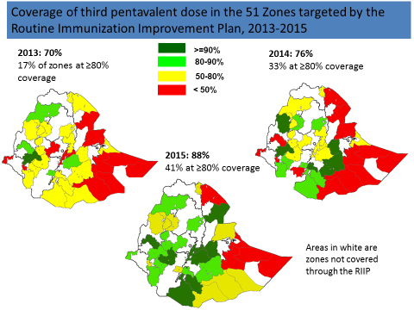

Many partners are providing assistance to the immunization program in Ethiopia, often in specific parts of the country. It has been suggested that a mapping of partner activities be undertaken to allow better coordination and planning by the Government, avoid duplication and identify current gaps in support.

**Acknowledgments**

We would like to thank the following persons who were interviewed or who reviewed this report:

* Robert Perry (WHO HQ)
* Messeret Eshetu, (WHO ESA IST)
* Thomas Karengera, (WHO CO)
* Assefu Lemlem, (WHO CO)

**ANNEXES**

**Annex 1: Country immunization profile**

1. **Polio**

* **Transmission stopped in year 2001 (imported cases in 2013 and 2015).**
* **Eradication certified: not yet (planned for 2018).**

1. **Measles and rubella**

Figure 3: Reported Measles cases and MCV coverage, Ethiopia, 1990-2015

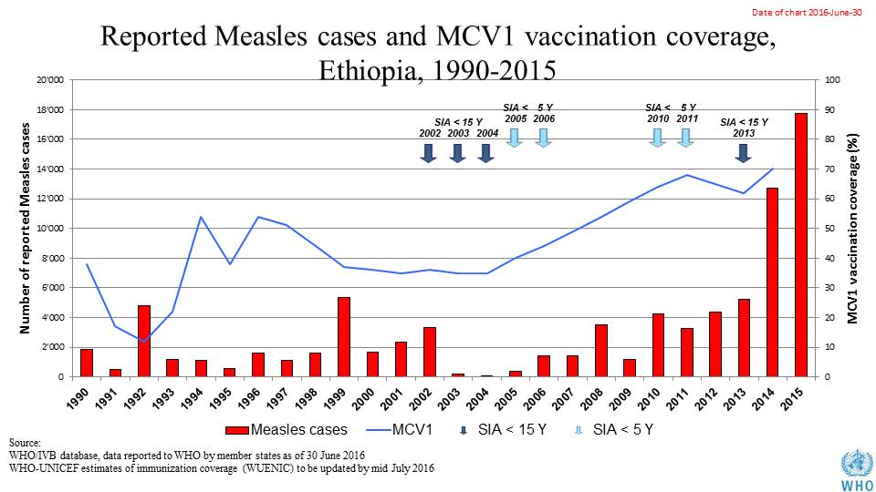

Table 1: SIA activities planned in 2016-2017

|  |  |  |  |  |  |  |  |  |
| --- | --- | --- | --- | --- | --- | --- | --- | --- |
| **Activity** | **Intervention** | **Year** | **Start Date** | **End Date** | **Age Group** | **Extent** | **Status** | **Target** |
| ORI | Measles | 2016 | 22/04/2016 | 28/04/2016 | 6 months to <15 years | Sub-national | done | 25,894,518 |
| SNID | tOPV | 2016 | 19/02/2016 | 21/02/2016 | 0 to 5 years | Sub-National | Planned | 4,043,159 |
| NID | tOPV | 2016 | 01/03/2016 | 01/03/2016 | 0 to 5 years | National | Planned | 12,251,996 |
| Follow Up | Measles | 2016 | 01/10/2016 | 31/10/2016 | 9 months to 14 years | Sub-national | planned | 11,777,083 |
| SNID | bOPV | 2016 | 01/05/2016 | 01/05/2016 | 0 to 5 years | Sub-National | Planned | 3,732,146 |
| SNID | bOPV | 2016 | 01/09/2016 | 01/09/2016 | 0 to 5 years | Sub-National | Planned | 4,043,159 |

Source: WHO/IVB Database as at 12/4/2016

1. **MNT**

* **partial validation in 2011 (remaining Somali Region likely before the end of 2016)**

1. **Coverage and Equity**

Figure 4: All vaccines national coverage, Ethiopia, 2000-2015

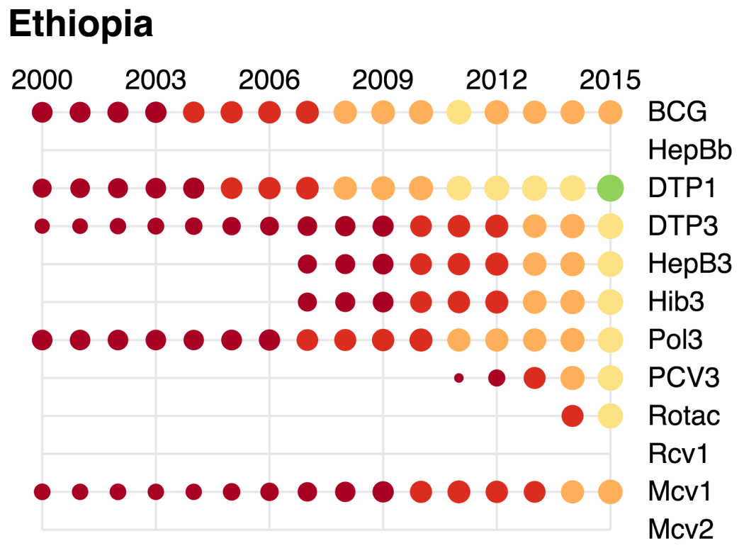

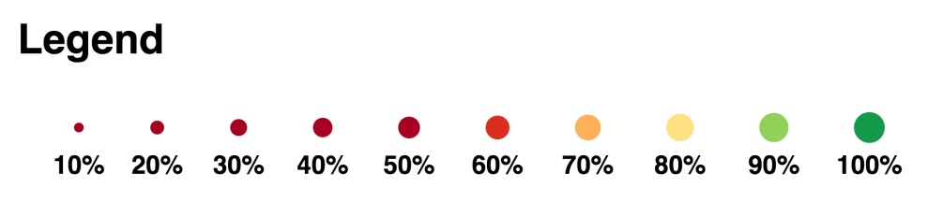

Table 2: Reported DTPcv doses administered & coverage, 2000-2015

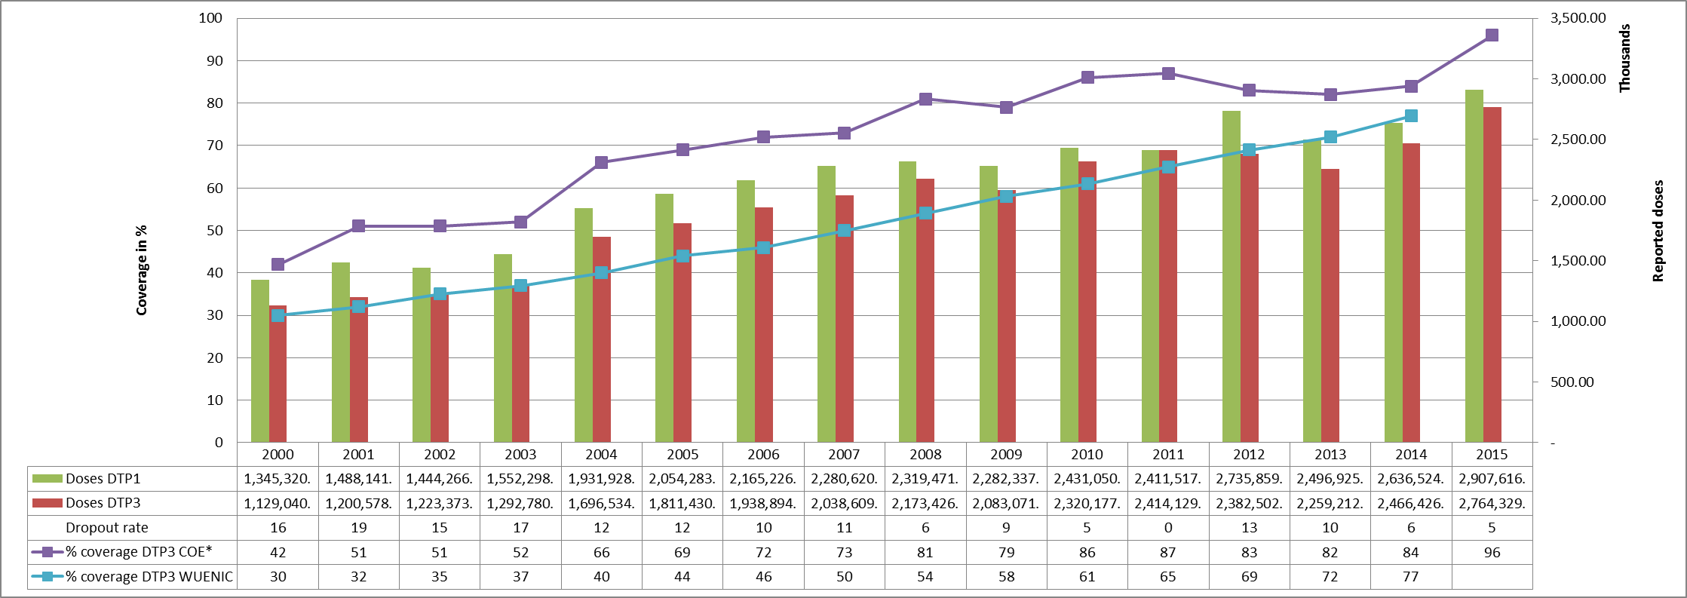

* COE: country Official Estimates

Source:

WHO/IVB database, data reported to WHO by member states as of 1 July 2016

WHO/UNICEF national coverage estimates, 2014 revision, data as of July 2015

Figure 5: Percentage of district achieving <50%; 50-79% and ≥80% coverage, 2000-2015

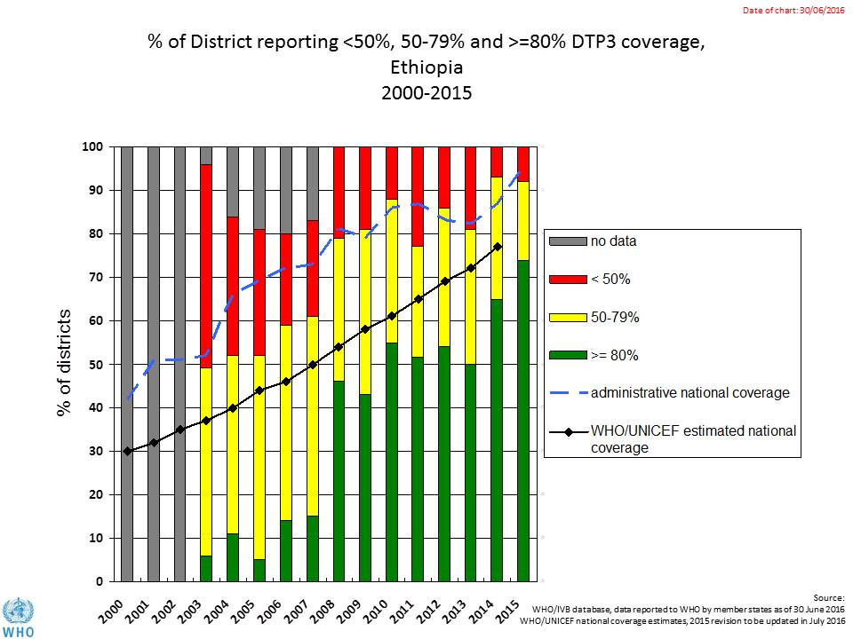

Figure 6: map with DTP3 coverage by district/province 2010 and 2015 (admin. data)

2015

2010

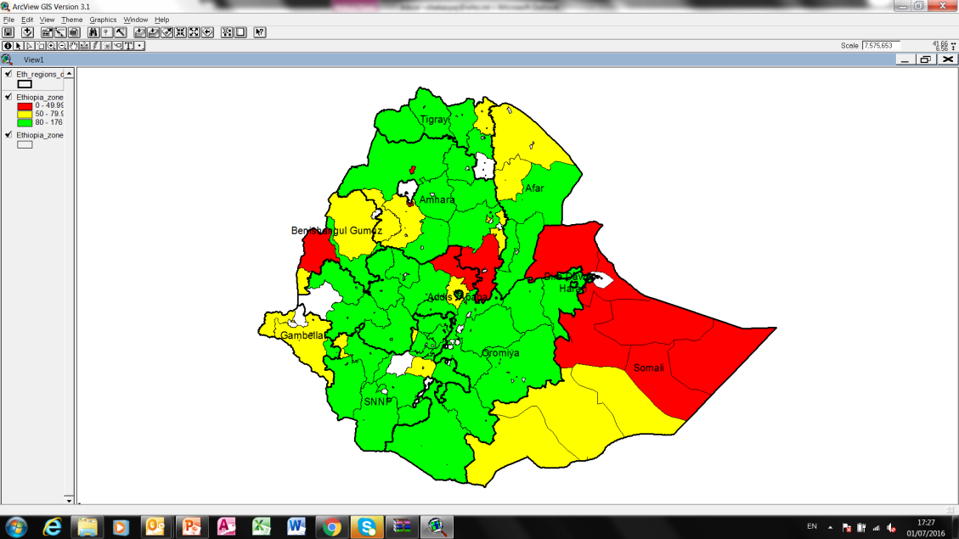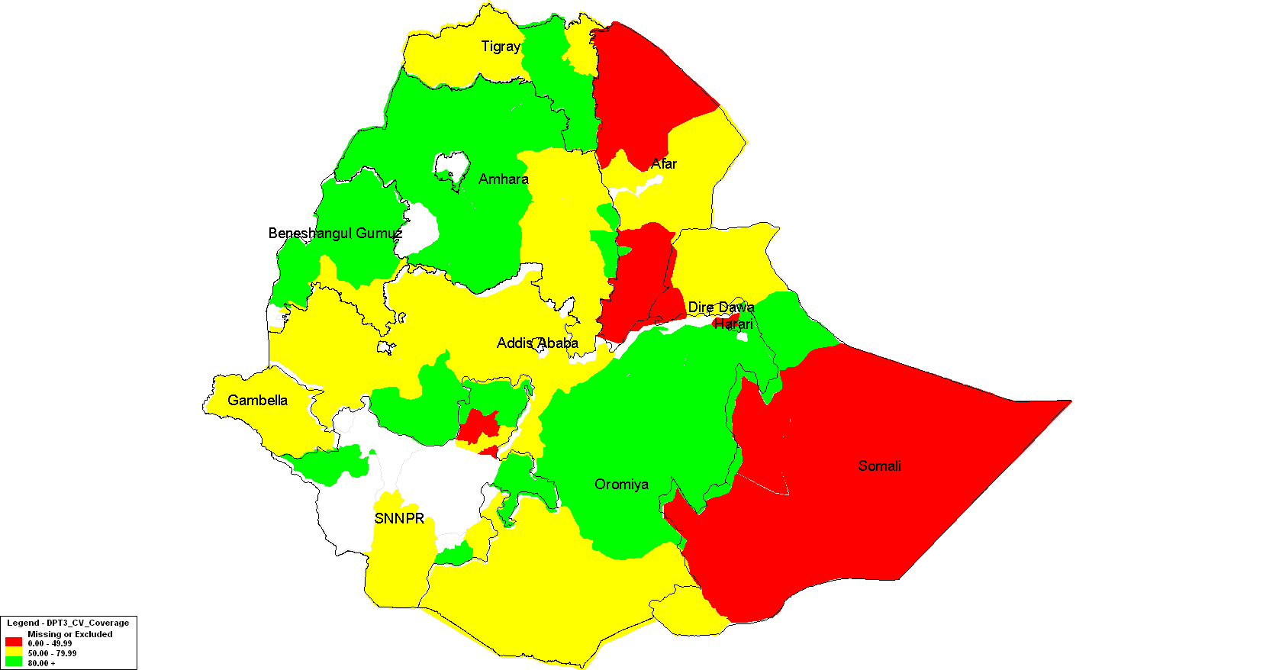

**80% and Above**

**< 50%**

**50 -79.99%**

**No Report / shape file issue**

**Legend**

Figure 7: Immunization coverage data disaggregated by sex and wealth quintile

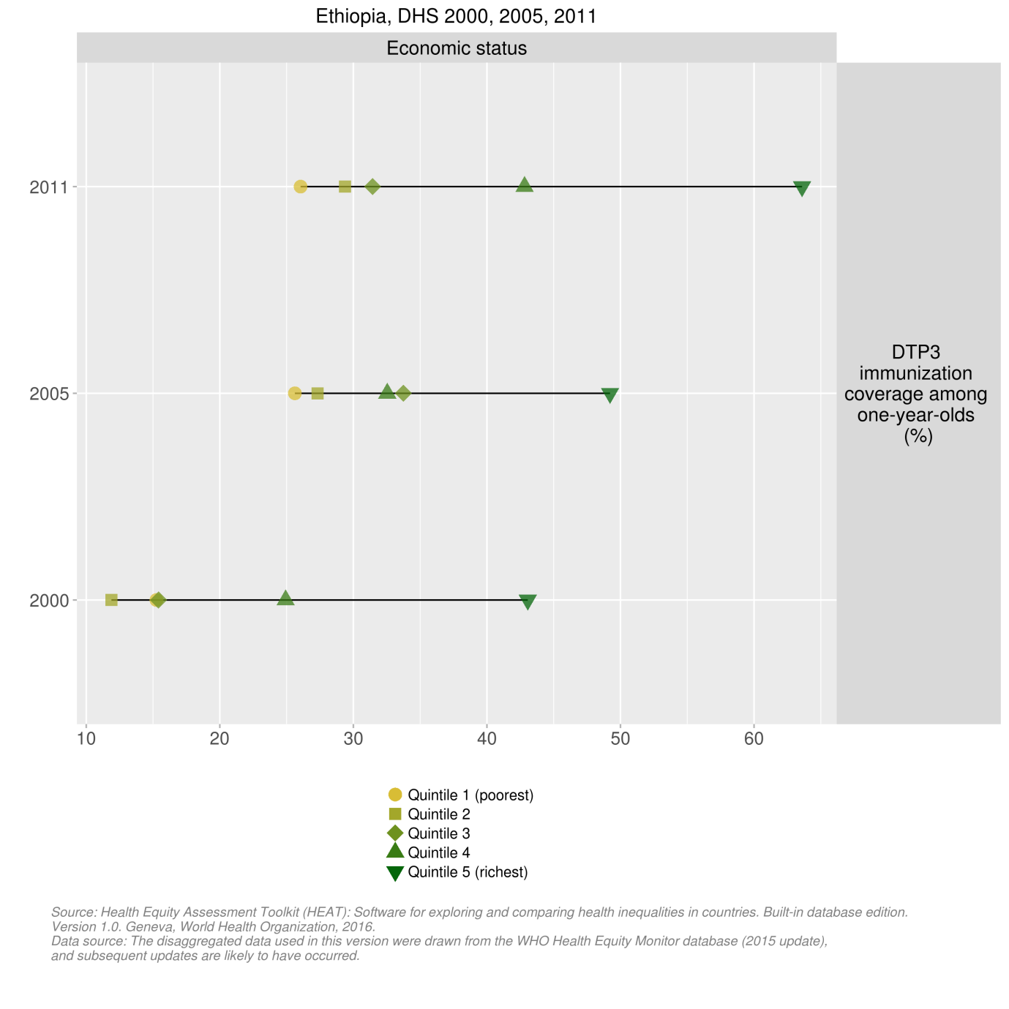

1. **Immunization systems highlights**

* Immunization schedule

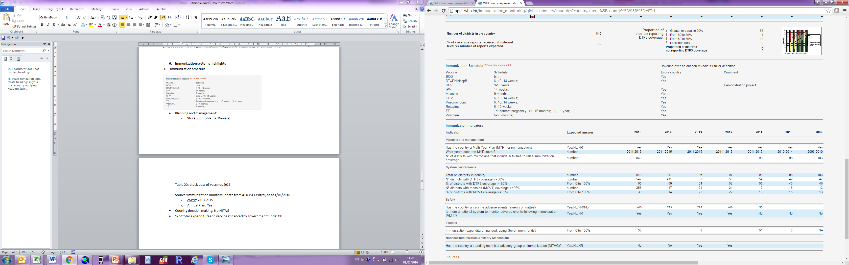

* Planning and management:
  + Stockouts : No stockouts reported in 2015 (as reported in JRF 2015)
  + cMYP: 2011-2015
  + Annual Action Plan: Yes
* Country decision making: NITAG established in 2015.
* % of total expenditures on vaccines financed by government funds (JRF 2015):

Figure 8: Percentage of total expenditures on vaccines financed by government funds (JRF 2015):

|  |  |  |  |  |  |  |  |  |  |  |
| --- | --- | --- | --- | --- | --- | --- | --- | --- | --- | --- |
| Country | Income | 2010 | 2011 | 2012 | 2013 | 2014 | 2015 | 2010-2011 Average | 2013-2015  Average | Change |
|  |  |  |  |  |  |  |  |  |  |  |
| Ethiopia | LIC | 13.80 |  | 1.79 | *9.42* | 11.54 | 13.62 | 13.80 | 11.53 | -16% |

1. Ethiopia: summary on key barriers in EPI, June 2013.
2. Ethiopia National Expanded Programme on Immunization. Comprehensive multi-year plan 2016-2020. Federal Ministry of Health, April 2015.
3. Now renamed the SDG Development Fund.
4. GAVI Joint Appraisal report for Ethiopia, 2015.
5. GAVI Joint Appraisal report for Ethiopia, 2015.
6. GAVI Joint Appraisal report for Ethiopia, 2015.
7. JSI. Africa Routine Immunization System Essentials (ARISE) project. A study of the drivers of routine immunization system performance in Ethiopia. August 2012; Workie NW and Ramana GNV. UNICO Studies Series 10: The Health Extension Program in Ethiopia. The World Bank, Washington, DC, January 2013.
8. UNICO Studies Series 10: The Health Extension Program in Ethiopia. The World Bank, Washington, DC, January 2013.
9. Comprehensive multi-year plan (cMYP), 2016-2020.
10. Global polio eradication initiative website (<http://www.polioeradication.org/Keycountries.aspx>).
11. cMYP 2016-2020.
12. WHO presentation on External Surveillance Review, Ethiopia, 29 Sept – 9 October, 2015.
13. cMYP 2016-2020.
14. cMYP 2016-2020.
15. cMYP 2016-2020.
16. WHO presentation on Desk analysis of measles surveillance data, July 2016.
17. WHO/ESA IST. Summary report on the investigation of recurrent measles outbreaks in SNNPR, Ethiopia, March-April 2014.
18. Ministry of Health, Federal Democratic Republic of Ethiopia. Ethiopian Immunization Coverage Survey, 2012.
19. WHO/ESA IST. Summary report on the investigation of recurrent measles outbreaks in SNNPR, Ethiopia, March-April 2014.
20. WHO Health Equity Monitor database (found at: [https://whoequity.shinyapps.io/HEAT/#](https://whoequity.shinyapps.io/HEAT/).
21. cMYP 2016-2020.
22. Federal Ministry of Health, Ethiopia. Post Introduction Evaluation of the Pneumococcal Conjugate Vaccine 10-Valent Technical Report, June 30, 2013.
23. Ethiopia: summary on key barriers in EPI, June 2013.
24. Federal Ministry of Health, Ethiopia. Post Introduction Evaluation of the Pneumococcal Conjugate Vaccine 10-Valent Technical Report, June 30, 2013; Federal Ministry of Health, Ethiopia. Post Introduction Evaluation of the Rotavirus Vaccine Technical Report, July 2015.