**Global Vaccine Action Plan**

*Secretariat Annual Report 2016*

*Priority Country report on progress towards*

*GVAP-RVAP goals*

**INDONESIA**

1. **Progress towards achievement of GVAP goals**
2. **Summary**

This summary table describes the current situation in Indonesia regarding achieving the GVAP goals. Data used to assess progress towards achievement of GVAP goals can be found in the annex.

| **Area** | **Indicator** | **Indonesia** |
| --- | --- | --- |
| **5. Reach 90% national coverage and 80% in every district with 3rd dose of DTP-containing vaccine** | **National coverage (WUENIC 2015)** | **81%** |
| **Drop-out rate DTP1 to DTP3 (WUENIC 2015)** | **10%** |
| **Actual numbers of children that dropped out (WUENIC 2015)** | **442,652** |
| **Difference between poorest and richest quintile DTP3 coverage (2013 survey data)** | **27.3 percentage points** |
| **% District coverage reaching 80% coverage from 2015 JRF** | **59%** |

* 1. **Goal 3: Meet vaccination coverage targets**

1. **Achieve 90% national coverage and 80% in every district with 3 doses of diphtheria-tetanus-pertussis containing vaccines**

Are the targets achieved?

The WHO-UNICEF estimated national coverage rate for three doses of DPT-containing vaccine in 2015 was 81%, which compares to the official county estimate of 84% and to 76% from the 2013 Riskesdas national coverage survey. According to the country’s official data on the JRF, 70% of the country’s districts achieved DPT3 coverage of ≥80%. However, the Riskesdas survey – which showed coverage data at the provincial level – found a broad range in coverage rates among 12-23 month olds – from a low of 41% in Papua to a high of 95% in Yogyakarta. Only 36% of provinces (12 out of 33) were found to reach the target coverage rate of ≥80%.

Concerning other vaccines in the immunization schedule, only BCG comes close to reaching the 90% national coverage target – with a WUENIC estimate of 89% in 2015. National coverage rates for the other childhood vaccines in 2015 were 72% for measles and 81-82% for DPT3 and OPV3. As shown in Figure 3, coverage rates have budged little in 10 years, with DPT3 rates showing the greatest increase – from 72% in 2005 to 81% in 2015. The WUENIC data actually show a reduction in coverage since 2013, especially for the first measles dose, as mentioned above, as well as for BCG.

Figure 3: Trends in national immunization coverage rates, using the WHO-UNICEF estimates, 2005 – 2015

These national rates mask large inequities in coverage by location and social class. The 2013 Riskesdas coverage survey found that 57% of children in the lowest wealth quintile had three doses of DPT-containing vaccine compared to 84% of children in the highest wealth quintile. Coverage in rural areas was 71% vs. 80% in urban areas. While the survey found that 8.7% of all 12-23 month olds had never received a single vaccination, the rate was 21% in the lowest wealth quintile (vs. 4.3% in the highest), and was double in rural as compared to urban areas (11.7% vs. 5.8%). More than one-third of children (37%) in the province of Papua had never been vaccinated. Overall, an estimated one million children in Indonesia are only partially vaccinated – many of them in hard-to-reach areas, urban slums and migrant populations.[1]

A manifestation of the insufficient vaccination coverage rates in Indonesia is the continual reporting of cases of diphtheria and pertussis each year. Reports of diphtheria cases peaked in 2012 – at 1,192 cases – and were concentrated in East Java. Vaccine hesitancy in this population was reportedly a factor. The NIP conducted sub-national diphtheria vaccine campaigns in E. Java in 2012 and since then, incidence has fallen each year – to 252 cases in 2015.

Major factors contributing to inadequate improvements in immunization coverage rates in Indonesia

* **High dropout rates between the first and third doses of DPT-containing vaccine**. The WUENIC estimated dropout rate between DPT doses nationally in 2015 was 10% (the difference between 90% and 81%). However, dropout rates are reportedly between 10% and 20% in many provinces.[2] The main factors attributed to these high dropout rates are the lack of awareness among parents in many areas about the vaccination schedule and need for repeat doses of certain vaccines, and inadequate tracking and follow-up of children who haven’t completed their vaccinations. Recent efforts to reduce dropout rates through an initiative called Drop Out Follow-Up (DOFU) are discussed in Section B below.
* **Infrequency of immunization services for much of the population.** Indonesia has made great strides to make primary health care services accessible to the population by establishing in the 1980s a system of 260,000 outreach sites called *posyandus*, where midwives operating from the country’s more than 9,300 health centers and 22,000 sub-health centers bring basic preventive health care services, including immunization, to the community. The *posyandus* can be mosques, schools, someone’s home or other village meeting places that function as an integrated health post for a few hours a day. While health centers and sub-centers, as well as private clinics and hospitals, also provide immunizations, an estimated 70-75% of all childhood vaccinations are delivered at these outreach posts.[3] However, the majority of *posyandus* have immunization sessions for only a half day once a month, often with only a day’s notice. When health centers are not able to reach their immunization targets at the end of the year, they conduct “sweeps” by visiting villages to catch up children on their vaccinations by going door-to-door. While there are funds available for these sweeps, the funding is irregular and often delayed, resulting in missed or delayed immunizations.
* **Insufficient demand generation for and community involvement in routine immunization.** In many parts of the country, especially the highly-populated areas of Java and Sumatra, the problem with children not completing their immunizations is not so much a lack of physical access to health services, but to a lack of information and other social barriers. While the population in general has a positive attitude towards immunization, with 85% of women in a recent coverage assessment in three provinces believing that their children should be vaccinated,[4] many have inadequate knowledge about immunization, including the vaccination schedule and need for repeat doses, as well as concerns and misperceptions about the safety of vaccines. The issue of reactogenicity of DPT and other vaccines was found to be the #1 reasons in the 2013 Ruskesdas survey for children not being vaccinated (cited by 29% of respondents). These safety concerns have sometimes been exacerbated by rumors and negative publicity about AEFI cases, as well as by a recent scandal involving counterfeit vaccines.

Each year, more than five million women in Indonesia become pregnant and therefore need information about routine immunization, including its importance for the health of their children, the risks of not being vaccinated, the vaccine schedule, vaccine side effects and vaccine safety. Communications around routine immunization must therefore be strengthened through community-based health promotion, mass communications, and training of health workers to improve their inter-personal communication skills. Indonesia does have a large network of community volunteers, called *kaders*, who are selected by the community and responsible for educating mothers about immunization, working with midwives to organize EPI sessions at *posyandus*, tracking pregnant women, and assisting with default tracking. However, these volunteers, who are under the responsibility of local governments, are often not sufficiently trained or provided with tools to counter vaccine safety concerns and misinformation, nor are they adequately monitored or provided with feedback. As a result, they are not always motivated or actively involved in immunization.

* **Health systems issues**. As mentioned in Section 2.2, decisions about allocated funds to immunization and other health services are made by local governments and thus the amount of available funding is dependent on the local leaders’ priority for immunization. Funding for critical operational expenditures, such as transportation, cold chain maintenance, and health worker incentives, is often inadequate, affecting the performance of the immunization program. The program’s performance is also affected by the limited number and capacity of the NIP staff at the national and provincial levels to provide critical monitoring, technical assistance, and follow-up in low-performing districts, as well as the high turnover rate among staff at all levels.
* **Difficulty in accessing remote, hard-to-reach areas**. There are very remote, inaccessible areas in Indonesia, such as Papua province, with difficult terrain and small and dispersed populations. It is therefore difficult, time-consuming and costly to deliver health care services on a regular basis to these populations, and consequently, they have amongst the lowest vaccination coverage rates in the country (e.g., 41% for DPT3 in Papua in the Riskesdas survey). While the size of these populations is relatively small, low coverage rates in these areas contribute to Indonesia’s challenge in meeting the GVAP goal of ≥80% coverage in all of the country’s districts. A project to improve the delivery of health services in remote areas (the Sustained Outreach Service project) is described in Section B below.
* **Missed opportunities to provide vaccinations to children**. The 2013 EPI/surveillance review found that several health worker practices and a lack of clear policies regarding them resulted in missed opportunities for children to receive all of their immunizations on schedule during immunization sessions. These include the reluctance among health workers to open a multi-dose vaccine vial if few children are to be vaccinated, to administer multiple injections to a child during the same session (despite little evidence of concern on the part of parents), and in some provinces, to provide vaccines to children once they reach the age of one year.[5] This points to the absence of clear national policies for handling multi-dose vials and for catch-up immunization for children over the age of one.
* **Data quality issues**. Despite a well-established system and regular schedule for reporting immunization data in Indonesia, there are often differences of 10 or 20 percentage points or more between administrative coverage data (often >90%), official country estimates, and the WHO-UNICEF estimates. For example, the official country estimate for coverage of one measles dose in 2015 is 86%, compared to the WUENIC estimate of 72%. A main factor is inaccurate and differing population estimates. While all programs are required to use estimates from the National Statistics Bureau, many provinces and districts use their own population estimates based on birth registrations – resulting in the central NIP generating two sets of coverage estimates.[6] There are also problems with the recording of immunizations at *posyandus*, with retention of immunization cards by mothers (<50%) and with the submission of immunization data by some private sector providers. Inflated and inaccurate coverage data can mask poor program performance and areas of low immunization coverage. A major activity under the GAVI HSS project involves addressing this issue by conducting independent data quality assessments (DQAs).
* **Local vaccine stockouts.** This is generally less of an issue in Indonesia than in many other GVAP priority countries, given Bio Farma’s strong track record and long experience in vaccine production, procurement and distribution (up to the province level). A facility census conducted in 2011, for instance, found that more than 90% of health centers visited had all mandated vaccines available.[7] The country’s buffer stock policies – requiring provincial stories to have a four-month buffer stock and health facilities to have a five-week buffer – help to prevent local stockouts in case of procurement or transportation delays. Nonetheless, there are sometimes local vaccine shortages or stockouts due to delays in finalizing procurement contracts or in delivering vaccine from the provinces to the districts and health centers, which is the responsibility of local governments. The lack of vaccines was reported by mothers in the 2013 three-province coverage assessment was the third most common reason for their children missing a vaccination (11% of responses).[8]

**ANNEXES**

1. **Coverage and Equity**

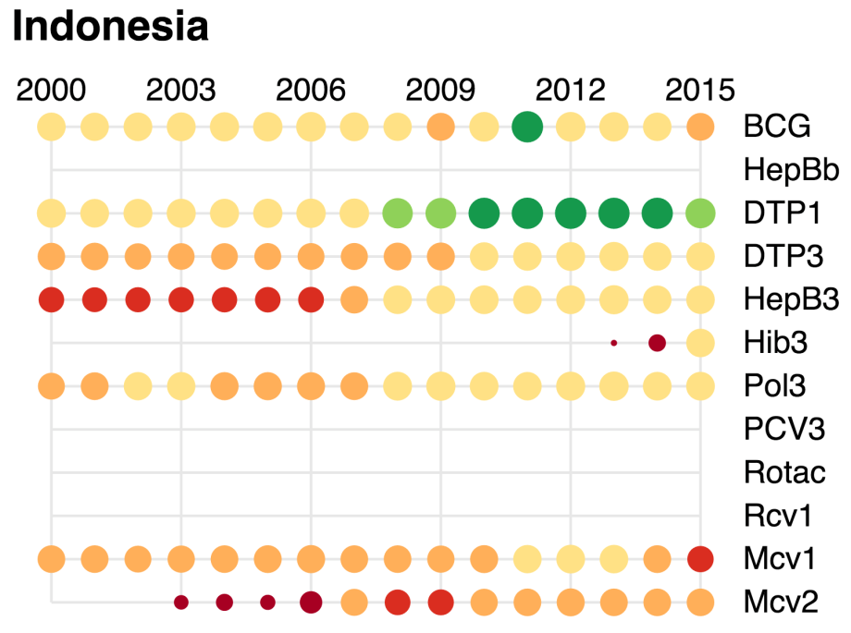

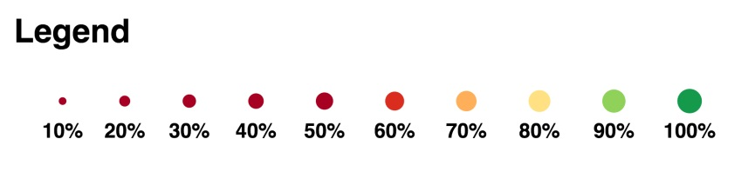

**Table 2: Reported DTPCV doses administered & coverage, Indonesia, 2000-2015**

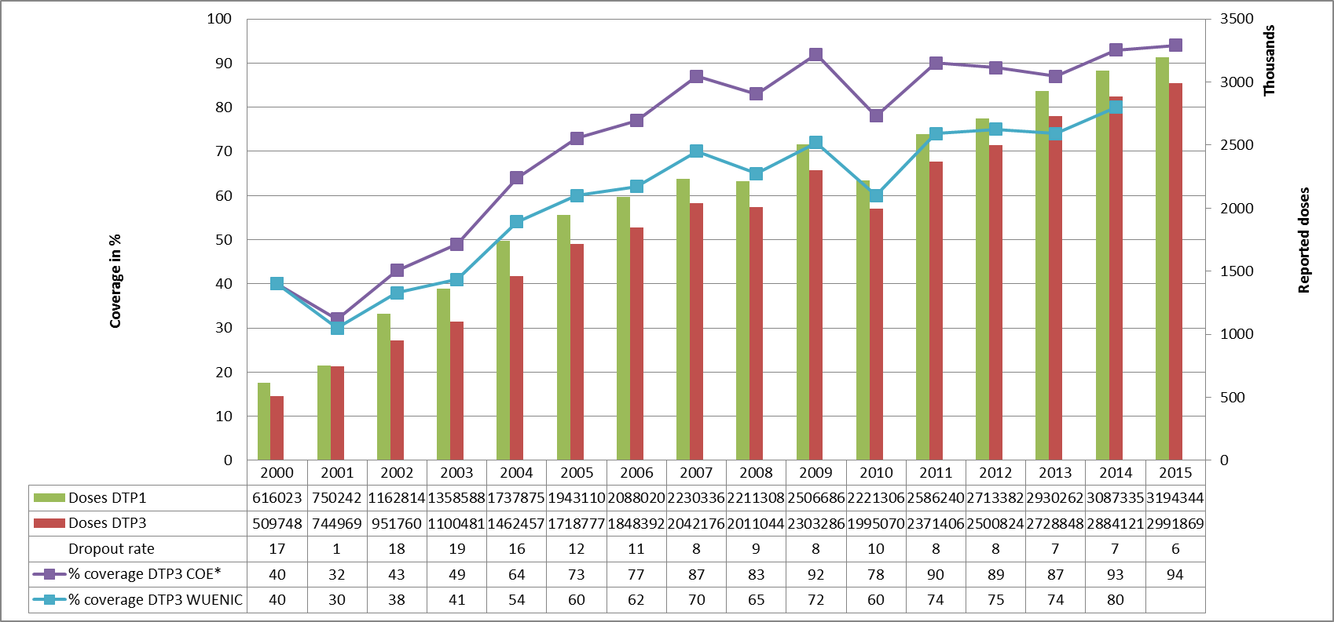

* COE: country Official Estimates

Source:

WHO/IVB database, data reported to WHO by member states as of 1 July 2016

WHO/UNICEF national coverage estimates, 2014 revision, data as of July 2015

Figure 6: Percentage of district achieving <50%; 50-79% and ≥80% coverage, 2000-2015

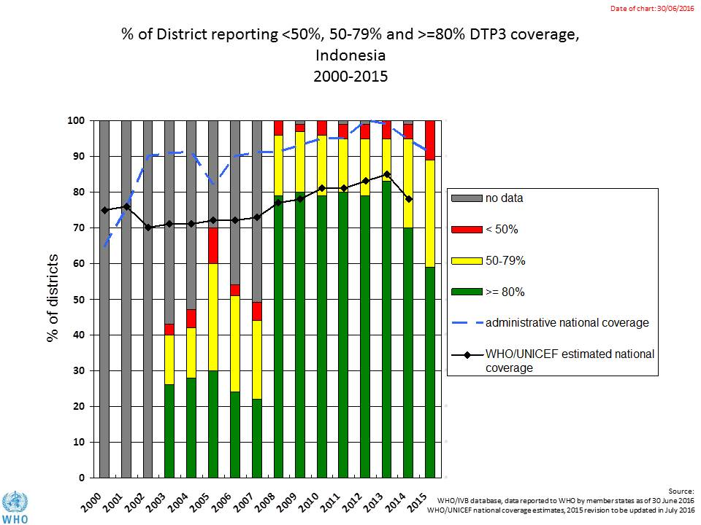

Figure 7: DTP3 coverage by district/province, Indonesia, 2010 and 2015 (admin)

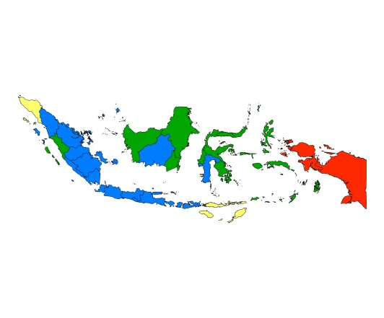 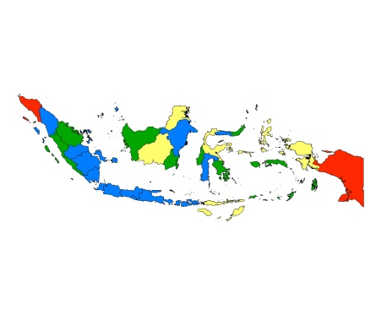 2010 2015

Figure 8: Immunization coverage data disaggregated by sex and wealth quintile

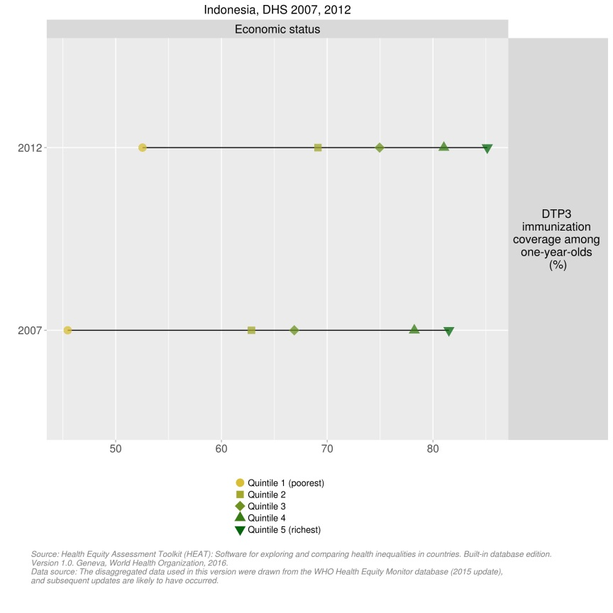

1. Joint appraisal and transition mission, Indonesia, debriefing presentation, 2016.
2. World Health Organization. Joint national and international EPI and VPD surveillance review, Indonesia, 2014.
3. World Bank Group. Issues affecting sustainability of the immunization program in Indonesia. Presentation February 18, 2016.
4. Assessment of district immunization coverage at three provinces (West Sumatra, West Nusa Tenggara and South Kalimantan), 2013.
5. World Health Organization. Joint national and international EPI and VPD surveillance review, Indonesia, 2014.
6. Ibid.
7. World Bank Group. Issues affecting sustainability of the immunization program in Indonesia. Presentation February 18, 2016.
8. Assessment of district immunization coverage at three provinces (West Sumatra, West Nusa Tenggara and South Kalimantan), 2013.