**Global Vaccine Action Plan**

*Secretariat Annual Report 2016*

*Priority Country report on progress towards*

*GVAP-RVAP goals*

**INDONESIA**

1. **Progress towards achievement of GVAP goals**
2. **Summary**

This summary table describes the current situation in Indonesia regarding achieving the GVAP goals. Data used to assess progress towards achievement of GVAP goals can be found in the annex.

| **Area** | **Indicator** | **Indonesia** |
| --- | --- | --- |
| **2. Neonatal tetanus elimination** | **TT2+ coverage (reported on JRF 2015)** | **63%** |
| **Protection at Birth against tetanus (WUENIC 2015)** | **85%** |
| **Last SIAs conducted in the country** | **2013** |
| **Elimination validation date** | **May 2016** |

* 1. **Goal 2 : Meet global and regional disease elimination targets**

**3.2.1 Achieve maternal and neonatal tetanus (MNT) elimination**

Indonesia was certified by WHO in May 2016 as having eliminated MNT nation-wide. This follows validation of elimination in three of the country’s regions in 2011, and a recent validation assessment in the fourth region – consisting of four remote provinces (Papua, West Papua, Maluku and North Maluku). Achieving MNT elimination in the last region required conducting two rounds of TT vaccination (integrated into the polio NIDs) in very isolated, hard-to-reach districts in the country’s extreme East, which involved intensive district-level technical assistance from WHO in micro planning, training and in increasing community awareness. There were reports of vaccine hesitancy against TT vaccine among some ethnic groups in Papua province. The country reported 69 cases in 2013, 0 in 2014, and 53 in 2015 (for an incidence rate of <0.01/1,000 live births).

Indonesia used a multi-pronged approach to eliminate the disease, which included:

* A focus on clean deliveries and cord care practices, which is facilitated in Indonesia by the high rate of pregnant women making at least four antenatal care visits (84%) and institutional births (70%).[1]
* Routine infant immunization with four doses of DPT-containing vaccine, as well as vaccination of pregnant women with two TT doses;
* A unique school-based vaccination program called BIAS, begun in 1984, which provides DT vaccine to all first graders (both girls and boys) nation-wide and dT to those in Grades 2 and 3. As a result of infant vaccination and the school-based program, many women have received the five recommended doses of TT-containing vaccine by the time they reach child-bearing age. The WUENIC estimated national rate for children protected at birth in 2015 is 85%.
* TT campaigns for women of child-bearing age in high risk districts since 2003. The last SIA was conducted in 2013 in 18 districts in the three remaining high-risk provinces.

Ensuring sustainability of neonatal tetanus elimination will require maintaining high-quality case-based MNT surveillance throughout the country, but especially in the last areas to have eliminated the disease; strengthening the BIAS program in areas where it is not fully operational; improving the recording of TT vaccination among pregnant women; reviewing neonatal tetanus cases and TT coverage regularly; and conducting additional SIAS if surveillance data reveals clusters of cases.

**ANNEXES**

1. **MNT eliminated in 2016.**
2. **Coverage and Equity**

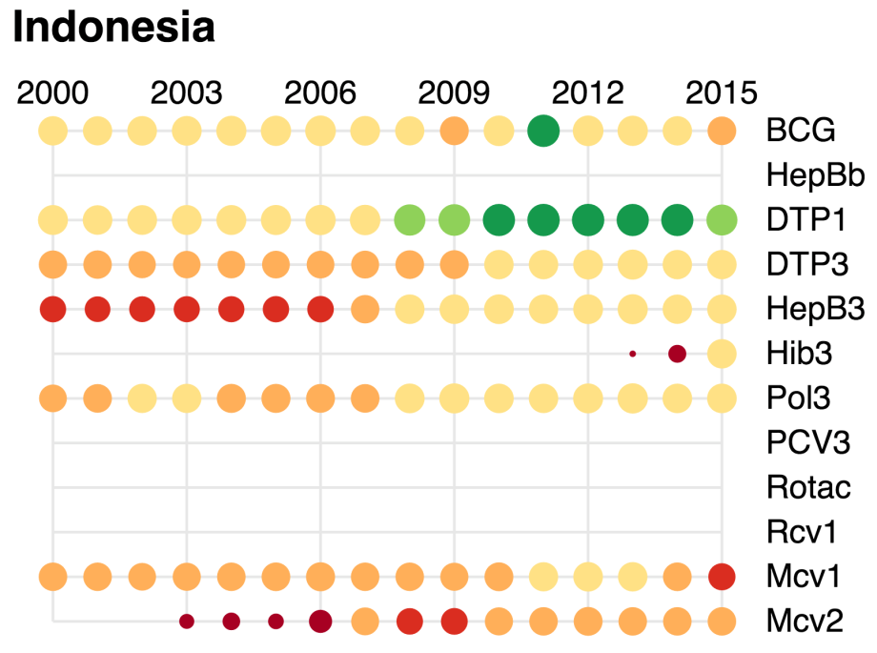

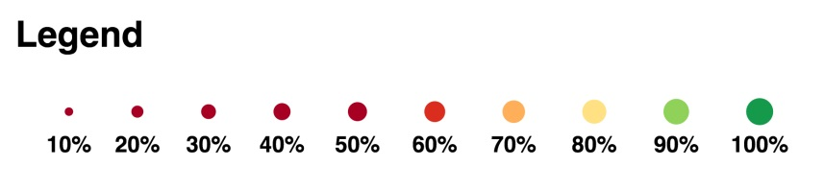

1. <http://data.unicef.org/maternal-health/antenatal-care.html>.