**Global Vaccine Action Plan**

*Secretariat Annual Report 2016*

*Priority Country report on progress towards*

*GVAP-RVAP goals*

**CHAD**

1. **Progress towards achievement of GVAP goals**
2. **Summary**

This summary table describes the current situation in Chad regarding achieving the GVAP goals. Data used to assess progress towards achievement of GVAP goals are included in the annex.

| **Area** | **Indicator** | **Chad** |
| --- | --- | --- |
| **10. Government expenditure on routine immunization per live birth USD** | **Baseline 2010-2011 and average for 2013-2015 (% change)** | **4.3 to 4.8 (+13%)** |

1. **Country ownership of the immunization programme**
   1. **Government financing of immunization**

Since 1996 the Government of Chad has fully funded the cost of traditional vaccines (TT, BCG, OPV, measles) and injection supplies. It has also met its co-financing obligations to GAVI each year for procurement of new vaccines (pentavalent and yellow fever) without defaults or delays. Funds for vaccines are covered through a budgetary line item established in 2011.

Once Chad started co-financing yellow fever and pentavalent vaccine in 2010, its financial contributions to the immunization program increased more than three-fold (from around 500,000 per year to $2.2 million) (Figure 1). As a result of advocacy from the Gates Foundation and other partners and in response to a polio outbreak in 2011, the Federal Government made a large, one-time investment of more than $49 million in 2011 as part of an emergency plan to finance polio SIAs, purchase vehicles and motorcycles, buy cold chain equipment and fuel, hold planning and review meetings and other related expenses.[1] Since 2011, the Government’s contribution has largely remained flat – between $2.7 and $3.2 million per year. These funds cover, in addition to vaccine procurement, recurrent costs for cold chain and logistics and other programmatic costs (e.g., fuel for supervisory visits and for refrigerators); the Government’s share of operational costs for polio, measles and other vaccination campaigns; as well as the costs of EPI-specific staff. Local (e.g., district) governments also contribute to recurrent immunization program costs to some degree.

Figure 1: Trends in the Government of Chad’s expenditures for immunization, 2008-2014

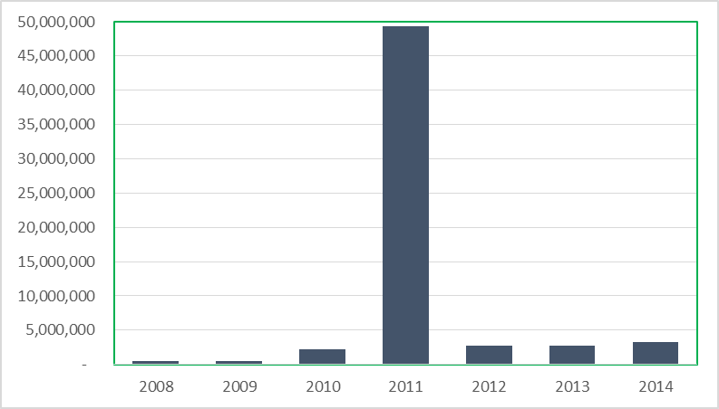

However, international partners – mainly UNICEF, WHO and GAVI – are the main funders of the national EPI program, covering 86% of the non-salary program costs from 2012 to 2014, while the Government covered the remaining 14%.[2] Partners cover much of the operational costs that makes the program function at the local level, including outreach activities, implementation of the Reach Every District (RED) strategy in selected districts, communication activities, and cold chain and logistics costs. They also pay the majority of the costs of polio, measles, MNT and meningitis vaccination campaigns, which in the 2016 EPI budget accounted for 75% of the service delivery budget and 40% of the entire immunization program budget.[3] In addition, a number of partners, such as the French cooperation, World Vision and other bilateral agencies, provide funding and technical support for immunization activities directly to certain health districts.

A key obstacle to improving the performance of the immunization program in Chad has been the complicated process of getting program funds released by the Government bureaucracy and transferred to the EPI or to health regions and districts. Only 56% of the GAVI HSS funds, which finance cold chain improvements and the implementation of the RED strategy in 60% of the country’s health districts, was spent in 2015 and only 14% in 2014.[4] This has significantly reduced the Government’s ability to increase vaccination coverage through the routine program and otherwise improve program performance.

**Annex 1: Country immunization profile**

* % of total expenditures on vaccines financed by government funds: 98%

1. EPI review 2012.
2. Joint Appraisal report, 2016.
3. Chad Annual EPI Action Plan, 2016.
4. Joint Appraisal report, 2016. The low spending rate in 2014 was due to the temporary suspension of GAVI funds, due to financial management issues.