**Global Vaccine Action Plan**

*Secretariat Annual Report 2016*

*Priority Country report on progress towards*

*GVAP-RVAP goals*

**UGANDA**

1. **Progress towards achievement of GVAP goals**
2. **Summary**

This summary table describes the current situation in Uganda regarding achieving the GVAP goals. Data used to assess progress towards achievement of GVAP goals are included in the annex (Country immunization profile).

| **Area** | **Indicator** | **Data for Uganda** |
| --- | --- | --- |
| **7. Introduction of new vaccines** | **New vaccines introduced** | **PCV10 in 2013; HPV in 2015; IPV in April 2016. Meningitis A campaign approved by GAVI. Rotavirus introduction also approved by GAVI but currently on hold by Government** |

**3.4 Goal 4: Introduce new and improved vaccines and technologies**

In recent years, UNEPI has introduced PCV (in 2013-14), HPV (in 2015) and IPV (in April 2016. Below is a summary of the PCV and HPV introductions:

* **PCV**: The vaccine was launched in one district in April 2013, but not in the rest of the country until 2014, when introduction was phased in from January to June in three phases. Nation-wide introduction was stretched out over more than a year for a number of reasons, including delays in the release of government funds to the districts for training, due to the establishment of a new financial management system. The training at the local level was comprehensive (lasting three days, including refresher EPI training) and the PCV post-introduction evaluation (PIE) indicates good knowledge about the vaccine among health workers.[1] However, it also found that not all staff administering PCV had received formal (vs. on-the-job) training in 35% of facilities. PCV coverage has been low (50% in 2014), due to the phased in roll-out, global shortages of PCV, which required the national medical stores (NMS) to ration the vaccine; and forecasting issues, including under-estimating the demand for the vaccine. The PIE conducted in February 2015 found “suboptimal routinization of PCV”, but it has become a regular part of the immunization schedule since then.
* **HPV**: UNEPI’s strategy is to vaccinate all 10 year old girls through fixed facilities, combined with outreach at schools and other community settings. The introduction, originally planned for April 2015, was delayed until November, due to a shortage of cold storage space at the central level and of refrigerators as lower levels. This was in turn due to procurement problems that have prevented the expansion of the cold chain system, including central cold storage facilities at NMS, with HSS funding. To enable the introduction of HPV, UNICEF renovated existing NMS facilities for temporary storage of the vaccine using GAVI HSS funds. The introduction was combined with measles SIAs and Child Health Days to save costs, since the Government was unable to raise its 50% share of operational costs for the measles campaign. Consequently, GAVI vaccine introduction grant funds for HPV were used for the training and other operational costs for the combined campaigns/HPV introduction. This resulted in short changing the HPV introduction, as training was reduced from three to one day and little social mobilization for HPV took place. Nonetheless, population acceptance has reportedly been good. Coverage data are not yet available, though reportedly the outreach activities, such as to schools, are insufficient, due to a lack of funding.

The introduction of rotavirus vaccine was scheduled for 2016, but due to problems with the Government meeting its co-financing obligations and concerns voiced by UNITAG about the financial sustainability of additional vaccines, this activity is currently on hold. UNEPI plans to apply to GAVI for support for rotavirus vaccine introduction once the financial sustainability plan has been completed, UNITAG has provided guidance, and the country has paid its co-financing arrears, as well as responded to the recommendations of the GAVI program capacity assessment conducted in 2015.

**ANNEX: Country immunization profile**

1. **Immunization coverage and equity**

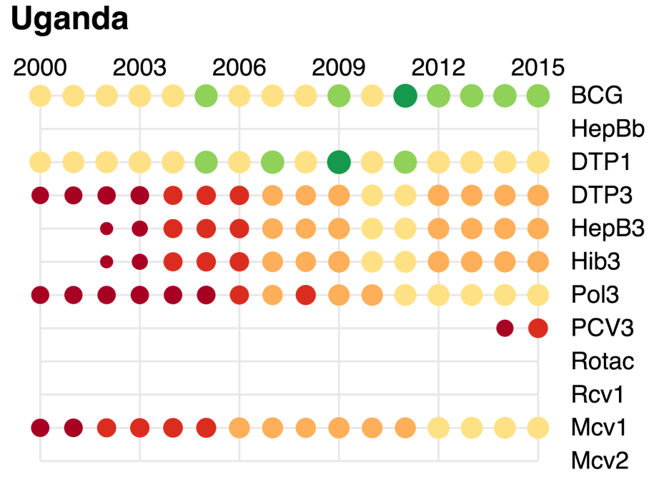

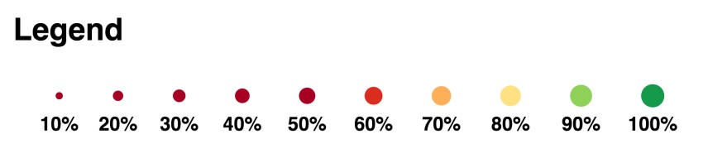

1. Uganda Comprehensive EPI, Surveillance, Immunization Financing Review and Post-introduction Evaluation of Pneumococcal vaccine, 23 Feb – 6 March 2015.