**Global Vaccine Action Plan**

*Secretariat Annual Report 2016*

*Priority Country report on progress towards*

*GVAP-RVAP goals*

**UGANDA**

1. **Progress towards achievement of GVAP goals**
2. **Summary**

This summary table describes the current situation in Uganda regarding achieving the GVAP goals. Data used to assess progress towards achievement of GVAP goals are included in the annex (Country immunization profile).

| **Area** | **Indicator** | **Data for Uganda** |
| --- | --- | --- |
| **1. Interrupt wild poliovirus transmission** | **Transmission Interrupted** | **Yes** |
| **Risk of late detection: Percent of adequate stool specimens (rolling 12 mo.) (Target > 80%)** | **91.3** |
| **Risk of late detection: Non polio AFP rate (rolling 12 mo.)  (Target > 2 per 100,000 )** | **3/100,000** |
| **Risk of spread after importation:  % of 6-59 month olds having received less than 3 doses in the last year before occurrence case/environmental positive)** | **8%** |

1. **Progress towards specific GVAP goals (issues/challenges/successes)**
   1. **Goal 1: Achieve a world free of poliomyelitis**

Uganda was certified polio-free in October 2006, but has experienced outbreaks of imported wild polio virus (WPV) in 2009 and in 2010/2011. The country has a robust AFP and polio surveillance system, as indicated by the polio target indicators on page 1. This has been the result of various partner-supported efforts and innovations, including:

* A national roll-out of an integrated disease surveillance and reporting (IDSR) system, operating from nine sub-national hubs. By the end of July 2016, district health staff in 108 out of the country’s 112 districts have received IDSR training.
* Both international and national STOP teams that provide on-the-ground short-term assistance to “silent” or poor-performing districts to improve their ability to detect AFP/polio cases as well as other outbreak-prone diseases (e.g., measles, yellow fever) and to improve routine immunization services. The international teams – supported by the U.S. CDC and WHO/AFRO – stay in a region for about a month, while the national STOP team (NSTOP) consists of public health students who spend a week in an area visiting all health facilities to train staff in surveillance and outbreak investigations. The NSTOP program is partner-supported, but funding is considered insufficient.
* An innovative specimen transport system established by the MOH with support from partners that delivers specimens on filter paper to the UVRI laboratory within 24 hours.
* An electronic (mTRAC) system, established in 2012 with WHO and UNICEF support, in which health facility staff submit IDSR data for key diseases to districts via mobile phones using a simple interface on a weekly basis. The data are then transferred up the chain. While it has been implemented nation-wide, there are issues with the availability of cell phones and reliability of network connections.

In addition, the country has organized polio national immunization days (NIDs) every year for several years, as well as sub-national immunization days (SNIDs) in high-risk and outbreak districts for children under five. Additional doses of OPV are also provided during the country’s annual Child Health Days. UNEPI introduced IPV into the immunization schedule in April 2016.

There are, however, a number of challenges to sustaining the country’s polio-free status:

* While the national AFP detection and stool adequacy rates meet the targets, not all districts achieve the minimum rates.[1] The surveillance system is also not sensitive enough to detect every possible case of wild polio virus or vaccine-derived virus in a timely fashion. In addition, active surveillance of vaccine-preventable diseases is not conducted systematically in some areas, due to delays in the disbursement of funds from higher levels, affecting the timely investigation and notification of cases. Reportedly, inadequate surveillance led to under-detection of WPV circulating along the border with Kenya, which caused the last outbreak in 2011.
* There is cross-border transmission of polio from areas and populations with low immunization rates, such as across the borders with Kenya and S. Sudan. Synchronized NIDS with bordering countries have been discussed, but have yet to take place.
* There also exist pockets of low polio immunization coverage within the country, including in communities bordering S. Sudan and some fishing communities.
* The frequent turnover of health staff at the district and health facility levels mean that many people trained in IDSR have left. Thus, frequent trainings are needed to train new staff, which is costly.

**ANNEX: Country immunization profile**

1. **Polio**

* Transmission stopped in 2011.
* Eradication certified in 2006 and in 2015 ARCC accepted a report on the response to the imported WPV outbreak following complete documentation.

**Table 2: SIA activities planned in 2016-2017**

|  |  |  |  |  |  |  |  |  |
| --- | --- | --- | --- | --- | --- | --- | --- | --- |
| **Activity** | **Intervention** | **Year** | **Start Date** | **End Date** | **Age Group** | **Extent** | **Status** | **Target population** |
| SNID | tOPV | 2016 | 23/01/2016 | 25/01/2016 | 0 to 5 years | Sub-National | Planned | 2,540,476 |
| NID | tOPV | 2016 | 01/04/2016 | 03/04/2016 | 0 to 5 years | National | Planned | 8,092,606 |
| SNID | tOPV | 2016 | 23/04/2016 | 25/04/2016 | 0 to 5 years | Sub-National | Planned | 4,046,303 |

Source: WHO/IVB Database as at 01 July 2016

1. **Immunization coverage and equity**

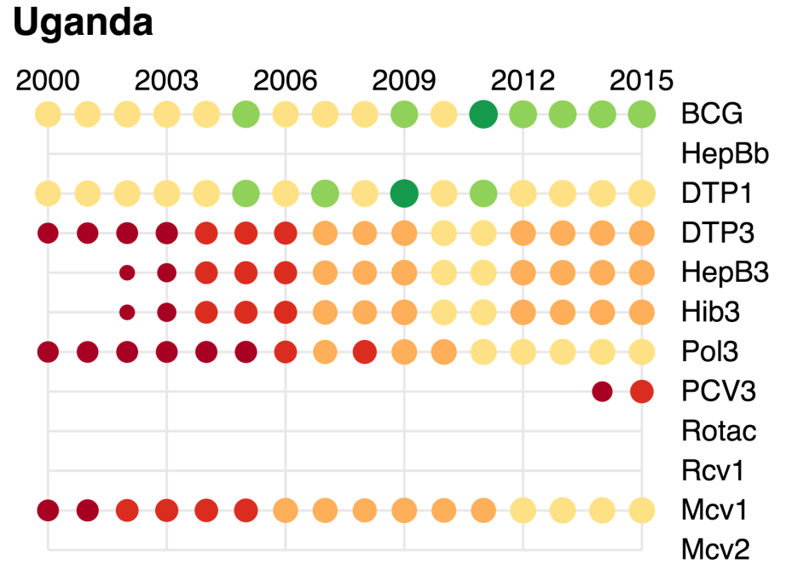

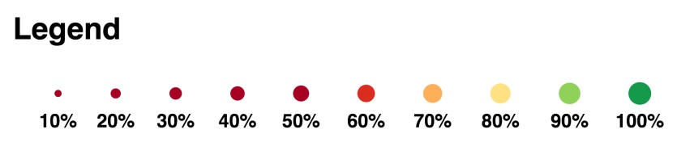

1. CMYP.