**Global Vaccine Action Plan**

*Secretariat Annual Report 2016*

*Priority Country report on progress towards*

*GVAP-RVAP goals*

**CHAD**

1. **Progress towards achievement of GVAP goals**
2. **Summary**

This summary table describes the current situation in Chad regarding achieving the GVAP goals. Data used to assess progress towards achievement of GVAP goals are included in the annex.

| **Area** | **Indicator** | **Chad** |
| --- | --- | --- |
| **3. Measles Elimination** | **Coverage MCV1 (2015 WUENIC)** | **62%** |
| **Coverage MCV2** | **Not in schedule** |
| **Percentage of districts with MCV1 coverage ≥95% (2015 JRF)** | **22%** |
| **Last national SIA** | **2012** |
| **Post SIA coverage survey conducted** | **No** |

* + 1. **Achieve measles elimination and rubella & CRS elimination**

Measles

Chad continues to report measles cases and outbreaks each year, with 1,275 cases reported to WHO in 2014 and 418 cases in 2015. Given that measles surveillance in the country is still not at the level of AFP/polio surveillance, the disease is likely significantly under-reported.

The main reasons why measles persists in Chad is inadequate vaccination coverage rates through the routine immunization program. With the WUENIC measles vaccination coverage rate only at 62% nationally, the routine program is failing to reach sufficient numbers of infants with measles vaccination. The problems related to vaccination coverage through the routine program are discussed in detail in Section 3.3 below. The Government does not yet have plans to introduce a second measles vaccine dose into the routine schedule.

To supplement routine immunization, the EPI has conducted national measles SIAs every three or four years since 2005, with smaller, local campaigns in between the SIA years and in response to outbreaks. SIAs for children under five (in most cases) have been taking place in 2016 in five districts experiencing local outbreaks. The last national measles catch-up campaigns – targeting all children under the age of ten – took place in 2013. However, the campaigns have reportedly not been well implemented in many instances and have missed many children, especially in urban areas, resulting in continual outbreaks.[1]

The suboptimal quality of the campaigns is not reportedly due to a lack of funding from the Government or delayed releases of funds, as is the case in many countries in the region. Unlike for the routine program, the Government has a record of providing funds to cover its share of the operational costs of SIAs in a timely fashion.[2]

With GAVI support, the EPI is conducting national follow-up campaigns in September and October 2016. To improve the quality of these SIAs and their evaluation, GAVI has provided an international consultant to assist with their planning, monitoring and assessment.

Measles surveillance has improved markedly in the past two years in Chad, earning the country congratulations from the WHO inter-country support team (IST) in Libreville. The percent of suspected cases that have been investigated and tested in the country’s measles laboratory in N’djamena rose from 3% in 2009 to 25% in 2011, 33% in 2015 and 45% thus far in 2016.[3] These improvements are due to a new focus on measles surveillance starting in 2013, once polio cases disappeared. Measles is now included in the quarterly AFP surveillance meetings, and training of district and zonal surveillance focal points in measles surveillance has recently been conducted with WHO support. However, the rate of cases investigated is still well below the target of 80%. In addition, only 65% of districts in 2016 have thus far reported at least one suspected measles case, compared to the target of 80%.[4]

Meeting the goal of measles elimination in Chad by 2020 will require substantially improving the measles vaccination coverage rates through the routine program. Adding a second measles dose in the routine immunization schedule, which is not yet under consideration, would help the country in meeting this target.

**Annex 1: Country immunization profile**

1. **Measles and rubella**

Figure 3: Reported Measles cases and MCV coverage, Chad, 1990-2015

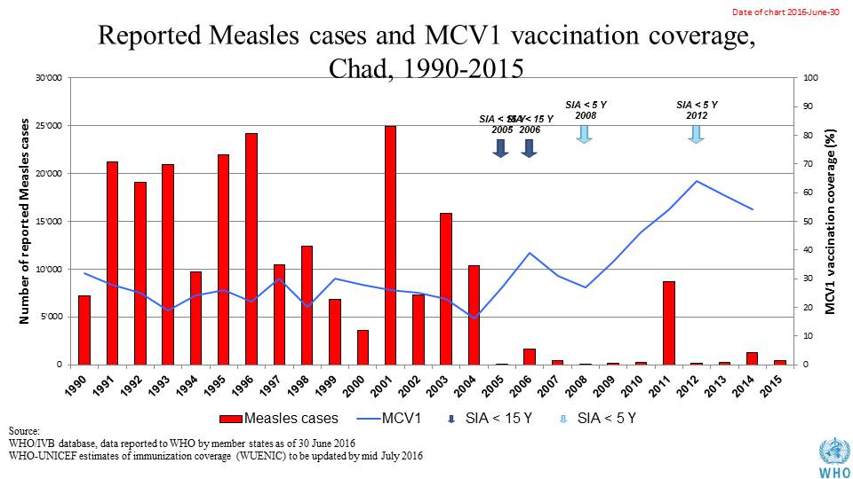

Table 1: SIA activities planned in 2016-2017

|  |  |  |  |  |  |  |  |  |
| --- | --- | --- | --- | --- | --- | --- | --- | --- |
| **Activity** | **Intervention** | **Year** | **Start Date** | **End Date** | **Age Group** | **Extent** | **Status** | **Target** |
| Follow Up | Measles | 2016 | 01/10/2016 |  | 9-59 M | National | planned | 1,123,643 |
| Follow Up | Measles | 2016 | 01/11/2016 |  | 9-59 M | National | planned | 1,664,934 |
| SNID | bOPV | 2016 | 01/09/2016 | 01/09/2016 | 0 to 5 years | Sub-National | Planned | 1,930,338 |
| NID | bOPV | 2016 | 01/10/2016 |  | 0 to 5 years | National | Planned | 3,860,675 |
| NID | tOPV | 2016 | 26/02/2016 | 28/02/2016 | 0 to 5 years | National | Planned | 4,179,810 |
| NID | tOPV | 2016 | 25/03/2016 | 27/03/2016 | 0 to 5 years | National | Planned | 4,179,810 |

Source: WHO/IVB Database as at 01 July 2016

Figure 4: All vaccines national coverage, Chad, 2000-2015

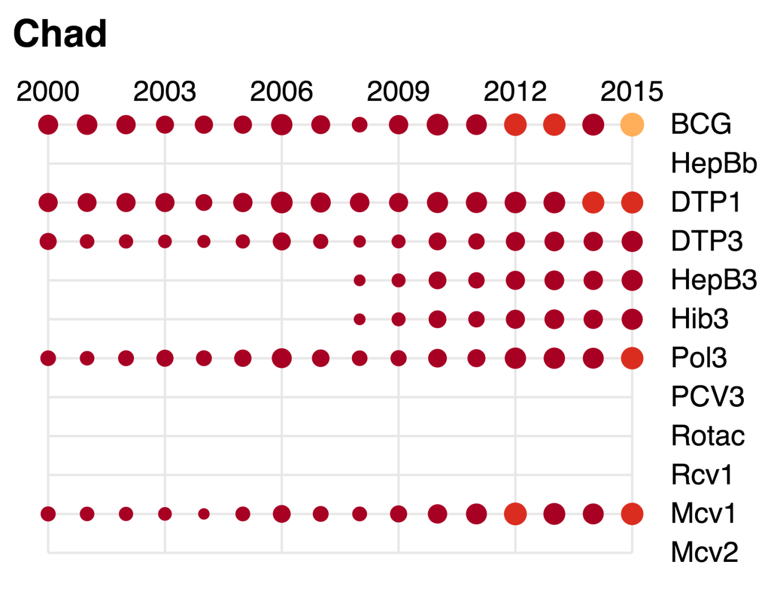

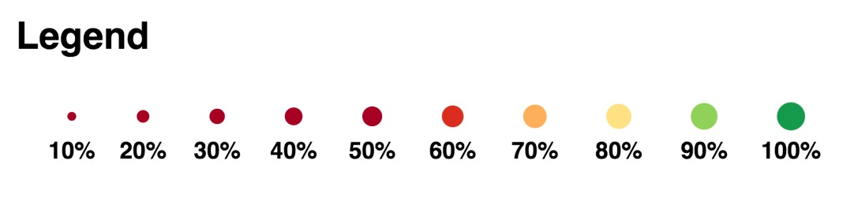

1. Joint Appraisal report 2016.
2. Personal communications with WCO immunization focal point.
3. cMYP 2013-2017, Chad 2016 Annual EPI Action Plan, WHO. Situation polio et PEV/Tchad, Semaine 28 (du 11 au 17 juillet 2016).
4. WHO. Situation polio et PEV/Tchad, Semaine 28 (du 11 au 17 juillet 2016).