**Global Vaccine Action Plan**

*Secretariat Annual Report 2016*

*Priority Country report on progress towards*

*GVAP-RVAP goals*

**CHAD**

1. **Progress towards achievement of GVAP goals**
2. **Summary**

This summary table describes the current situation in Chad regarding achieving the GVAP goals. Data used to assess progress towards achievement of GVAP goals are included in the annex.

| **Area** | **Indicator** | **Chad** |
| --- | --- | --- |
| **2. Neonatal tetanus elimination** | **Coverage for TT (administrative data for 2015)** | **96%** |
| **Protection at Birth against tetanus (WUENIC 2015)** | **75%** |
| **Last SIAs conducted in the country** | **SIAs taking place in 80% of the country in phases from 2011 to 2016. Two rounds took place in 46 districts. The last round in 12 remaining districts planned for 2016.** |
| **Elimination validation date** | **Not yet validated** |

* 1. **Goal 2 : Meet global and regional elimination targets**

**3.2.1 Achieve maternal and neonatal tetanus elimination**

Chad developed an MNT elimination plan for 2008-2011, but it was not fully or adequately implemented. The country continues to report an average of around 200 cases each year and nearly all districts (84/87) in 2015 reported at least one MNT case. However, according to several documents, there is likely to be under-reporting of MNT cases in the country.[1]

There are two major challenges to Chad achieving MNT elimination by the target date of 2017 stated in its comprehensive multi-year plan for EPI (cMYP):

1. TT coverage for pregnant women remains inadequate. The majority of women (66%) still give birth without a skilled birth attendant and use of antenatal care services remains quite low, with only 31% of pregnant women making at least four antenatal care visits.[2] As a result, according to the 2015 DHS/MICS study, the protection at birth (PAB) rate against tetanus was only 56% in 2014.
2. MNT case-based surveillance remains inadequate, with only 37% of cases reported in the first half of 2016 investigated and ring vaccination conducted in response to only 74% of these cases.[3] Data on MNT cases are also not consistent across different sources. WHO is working with the Ministry of Health to improve MNT surveillance, which is conducted by the same surveillance teams that perform strong AFP surveillance.

While delayed, TT campaigns have been conducted for women of childbearing age in phases since 2010, covering around 80% of the country. The last phase – targeting the remaining 12 high-risk districts – is being carried out in 2016. The SIAs are a key factor contributing to the jump in the WUENIC estimate for children protected at birth from 60% in 2014 to 75% in 2015. Chad will begin to prepare a dossier for certification of elimination once the SIAs are completed. Improving routine TT coverage among pregnant women and MNT surveillance will be critical to achieving and sustaining MNT elimination.

**Annex 1: Country immunization profile**

Figure 4: All vaccines national coverage, Chad, 2000-2015

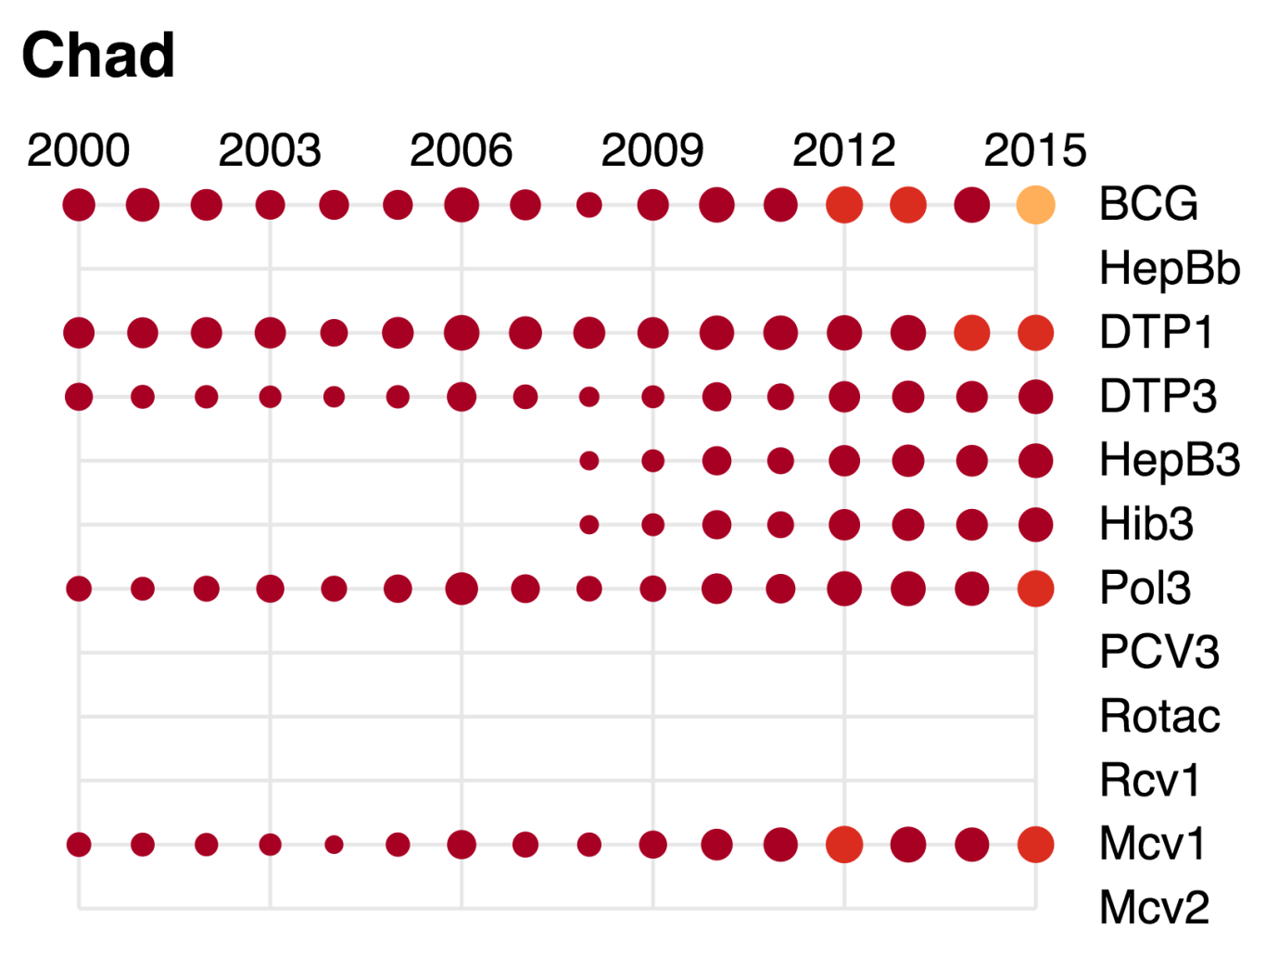

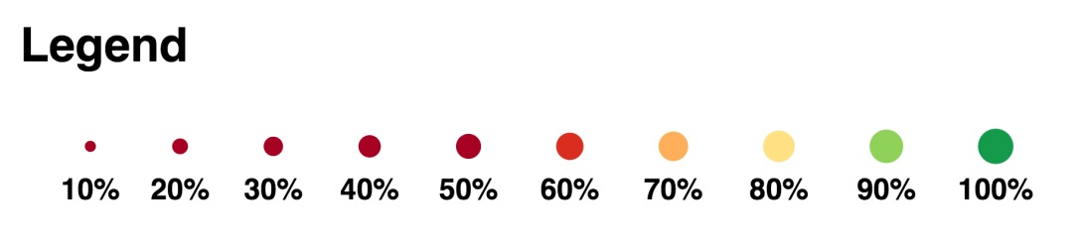

1. Comprehensive multi-year plan for the EPI program, Chad, 2013-2017, Chad Annual EPI Action Plan, 2016.
2. Republic of Chad, Demographic and Health Survey (DHS) and Multiple indicator Cluster Survey (MICS), 2015.
3. WHO. Situation polio et PEV/Tchad, Semaine 28 (du 11 au 17 juillet 2016).