**Global Vaccine Action Plan**

*Secretariat Annual Report 2016*

*Priority Country report on progress towards*

*GVAP-RVAP goals*

**CHAD**

1. **Progress towards achievement of GVAP goals**
2. **Summary**

This summary table describes the current situation in Chad regarding achieving the GVAP goals. Data used to assess progress towards achievement of GVAP goals are included in the annex.

| **Area** | **Indicator** | **Chad** |
| --- | --- | --- |
| **1. Interrupt wild poliovirus transmission** | **Transmission interrupted** | **Yes** |
| **Risk of late detection: Percent of adequate stool specimens (Rolling 12m) Target > 80%** | **97.8** |
| **Risk of late detection: Non-polio AFP rate per 100,000 (rolling 12 mo.) (Target > 2/100,000)** | **6.3** |
| **Risk of spread after importation: % of 6-59 month olds having received less than 3 doses in the last year before occurrence case/environmental positive)** | **9** |

* 1. **Goal 1: Achieve a world free of poliomyelitis**

Has the GVAP target of interrupted polio transmission been achieved?

Chad has not had a case of wild polio virus (WPV) since June 2012 and no cases of vaccine-derived disease since 2013. The AFRO certification committee declared Chad polio-free in 2016. This achievement is the result of an emergency plan that the Federal Government put in place in 2011 in response to an outbreak of WVP that caused 132 lab-confirmed cases.[1] The plan – financed with an infusion of funding from the Government (as mentioned above) and by development partners – involved improving the quality of polio SIAs, strengthening AFP surveillance, improving communications activities, and identifying priority areas for special efforts.

Is Chad considered at high risk of polio transmission?

The country is considered at medium risk of polio transmission as a whole. It does have several areas at high-risk – especially along the border with the Central African Republic (CAR) and in the Lake Chad region. These areas are at elevated risk due to the movement of populations, including refugees from conflict-ridden CAR who are often not vaccinated and those from Northern Nigeria where WVP is still circulating (with two cases reported in July 2016 in Borno state).[2] These areas are also at high risk due to low routine polio immunization coverage rates. Pockets of inadequate AFP surveillance – with eight silent districts identified in 2015 – also places these areas at risk.

What needs to be done to ensure that Chad remains polio-free

Since the 2011 outbreak, the Chadian Government, with much partner support, has conducted a series of national and sub-national polio vaccination campaigns each year. Four national rounds and two local campaigns were conducted in 2015, achieving high coverage, according to administrative data. Sub-national campaigns have continued into 2016, including in the Lake Chad area and among refugees from the CAR living in camps along the border. Sub-national polio vaccination campaigns will continue into 2017.

Improving polio vaccination coverage through the routine immunization program will also be critical to preventing future outbreaks from importations. The 2015 WUENIC estimate for national measles vaccination coverage is 62%, up from only 54% in 2014, and rates are likely to be considerably lower in many districts. This is clearly inadequate to ensure sustainability of polio eradication in Chad.

Strong surveillance is the other critical piece to preventing outbreaks of imported cases and ensuring that Chad remains polio-free. The country has a strong AFP surveillance infrastructure in place. There are six surveillance hubs established with funding from the Bill & Melinda Gates Foundation that cover the entire country. There are also WHO-supported regional surveillance officers and at least two Government surveillance focal points in each district, who are responsible for investigating all reported AFP cases. Private providers, including traditional leaders, are included in the surveillance system, though traditional healers rarely report cases. The AFP/polio surveillance results are published in a weekly bulletin. To further strengthen polio surveillance, the Government established four environmental sentinel sites in 2015 in canals in N’djamena to detect polio virus.

Case-based surveillance is conducted for AFP (as well as for measles, neonatal tetanus and yellow fever) and the country has, as a whole, has met the AFP surveillance criteria since at least 2008. Over the past year (mid-July 2015 to mid-July 2016), 98% of notified cases were investigated within two days of being reported, and the non-polio AFP rate was 6.15/100,000 (meeting the target of >2/100,000 children).[3] However, there remains no polio testing laboratory in the country, which uses a reference lab in Yaounde, Cameroon.

**Annex 1: Country immunization profile**

1. **Polio**

* **Transmission stopped in 2013**
* **Eradication certified: not yet**

Table 1: SIA activities planned in 2016-2017

|  |  |  |  |  |  |  |  |  |
| --- | --- | --- | --- | --- | --- | --- | --- | --- |
| **Activity** | **Intervention** | **Year** | **Start Date** | **End Date** | **Age Group** | **Extent** | **Status** | **Target** |
| Follow Up | Measles | 2016 | 01/10/2016 |  | 9-59 M | National | planned | 1,123,643 |
| Follow Up | Measles | 2016 | 01/11/2016 |  | 9-59 M | National | planned | 1,664,934 |
| SNID | bOPV | 2016 | 01/09/2016 | 01/09/2016 | 0 to 5 years | Sub-National | Planned | 1,930,338 |
| NID | bOPV | 2016 | 01/10/2016 |  | 0 to 5 years | National | Planned | 3,860,675 |
| NID | tOPV | 2016 | 26/02/2016 | 28/02/2016 | 0 to 5 years | National | Planned | 4,179,810 |
| NID | tOPV | 2016 | 25/03/2016 | 27/03/2016 | 0 to 5 years | National | Planned | 4,179,810 |

Source: WHO/IVB Database as at 01 July 2016

Figure 4: All vaccines national coverage, Chad, 2000-2015

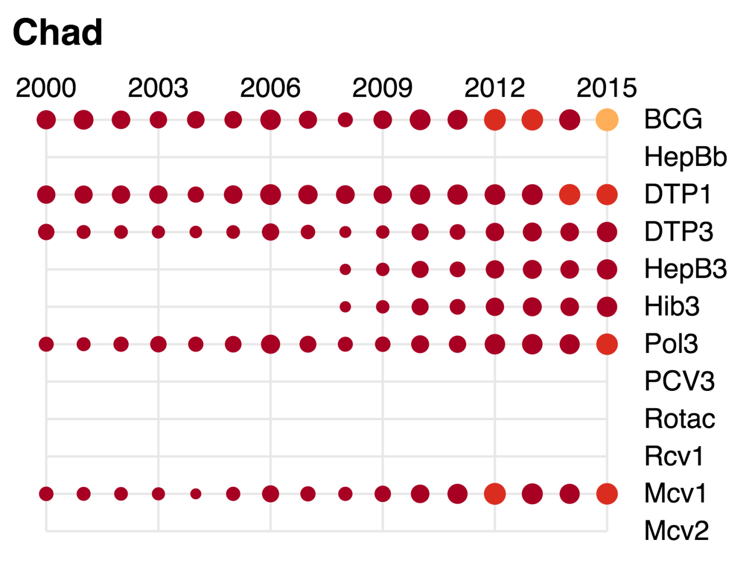

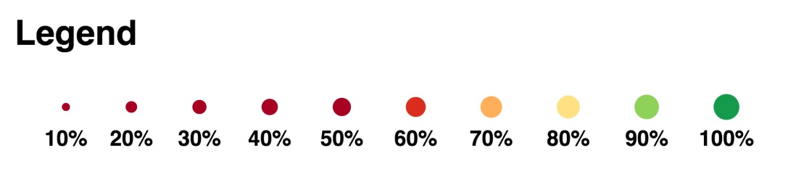

1. Comprehensive multi-year plan for the EPI program, Chad, 2013-2017.
2. Polio weekly global update, 10 August 2016.
3. WHO. Situation polio et PEV/Tchad, Semaine 28 (du 11 au 17 juillet 2016).