**Global Vaccine Action Plan**

*Secretariat Annual Report 2016*

*Priority Country report on progress towards*

*GVAP-RVAP goals*

**DEMOCRATIC REPUBLIC OF CONGO**

1. **Progress towards achievement of GVAP goals**
2. **Summary**

This summary table describes the current situation in DRC regarding achieving the GVAP goals. Data used to assess progress towards achievement of GVAP goals are included in the annex (Country immunization profile).

| **Area** | **Indicator** | **DR Congo** |
| --- | --- | --- |
| **3. Measles Elimination** | **Coverage MCV1 (2015 WUENIC)** | **79%** |
| **Coverage MCV2** | **Not in schedule** |
| **Percentage of districts with MCV1 coverage ≥95% (2015 JRF)** | **36%** |
| **Last national SIA** | **2013 and 2014 (children <5 years)** |
| **Post SIA coverage survey conducted** | **No** |

* + 1. **Achieve measles elimination and rubella & CRS elimination**

**Measles**

DRC is not currently on track to eliminate measles by 2020. In fact, there has been a resurgence of measles since 2010, with annual outbreaks affecting more than 134,000 reported cases in 2011, more than 87,000 in 2013 and nearly 51,000 cases in 2015, including 565 deaths. The outbreaks jump around to different areas from year to year, but both the 2011 and 2015 epidemics were concentrated in Katanga province (or the DPSs that were formerly in Katanga), where 80% of cases in 2015 took place. Outbreaks have continued into 2016, but at a lower intensity, with around 5,400 reported cases from January to early July in 13 of the country’s 516 health districts (down from 44 affected districts in 2015.[1]

The main reason given in documents and by WHO informants for the continual measles outbreaks is insufficient measles vaccination coverage through the routine program and through measles SIAs that vary in quality and miss too many children. The 2015 Katanga outbreak, for instance, has been attributed to a large accumulation of children not vaccinated against measles, due to geographic inaccessibility in the worse-affected districts, insecurity caused by the presence of armed groups, an inadequate cold chain system at the local level – resulting in most health centers offering immunization only once a month (see below) – and resistance to vaccination in some communities due to religious or cultural reasons.[2] The WUENIC estimates for national measles immunization coverage ranged from 72-77% from 2011 to 2014 and reached 79% in 2015, showing gradual improvement, but still quite a bit below the 90% national GVAP target. Some provinces and districts have much lower coverage rates, notably Katanga (at 53% in the 2013 DHS) and Kasi-Oriental (58%).[3]

DRC, with the support of many partners, has conducted a series measles campaigns in the past five years to reduce incidence and halt outbreaks. Catch-up campaigns for children under 15 years of age were conducted in 2012 in 31 health districts in eight provinces, followed by follow-up campaigns for children under five conducted nation-wide in three phases in 2013 and 2014, often in combination with polio campaigns. A series of catch-up campaigns took place in 2015 in 40 outbreak districts, targeting varying age groups (<5s, <10 or <14 or 15), depending on the area and supporting partner organization. Some of the 2015 SIAs took place quite late after cases were identified due to problems mobilizing funds for operational costs, they lacked coordination among various partners, and independent coverage surveys often didn’t take place.[4] The 2015 campaigns have been described as “too little, too late”. One indication of the suboptimal quality and coverage of the SIAs in some areas is the fact that confirmed measles outbreaks in several districts took place within a month or more of SIAs having been conducted in these same districts.[5] Nonetheless, administrative data consistently show coverage rates of more than 100% for nearly all measles campaigns since 2012.

While it has improved in recent years, measles surveillance – including case-based surveillance linked to the AFP/polio surveillance system – is considered inadequate and another key factor for DRC’s difficulty in reducing measles incidence. The country as a whole meets the target non-measles febrile infection rate of ≥2/100,000 children, with a national rate of 2.16/100,000 in 2015.[6] However, more than half of the provinces (six out of 11) had rates below this threshold and three had rates of <1/100,000. In addition, the percent of districts reporting at least one measles case with a specimen obtained was 61% in 2015 (compared to the target of 80%) and only three provinces met this target.

**ANNEX: Country immunization profile**

1. **Measles and rubella**

Figure 4: Reported Measles cases and MCV coverage, DRC, 1990-2015

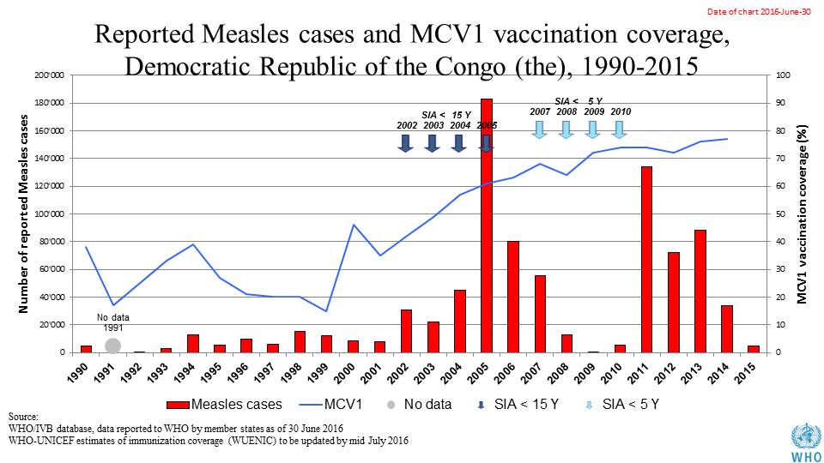

Table 1: SIA activities planned in 2016-2017

|  |  |  |  |  |  |  |  |  |
| --- | --- | --- | --- | --- | --- | --- | --- | --- |
| **Activity** | **Intervention** | **Year** | **Start Date** | **End Date** | **Age Group** | **Extent** | **Status** | **Target** |
| Catch up | MR | 2017 |  |  | 6 M-14 Y | National rollout | planned | 7,320,281 |
| Follow up | Measles | 2016 | 19/07/2016 | 01/11/2016 | 6-59 M | National rollout | planned | 16,109,995 |
| SNID | bOPV | 2016 | 01/10/2016 |  | 0 to 5 years | Sub-national | Planned | 8,121,548 |
| NID | tOPV | 2016 | 14/04/2016 | 16/04/2016 | 0 to 5 years | National | Planned | 18,166,533 |
| NID | tOPV | 2016 | 24/03/2016 | 26/03/2016 | 0 to 5 years | National | Planned | 18,166,533 |
| SNID | tOPV | 2016 | 25/04/2016 | 27/04/2016 | 0 to 9 years | Sub-national | Planned | 1,430,939 |
| Campaign | MenA | 2016 | 01/02/2016 |  | 1-29 Y | Sub-national | planned | 10,117,371 |
| Campaign | MenA | 2016 | 01/05/2016 |  | 1-29 Y | Sub-national | planned | 7,927,555 |

Source: WHO/IVB Database as at 12/4/2016

1. **Coverage and Equity**

Figure 5: All vaccines national coverage, DRC, 2000-2015

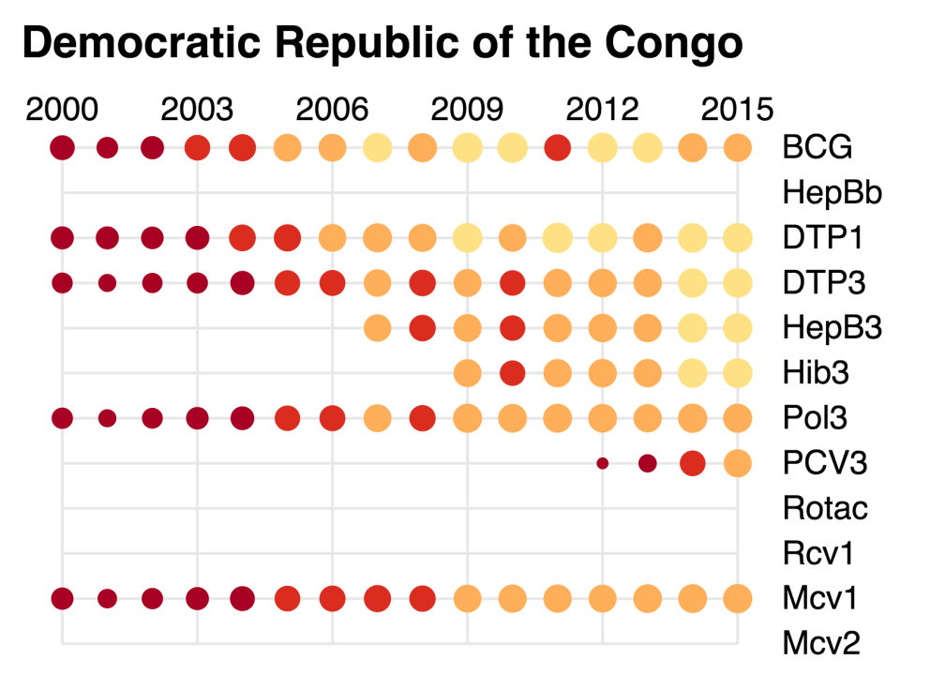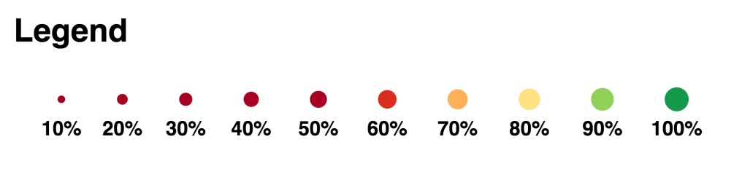

1. Internal WHO/UNICEF memo, July 5, 2016.
2. Measles epidemic in the Democratic Republic of Congo: WHO and UNICEFF concerned about the spread of the epidemic in the former province of Katanga. ReliefWeb report, 5 October 2015 (<http://reliefweb.int/report/democratic-republic-congo/measles-epidemic-democratic-republic-congo-who-and-unicef-concerned>).
3. cMYP 2015-2019.
4. Draft EPI Action Plan for 2016, February 2016.
5. cMYP 2015-2019.
6. DRC MOH and WHO. Situation epidemiologique de al rougeole en RDC, 21 June 2016 (weekly disease reporting bulletin).