**Global Vaccine Action Plan**

*Secretariat Annual Report 2016*

*Priority Country report on progress towards*

*GVAP-RVAP goals*

**INDONESIA**

1. **Progress towards achievement of GVAP goals**
2. **Summary**

This summary table describes the current situation in Indonesia regarding achieving the GVAP goals. Data used to assess progress towards achievement of GVAP goals can be found in the annex.

| **Area** | **Indicator** | **Indonesia** |
| --- | --- | --- |
| **Socio-demographic** | **GNI 2014** | **3650** |
| **WB Status** | **Lower Middle Income** |
| **Infant mortality (<12 M) 2015 UN IAG CME** | **23** |
| **GAVI status** | **Graduating (2016)** |
| **Total population** | **257,564,000** |
| **Birth cohort** | **5,037,000** |
| **Surviving infants (JRF)** | **4,918,000** |
| **1. Interrupt wild poliovirus transmission** | **Transmission Interrupted** | **Yes (since 2006)** |
| **Risk of late detection: Percent of adequate stool specimens (Rolling 12 mo.)(Target > 80%)** | **95.4** |
| **Risk of late detection: Non polio AFP rate (Rolling 12 mo. )  (Target > 2/100,000 children** | **1.6** |
| **Risk of spread after importation:  % of 6-59 month olds having received less than 3 doses in the last year before occurrence case/environmental positive)** | **23%** |
| **2. Neonatal tetanus elimination** | **TT2+ coverage (reported on JRF 2015)** | **63%** |
| **Protection at Birth against tetanus (WUENIC 2015)** | **85%** |
| **Last SIAs conducted in the country** | **2013** |
| **Elimination validation date** | **May 2016** |
| **3. Measles Elimination** | **Coverage MCV1 (WUENIC 2015)** | **69%** |
| **Coverage MCV2** | **76%** |
| **Percentage of districts with MCV1 coverage ≥95% (2015 JRF)** | **39%** |
| **Last national SIA** | **2009-2011. SIAs in 183 high-risk districts planned for August 2016** |
| **Post SIA coverage survey conducted** | **No** |
| **4. Rubella/CRS Elimination** | **Rubella vaccination coverage** | **Not introduced (2015)** |
| **SIAs planned?** | **MR SIAs planned for 2017-2018** |
| **5. Reach 90% national coverage and 80% in every district with 3rd dose of DTP-containing vaccine** | **National coverage (WUENIC 2015)** | **81%** |
| **Drop-out rate DTP1 to DTP3 (WUENIC 2015)** | **10%** |
| **Actual numbers of children that dropped out (WUENIC 2015)** | **442,652** |
| **Difference between poorest and richest quintile DTP3 coverage (2013 survey data)** | **27.3 percentage points** |
| **% District coverage reaching 80% coverage from 2015 JRF** | **59%** |
| **6. Reach 90% national coverage and 80% in every district with all vaccines in the national immunization schedule** | **National Coverage (WUENIC 2015)** | **BCG: 89% Pentavalent 1: 90% Pentavalent 3: 81% MCV1: 72% MCV2 : 76% Polio 3 : 82%** |
| **7. Introduction of new vaccines** | **New vaccines introduced** | **Hib (pentavalent) in 2013-2015; introducing MR and JE in SIAs in 2017; HPV: introduction in one province in 2016 and demonstration project in 2017** |
| **8. Reduction in under 5 mortality rate** | **Percent reduction from 2010 to 2015** | **2010: 33.1 2015: 27.2 (17.8%)** |
| **9. NITAG** | **NITAG established?** | **Yes** |
| **10. Government expenditure on routine immunization per live birth (USD)** | **Baseline 2010-2011 and average for 2013-2015 (% change)** | **13.2 to 10.7 (-19%)** |

1. **Country ownership of the immunization program**
   1. **Immunization policy decision-making capacity**

There is strong county ownership of and commitment to immunization in Indonesia, which has its own vaccine production capacity at Bio Farma – a major producer of WHO pre-qualified vaccines for UNICEF and GAVI – a fully-functioning national regulatory authority, a strong vaccine storage and transport system, and supportive government policies.

The country has had a NITAG – the Indonesia Technical Advisory Group for Immunization (ITAGI) since 2007. The committee consists of 18 core members who are experts in a range of fields (paediatrics, public health, infectious diseases, epidemiology, immunology, etc.) and who serve for three years (with the possible renewal for an additional three years). There are additional *ex-officio* and liaison members from other agencies (e.g., the NRA). ITAGI has received assistance from the SIVAC project and WHO to strengthen its decision-making skills based on a technical review of evidence. It is fully-functional, as defined by WHO, and meets at least four times a year (and seven times in 2015).

ITAGI’s main role has been to make recommendations to the MOH about the introduction of new vaccines. For each specific vaccine under consideration, a working group is formed to weigh the evidence and conduct or commission specific studies. Studies requested by the ITAGI and reviewed by the working groups on the impact and cost-effectiveness of JE vaccination in high-risk areas (e.g., Bali) and on the cost effectiveness of introducing measles-rubella (MR) vaccine to control rubella were instrumental to the Government’s decision to apply to GAVI for support for targeted JE campaigns and for nation-wide MR campaigns (to be followed by their introduction into the routine program).[1] The ITAGI has recently expanded its role to include monitoring of the national immunization program’s progress and to address programmatic issues. In 2013, it recommended changes to the childhood immunization schedule to add a booster dose of DTP at 18 months and a second measles vaccine dose at 24 months. The committee also serves as a trusted, credible voice to the public when issues about vaccine safety arise. For instance, the group communicated with the public following a scandal involving counterfeit vaccines to maintain the population’s confidence in vaccination.

* 1. **Government financing of immunization**

The Government of Indonesia covers the vast majority of expenditures for the immunization program, including the cost of all traditional vaccines, co-financing for new vaccines, all cold chain and logistics costs, and most EPI personnel costs. In 2014, central government expenditures accounted for 90.6% of total estimated expenditures for the program ($140 million out of $154.7 million).[2] Most of the remaining 9% was financed by GAVI ($14.3 million), mainly to cover 50% of the cost of pentavalent vaccine, 16% of the cost of AD syringes, and activities implemented through the HSS grant.[3] As the country is graduating from GAVI support in December 2016, it will pick up 100% of the costs of pentavalent vaccine and injection supplies starting in 2017 and the HSS grant will end. However, GAVI will provide “exceptional catalytic support” to the country for the introduction of new vaccines by co-financing the vaccine costs for the targeted JE campaigns and the measles-rubella SIAs in 2017, as well as a two-year demonstration of HPV vaccination planned for 2017 and 2018. GAVI will also continue to co-finance the recently-introduced IPV vaccine up to 2018. The Government has a history of making its co-financing payments in full and on time and for fully paying for traditional vaccines and other essential supplies and equipment for the immunization program.

The main issues regarding immunization financing in Indonesia are insufficient government funding for health, the great variation in health spending at the local level since the government was decentralized, and the lack of guaranteed funding at the local level for the delivery of immunization services. Although the central government is required by law to allocate at least 5% of its budget to health, health expenditures each year make up only around 2% of total government spending.[4] In addition, since decentralization in 2001, half of national government expenditures on health occur at the district level, using block grants that districts receive from the central government to pay for health and other public services. The district governments are responsible for managing and covering the costs of health services in their area, including the costs of operating health centers and village health posts, and all the operational costs associated with service delivery, including transportation, cold chain maintenance, and so forth. It is up to the district government officials to decide how to allocate the block grant funds and, while they are mandated to spend at least 10% on health (excluding salaries), there is no means of enforcing or monitoring this rule. In fact, less than half (48%) of districts included in a World Bank health financing assessment spent 10% or more of their funds on health in 2013, and it ranged from 3% to over 18% (see orange bars in Figure 1).[5] There is also no guaranteed amount or earmarking of funds for immunization services. The consequence of these factors – insufficient government health spending and a lack of guaranteed funding for health or immunization at the local level – is that available funding for many key immunization activities, such as default tracking, supervision, VPD surveillance, monitoring and evaluation, and transport is inadequate in many districts.[6]

The Government is in the process of expanding its national health insurance program (JKN) in the aim of providing universal health coverage to all of its citizens (with premiums for the poor and non-poor heavily subsidized) under a single payer insurance scheme. The Government contracts with both public and private health facilities to provide health services, including routine immunization, to beneficiaries and pays the facilities on a capitation basis (i.e., per beneficiary). This should increase not only the Government’s overall health spending, but also the funds that health facilities have to deliver preventive health services, such as immunization. However, the JKN benefits package is not at present clearly defined, causing confusion among health providers about whether preventive health services are covered. This has reportedly led to some public sector health facilities to no longer offer immunization services or to charge a user fee for vaccinations.[7] The World Bank is working with the JKN to improve the design of the program and to ensure the inclusion of immunization and other preventive health services by developing a well-defined benefits package and exploring performance-based payments to providers (e.g., based on immunization coverage results).

Figure 1: Share of government budget for health and per capita spending across 44 districts, 2013



**2.3 Human resources situation and its impact on the immunization program**

Indonesia benefits from a relatively large workforce of health professionals. Most health workers who administer vaccinations are midwives, many working from outreach health posts called *posyandus*). Immunizations are also provided by nurses, doctors and other health workers at health centers (*puskesmas*) and hospitals. Each *puskesmas* has an EPI coordinator, though their skills and training in immunization may be limited. At the provincial and district levels, there are typically two health officers dedicated to immunization – one responsible for program management and the other for cold chain, vaccine, and logistics management.[8] The number of these positions is inadequate in many places and often not proportional to the size of the population in their area. In recognition of the lack of immunization personnel at the sub-national level, new positions – called supervisor assistants or *wasor* – were created in the past ten or so years in low-performing districts to supplement the immunization staff, with funding from the GAVI HSS grant and from local governments. In 2013, there were more than 200 *wasors* operating in 184 of the country’s 511 districts across 25 of the country’s 33 provinces.[9] According to one informant, these positions are likely to continue with local government funding after GAVI support ends because their value has been well demonstrated.

According to several assessments, a major human resources problem affecting the immunization program at the district and village level is the high turnover rate – often every 3-6 months – among EPI coordinators and managers, nurses, midwives, and cold chain technicians and other health workers.[10] This reduces the development of expertise in immunization and commitment to immunization activities, and requires frequent staff training on the topic. In 2013 alone, more than 111,000 health personnel received training in routine immunization.[11] A joint EPI and VPD surveillance review conducted in 2013 also found little or no supportive supervision occurring at below the district level.[12]

At the central Ministry of Health level, there are 20 full-time positions in the national immunization program (NIP), as well as several staff on contract for special assignments (e.g., ITAGI secretariat, AEFI monitoring). However, at the time of the EPI/surveillance review, only 14 of the permanent positions were filled. Some of these positions are supported financially by WHO, and this assistance will end in December, along with most GAVI support. The central immunization program team also experiences a high level of turnover; most there at present are relatively new and not specialists in immunization. They have recently received mid-level management (MLM) training in immunization with GAVI and WHO support. The team members make supervisory visits to the provinces on average 2-3 times a year. Their influence to affect change and to advocate for increased immunization funding and activities at the local level is, however, somewhat limited by their relatively small number, lack of skills in advocacy, relatively junior status and newness to the field of immunization, and by the decentralized government structure.

1. **Progress towards specific GVAP goals (issues/challenges/successes)**

**3.1 Goal 1: Achieve a world free of poliomyelitis**

Has polio transmission been interrupted?

Indonesia has not experienced a case of wild polio virus since 2005, when there was an outbreak in Aceh province following the tsunami, with more than 300 cases reported.[13]

Is the country at high risk of polio transmission?

The polio risk assessment conducted by WHO in 2015 assessed the nation as a whole as at low risk of polio importation and spread. However, the assessment found that 19 of the country’s 33 provinces were at high risk of polio transmission, seven were at medium risk and eight were at low risk. The main factors accounting for the continual risk in many provinces are:

* **Pockets of low immunization among young children** due to inadequate coverage of polio vaccination. The WHO-UNICEF (WUENIC) estimated national coverage rate for three polio vaccine doses is 82% -- well below the 90% target – and coverage is considerably lower in several areas. According to the 2013 Riskesdas immunization coverage survey, one-quarter of provinces (8 out of 33) had coverage rates for the four polio vaccine doses in the national schedule of less than 70%, with the lowest rate in Papua province at 49%.
* **Inadequate performance of AFP/polio surveillance in many areas**. AFP surveillance is conducted in all 33 provinces, through a network of provincial and district surveillance officers. It is integrated with measles surveillance and supported by three national laboratories. Environmental polio surveillance is also in place in two sites. However, the 2013 EPI/surveillance review found weak active surveillance at hospitals in the provinces, with poor understanding of AFP case definitions among doctors, and identified several unreported AFP cases.[14] While the polio risk assessment found that the national rate of non-polio AFP just meets the target indicator (at 2.02/100,000 children), 14 provinces did not meet this standard and many had stool adequacy rates below the 90% target. Several sources report a recent decline in the performance of the AFP/polio surveillance system overall, coinciding with a reduction in donor support.

Other sources also cite the risk of possible importation from immigrants from at-risk countries and from the large number of travellers to the Haj each year.

What needs to be done to ensure sustainability of polio eradication?

Until recently, Indonesia had not conducted polio vaccination campaigns since sub-national campaigns were held in 2011. The country conducted a national immunization day (NID) in March 2016, which targeted more than 22 million children under the age of five prior to the switch from trivalent to bivalent OPV in April. This was followed by the introduction of IPV as the third polio vaccine dose in the routine immunization schedule in July. A second NID is planned for 2017 to increase population immunity and further reduce risk of transmission.

Sustaining polio-free status and reducing the risk of transmission in Indonesia in high-risk areas will require strengthening case-based surveillance in health facilities, including hospitals (through training of staff) and increasing polio vaccine coverage through the routine immunization program in all low-performing districts in the country.

* 1. **Goal 2 : Meet global and regional disease elimination targets**

**3.2.1 Achieve maternal and neonatal tetanus (MNT) elimination**

Indonesia was certified by WHO in May 2016 as having eliminated MNT nation-wide. This follows validation of elimination in three of the country’s regions in 2011, and a recent validation assessment in the fourth region – consisting of four remote provinces (Papua, West Papua, Maluku and North Maluku). Achieving MNT elimination in the last region required conducting two rounds of TT vaccination (integrated into the polio NIDs) in very isolated, hard-to-reach districts in the country’s extreme East, which involved intensive district-level technical assistance from WHO in micro planning, training and in increasing community awareness. There were reports of vaccine hesitancy against TT vaccine among some ethnic groups in Papua province. The country reported 69 cases in 2013, 0 in 2014, and 53 in 2015 (for an incidence rate of <0.01/1,000 live births).

Indonesia used a multi-pronged approach to eliminate the disease, which included:

* A focus on clean deliveries and cord care practices, which is facilitated in Indonesia by the high rate of pregnant women making at least four antenatal care visits (84%) and institutional births (70%).[15]
* Routine infant immunization with four doses of DPT-containing vaccine, as well as vaccination of pregnant women with two TT doses;
* A unique school-based vaccination program called BIAS, begun in 1984, which provides DT vaccine to all first graders (both girls and boys) nation-wide and dT to those in Grades 2 and 3. As a result of infant vaccination and the school-based program, many women have received the five recommended doses of TT-containing vaccine by the time they reach child-bearing age. The WUENIC estimated national rate for children protected at birth in 2015 is 85%.
* TT campaigns for women of child-bearing age in high risk districts since 2003. The last SIA was conducted in 2013 in 18 districts in the three remaining high-risk provinces.

Ensuring sustainability of neonatal tetanus elimination will require maintaining high-quality case-based MNT surveillance throughout the country, but especially in the last areas to have eliminated the disease; strengthening the BIAS program in areas where it is not fully operational; improving the recording of TT vaccination among pregnant women; reviewing neonatal tetanus cases and TT coverage regularly; and conducting additional SIAS if surveillance data reveals clusters of cases.

**3.2.2 Achieve measles elimination and rubella & CRS elimination**

**Measles**

Is the GVAP target achieved?

While measles incidence has declined significantly since the 1990s and early 2000s, Indonesia continues to experience measles transmission, with between 8,400 and around 22,000 cases reported each year on the Joint Report Format from 2010 to 2014[16] and 65 to 251 lab-confirmed outbreaks.[17] Measles incidence seems to have declined in 2015, with only 26 lab-confirmed outbreaks and 818 reported cases – by far the lowest in many years.

To control the disease, the NIP conducted a national measles catch-up vaccination campaign for children 9 months to 15 years in phases between 2005 and 2007. Follow-up campaigns for children under five – combined with polio vaccination – took place from 2009 to 2011 in three phases. Once the country shifted its goal from measles control to measles elimination, it introduced case-based surveillance in a phase manner (starting in 2008), added measles vaccination to the schedule for first graders through the school-based BIAS program, and in 2013 added a second measles dose at 24 months to the routine immunization schedule (the third dose for school children will be phased out).

To meet the 2020 target date for measles elimination, the NIP will be conducting “crash” vaccination campaigns in August 2016 in 183 high-risk districts identified through the surveillance system for four million children 9-59 months old. This will be followed by GAVI-supported national measles-rubella (MR) campaigns for children nine months to 15 years in 2017 and 2018 targeting over 70 million children.

Key issues affecting progress towards measles elimination

There are two main challenges to achieving measles elimination by 2020 in Indonesia:

* **Insufficient case-based measles surveillance**. The joint EPI/surveillance review conducted in 2013 found that the implementation of case-based measles surveillance has been uneven. The review found evidence of unreported measles outbreaks, as well as suspected outbreaks that were not investigated (accounting for 12% of all suspected outbreaks in 2013).[18] Only around 16-26% of suspected cases each year between 2010 and 2013 were lab-tested,[19] due in part to insufficient funding to test all individual cases (the NIHRD lab continues to rely on WHO funds for testing specimens).
* **Lackluster measles coverage rates and pockets of low coverage**. According to the WUENIC estimates, coverage rates for a single measles vaccine dose have not improved significantly in the past ten years and have declined somewhat in the past four years (from 82% in 2012 to 72% in 2015)[20] (see Figure 2). (Coverage with the dose given to six year olds in school (referred to as MCV2 in the figure) appears to be greater than that of the infant dose.) Measles coverage rates also vary widely by province; the 2013 Riskesdas survey found that provincial coverage rates among 12-23 month olds ranged from 57% to 94%. This points to a need to improve the delivery of vaccination to infants through the routine immunization program. Issues concerning the routine program are discussed in the next section.

**Rubella**

There appears to be a significant burden of rubella in Indonesia. Of 145 suspected measles outbreaks that were investigated in 2012, more of them (56%) turned out to be rubella or mixed measles/rubella outbreaks than measles.[21] The country’s disease surveillance system reported between seven and 76 rubella outbreaks each year between 2010 and 2015, including 152 outbreaks and more than 3,200 reported cases in 2014.[22] The estimated incidence of rubella in 2015 was nearly identical to that for measles: 3.26 cases per million population for rubella and 3.23 cases for measles. CRS surveillance has been established with WHO support in 13 major hospitals in 10 provinces.

As mentioned above, Indonesia will introduce rubella vaccination (MR vaccine) in catch-up campaigns in 2017 and 2018 and in the routine immunization schedule in two doses (at nine and 24 months), starting in 2018.

Figure 2: Measles vaccination coverage rates and measles cases, 1980 to 2015, WUENIC estimates[23]



* 1. **Goal 3: Meet vaccination coverage targets**

1. **Achieve 90% national coverage and 80% in every district with 3 doses of diphtheria-tetanus-pertussis containing vaccines**
2. **Achieve 90% national coverage and 80% in every district with all vaccines included in the national schedule**

Are the targets achieved?

The WHO-UNICEF estimated national coverage rate for three doses of DPT-containing vaccine in 2015 was 81%, which compares to the official county estimate of 84% and to 76% from the 2013 Riskesdas national coverage survey. According to the country’s official data on the JRF, 70% of the country’s districts achieved DPT3 coverage of ≥80%. However, the Riskesdas survey – which showed coverage data at the provincial level – found a broad range in coverage rates among 12-23 month olds – from a low of 41% in Papua to a high of 95% in Yogyakarta. Only 36% of provinces (12 out of 33) were found to reach the target coverage rate of ≥80%.

Concerning other vaccines in the immunization schedule, only BCG comes close to reaching the 90% national coverage target – with a WUENIC estimate of 89% in 2015. National coverage rates for the other childhood vaccines in 2015 were 72% for measles and 81-82% for DPT3 and OPV3. As shown in Figure 3, coverage rates have budged little in 10 years, with DPT3 rates showing the greatest increase – from 72% in 2005 to 81% in 2015. The WUENIC data actually show a reduction in coverage since 2013, especially for the first measles dose, as mentioned above, as well as for BCG.

Figure 3: Trends in national immunization coverage rates, using the WHO-UNICEF estimates, 2005 – 2015

These national rates mask large inequities in coverage by location and social class. The 2013 Riskesdas coverage survey found that 57% of children in the lowest wealth quintile had three doses of DPT-containing vaccine compared to 84% of children in the highest wealth quintile. Coverage in rural areas was 71% vs. 80% in urban areas. While the survey found that 8.7% of all 12-23 month olds had never received a single vaccination, the rate was 21% in the lowest wealth quintile (vs. 4.3% in the highest), and was double in rural as compared to urban areas (11.7% vs. 5.8%). More than one-third of children (37%) in the province of Papua had never been vaccinated. Overall, an estimated one million children in Indonesia are only partially vaccinated – many of them in hard-to-reach areas, urban slums and migrant populations.[24]

A manifestation of the insufficient vaccination coverage rates in Indonesia is the continual reporting of cases of diphtheria and pertussis each year. Reports of diphtheria cases peaked in 2012 – at 1,192 cases – and were concentrated in East Java. Vaccine hesitancy in this population was reportedly a factor. The NIP conducted sub-national diphtheria vaccine campaigns in E. Java in 2012 and since then, incidence has fallen each year – to 252 cases in 2015.

Major factors contributing to inadequate improvements in immunization coverage rates in Indonesia

* **High dropout rates between the first and third doses of DPT-containing vaccine**. The WUENIC estimated dropout rate between DPT doses nationally in 2015 was 10% (the difference between 90% and 81%). However, dropout rates are reportedly between 10% and 20% in many provinces.[25] The main factors attributed to these high dropout rates are the lack of awareness among parents in many areas about the vaccination schedule and need for repeat doses of certain vaccines, and inadequate tracking and follow-up of children who haven’t completed their vaccinations. Recent efforts to reduce dropout rates through an initiative called Drop Out Follow-Up (DOFU) are discussed in Section B below.
* **Infrequency of immunization services for much of the population.** Indonesia has made great strides to make primary health care services accessible to the population by establishing in the 1980s a system of 260,000 outreach sites called *posyandus*, where midwives operating from the country’s more than 9,300 health centers and 22,000 sub-health centers bring basic preventive health care services, including immunization, to the community. The *posyandus* can be mosques, schools, someone’s home or other village meeting places that function as an integrated health post for a few hours a day. While health centers and sub-centers, as well as private clinics and hospitals, also provide immunizations, an estimated 70-75% of all childhood vaccinations are delivered at these outreach posts.[26] However, the majority of *posyandus* have immunization sessions for only a half day once a month, often with only a day’s notice. When health centers are not able to reach their immunization targets at the end of the year, they conduct “sweeps” by visiting villages to catch up children on their vaccinations by going door-to-door. While there are funds available for these sweeps, the funding is irregular and often delayed, resulting in missed or delayed immunizations.
* **Insufficient demand generation for and community involvement in routine immunization.** In many parts of the country, especially the highly-populated areas of Java and Sumatra, the problem with children not completing their immunizations is not so much a lack of physical access to health services, but to a lack of information and other social barriers. While the population in general has a positive attitude towards immunization, with 85% of women in a recent coverage assessment in three provinces believing that their children should be vaccinated,[27] many have inadequate knowledge about immunization, including the vaccination schedule and need for repeat doses, as well as concerns and misperceptions about the safety of vaccines. The issue of reactogenicity of DPT and other vaccines was found to be the #1 reasons in the 2013 Ruskesdas survey for children not being vaccinated (cited by 29% of respondents). These safety concerns have sometimes been exacerbated by rumors and negative publicity about AEFI cases, as well as by a recent scandal involving counterfeit vaccines.

Each year, more than five million women in Indonesia become pregnant and therefore need information about routine immunization, including its importance for the health of their children, the risks of not being vaccinated, the vaccine schedule, vaccine side effects and vaccine safety. Communications around routine immunization must therefore be strengthened through community-based health promotion, mass communications, and training of health workers to improve their inter-personal communication skills. Indonesia does have a large network of community volunteers, called *kaders*, who are selected by the community and responsible for educating mothers about immunization, working with midwives to organize EPI sessions at *posyandus*, tracking pregnant women, and assisting with default tracking. However, these volunteers, who are under the responsibility of local governments, are often not sufficiently trained or provided with tools to counter vaccine safety concerns and misinformation, nor are they adequately monitored or provided with feedback. As a result, they are not always motivated or actively involved in immunization.

* **Health systems issues**. As mentioned in Section 2.2, decisions about allocated funds to immunization and other health services are made by local governments and thus the amount of available funding is dependent on the local leaders’ priority for immunization. Funding for critical operational expenditures, such as transportation, cold chain maintenance, and health worker incentives, is often inadequate, affecting the performance of the immunization program. The program’s performance is also affected by the limited number and capacity of the NIP staff at the national and provincial levels to provide critical monitoring, technical assistance, and follow-up in low-performing districts, as well as the high turnover rate among staff at all levels.
* **Difficulty in accessing remote, hard-to-reach areas**. There are very remote, inaccessible areas in Indonesia, such as Papua province, with difficult terrain and small and dispersed populations. It is therefore difficult, time-consuming and costly to deliver health care services on a regular basis to these populations, and consequently, they have amongst the lowest vaccination coverage rates in the country (e.g., 41% for DPT3 in Papua in the Riskesdas survey). While the size of these populations is relatively small, low coverage rates in these areas contribute to Indonesia’s challenge in meeting the GVAP goal of ≥80% coverage in all of the country’s districts. A project to improve the delivery of health services in remote areas (the Sustained Outreach Service project) is described in Section B below.
* **Missed opportunities to provide vaccinations to children**. The 2013 EPI/surveillance review found that several health worker practices and a lack of clear policies regarding them resulted in missed opportunities for children to receive all of their immunizations on schedule during immunization sessions. These include the reluctance among health workers to open a multi-dose vaccine vial if few children are to be vaccinated, to administer multiple injections to a child during the same session (despite little evidence of concern on the part of parents), and in some provinces, to provide vaccines to children once they reach the age of one year.[28] This points to the absence of clear national policies for handling multi-dose vials and for catch-up immunization for children over the age of one.
* **Data quality issues**. Despite a well-established system and regular schedule for reporting immunization data in Indonesia, there are often differences of 10 or 20 percentage points or more between administrative coverage data (often >90%), official country estimates, and the WHO-UNICEF estimates. For example, the official country estimate for coverage of one measles dose in 2015 is 86%, compared to the WUENIC estimate of 72%. A main factor is inaccurate and differing population estimates. While all programs are required to use estimates from the National Statistics Bureau, many provinces and districts use their own population estimates based on birth registrations – resulting in the central NIP generating two sets of coverage estimates.[29] There are also problems with the recording of immunizations at *posyandus*, with retention of immunization cards by mothers (<50%) and with the submission of immunization data by some private sector providers. Inflated and inaccurate coverage data can mask poor program performance and areas of low immunization coverage. A major activity under the GAVI HSS project involves addressing this issue by conducting independent data quality assessments (DQAs).
* **Local vaccine stockouts.** This is generally less of an issue in Indonesia than in many other GVAP priority countries, given Bio Farma’s strong track record and long experience in vaccine production, procurement and distribution (up to the province level). A facility census conducted in 2011, for instance, found that more than 90% of health centers visited had all mandated vaccines available.[30] The country’s buffer stock policies – requiring provincial stories to have a four-month buffer stock and health facilities to have a five-week buffer – help to prevent local stockouts in case of procurement or transportation delays. Nonetheless, there are sometimes local vaccine shortages or stockouts due to delays in finalizing procurement contracts or in delivering vaccine from the provinces to the districts and health centers, which is the responsibility of local governments. The lack of vaccines was reported by mothers in the 2013 three-province coverage assessment was the third most common reason for their children missing a vaccination (11% of responses).[31]

**3.4 Introduce new and improved vaccines and technologies**

The introduction of new vaccines has been slower in Indonesia than in many other GVAP priority countries, a key reason being the country’s dependence on Bio Farma to produce vaccines for the national immunization program. The introduction of Hib vaccine – by replacing DPT-Hepatitis B vaccine with the pentavalent (DPT-HepB-Hib) – did not begin until 2013, once Bio Farma received market authorization by the NRA for its vaccine. The rollout of pentavalent – supported by GAVI – took place in five phases (by province) over a year and a half period, from mid-2013 to early 2015. According to the 2015 Joint Appraisal report, the introduction of the vaccine went smoothly, with health staff well trained, a well-planned communications and social mobilization strategy that engaged all sectors of society and pre-empted serious opposition from anti-vaccine groups, and no serious AEFI cases reported. GAVI’s co-financing of the vaccine ends in December 2016 when the country graduates from GAVI support.

The Government’s policy of linking the introduction of new vaccines with Bio Farma’s R&D agenda and production plans has begun to change. The country – with three years of support from GAVI – introduced IPV in July 2016 before the Bio Farma-produced vaccine was available. A stepped approach is being used, in which the vaccine is initially supplied by Sanofi, then Bio Farma will fill-finish sanofi’s bulk vaccine, and finally, Bio Farma will produce its own vaccine. Several other new vaccine introductions are also planned for the next few years:

* Measles-rubella vaccine is being introduced with one-time financial support from GAVI in national catch-up campaigns that will take place in 2017 and 2018. As mentioned above, the vaccine will then be introduced into the routine immunization schedule, replacing the monovalent measles vaccine. Indonesia will use imported vaccine until Bio Farma obtains licensure of its own MR vaccine, expected around 2018.
* Japanese encephalitis vaccine is being introduced in campaigns in Bali (a high-risk area) in 2017, with GAVI supported, using the Chinese vaccine. The vaccine will be incorporated into the routine immunization schedule in Bali and other high-risk provinces (determined by epidemiological research) after that.
* A demonstration of HPV vaccine will take place in two districts in Yogyakarta province in 2017 and 2018, with GAVI support, using imported vaccine. In addition, the Government will introduce the vaccine in 2016 in the city of Jakarta, with central and local government funding.
* Pilot introductions of PCV and rotavirus vaccines are being planned with government funding (for 2017 in the case of PCV). The demonstrations will evaluate the impact and cost-effectiveness of the vaccines to inform government decisions about their introduction nation-wide. Both vaccines are in development at Bio Farma, with the rotavirus vaccine further advanced. Rotavirus surveillance is currently on-going in four sentinel hospitals in different parts of the country.

1. **Partner support to address major challenges to meet the GVAP goals and targets**

While financial support from partners for the immunization program makes up a relatively small portion of immunization financing in Indonesia, partners have provided important technical support and expertise to the Government in specific areas for several years. Critical support has included assistance in developing the surveillance system for AFP/polio and other vaccine-preventable diseases, including laboratory support; strengthening capacity of the country’s national regulatory authority (POM); and assistance in designing and implementing studies and assessments to guide the immunization program and measure the impact and value of vaccination. These include coverage surveys, studies of cost-effectiveness, among many others. With financial support from GAVI, partners have also assisted in the introduction of pentavalent and IPV vaccines.

Though the GAVI HSS grant, partners have helped improve the immunization program’s performance by: 1) assisting with special efforts to improve immunization coverage; 2) improving the quality of immunization data and local capacity in data collection, reporting and analysis; and 3) improving health worker skills and knowledge in immunization by developing teaching materials on immunization and MCH service delivery for midwifery training institutes. Two initiatives to note that are supported by partners with GAVI HSS financing in the aim of addressing the country’s lagging immunization coverage rates are:

* The **Drop-Out Follow-Up (DOFU) strategy** being implemented in 60 districts in 18 provinces,
* The **Sustained Outreach Service (SOS) strategy** to improve the delivery of immunization and other MCH services to remote, sparsely-populated islands in three provinces (E. Nusa Tenggara, Maluku and N. Maluku). This strategy, supported by UNICEF and WHO, involves outreach visits to these communities (at least 3-4 times a year) to provide children and women with integrated MCH services. Local governments have recognized the benefits of this strategy and have started to contribute to its implementation.

Much of the funding for technical support from partners, including WHO and UNICEF, will end when regular GAVI support, including the HSS grant, concludes in December 2016. However, it will be critical that partners continue to provide technical assistance to both the central government and sub-national governments with such activities as VPD surveillance, new vaccine introductions (e.g., JE, PCV, HPV), impact assessments, and other advocacy efforts to justify investments in immunization. Technical assistance from partners will help ensure that the gains made with past support, including polio eradication and progress towards measles elimination, can be sustained and reach their full potential.

**Acknowledgments**

We would like to thank the following people who were interviewed for this report:

* Xiao Xian Huang ( WHO HQ)
* Vinod Bura (WHO CO)

**ANNEXES**

**Annex 1: Country immunization profile**

1. **Polio**

* **Transmission stopped in 2005.**
* **Eradication certified in 2014**

1. **Measles and rubella**

Figure 4: Reported Measles cases and MCV coverage WHO-UNICEF estimates, Indonesia, 1990-2015

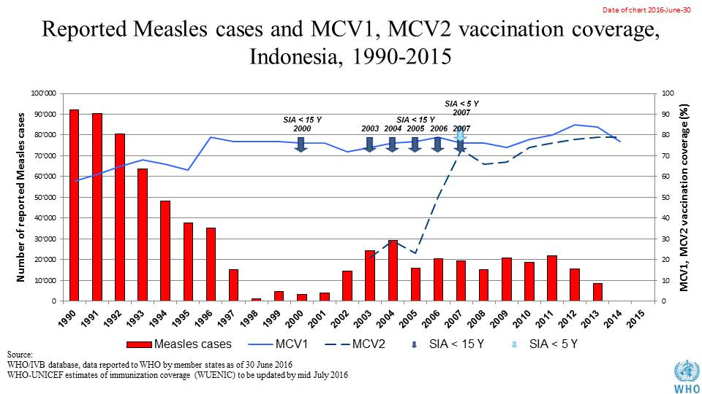

Table 1: SIA activities planned in 2016-2017

|  |  |  |  |  |  |  |  |  |
| --- | --- | --- | --- | --- | --- | --- | --- | --- |
| **Activity** | **Intervention** | **Year** | **Start Date** | **End Date** | **Age Group** | **Extent** | **Status** | **Target** |
| **Follow Up** | **Measles** | **2016** | **01/10/2016** |  | **9-59 M** | **Sub-national** | **planned** | **3,900,554** |
| **Campaign** | **MR** | **2017** | **01/08/2017** |  | **9 M-15 Y** | **National** | **planned** | **70,000,000** |
| **NID** | **tOPV** | **2016** | **01/03/2016** |  | **0 to 5 years** | **National** | **Planned** | **23,093,592** |

Source: WHO/IVB Database as at 01 July 2016

1. **MNT eliminated in 2016.**
2. **Coverage and Equity**

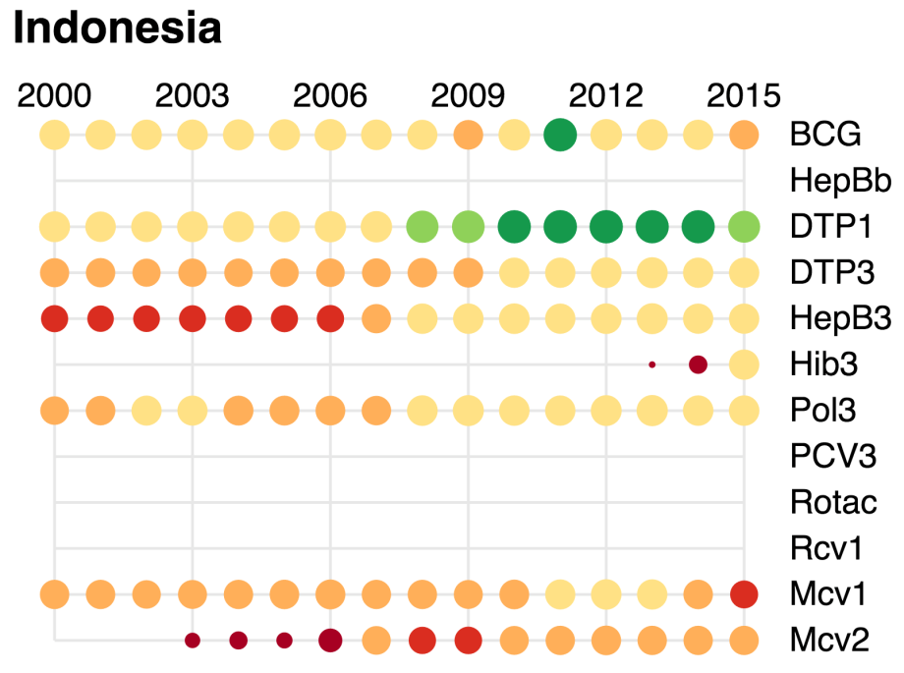

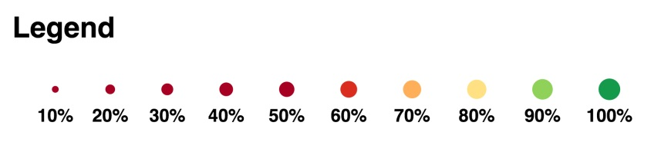

**Table 2: Reported DTPCV doses administered & coverage, Indonesia, 2000-2015**

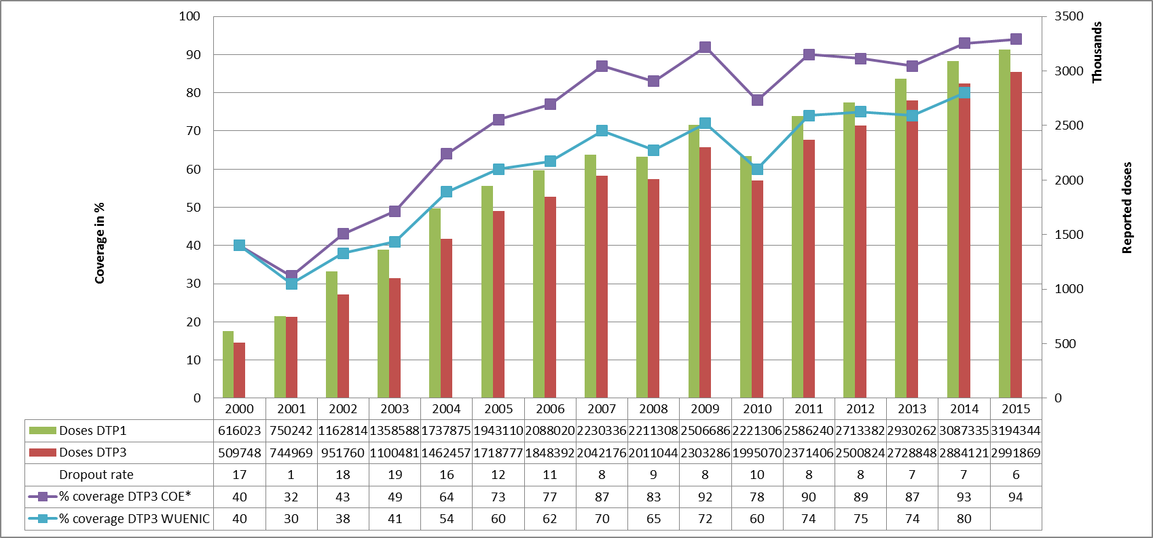

* COE: country Official Estimates

Source:

WHO/IVB database, data reported to WHO by member states as of 1 July 2016

WHO/UNICEF national coverage estimates, 2014 revision, data as of July 2015

Figure 6: Percentage of district achieving <50%; 50-79% and ≥80% coverage, 2000-2015

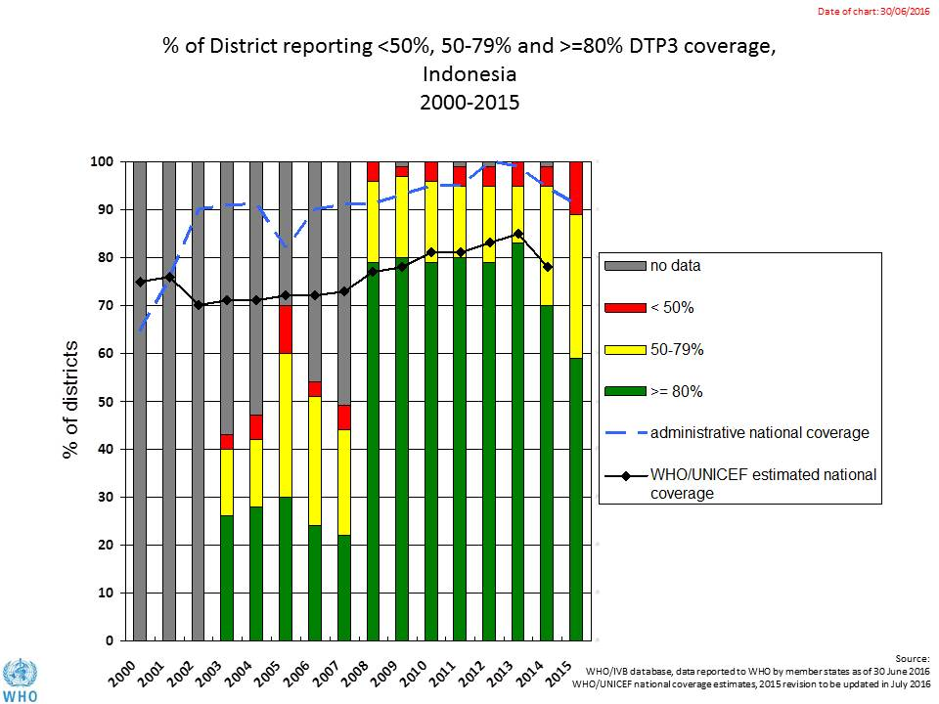

Figure 7: DTP3 coverage by district/province, Indonesia, 2010 and 2015 (admin)

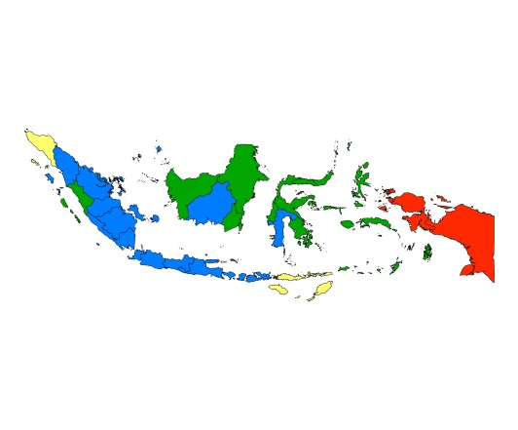 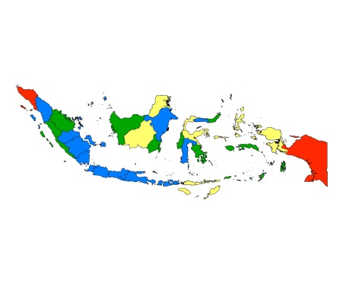 2010 2015

Figure 8: Immunization coverage data disaggregated by sex and wealth quintile

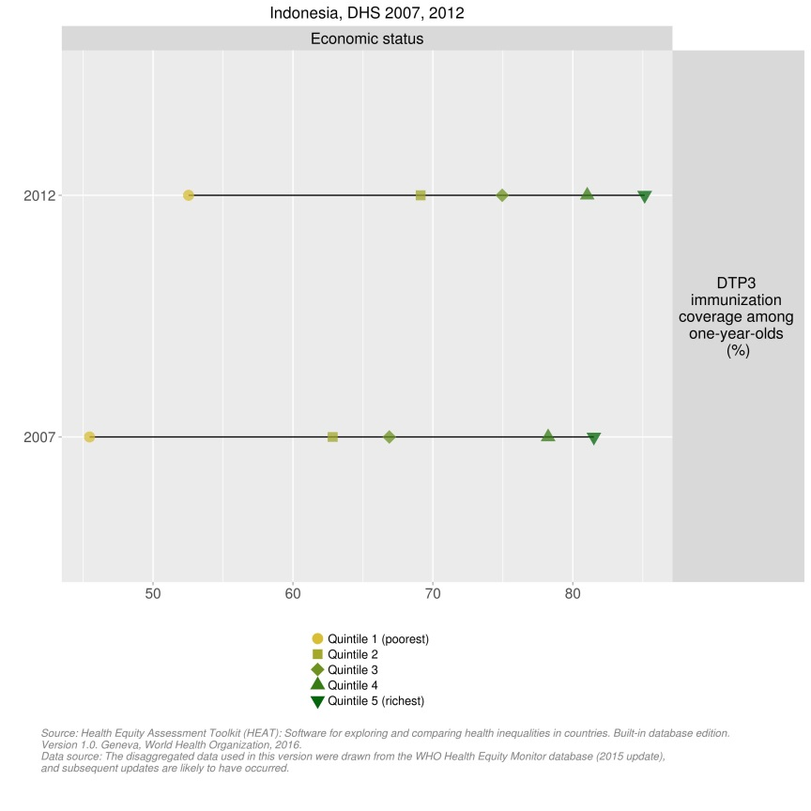

1. **Immunization systems highlights**

Figure 9: Immunization schedule, Indonesia 2015

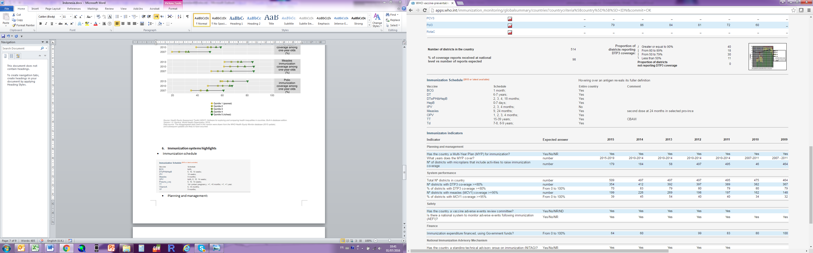

Planning and management:

* + Stockout of vaccines: no events in 2015.
  + cMYP: 2015-2019
  + Annual Plan: Yes
* Country decision making: NITAG meeting the 6 minimum criteria defined by WHO for a functioning NITAG
* % of total expenditures on vaccines financed by government funds: 78

1. In the case of JE, the vaccine will be introduced only in high-risk areas.
2. GAVI Annual Progress Report 2014
3. Joint Appraisal Report 2015
4. World Bank Group. Issues affecting sustainability of the immunization program in Indonesia. Presentation February 18, 2016.
5. World Bank. Health Financing System Assessment: Indonesia, 2016.
6. World Health Organization. Joint national and international EPI and VPD surveillance review, Indonesia, 2014.
7. World Bank Group. Issues affecting sustainability of the immunization program in Indonesia. Presentation February 18, 2016.
8. Government of Indonesia. Comprehensive multi-year plan for the national immunization program, 2015-2019.
9. Government of Indonesia. Comprehensive multi-year plan for the national immunization program, 2015-2019.
10. World Bank Group. Issues affecting sustainability of the immunization program in Indonesia. Presentation February 18, 2016.
11. cMYP.
12. World Health Organization. Joint national and international EPI and VPD surveillance review, Indonesia, 2014.
13. World Health Organization. Joint national and international EPI and VPD surveillance review, Indonesia, 2014.
14. World Health Organization. Joint national and international EPI and VPD surveillance review, Indonesia, 2014.
15. <http://data.unicef.org/maternal-health/antenatal-care.html>.
16. SEARO. EPI Fact Sheet, Indonesia, 2016.
17. Presentation by the Sub-Directorate, Surveillance & Outbreak Response, Indonesia on Vaccine preventable disease surveillance and immunization analysis, May 2016.
18. World Health Organization. Joint national and international EPI and VPD surveillance review, Indonesia, 2014.
19. cMYP.
20. SEARO. EPI Factsheet for Indonesia, 2016.
21. World Health Organization. Joint national and international EPI and VPD surveillance review, Indonesia, 2014.
22. SEARO. EPI Factsheet for Indonesia, 2016.
23. SEARO. EPI Factsheet, Indonesia, 2016.
24. Joint appraisal and transition mission, Indonesia, debriefing presentation, 2016.
25. World Health Organization. Joint national and international EPI and VPD surveillance review, Indonesia, 2014.
26. World Bank Group. Issues affecting sustainability of the immunization program in Indonesia. Presentation February 18, 2016.
27. Assessment of district immunization coverage at three provinces (West Sumatra, West Nusa Tenggara and South Kalimantan), 2013.
28. World Health Organization. Joint national and international EPI and VPD surveillance review, Indonesia, 2014.
29. Ibid.
30. World Bank Group. Issues affecting sustainability of the immunization program in Indonesia. Presentation February 18, 2016.
31. Assessment of district immunization coverage at three provinces (West Sumatra, West Nusa Tenggara and South Kalimantan), 2013.