**Global Vaccine Action Plan**

*Secretariat Annual Report 2016*

*Priority Country report on progress towards*

*GVAP-RVAP goals*

**INDONESIA**

1. **Progress towards achievement of GVAP goals**
2. **Summary**

This summary table describes the current situation in Indonesia regarding achieving the GVAP goals. Data used to assess progress towards achievement of GVAP goals can be found in the annex.

| **Area** | **Indicator** | **Indonesia** |
| --- | --- | --- |
| **1. Interrupt wild poliovirus transmission** | **Transmission Interrupted** | **Yes (since 2006)** |
| **Risk of late detection: Percent of adequate stool specimens (Rolling 12 mo.)(Target > 80%)** | **95.4** |
| **Risk of late detection: Non polio AFP rate (Rolling 12 mo. )  (Target > 2/100,000 children** | **1.6** |
| **Risk of spread after importation:  % of 6-59 month olds having received less than 3 doses in the last year before occurrence case/environmental positive)** | **23%** |

1. **Progress towards specific GVAP goals (issues/challenges/successes)**

**3.1 Goal 1: Achieve a world free of poliomyelitis**

Has polio transmission been interrupted?

Indonesia has not experienced a case of wild polio virus since 2005, when there was an outbreak in Aceh province following the tsunami, with more than 300 cases reported.[1]

Is the country at high risk of polio transmission?

The polio risk assessment conducted by WHO in 2015 assessed the nation as a whole as at low risk of polio importation and spread. However, the assessment found that 19 of the country’s 33 provinces were at high risk of polio transmission, seven were at medium risk and eight were at low risk. The main factors accounting for the continual risk in many provinces are:

* **Pockets of low immunization among young children** due to inadequate coverage of polio vaccination. The WHO-UNICEF (WUENIC) estimated national coverage rate for three polio vaccine doses is 82% -- well below the 90% target – and coverage is considerably lower in several areas. According to the 2013 Riskesdas immunization coverage survey, one-quarter of provinces (8 out of 33) had coverage rates for the four polio vaccine doses in the national schedule of less than 70%, with the lowest rate in Papua province at 49%.
* **Inadequate performance of AFP/polio surveillance in many areas**. AFP surveillance is conducted in all 33 provinces, through a network of provincial and district surveillance officers. It is integrated with measles surveillance and supported by three national laboratories. Environmental polio surveillance is also in place in two sites. However, the 2013 EPI/surveillance review found weak active surveillance at hospitals in the provinces, with poor understanding of AFP case definitions among doctors, and identified several unreported AFP cases.[2] While the polio risk assessment found that the national rate of non-polio AFP just meets the target indicator (at 2.02/100,000 children), 14 provinces did not meet this standard and many had stool adequacy rates below the 90% target. Several sources report a recent decline in the performance of the AFP/polio surveillance system overall, coinciding with a reduction in donor support.

Other sources also cite the risk of possible importation from immigrants from at-risk countries and from the large number of travellers to the Haj each year.

What needs to be done to ensure sustainability of polio eradication?

Until recently, Indonesia had not conducted polio vaccination campaigns since sub-national campaigns were held in 2011. The country conducted a national immunization day (NID) in March 2016, which targeted more than 22 million children under the age of five prior to the switch from trivalent to bivalent OPV in April. This was followed by the introduction of IPV as the third polio vaccine dose in the routine immunization schedule in July. A second NID is planned for 2017 to increase population immunity and further reduce risk of transmission.

Sustaining polio-free status and reducing the risk of transmission in Indonesia in high-risk areas will require strengthening case-based surveillance in health facilities, including hospitals (through training of staff) and increasing polio vaccine coverage through the routine immunization program in all low-performing districts in the country.

**ANNEXES**

**Annex 1: Country immunization profile**

1. **Polio**

* **Transmission stopped in 2005.**
* **Eradication certified in 2014**

Table 1: SIA activities planned in 2016-2017

|  |  |  |  |  |  |  |  |  |
| --- | --- | --- | --- | --- | --- | --- | --- | --- |
| **Activity** | **Intervention** | **Year** | **Start Date** | **End Date** | **Age Group** | **Extent** | **Status** | **Target** |
| **Follow Up** | **Measles** | **2016** | **01/10/2016** |  | **9-59 M** | **Sub-national** | **planned** | **3,900,554** |
| **Campaign** | **MR** | **2017** | **01/08/2017** |  | **9 M-15 Y** | **National** | **planned** | **70,000,000** |
| **NID** | **tOPV** | **2016** | **01/03/2016** |  | **0 to 5 years** | **National** | **Planned** | **23,093,592** |

Source: WHO/IVB Database as at 01 July 2016

1. **Coverage and Equity**

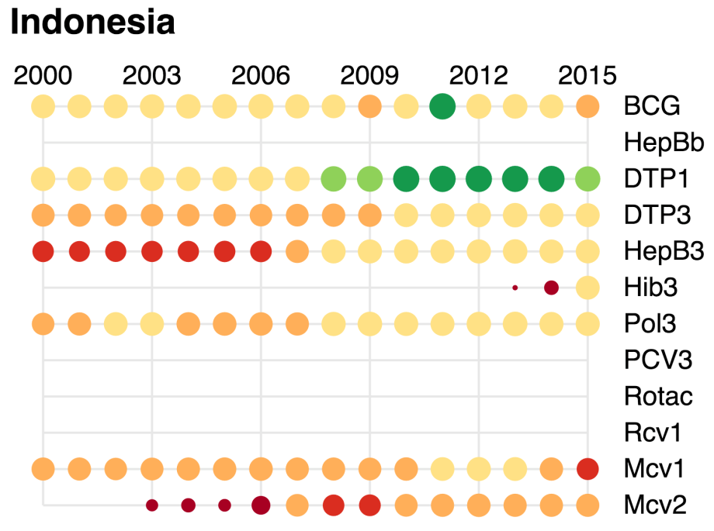

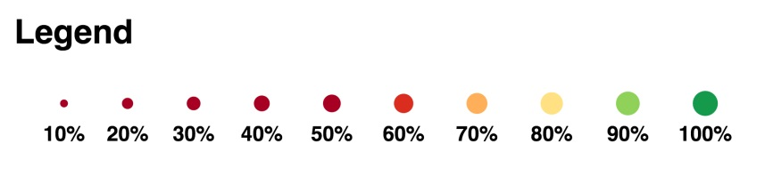

1. World Health Organization. Joint national and international EPI and VPD surveillance review, Indonesia, 2014.
2. World Health Organization. Joint national and international EPI and VPD surveillance review, Indonesia, 2014.