**Global Vaccine Action Plan**

*Secretariat Annual Report 2016*

*Priority Country report on progress towards*

*GVAP-RVAP goals*

**UGANDA**

1. **Progress towards achievement of GVAP goals**
2. **Summary**

This summary table describes the current situation in Uganda regarding achieving the GVAP goals. Data used to assess progress towards achievement of GVAP goals are included in the annex (Country immunization profile).

| **Area** | **Indicator** | **Data for Uganda** |
| --- | --- | --- |
| **2. Neonatal tetanus elimination** | **TT2 coverage (reported 2015 on JRF)** | **58%** |
| **Protection at birth against tetanus (WUENIC 2015)** | **85%** |
| **Last SIAs conducted in the country** | **N/A** |
| **Elimination validation date** | **Validated in 2011** |

* 1. **Goal 2 : Meet global and regional elimination targets**

**3.2.1 Achieve maternal and neonatal tetanus elimination**

Uganda received validation for having eliminated MNT in 2011. The main strategies the country is employing to sustain elimination consist of:

* TT immunization of high school girls (15-17 year olds) through annual school-based vaccination campaigns;
* A strong culture of vaccinating all women who come for antenatal care services (the rates of which have been increasing) with at least two doses of TT.
* Mandating of TT vaccination for all women 18-49 years of age, as well as for all 15-17 year old girls through the new Immunization Act. Parents and schools are held responsible for ensuring vaccination of girls and can receive fines or imprisonment if they are not (the same holds true for 18-49 year old women).

The current TT coverage rate for two or more doses is 58% among pregnant women, while the protection at birth (PAB) rate among infants is 85%. The low TT coverage rate is reportedly due to recording problems rather than to women not being vaccinated, as women who have received the full time doses or only need one more dose when they are pregnant are not often not included in the TT2 coverage reports.

There remains some risk of not sustaining the elimination in some areas of the country, however, due to weak implementation of case-based NNT surveillance in some districts to confirm whether reported cases are truly NNT. At least one district in the 2011 MNT risk assessment report had a rate above 1/1,000 live births.[1] In addition, the stated policy of ring vaccination around a confirmed case is probably not taking place, according to two informants. A further constraint to high TT coverage rates is that target-age girls not enrolled in school are missed through the school-based program. In addition, health personnel have difficulty calculating PAB rates and require training in this.

The following steps can help ensure sustainability of MNT elimination:

* Improve NMT surveillance, including investigating and testing all suspected cases;
* Strengthening and sustaining the school-based TT vaccination program for girls, and extend it to 15-17 year old girls not in school;
* Provide additional booster doses (of TT or Td) during childhood and include boys, since there have been a few cases in young men following circumcision. This proposal is currently under discussion within the government.

**ANNEX: Country immunization profile**

1. **MNT**

MNTE elimination was validated in 2011.

1. **Immunization coverage and equity**

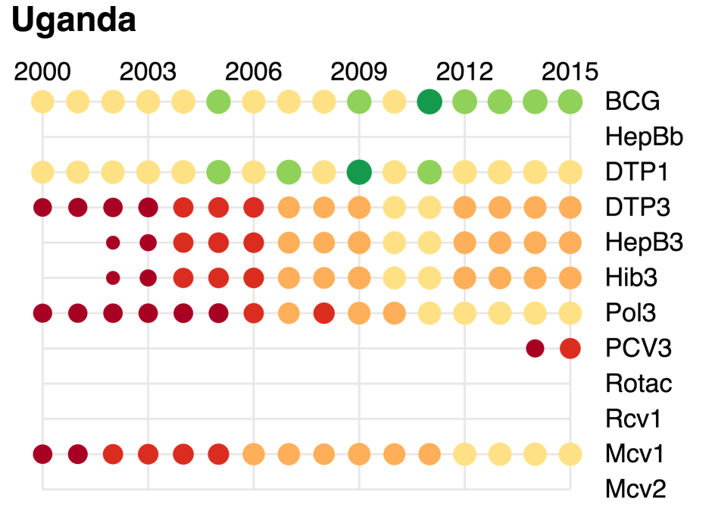

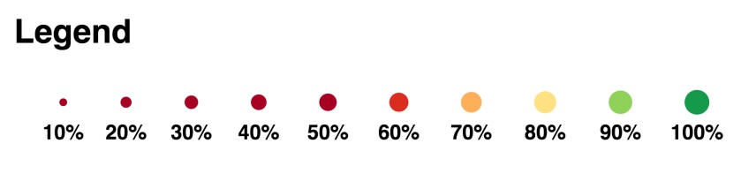

1. cMYP.