**Hepatitis B vaccine recommendations**

WHO recommends that all infants receive the hepatitis B vaccine as soon as possible after birth, preferably within 24 hours. If administration within 24 hours is not feasible, a late birth dose has some effectiveness. Although effectiveness declines progressively in the days after birth, after 7 days, a late birth dose can still be effective in preventing horizontal transmission and therefore remains beneficial. WHO recommends that all infants receive the late birth dose during the first contact with health-care providers at any time up to the time of the next dose of the primary schedule.

The birth dose should be followed by 2 or 3 doses to complete the primary series. In most cases, 1 of the following 2 options is considered appropriate:

* a 3-dose schedule of hepatitis B vaccine, with the first dose (monovalent) being given at birth and the second and third (monovalent or combined vaccine) given at the same time as the first and third doses of diphtheria, pertussis (whooping cough), and tetanus – (DTP) vaccine; or
* a 4-dose schedule, where a monovalent birth dose is followed by three monovalent or combined vaccine doses, usually given with other routine infant vaccines**.**

[WHO Hepatitis B Vaccine position paper](http://apps.who.int/iris/bitstream/10665/255841/1/WER9227.pdf?ua=1)

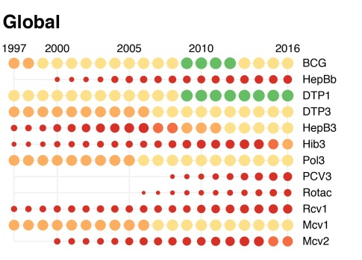

[Immunization surveillance assessment and monitoring](http://www.who.int/immunization/monitoring_surveillance/data/en/)

[Global Health Observatory visualizations](http://apps.who.int/gho/data/node.wrapper.immunization-cov)