Touchstone 3 Visual Design and Responsive Layout
North Star Bakery
Name | Ryan Geddie
Course | Introduction to Web Development
Date | October 5, 2026
Selected Client | Client A North Star Bakery

Section 1: Preview Link and GitHub Link
GitHub Repository Link: To be added after the project is uploaded to GitHub.
Working Project Preview Link: To be added after GitHub Pages is enabled.

Section 2: Design Explanation

Client Alignment
My design supports North Star Bakery as a welcoming neighborhood business for families and local customers. The homepage pairs a storefront photograph with an introduction to handmade bread, pastries, and celebration cakes. The brown product button gives visitors a clear route to the product descriptions and sample prices. The same navigation on every page makes it easy to find the bakery story, hours, and pre-order practice form.

Color Palette
I used cream (#FFF8F0), brown (#6B3E26), peach (#D88C5A), and charcoal (#2F2A26). Cream backgrounds and brown headings create a warm tone that fits a neighborhood bakery. Charcoal body text is readable against cream, and cream button text contrasts with brown. Peach outlines separate the content cards without being used for small text, where it would provide weaker contrast.

Typography
I used Georgia for headings and Arial for body text, navigation, and form controls. Georgia gives the bakery headings a traditional appearance, while Arial keeps product descriptions and instructions easy to read. The homepage heading scales from 2rem to 3.8rem and is larger than the 1.65rem section headings. Bold labels and buttons identify form fields and important actions consistently across the four pages.

Responsive Design
I used Flexbox for the header, navigation, homepage introduction, and content sections. On larger screens, the homepage introduction places text beside the storefront image and the sections form two columns. At widths of 700 pixels or less, a media query stacks the introduction and sections into one column and reduces the page padding. Navigation wraps so every link remains visible, and images and form controls fit the available width. The featured picture also selects the larger image at 800 pixels or more.

Design Challenge
A design challenge was keeping the long Contact and Pre-orders navigation link and the form readable on small screens. I allowed the navigation to wrap instead of forcing all links onto one line. I also gave inputs and text areas a maximum width of 100 percent and reduced section padding in the mobile media query. I checked all four pages at 390 and 1280 pixels wide and found no horizontal overflow or broken images.

Section 3: Submission Checklist
☑ Updated HTML files
☑ External CSS file
☐ Working preview link added after publication
☑ Consistent color palette (2–4 colors)
☑ Consistent typography (1–2 fonts)
☑ Styles applied across all pages
☑ Flexbox used in layout
☑ At least one media query
☑ Readable text with sufficient contrast
☑ Completed design explanation

Section 4: Screenshot
The homepage screenshot shows the Georgia heading, cream background, brown product button, peach card outlines, and two-column desktop layout.
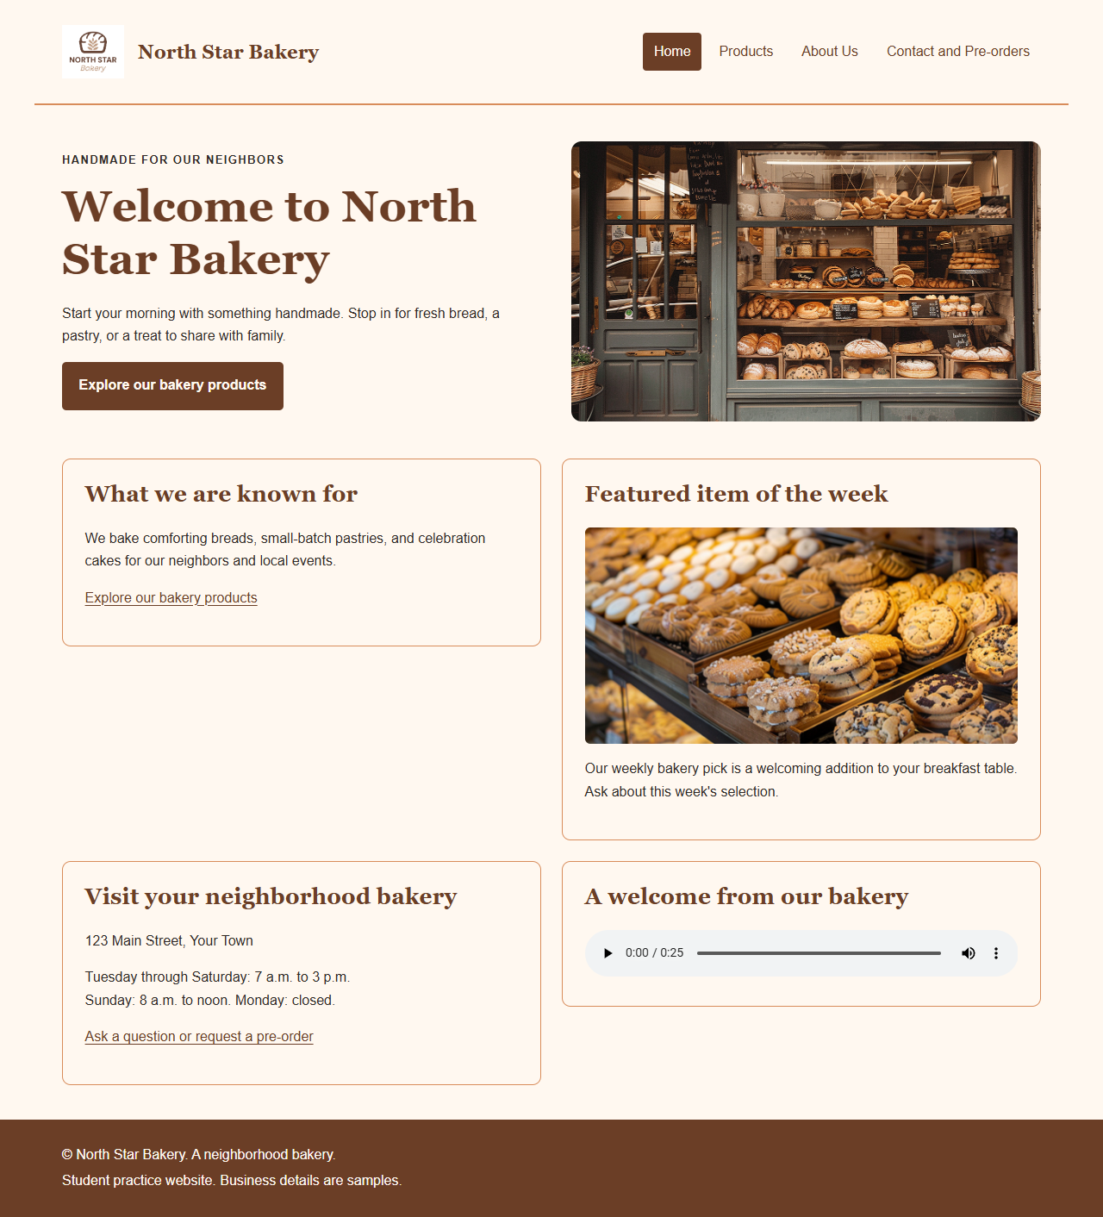

Section 5: Final Review
☑ All pages display correctly
☑ Navigation works across all pages
☑ Layout adjusts across screen sizes
☑ Design is consistent and readable

