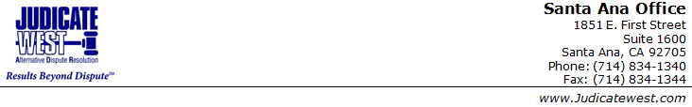

5/30/2017

**Stipulation for Settlement**

|  |  |
| --- | --- |
|  |  |
| **Frank Rizzo** | Judicate West Case No **A231940** |
|  |  |

IT IS HEREBY STIPULATED by and between the parties through the respective counsel or representative of each that the above-referenced case has been settled according to the terms memorialized herein below. This settlement document is intended by the parties to be binding and enforceable in court - in state court by motion pursuant to C.C.P § 664.6 and Evidence Code § 1123, or in federal court by motion pursuant to the inherent power of the court to enforce settlement agreements and in accordance with applicable federal rules of procedure and evidence.

In order to facilitate the above specified terms of settlement, the parties further agree that on or before

the  4rd day of  january 2017 they will execute or exchange the following:

|  |  |  |  |  |  |  |
| --- | --- | --- | --- | --- | --- | --- |
| [x] | Settlement / Release Agreement | Prepared by |  | plaintiff | fff | defendant |
| [ ] | Request for Dismissal | Prepared by | sam wilton | plaintiff | zzz | defendant |
| [ ] | Other |  | | | | |

**The terms, conditions and content of this stipulation are the product of the counsel and not the mediator, the parties acknowledge that the mediator serves only as scribe not originator. All relevant parties must sign below. Copies are acceptable in lieu of originals.**

|  |  |  |
| --- | --- | --- |
|  |  |  |
| Different Tea |  | Ice Tea |
|  |  |  |
|  |  |  |
|  |  |  |
|  |  |  |

