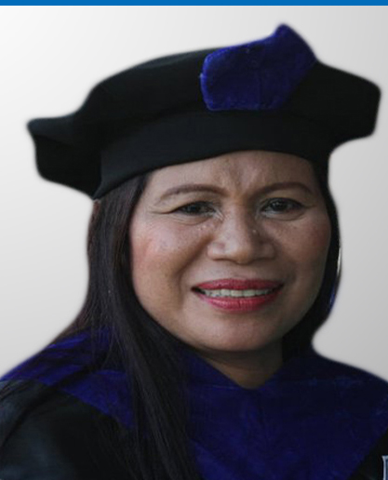
ANNABELLE HUFALAR
Brgy. Rizal, Sogod Southern Leyte
Email Address: annabell_hufalar@yahoo.com

Family and Personal Data

Born on December 25, 1959 in Sogod, Southern Leyte, Married to
Mr. Baltazar Hufalar.

Children: IRENE MARCEL, JUNE NINA, BALTAZAR JR., PRINCESS BELZAR

Residence: j. Veloso St. Rizal, Sogod Southern Leyte

Office: Office of the Under Graduate Studies
Southern Leyte State University, Sogod, Southern Leyte

Education

2010:  Dev. Ed. D. | Cebu Technological University – Cebu City
2001:  MAED | St. Joseph College, Maasin City Southern Leyte
1982:  Bachelor of Science in Industrial Education | Cebu Technological University – Cebu City
1978:  Secondary Education | Southern Leyte School of Arts and Trades. Sogod Southern Leyte | Class Salutatorian
1973:  Elementary Education | Sogod Central School  Sogod Southern Leyte | 1st Honorable Mention

Researches Undertaken (2009-2013)

- Southern Leyte State University-Main Campus Curricular Assessment and Curriculum Management Information System (CMIS) Establishment: Bases for Curriculum Planning, Revision, Implementation, Monitoring and Evaluation
Language Used by People with Ages 50 and Above in Sogod Bay Area
- Utility of the Existing SLSU Faculty Performance Evaluation System for Effective Teaching
- Teaching Strategies of Faculty and the Academic Performance of SLSU Students
- Educational Performance of the Pupils in the Pantawid Pampamilya Pilipino Program (4Ps) in the Selected Barangays of Sogod, Southern Leyte
- Career Path Preference and Factors Affecting Its Choice Among High School Graduates and Graduating Students
- SLSU-Main Campus Senior High Curriculum Modelling Project
- Teachers Capability Building on Self-Learning Instructional Materials (SLIMs) Preparation and Utilization
- Professional Development Needs of Part-Time Instructors of SLSU-Main Campu7s: Basis for Training Program Development
- Educational Qualification and Relevant Trainings of Faculty Members of Southern Leyte State University
- The Effects of Four-Day Class implementation to the BSIE 4 Students
- Implementation of Support to Students of Southern Leyte State University

Instructional Materials Prepared

- Graduate Classes

Module 1: Historical Foundations of Education
Module 2: Philosophical Foundations of Education
Module 3: legal Foundations of Education
Module 4: Anthropological Foundations of Education
Module 5: Psychological Foundations of Education
Module 6: Sociological Foundations of Education

- Undergraduate Classes

- Sociology and Family Planning Study Guide
- Working with Curriculum Development

Attended Trainings /Seminars/Conventions/Others

Title of the Seminar/Training/  Symposium/Convention/ Forum | Date and Type of  Attendance | Venue
Module Writing | June 9, 2011 | SLSU-Sogod
Regional Congress for Student Teacher and Mentors | December 2, 2010 | PAFTE and CDTE
Employees Forum on Welfares and Benefits | November 5, 2010 | CSC and SLSU
Training of New Accreditors | June 8, 2010 | AACCUP
Orientation/Reorientation Program for Designated Faculty | November, 14, 2010 | SLSU-Sogod
Empowerment Program for Grievance Committee and Personnel Selection Board Members | May 30. 2007 | SLSU-Sogod
Computer Aided Teaching | March 29, 2007 | SLSU-IE Department
Seminar-Workshop Assessment | February , 2, 2007 | CHED – R8
Distance Learning Program | June 9, 2006 | CSC-R7
2006 AACCUP Annual National Conference | February, 15, 2006 | AACCUP

Positions/Designations Held

- Department Head Industrial Education Department
- Dean Undergraduate Studies (2010- present)

