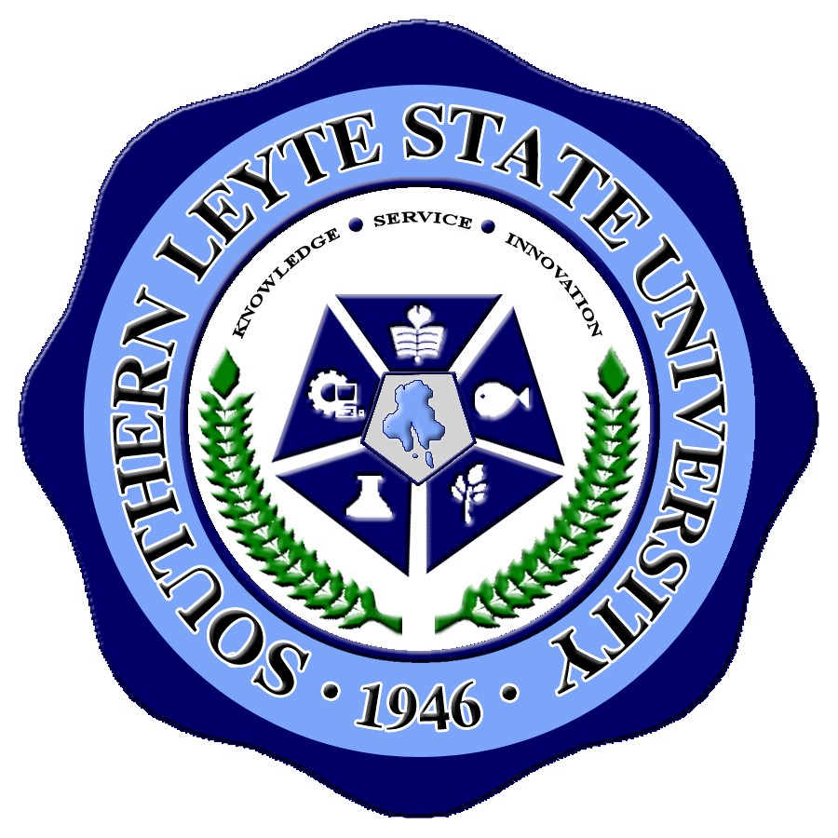
Republic of the Philippines
SOUTHERN LEYTE STATE UNIVERSITY
Main Campus, Sogod, Southern Leyte
Telefax no. (053) 382-3294 website: www.slsuonline.edu.ph

TRAVEL AUTHORITY

July 14, 2014

MR. JAMES BRIAN FLORES
Administrative Aide IV

Dr. Paulo:

In connection to your teaching assignment at Tra Vinh University (TVU), Tra Vinh Province, Vietnam for the Master in Management program of Southern Leyte State University (SLSU) offered in TVU, you are granted AUTHORITY TO TRAVEL from July 17 to July 28, 2014. You are expected to execute the purpose of your travel in such a way that it could give honor to the university and the Philippines.

Considering that your foreign travel is official, you will be entitled to traveling expenses including insurance, actual cost of visa processing, pre-departure expenses and daily subsistence allowance chargeable against the amount collected from the tuition fees paid by MM students in Vietnam, which shall be transferred to SLSU in accordance with Item 6.4, Article 6 of the MOA. However, due to financial constraints, you will not be paid clothing allowance. Moreover, lodging or hotel rate will not be provided since TVU will be responsible for your accommodation.

Thank you for supporting the university’s bilateral cooperation agreement with TVU in Vietnam as part of its international linkage and Transnational Education Program of CHED under the Cooperation Implementation Scheme Arrangement.

Very truly yours,

GLORIA M. REYES, Ph.D.
University President

cc: Records
Accounting
HRMO
File

