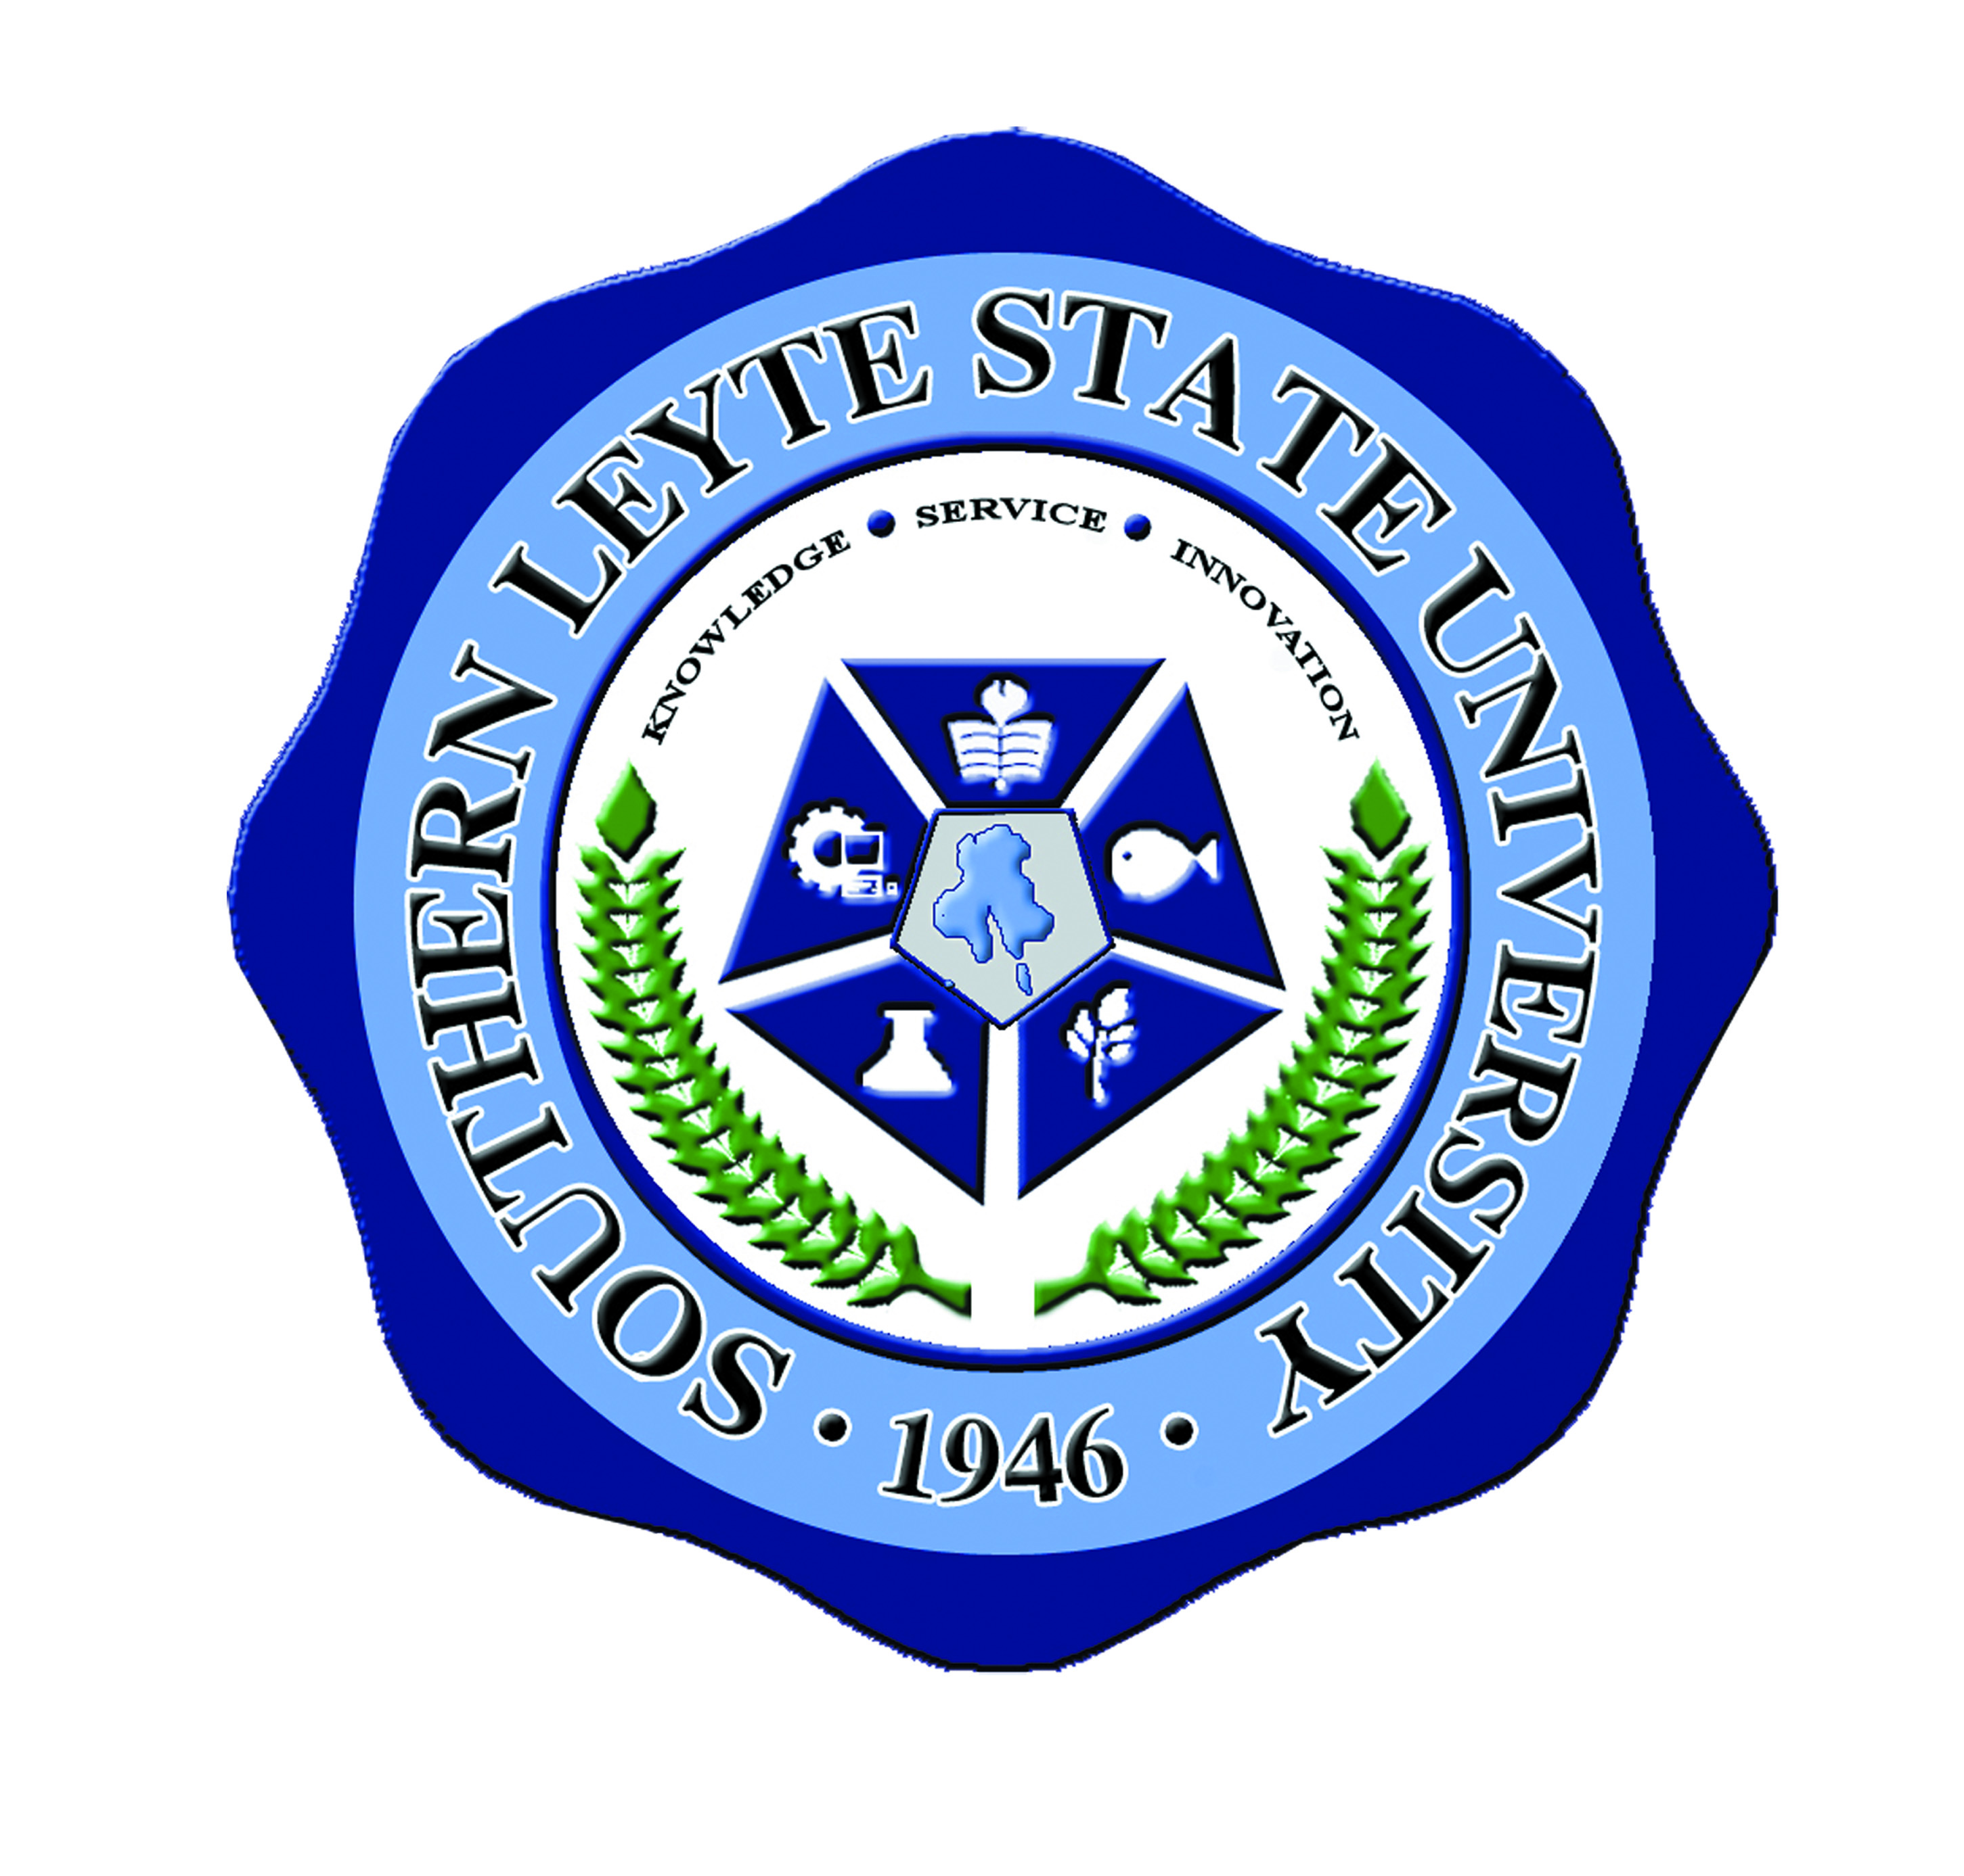Republic of the Philippines

SOUTHERN LEYTE STATE UNIVERSITY

Sogod, Southern Leyte

[www.slsuonline.edu.ph](http://www.slsuonline.edu.ph)

MINUTES ON *SPECIAL MEETING* ON *FEBRUARY 17, 2014*

*8:30AM* AT THE *GS OFFICE*

Presiding Officer: Dr. Juanita M. Costillas – Dean, Graduate Studies

Agenda:

1. ICO Report on:
   1. Status of UBIS-SLSU Dual Master’s degree
   2. Bureau of Immigration Certification
2. Schedule of Classes for CTEC 3 and MMBD2
3. Submission of requirements for MM classes on international collaboration
4. Other Matters
   1. Phase 3 of GS Building
   2. RDE Activities
   3. Attendance of CTEC students during graduation

Present:

Dr. Rosario L. Paulo

Mr. Feliciano C. Hampac

Engr. Joel T. Guasa

Ms. Mabel Calva

Mr. James Brian Flores

Minutes:

1. The meeting was called to order by the Dean of the Graduate Studies Dr. Juanita M. Costillas at 8:45 in the morning. It started with a short prayer led by Mr. Feliciano Hampac.
2. Dean Costillas presented the provisional agenda with the other matters as well, Upon the motion of Mr. Hampac duly seconded by Ms. Calva, the provisional agenda with the additional concerns under other matters were approved by the body.
3. For the ICO report Dr. Costillas asked Mr. Flores give some updates. Mr. Flores reported that the Dual MM-MBA degree document was already sent to CHED for evaluation. Once the CHED will reply, the processing of the collaboration between SLSU and UBIS will be finalized. On the status of the Bureau of Immigration Certification, Mr. Flores stressed that the certification was already processed and ready for pick-up by SLSU official liaison officer for BI and DFA transaction Processing Ms. Hazelle V. Asaldo. Dr. Paulo asked a clarification on UBIS MOU and the content of the UBIS documents. She also asked if the collaboration between SLSU and UBIS was presented to the Academic Meeting. In this connection, Dr. Costillas explained that the UBIS collaboration was already presented to the academic meeting. For the agendum 1.2 Dr. Paulo proposed that the liaison officer should be a personnel of ICO office. In addition Mr. Hampac also suggested that ICO should be the one to facilitate the BI transaction. On the other hand, Engr. Guasa said that ICO staff must review their duties and responsibilities of their office so that they will know the full extent of their responsibility.
4. Dr. Costillas presented the schedule of classes for MMBD2 and CTEC 3. She showed all the prepared schedules to each faculty member .After showing the schedule Dr. Costillas open-up the problem about Mr. Allan Abiera for not being active anymore and showing less interest in teaching MM subjects in Vietnam. In this connection, Dr. Costillas decided to find new teachers that can handle subjects previously handled by Mr. Abiera.
5. Dr. Costillas presented the concerns about the course materials for MM classes on international collaboration. Dr. Costillas pointed out that faculty should pass all the course materials two weeks before the classes start so that the partner will be able to translate them if necessary. Dr Costillas also mentioned that the course materials will be compiled in preparation for Accreditation. Engr. Guasa asked Dr. Costillas if it is possible not to make any Table of Specification TOS during midterm and final Exam specially subjects which uses especial projects instead of Exam. In this connection, Dr. Costillas told Engr. Guasa that it is ok to have no TOS as long as they use approved rubrics as a guideline for giving grades. Dr. Paulo agreed on using raw rubrics.
6. Dr. Costillas presented the status of the GS building. Engr. Guasa and Dr. Paulo suggested on the room arrangement. They mentioned that each room must have video wall and must become a virtual classroom. Dr. Costillas asked the body to support her in making the PPMP for the proposed set-up of the new GS building. In this connection, Engr. Guasa asked Dr. Costillas to make list of all possible classroom related materials and all furniture so that the PPMP making will become more easier. On the other hand, Engr. Guasa proposed that the GS building must be Solar powered building. He mentioned Dr. Clavejo, a PhD instructor, who can help facilitate the said proposal since he has bigger knowledge on this project. In preparation for the solar powered building

Engr. Guasa asked Dr. Costillas to help him prepare a proposal for the said project.

1. Dr. Costillas said, that during the presentation of Research in RDE she included all faculty as proponent on some research. She said that she will delegate some activity to the faculty for their involvement in the project and everyone agreed.

Dr. Costillas presented the research title and assigned some faculty members.

1. Finally, Dr. Costillas told the body that the CTEC students were planning to come to SLSU for graduation program but, according to her it is not yet final since the CTEC partner is still checking the availability of the students particularly their schedules. Dr Costillas also added that some TVU personnel will come to visit SLSU and she asked the ICO office to facilitate the entire visit.
2. There being no other matter discussed, the meeting was adjourned at 10:30 AM

Certified true and correct:

JAMES BRIAN FLORES

Recording Secretary

Attested by:

JUANITA M. COSTILLAS, PhD

Dean, Graduate Studies