COMO 401
Assignment One:
Kinematics of Rigid Body Linkages & 3D Visualization
Ryan George

Two main scripts perform the action of the application. The first is ‘setup.m’, which creates the skull, sets up orientations, and connects the objects. This script should be run first. After setup.m is run, use the function ‘pose.m’ to move the skull and its various components around. A typical call of the pose function is:

pose(object, r4([psi phi theta], [x y z]), object_two)

This call rotates specified object by angles psi, phi, and theta in relation to object two, and translates it to [x y z] is object two’s frame. If no second object is specified, rotation and translation are done in the object’s parent frame.

The foundation of the function pose.m is the pose matrix. The pose matrix matrix takes the form:

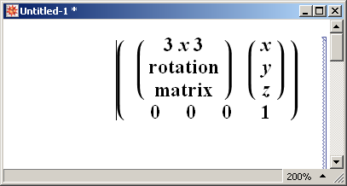

The 3x3 rotation matrix is the composition of rotation matrices for x-z-x Euler angles:

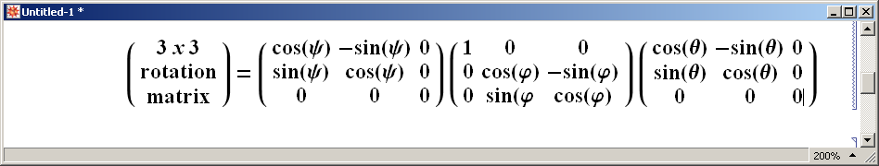

A pose matrix specifies orientation and translation in a certain reference frame. In our case it describes where one reference frame is in relation to another. We can compose matrices so that we can arbitrarily move from one reference frame to another with only the pose matrices that describe their relation to another. The pose composition rule is:

